Name: Duong Minh Hieu

Stdudent ID: T146150

SHOE SIZE

# Program description

The application is running on computer . It supports to user check their own shoe size.

It allows the user to input the length of foot, the system will respone the corresponding shoe size for user. The system supply the branches (Bitis, Nike ) for user can choose.

The application’s functionalities are:

* Show interface when user run that application.
* Allow user to choose kind of branch .
* Allow user to input number that is length of foot in the blank text-box.
* Load and show the number that is corresponding shoe size .
* Allow user setting data in application.

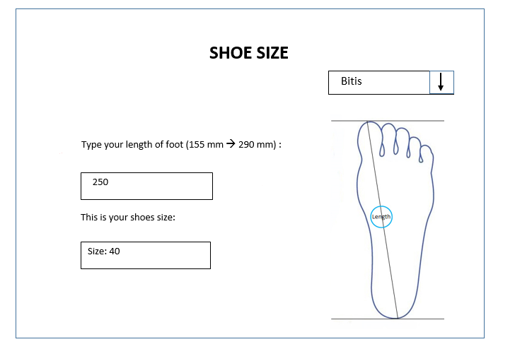

Setting

Exit

Branch

Compute

Interface description:

**SHOE SIZE**

1

Branch

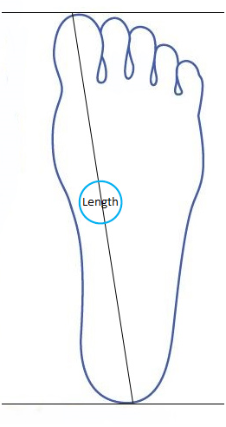

Type your length of foot (155 mm 🡪 290 mm) :

250

2

3 description

This is your shoes size :

4

Size: 40



Exit

Compute

I eliminate the scope of length foot in criteria range (155mm --> 290mm ) and (25🡪 45 ) is a range size to correspondent it.

And this is explaining for prototype

1: Name of product

2: Text to guide the box below

3: Input text-box: length of foot

4: Output text-box: outcome shoe size

5: The picture to guide how to know exactly the length of foot

6: The combo-box to choose the branch

7: Button to excute implement.

This is the interface when user click on “Setting” button



SETTING

( StartingLenght , EndingLenght) 🡪 Size

Delete Branch

Delete Size

Add Size

Bitis

|  |  |  |
| --- | --- | --- |
| Srating Length (mm) | Ending Length (mm) | Size |
| 150 | 158 | 25 |
| 158 | 165 | 26 |
| 165 | 170 | 27 |
| 170 | 175 | 28 |
| 175 | 180 | 29 |
| 180 | 188 | 30 |
| 188 | 195 | 31 |
| 195 | 200 | 32 |
| 200 | 210 | 33 |
| 210 | 215 | 34 |
| 215 | 220 | 35 |
| 220 | 226 | 36 |
| 226 | 233 | 37 |
| 233 | 240 | 38 |
| 240 | 248 | 39 |
| 248 | 255 | 40 |
| 255 | 260 | 41 |
| 260 | 265 | 42 |
| 265 | 270 | 43 |
| 270 | 275 | 44 |
| 280 | 285 | 45 |

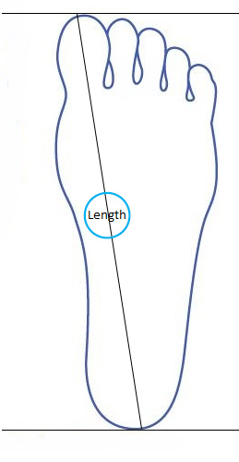

Add Branch

SAVE

BACK

# Use cases

Usecase Diagram

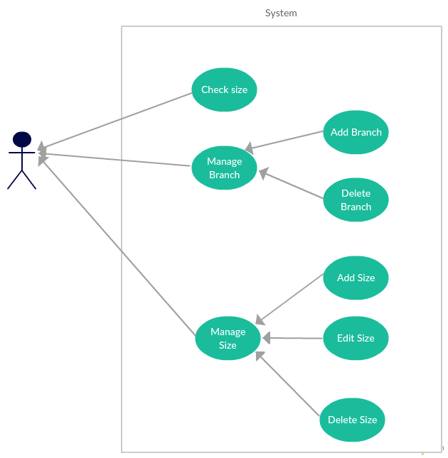

|  |  |
| --- | --- |
| **Use Case ID:** | 01 |
| **Use Case Name:** | Check Size |
| **Date Created:** | 5/18/2016 |
| **Actors:** | User |
| **Description:** | User runs program, type length of foot and respone the corresponding shoe size. |
| **Trigger:** | When user need find their shoe size. |
| **Preconditions:** | None |
| **Postconditions:** | User will receive the corressponding shoe size (shoe size by Bitis criterion). |
| **Normal Flow:** | * User run program * System show the interface * User choose branch in the branch Combobox, type length of foot ( number) and click on button “Compute” . * System respone the corresponding shoe size in output text-box. |
| **Alternative Flows:** | None |
| **Exceptions:** | If user type the invalid input (not number) in the input text-box, system show the Message Box is “Invalid input”.  If user type the numer (length of foot) is over the number in data program, system show “ Over Size ” in the output text-box. |
| **Priority:** | High |

|  |  |
| --- | --- |
| **Use Case ID:** | 02 |
| **Use Case Name:** | Manage Branch |
| **Date Created:** | 5/18/2016 |
| **Actors:** | User |
| **Description:** | User can manage branch in application, it include add Branch, deleta Branch. |
| **Trigger:** | When user want to manage and customize branch in application. |
| **Preconditions:** | None |
| **Postconditions:** | The information of branch is updated. |
| **Normal Flow:** | * User choose “Setting” button. * System show the new Setting Form. * User choose the name Branch in “NameBranch” combobox. * System show the size table of Branch that user choose . * User customize branches are click on “Add branch” ot “Delete Branch” that they want to add or delete. * System update information of branch . |
| **Alternative Flows:** | None |
| **Exceptions:** | None |
| **Priority:** | Medium |

|  |  |
| --- | --- |
| **Use Case ID:** | 03 |
| **Use Case Name:** | Add Branch |
| **Date Created:** | 5/18/2016 |
| **Actors:** | User |
| **Description:** | User can add new branch into application. |
| **Trigger:** | When user want to add new branch in application. |
| **Preconditions:** | User have to click on “Setting” button |
| **Postconditions:** | The new branch is added. |
| **Normal Flow:** | * User click on “Add Branch” button * System show a Add Branch interface (new Form) * User type a name Branch and click on “Save”. * System add a new name Branch in Branch combobox and new table of Branch. |
| **Alternative Flows:** | * None |
| **Exceptions:** | If user add a name branch is same as name branch that existed before, system show the Message Box is “The name branch existed, Try again” and don’t add new Branch into applicaition. |
| **Priority:** | Medium |

|  |  |
| --- | --- |
| **Use Case ID:** | 04 |
| **Use Case Name:** | Delete Branch |
| **Date Created:** | 5/18/2016 |
| **Actors:** | User |
| **Description:** | User can delete branch from application. |
| **Trigger:** | When user want to manage and customize branch in application. |
| **Preconditions:** |  |
| **Postconditions:** | The new branch is deleted. |
| **Normal Flow:** | * User click on “Delete Branch”. * User click on “OK”. * System delete the name Branch in combobox and table of Branch. |
| **Alternative Flows:** | None |
| **Exceptions:** | None |
| **Priority:** | Medium |

|  |  |
| --- | --- |
| **Use Case ID:** | 05 |
| **Use Case Name:** | Manage Size |
| **Date Created:** | 5/18/2016 |
| **Actors:** | User |
| **Description:** | User can manage size in application, it : add , edit, delete size. |
| **Trigger:** | When user want to manage and customize size in application. |
| **Preconditions:** | None |
| **Postconditions:** | The information of size is updated. |
| **Normal Flow:** | * User choose “Setting” button. * System show the new Setting interface. * User choose the name Branch in “NameBranch” combobox. * System show the size table of Branch that user choose . * User customize sizes. * System update information of size |
| **Alternative Flows:** | None |
| **Exceptions:** | None |
| **Priority:** | Medium |

|  |  |
| --- | --- |
| **Use Case ID:** | 06 |
| **Use Case Name:** | Add Size |
| **Date Created:** | 5/18/2016 |
| **Actors:** | User |
| **Description:** | User can add a row of new size on table. |
| **Trigger:** | When user want to add new size in application. |
| **Preconditions:** | User have to click on “Edit Size” button |
| **Postconditions:** | The size is added. |
| **Normal Flow:** | * User click on “Add Size ” button * System show a Add Size interface (new Form) * User fill information are length, size in table and click on “Save” button. * System add new row size on table. |
| **Alternative Flows:** | None |
| **Exceptions:** | If user type the invalid input (not number) in the row on table. Click ”Save” button, system show the Message Box is “Invalid input”. |
| **Priority:** | Medium |

|  |  |
| --- | --- |
| **Use Case ID:** | 07 |
| **Use Case Name:** | Edit Size |
| **Date Created:** | 5/18/2016 |
| **Actors:** | User |
| **Description:** | User can edit a row of size on table. |
| **Trigger:** | When user want to edit size in application. |
| **Preconditions:** | User have to click on “Edit Size” button |
| **Postconditions:** | The size is editted. |
| **Normal Flow:** | * User choose a row on Branch table and double-click. * System show a Edit Branch interface (new Form) * User edit information at row. * User click on “Save” button * System update the changes on table. |
| **Alternative Flows:** | None |
| **Exceptions:** | If user edit wrong information (not number) or coincidence information at row. Click on “Save” button system show the Message Box is “Can not Edit Size”. |
| **Priority:** | Medium |

|  |  |
| --- | --- |
| **Use Case ID:** | 08 |
| **Use Case Name:** | Delete Size |
| **Date Created:** | 5/18/2016 |
| **Actors:** | User |
| **Description:** | User can delete row of size on table. |
| **Trigger:** | When user want to delete size in application. |
| **Preconditions:** |  |
| **Postconditions:** | The size is deleted. |
| **Normal Flow:** | * User choose a size row on Branch table. * User click on “Delete” button. * System delete that size on table. |
| **Alternative Flows:** | None |
| **Exceptions:** | None |
| **Priority:** | Medium |

Database

We use 2 tables in database that we have to manage:

1. Branch: The table contains information about name Branch. It has Branch_id and Name of Branch
2. Size : The table containts information about list Size of Branch. It has id, Branch_id, L1, L2, Size.

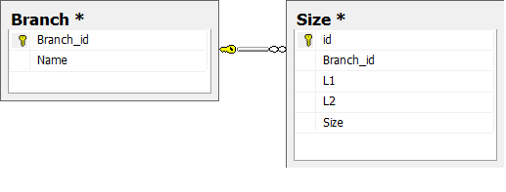

|  |  |  |  |  |
| --- | --- | --- | --- | --- |
| Name | Description | Constraint | Data type | Allow null |
| Branch_id | The id of branch | Primary key | Int | Not null |
| Name | The name of branch | Unique | Nvarchar(50) | Not null |

Branch Description:

Size Description:

|  |  |  |  |  |
| --- | --- | --- | --- | --- |
| Name | Description | Constraint | Data type | Allow null |
| id | The id of Size | Primary key | Int | Not null |
| Branch_id | The name of branch | Foregin key references Branch(Branch_id) | Nvarchar(50) | Not null |
| L1 | The starting length of foot in lenght range (L1,L2) |  | Float | Not null |
| L2 | The ending length of foot in lenght range (L1,L2) |  | Float | Not null |
| Size | The responding size in range ( L1,L2) |  | Float | Not null |