Homework 1：Faulty Programs with Faults and Failures
Student：314551102 / 曹育瑄

Part 1
Section 1：Last Index of Element
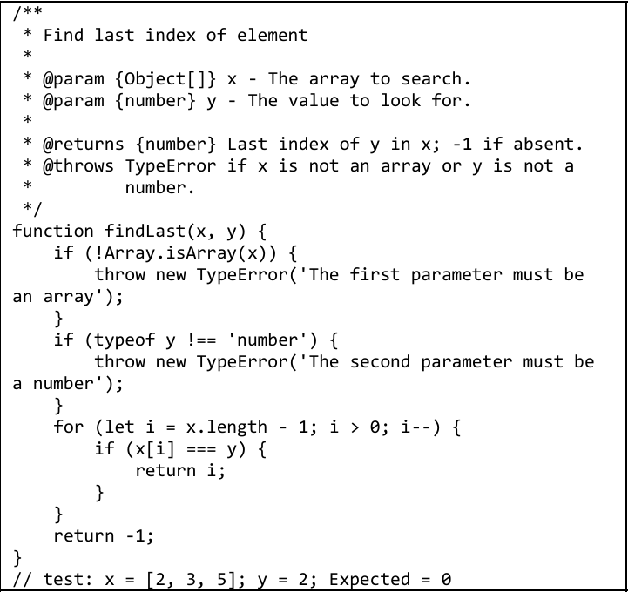
Figure 1 The code of Last Index of Element.

(a) Explain what is wrong with the given code.
Describe the fault precisely by proposing a modification to the code.
for (let i = x.length - 1; i > 0; i--)讀不到index=0的element，應該改為for (let i = x.length - 1; i >= 0; i--)，才會讀完整個迴圈。

(b) If possible, give a test case that does not execute the fault.
If not, briefly explain why not. (You need to give the same number of arguments.)
test: x = [2, 3, 5]; y = "3";
如此一來，程式碼會在if (typeof y !== 'number')下扔出TypeError('The second parameter must be a number')，就不會執行到for (let i = x.length - 1; i > 0; i–) 。

(c) If possible, give a test case that executes the fault, but does not result in an error state.
test: x = [2, 3, 5]; y = 3; Expected = 1, Actual = 1
會執行到for (let i = x.length - 1; i > 0; i–)，但因為要找的元素在index = 1，程式不需要檢查 i = 0 就找到。雖然Fault 被執行（因為迴圈條件 i > 0 真的影響到檢查範圍），但因為是從最後一個index找，所以沒有導致error state。

(d) If possible, give a test case that results in an error state, but not a failure.
If not, briefly explain why not. (You also need to answer expected and actual output.)
沒有，因為在這個題目的error state勢必要在我們要找的元素在index = 0的情況下才會發生，而這個error state發生時，就一定會導致failure。 例如，test: x = [2, 3, 5]; y = 2; Expected = 0, Actual = -1。

(e) For the given test case in (d), describe the first error state. Be sure to describe the complete state.
無。

Section 2：Last Index of Zero
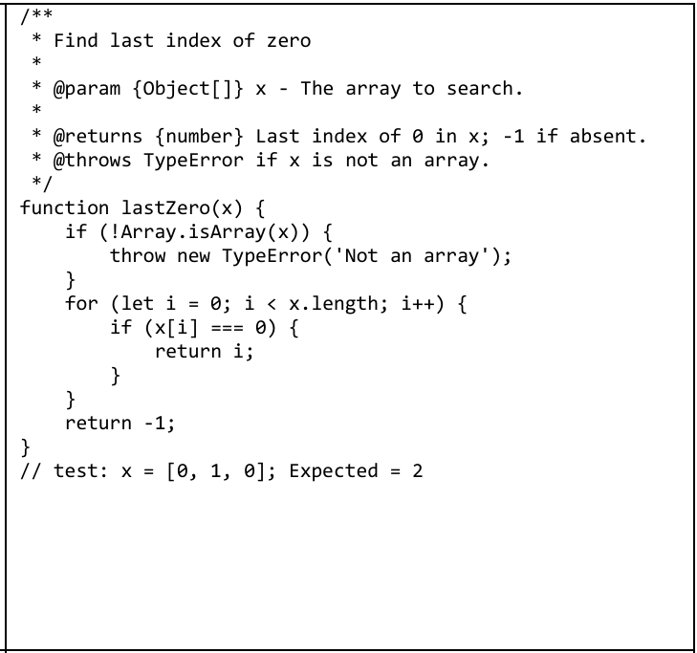
Figure 2 The code of Last Index of Zero.

(a) Explain what is wrong with the given code.
Describe the fault precisely by proposing a modification to the code.
for (let i = 0; i < x.length; i++)的功能會是找到第一個0的index，而不是最後的index。應改為由後往前找，應該改為for (let i = x.length - 1; i >= 0; i--)。

(b) If possible, give a test case that does not execute the fault.
If not, briefly explain why not. (You need to give the same number of arguments.)
test: x = "miku";
如此一來，程式碼會在if (!Array.isArray(x))下扔出TypeError('Not an array')，就不會執行到for (let i = 0; i < x.length; i++)

(c) If possible, give a test case that executes the fault, but does not result in an error state.
test: x = [3, 9, 0, 2]; Expected = 2, Actual = 2
Fault 被執行（遇到 x[2] = 0，馬上 return），但因為這個0是第一個0也是最後一個0，所以不會導致error state。

(d) If possible, give a test case that results in an error state, but not a failure.
If not, briefly explain why not. (You also need to answer expected and actual output.)
沒有，導致error state的情況下是該元素不是陣列的最後一個0，像是[0, 1, 0]，在index=0時會直接return 0，一定會導致failure。此題在error state發生時，就一定會導致failure。

(e) For the given test case in (d), describe the first error state. Be sure to describe the complete state.
無。

Section 3：Count Positive Elements
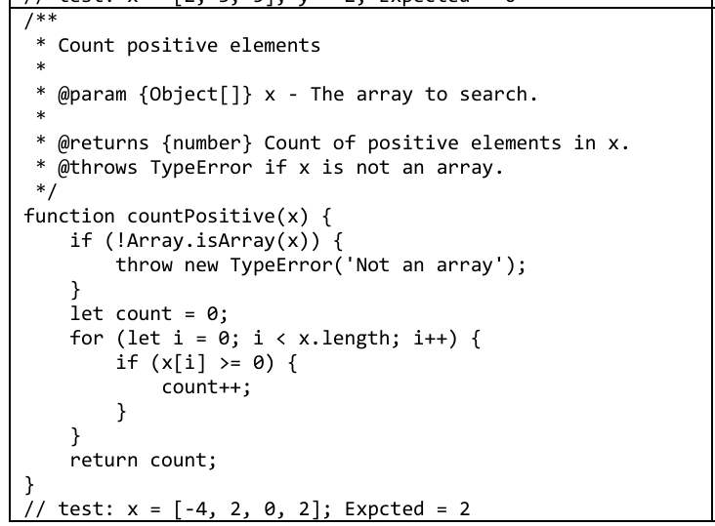
Figure 3 The code of Count Positive Elements.

(a) Explain what is wrong with the given code.
Describe the fault precisely by proposing a modification to the code.
for (let i = 0; i < x.length; i++)裡面的x[i] >= 0會包含0，應改為if (x[i] > 0)。

(b) If possible, give a test case that does not execute the fault.
If not, briefly explain why not. (You need to give the same number of arguments.)
test: x = "みくみくにしてあげる♪";
程式碼會在if (!Array.isArray(x))下扔出TypeError('Not an array')，就不會執行到if (x[i] >= 0)
或者test: x = []; Expected = 0, Actual = 0
程式碼會在for迴圈判斷時，因為i<x.length，所以直接跳出迴圈回傳0(count)，不會執行到x[i] >= 0。
(c) If possible, give a test case that executes the fault, but does not result in an error state.
test: x = [3, 9, 3, 9]; Expected = 4, Actual = 4
他會執行到if (x[i] >= 0) { count++; }，但因為陣列裡都是正整數，所以不會導致出現error state。

(d) If possible, give a test case that results in an error state, but not a failure.
If not, briefly explain why not. (You also need to answer expected and actual output.)
沒有，因為這個程式碼的error state是當陣列裡的元素是0時，count會被+1，導致count與我們預期的不一致。此題在error state發生時，就一定會導致failure。

(e) For the given test case in (d), describe the first error state. Be sure to describe the complete state.
無。

Section 4：Count Odd or Postive Elements
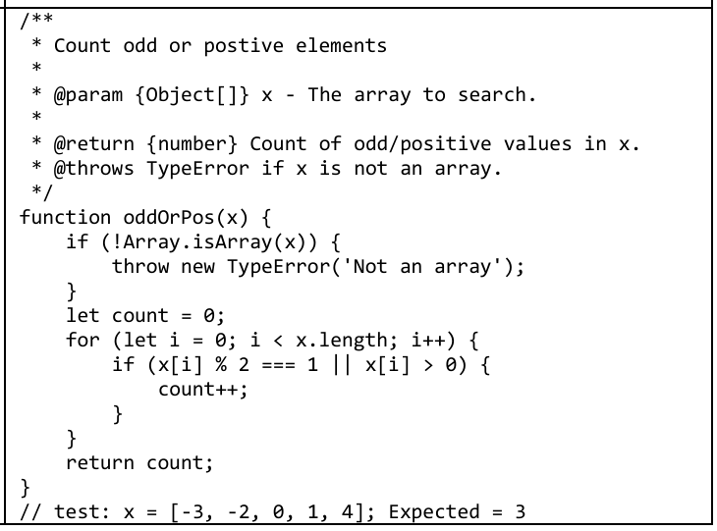
Figure 3 The code of Count Odd or Positive Elements.

(a) Explain what is wrong with the given code.
Describe the fault precisely by proposing a modification to the code.
for (let i = 0; i < x.length; i++)裡面的x[i] % 2 === 1 || x[i] > 0無法處理負奇數的情況，應改為if (x[i] % 2 !== 0)。

(b) If possible, give a test case that does not execute the fault.
If not, briefly explain why not. (You need to give the same number of arguments.)
test: x = "みくみくにしてあげる♪";
程式碼會在if (!Array.isArray(x))下扔出TypeError('Not an array')，就不會執行到if (x[i] >= 0)
或者test: x = []; Expected = 0, Actual = 0
程式碼會在for迴圈判斷時，因為i<x.length，所以直接跳出迴圈回傳0(count)，不會執行到x[i] >= 0。
(c) If possible, give a test case that executes the fault, but does not result in an error state.
test: x = [3, 9, 3, 9]; Expected = 4, Actual = 4
他會執行到if (x[i] % 2 === 1 || x[i] > 0) { count++; }，但因為陣列裡都是正整數跟奇數，所以不會導致出現error state。

(d) If possible, give a test case that results in an error state, but not a failure.
If not, briefly explain why not. (You also need to answer expected and actual output.)
沒有，因為這個程式碼的error state是當陣列裡的元素是負奇數時，count不會被+1，只要陣列有負奇數就會產生error state，而一旦有error state的情況下這一題一定會導致failure。

(e) For the given test case in (d), describe the first error state. Be sure to describe the complete state.
無。

Part 2
Section 1：DataProcessor.cpp
Fault:
由於動態分配的 DataRecord objects和 data_buffer 記憶體未在 processLargeFile 內釋放而造成Memory leak。
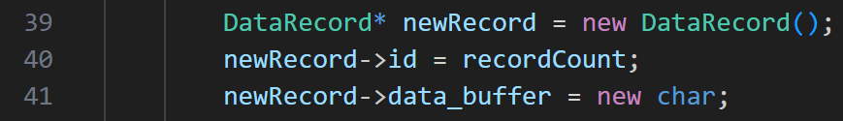

Test Case:
Run the provided main() function (which generates a data.txt file with 10,000 records and calls processLargeFile).
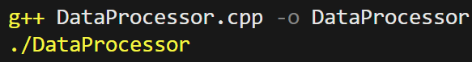
Then use the tool Valgrind to check if there is a memory leak.

Expected Output:
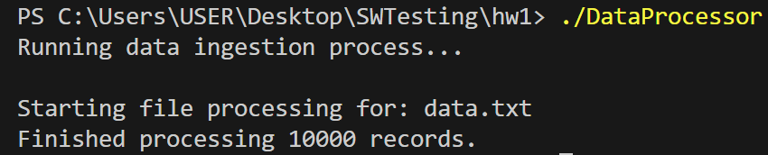 (with no memory leak)

Actual Output:
(but have memory leak)
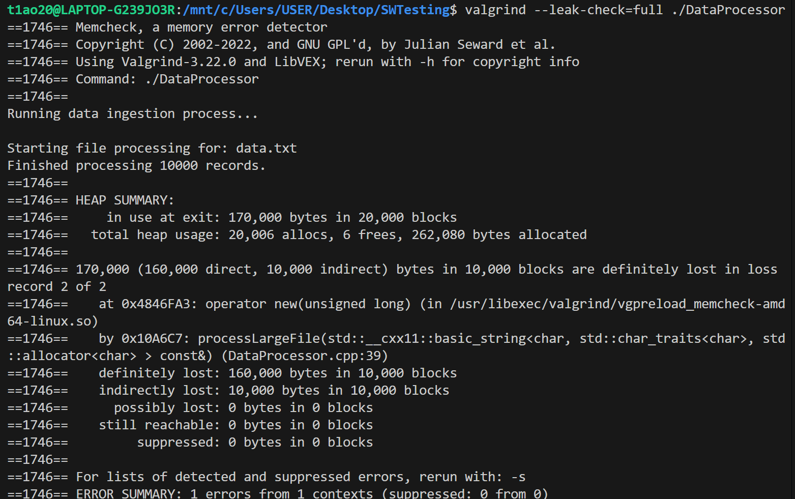

Output說明：
程式結束時還有 170,000 bytes 沒釋放。
一共做了 20,006 次記憶體配置 (alloc)，但只釋放了 6 次。
direct lost 160 KB：new DataRecord() 本身沒被 delete。
indirect lost 10 KB：每個 DataRecord 裡的 new char 沒釋放。

Section 2：MatrixProcessor.cpp
Fault:
在 process_matrix(const int* const* matrix, int rows, int cols); 中使用 const_cast 破壞了matrix變數 const 的語意，還把指標設為非法地址 999。會導致在執行過程中可能導致程式 crash，輸出異常或記憶體存取錯誤。

Test Case:
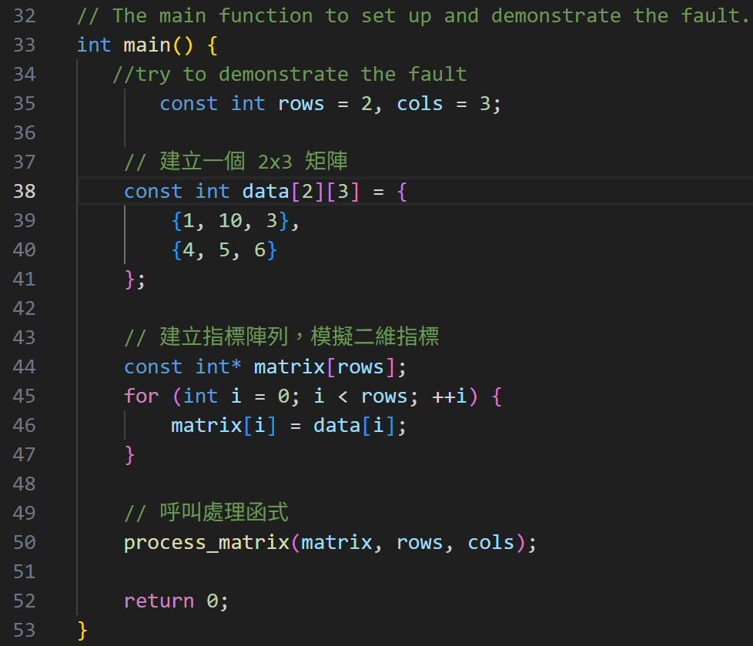

Expected Output:
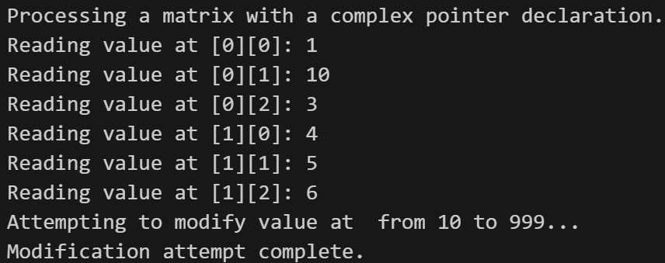
Actual Output:
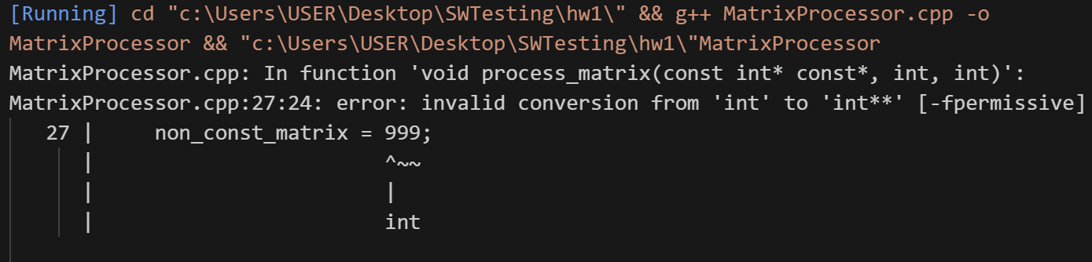

Section 3：ResourceScheduler.py
Fault:
Deadlock的問題
Thread A 嘗試先取得 Resource A，再等待 Resource B。
Thread B 嘗試先取得 Resource B，再等待 Resource A。
→ 導致互相等待，永遠不會結束。

Test Case:
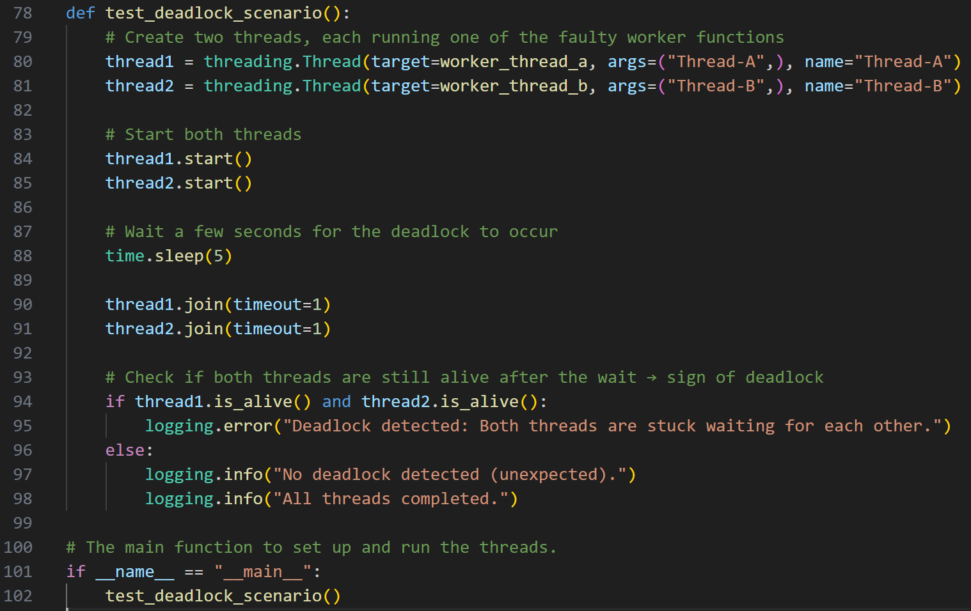

Expected Output:
Thread-A 取得 Resource A，並嘗試取得 Resource B。
Thread-B 取得 Resource B，並嘗試取得 Resource A。
其中一個應該完成 complex_task_function，並釋放所有鎖。
程式應正常結束並印出 "All threads completed."。

Actual Output:
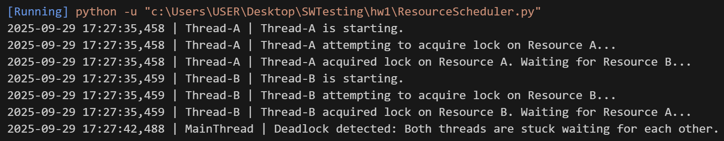

Section 4：LoggingSystem.cpp
Fault:
Race condition due to missing mutex when incrementing total_logs_processed.
Test Case:
Run the program with NUM_THREADS = 10 and LOGS_PER_THREAD = 10000.
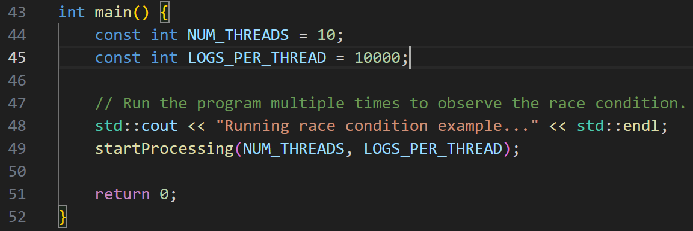

Expected Output:
Running race condition example...
Expected total logs: 100000
Starting log processing with 10 threads.
Thread 0 starting to process logs...
Thread 1 starting to process logs...
...
Thread 9 finished.

All threads have finished.
Final count of logs processed: 100000
Final count of logs processed should be 100000.

Actual Output:
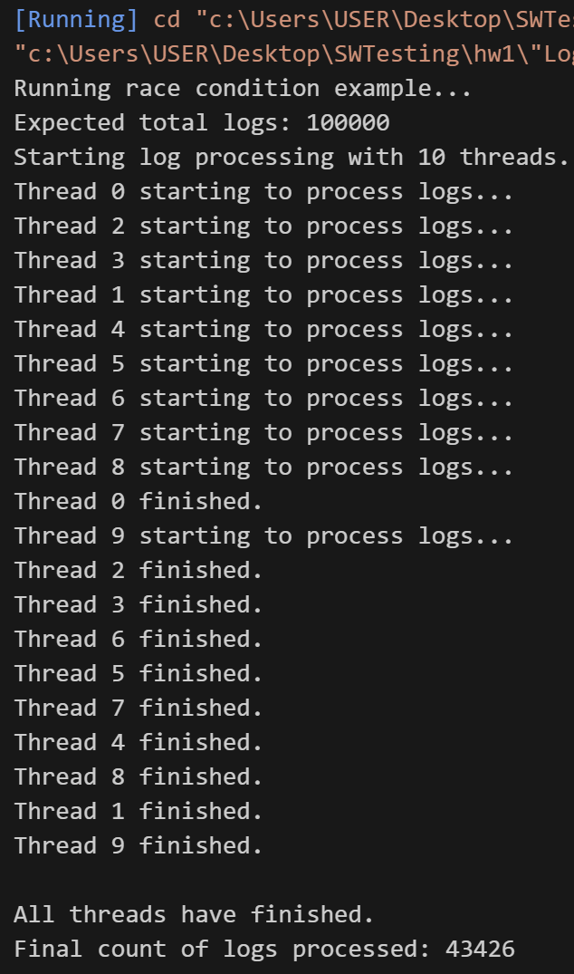 | Final count of logs processed: 43426  -> less than expected.
Section 5：ProfileUpdater.cpp
Fault:
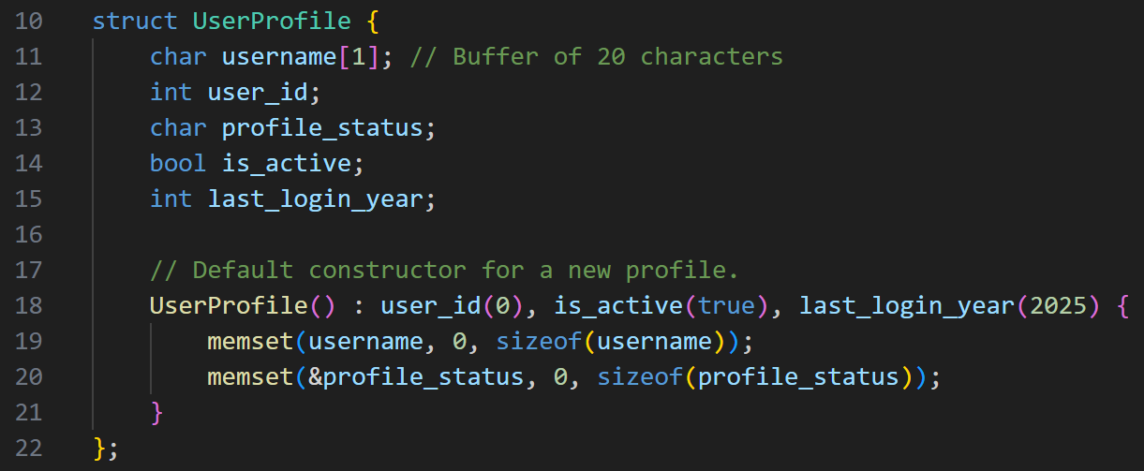
char username[1]; 實際只有buffer of 1 character
Test Case:
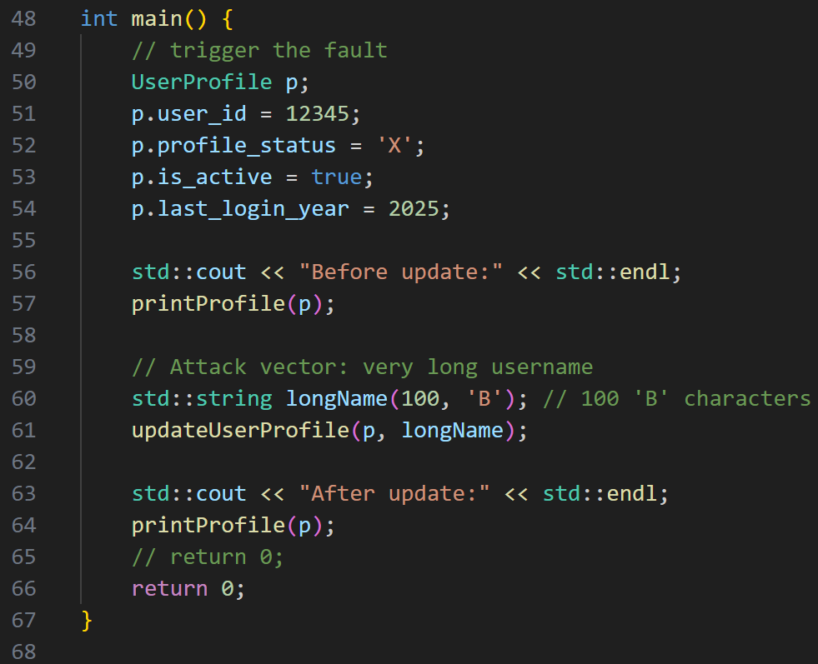
Using a very long username: longName(100, 'B'); // 100 'B' characters
Expected Output:
Before update:
--- User Profile Details ---
Username:
User ID: 12345
Status: X
Is Active: Yes
Last Login: 2025
----------------------------
Updating...
After update:
--- User Profile Details ---
Username: BBBBBBBBB... B
User ID: 12345
Status: X
Is Active: Yes
Last Login: 2025
----------------------------

Actual Output:
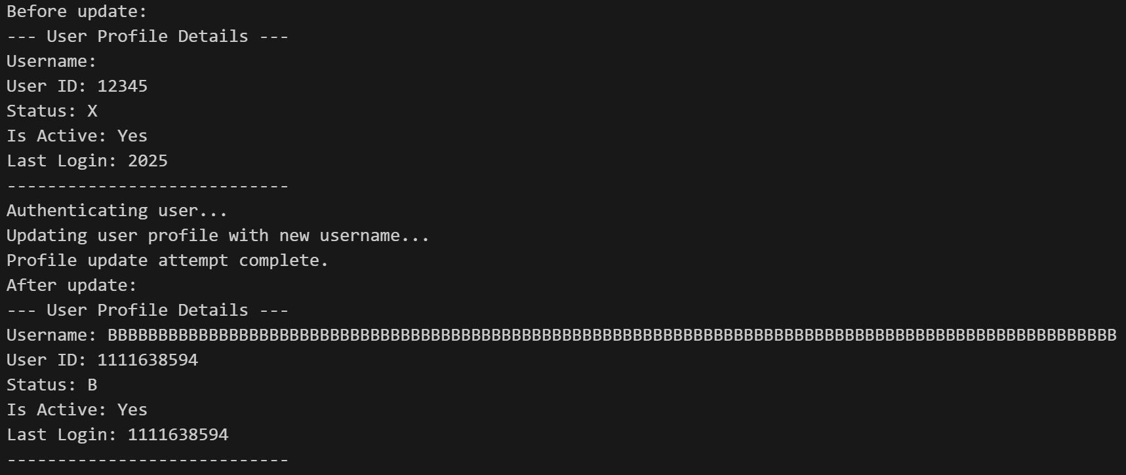
可以看到User ID、Status 、Last Login 被溢出的 username 字元覆寫成亂數或大數值。

