class0.4.R

thoma

2025-01-16

x<- 1:50  
plot(x, sin(x))

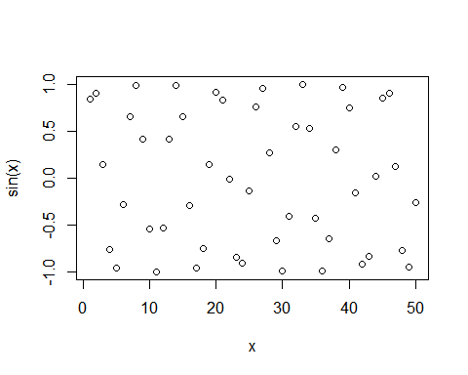

#make this nicer  
plot(x, sin(x), col="blue", typ="l", lwd=3 )

