Data Go Brrrrrrrrrrr

If we look at the contents of the requests from packet 13 to packet 27, we can see some rather odd data; in packet 27, the data ends with an ‘=’, which means it is Base64-encoded data. If we combine all the data from each packet into a single Base64 string, we get:

ZGVhZGZhY2V7aWNtcF8zeGZpbF93aDNuX3RoM3lfbGVhc3Rfc3VzcDNjdH0=
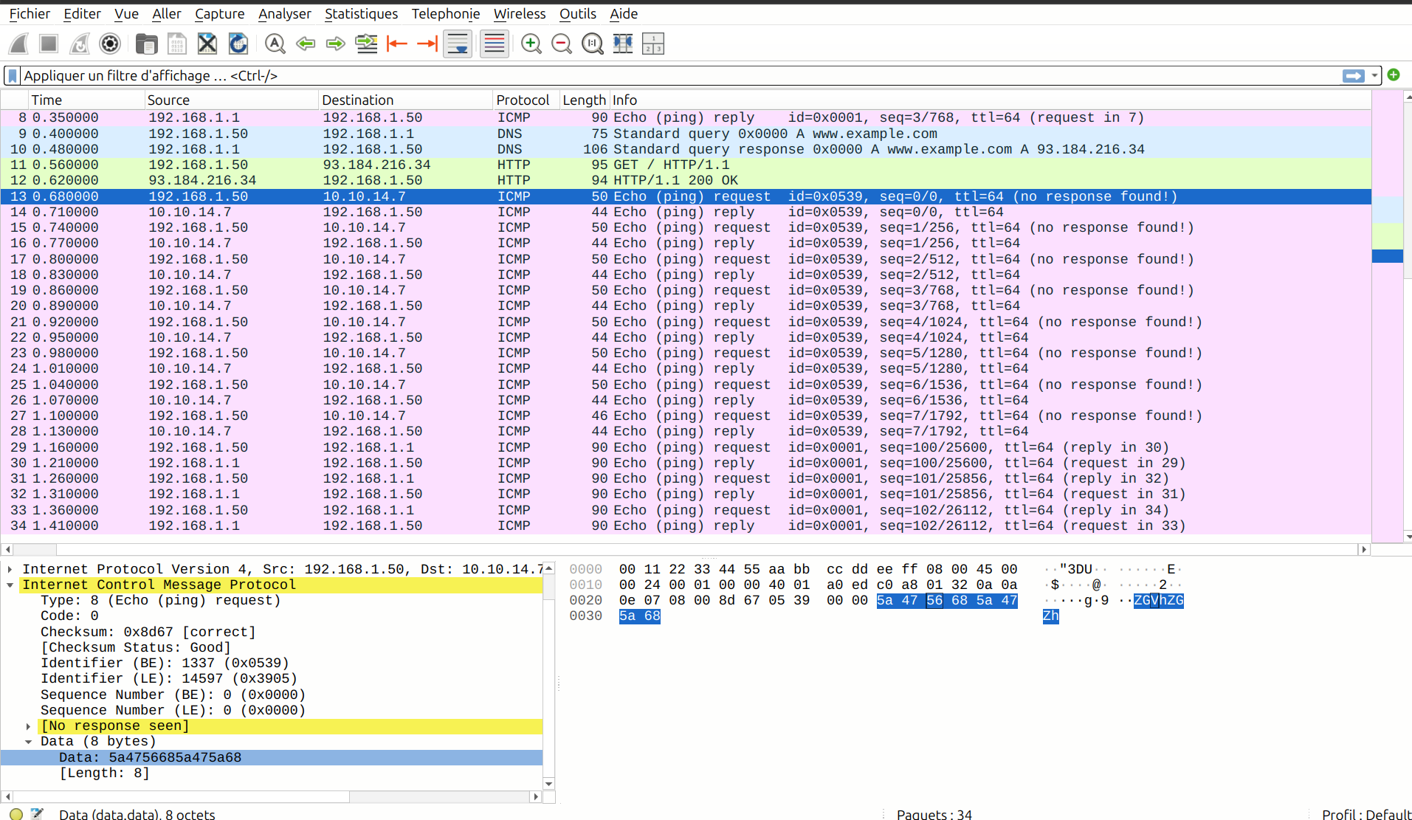

If we decode this base64 string we obtain this good flag :

