Bad Guys Be Bad

Firstly, we need to examine the character strings in the file; on line 1194, we notice something rather suspicious:

1191:# staging config -- do not commit
1192:mode=exfil
1194:xor_key=Sp00ky
1195:target=exfil.deadface-c2.net

I gather that we need to apply a Wireshark filter to our pcap to extract the relevant data:

dns.qry.name contains ‘exfil.deadface-c2.net’

There are some interesting search queries that start with ‘s00’, ‘s01’, ‘s02’ … followed by letters

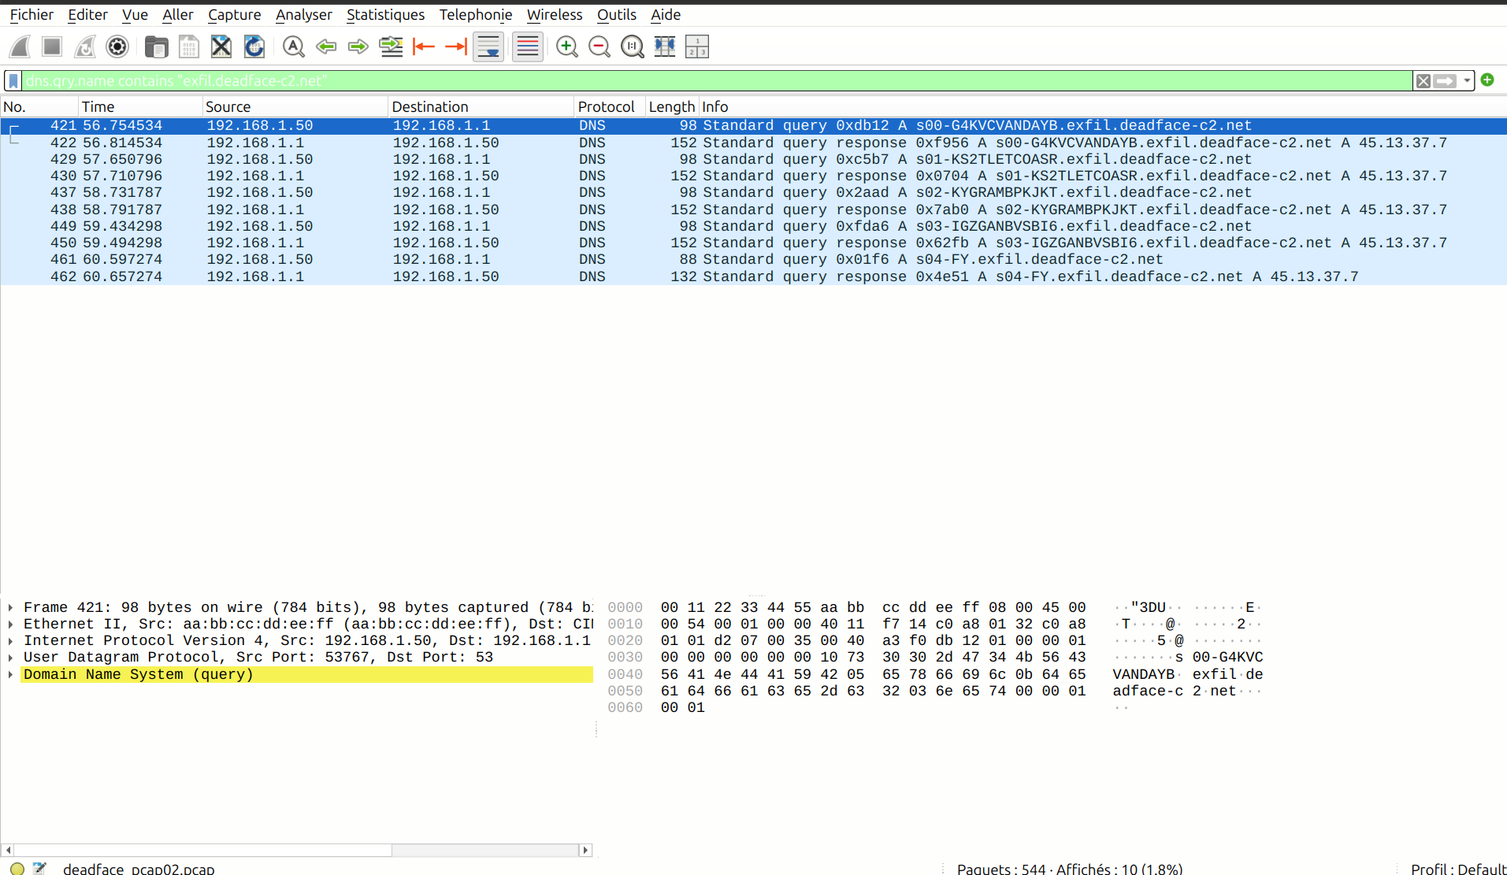
Now, if we carefully extract each section after ‘sXX-’ and before ‘.exfill’, we get: G4KVCVANDAYBKS2TLETCOASRKYGRAMBPKJKTIGZGANBVSBI6FY

If we look back, we saw an xor key; all that remains is to decrypt the string using the key Sp00ky, and we get a splendid flag :

deadface{c2_traffic_be_bussing}

