LabWork 1: Relational Model & Keys
Part 1: Key Identification Exercises
Task 1.1: Superkey and Candidate Key Analysis
Relation A: Employee
1. List at least 6 different superkeys
{EmpID} , {SSN} , {Email} , {Phone} , {EmpID, Name}, {EmpID, Department}
2. Identify all candidate keys
{EmpID}, {SSN}, {Email}, {Phone}
3. Which candidate key would you choose as primary key and why?
{EmpID} . It is a concise, system-generated integer (surrogate key). Unlike SSN, it does not contain sensitive personal data (PII), and unlike Email or Phone, it is immutable (does not change over time).
4. Can two employees have the same phone number? Justify your answer based on the data shown.
Based solely on the provided sample data, no, because every listed employee has a unique phone number (555-0101, 555-0102, 555-0103), making Phone a valid candidate key in this specific dataset.

Relation B: Course Registration
1. Determine the minimum attributes needed for the primary key
{StudentID, CourseCode, Section, Semester, Year}
2. Explain why each attribute in your primary key is necessary
StudentID: identifies a specific student.
CourseCode: defines the subject matter.
Section: distinguishes between sections of the same course within a single semester.
Semester and Year: allow the student to take the same course/section during different academic periods.
3. Identify any additional candidate keys (if they exist)
There are no additional candidate keys.
The composite key {StudentID, CourseCode, Section, Semester, Year} is the unique candidate key for this relation

Task 1.2: Foreign Key Design
Student.AdvisorID $→$ Professor(ProfID)
Course.DepartmentCode $→$ Department(DeptCode)
Department.ChairID $→$ Professor(ProfID)
Enrollment.StudentID $→$ Student(StudentID)
Enrollment.CourseID $→$ Course(CourseID)
Part 2: ER Diagram Construction
Task 2.1: Hospital Management System
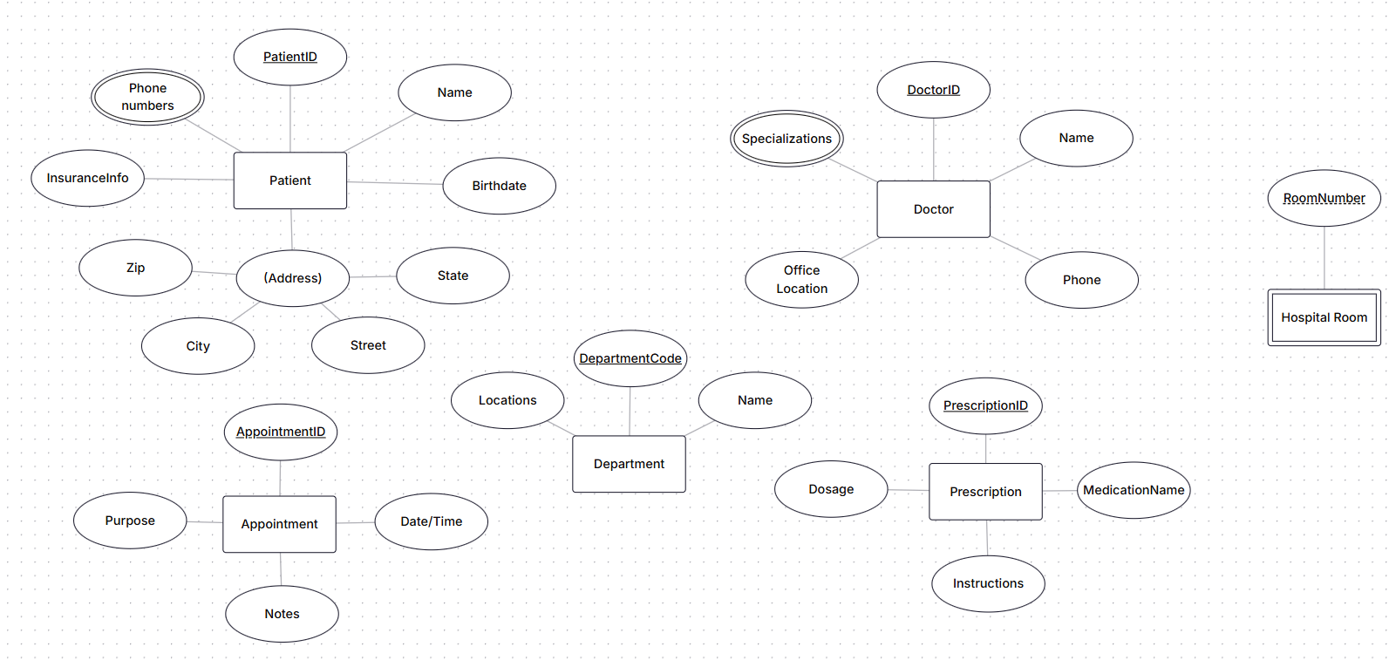
Strong Entities: Patient, Doctor, Department, Appointment, Prescription.
Weak Entities: Hospital Room.
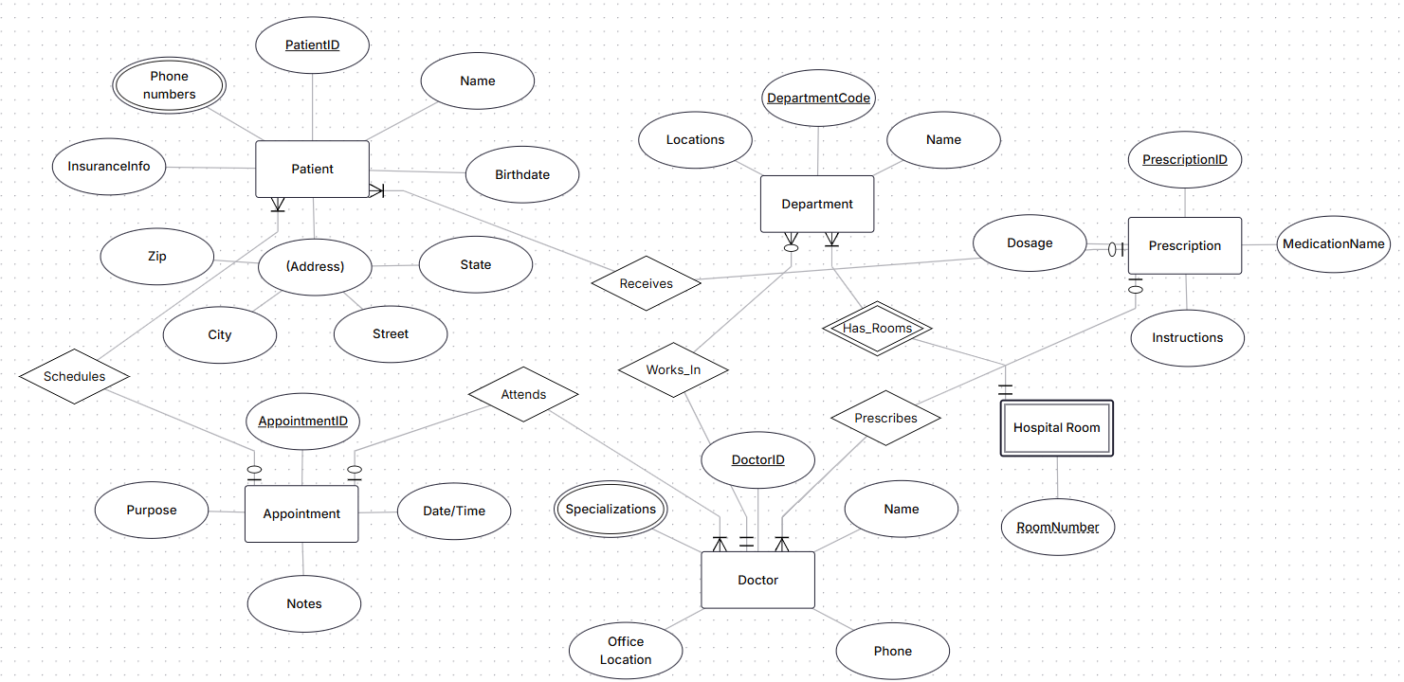
1.PATIENT (PatientID, Name, Birthdate, InsuranceInfo, Street, City, State, Zip)
Primary Key: PatientID
2.PATIENT_PHONE (PatientID, PhoneNumber)
Primary Key: (PatientID, PhoneNumber)
Foreign Key: PatientID references PATIENT(PatientID)
3.DEPARTMENT (DepartmentCode, DeptName, Location)
Primary Key: DepartmentCode
4.DOCTOR (DoctorID, Name, Phone, OfficeLocation, DepartmentCode)
Primary Key: DoctorID
Foreign Key: DepartmentCode references DEPARTMENT(DepartmentCode)
5.DOCTOR_SPECIALIZATION (DoctorID, Specialization)
Primary Key: (DoctorID, Specialization)
Foreign Key: DoctorID references DOCTOR(DoctorID)
6.APPOINTMENT (AppointmentID, DateTime, Purpose, Notes, PatientID, DoctorID)
Primary Key: AppointmentID
Foreign Keys:
PatientID references PATIENT(PatientID)
DoctorID references DOCTOR(DoctorID)
7.PRESCRIPTION (PrescriptionID, MedicationName, Dosage, Instructions, PatientID, DoctorID)
Primary Key: PrescriptionID
Foreign Keys:
PatientID references PATIENT(PatientID)
DoctorID references DOCTOR(DoctorID)
8.HOSPITAL_ROOM (DepartmentCode, RoomNumber)
Primary Key: (DepartmentCode, RoomNumber)
Foreign Key: DepartmentCode references DEPARTMENT(DepartmentCode)

Task 2.2: E-commerce Platform
1. Weak Entity & Justification
Weak Entity: Order Item
Justification: Order Item cannot exist independently without a parent Order. It relies on Order for its primary identification, and deleting an order automatically removes all of its associated items.
2. Many-to-Many Relationship with Attributes
Relationship: Between Order and Product (a single order can include multiple products, and a product can appear in many orders).
Attributes on the relationship (Order Item):
quantity: The number of units purchased for a specific product.
price_at_purchase: The exact price of the product at the time of order placement, preserving historical accuracy even if catalog prices change later.
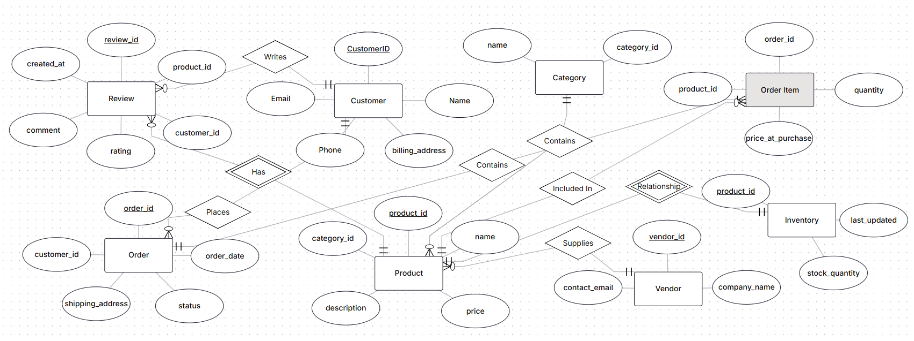

Part 4: Normalization Workshop
Task 4.1: Denormalized Table Analysis
Given Table:
StudentProject(StudentID, StudentName, StudentMajor, ProjectID, ProjectTitle, ProjectType, SupervisorID, SupervisorName, SupervisorDept, Role, HoursWorked, StartDate, EndDate)
1.Functional Dependencies (FDs)
FD1: StudentID -> StudentName, StudentMajor
FD2: ProjectID -> ProjectTitle, ProjectType, SupervisorID
FD3: SupervisorID -> SupervisorName, SupervisorDept
FD4: StudentID, ProjectID -> Role, HoursWorked, StartDate, EndDate
2.Problems and Anomalies
Redundancy:
Student information (StudentName, StudentMajor) is repeated for every project a student works on.
Project and Supervisor details (ProjectTitle, ProjectType, SupervisorName, SupervisorDept) are duplicated for every student assigned to the same project.
Update Anomaly:
If a student changes their major, multiple rows must be updated. Missing a row leads to inconsistent data.
Insert Anomaly:
You cannot add a new project or a new supervisor into the database until a student is assigned to that project (because StudentID is part of the primary key).
Delete Anomaly:
If the only student assigned to a project is removed, the entire record of the project and its supervisor is deleted from the database.

3.Apply 1NF
1NF Violation Check: The table is already in 1NF assuming all attribute values are atomic and there are no repeating groups.
Fix: Ensure all attributes contain single, atomic values.
4.Apply 2NF
Primary Key: (StudentID, ProjectID)
Partial Dependencies Identified:
StudentID -> StudentName, StudentMajor (depends on part of the primary key)
ProjectID -> ProjectTitle, ProjectType, SupervisorID, SupervisorName, SupervisorDept (depends on part of the primary key)
2NF Decomposition:
1.Student(StudentID, StudentName, StudentMajor)
2.Project(ProjectID, ProjectTitle, ProjectType, SupervisorID, SupervisorName, SupervisorDept)
3.StudentProjectAssignment(StudentID, ProjectID, Role, HoursWorked, StartDate, EndDate)
5.Apply 3NF
Transitive Dependency Identified:
In the Project relation: ProjectID -> SupervisorID and SupervisorID -> SupervisorName, SupervisorDept.
Thus, SupervisorName and SupervisorDept transitively depend on ProjectID.
Final 3NF Decomposition (Table Schemas):
1.Student
Schema: Student(StudentID, StudentName, StudentMajor)
Primary Key: StudentID
2.Supervisor
Schema: Supervisor(SupervisorID, SupervisorName, SupervisorDept)
Primary Key: SupervisorID
3.Project
Schema: Project(ProjectID, ProjectTitle, ProjectType, SupervisorID)
Primary Key: ProjectID
Foreign Key: SupervisorID references Supervisor(SupervisorID)
4.Student Project Assignment
Schema: StudentProjectAssignment(StudentID, ProjectID, Role, HoursWorked, StartDate, EndDate)
Primary Key: (StudentID, ProjectID)
Foreign Keys: StudentID references Student(StudentID), ProjectID references Project(ProjectID)
Task 4.2: Advanced Normalization
Given Table:
CourseSchedule(StudentID, StudentMajor, CourseID, CourseName, InstructorID, InstructorName, TimeSlot, Room, Building)
1.Primary Key Primary Key: (StudentID, CourseID)
Reasoning: Based on the business rules, a student can enroll in multiple courses, and each course section is taught by one instructor at a fixed time slot in a room. Therefore, (StudentID, CourseID) uniquely identifies a student's enrollment record.
2.Functional Dependencies (FDs)
FD1: StudentID -> StudentMajor
FD2: CourseID -> CourseName
FD3: InstructorID -> InstructorName
FD4: Room -> Building FD5: CourseID -> InstructorID, TimeSlot, Room
3.Check for BCNF
BCNF Definition: A relation is in BCNF if for every non-trivial functional dependency X -> Y, X is a superkey.
Analysis:
StudentID -> StudentMajor (StudentID is not a superkey)
CourseID -> CourseName, InstructorID, TimeSlot, Room (CourseID is not a superkey)
InstructorID -> InstructorName (InstructorID is not a superkey)
Room -> Building (Room is not a superkey)
Conclusion: The table violates BCNF.
4.BCNF Decomposition
1.Student(StudentID, StudentMajor)
Primary Key: StudentID
2.Instructor(InstructorID, InstructorName)
Primary Key: InstructorID
3.Location(Room, Building)
Primary Key: Room
4.CourseSection(CourseID, CourseName, InstructorID, TimeSlot, Room)
Primary Key: CourseID
Foreign Keys: InstructorID references Instructor(InstructorID), Room references Location(Room)
5.Enrollment(StudentID, CourseID)
Primary Key: (StudentID, CourseID)
Foreign Keys:
StudentID references Student(StudentID)
CourseID references CourseSection(CourseID)
5.Loss of Information / Dependencies Analysis
Lossless Join: The decomposition is lossless because every join operation uses shared candidate keys/foreign keys, ensuring no spurious tuples are created upon joining the tables back. Dependency Preservation: All functional dependencies (FD1 through FD5) are fully preserved within individual decomposed tables without requiring cross-table joins.

Part 5: Design Challenge
Task 5.1: Real-World Application

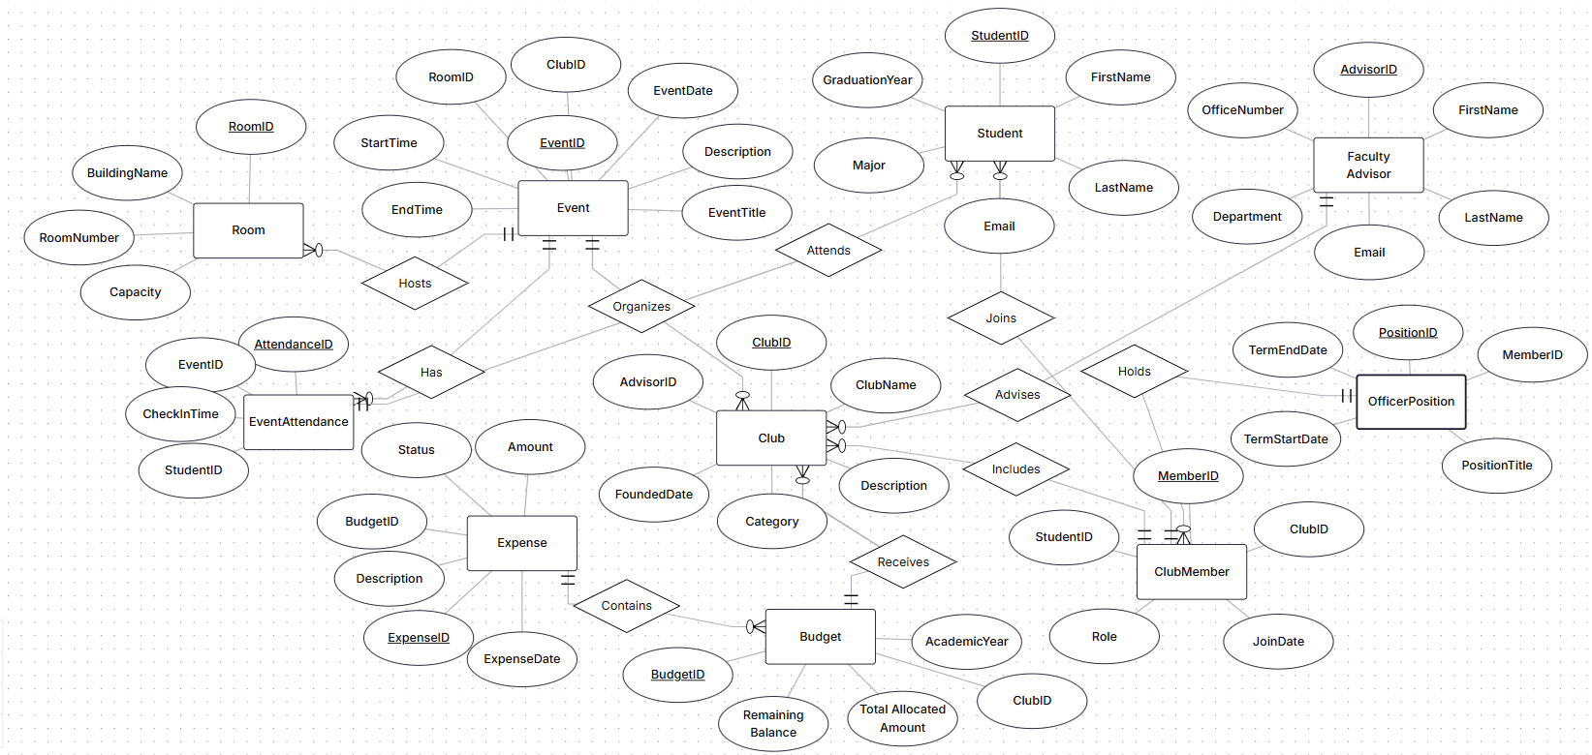
1.ER Diagram Structure
Entities and Attributes:
Student: StudentID (PK), FirstName, LastName, Email, Major, GraduationYear
FacultyAdvisor: AdvisorID (PK), FirstName, LastName, Email, Department, OfficeNumber
Club: ClubID (PK), ClubName, Description, Category, FoundedDate, AdvisorID
ClubMember: MemberID (PK), StudentID, ClubID, JoinDate, Role
OfficerPosition: PositionID (PK), MemberID, PositionTitle, TermStartDate, TermEndDate
Event: EventID (PK), ClubID, EventTitle, Description, EventDate, StartTime, EndTime, RoomID
EventAttendance: AttendanceID (PK), EventID (FK), StudentID (FK), CheckInTime
Room: RoomID (PK), BuildingName, RoomNumber, Capacity
Budget: BudgetID (PK), ClubID, AcademicYear, TotalAllocatedAmount, RemainingBalance
Expense: ExpenseID (PK), BudgetID (FK), Description, Amount, ExpenseDate, Status
Relationships and Cardinalities:
FacultyAdvisor to Club: One-to-Many (1:N) - One advisor can advise multiple clubs; each club has exactly one advisor.
Student to Club (Membership): Many-to-Many (M:N) - Resolved via ClubMember junction table.
ClubMember to OfficerPosition: One-to-Many (1:N) - A member can hold officer positions across terms.
Club to Event: One-to-Many (1:N) - A club can organize multiple events.
Student to Event (Attendance): Many-to-Many (M:N) - Resolved via EventAttendance junction table.
Room to Event: One-to-Many (1:N) - A room can host multiple events over time.
Club to Budget: One-to-Many (1:N) - A club receives budget allocations for different academic years.
Budget to Expense: One-to-Many (1:N) - A budget tracks multiple expense entries.

2.Normalized Relational Schema
1.Student
Schema: Student(StudentID, FirstName, LastName, Email, Major, GraduationYear)
Primary Key: StudentID
2.FacultyAdvisor
Schema: FacultyAdvisor(AdvisorID, FirstName, LastName, Email, Department, OfficeNumber)
Primary Key: AdvisorID
3.Club
Schema: Club(ClubID, ClubName, Description, Category, FoundedDate, AdvisorID)
Primary Key: ClubID
Foreign Key: AdvisorID references FacultyAdvisor(AdvisorID)
4.ClubMember
Schema: ClubMember(MemberID, StudentID, ClubID, JoinDate, Role)
Primary Key: MemberID
Foreign Keys: StudentID references Student(StudentID), ClubID references Club(ClubID)
5.OfficerPosition
Schema: OfficerPosition(PositionID, MemberID, PositionTitle, TermStartDate, TermEndDate)
Primary Key: PositionID
Foreign Key: MemberID references ClubMember(MemberID)
6.Room
Schema: Room(RoomID, BuildingName, RoomNumber, Capacity)
Primary Key: RoomID
7.Event
Schema: Event(EventID, ClubID, EventTitle, Description, EventDate, StartTime, EndTime, RoomID)
Primary Key: EventID
Foreign Keys: ClubID references Club(ClubID), RoomID references Room(RoomID)
8.EventAttendance
Schema: EventAttendance(AttendanceID, EventID, StudentID, CheckInTime)
Primary Key: AttendanceID
Foreign Keys: EventID references Event(EventID), StudentID references Student(StudentID)
9.Budget
Schema: Budget(BudgetID, ClubID, AcademicYear, TotalAllocatedAmount, RemainingBalance)
Primary Key: BudgetID
Foreign Key: ClubID references Club(ClubID)
10.Expense
Schema: Expense(ExpenseID, BudgetID, Description, Amount, ExpenseDate, Status)
Primary Key: ExpenseID
Foreign Key: BudgetID references Budget(BudgetID)

3.Design Decision and Justification
Design Decision: Modeling Officer Positions
Option A: Add an "IsOfficer" boolean flag and "PositionTitle" attribute directly into the Student or ClubMember table.
Option B: Create a separate OfficerPosition entity linked to ClubMember with term dates.
Chosen choice: Option B (Separate Entity with History). Justification: If officer titles are stored directly inside the ClubMember table, the system cannot maintain a historical record of past club officers across different academic years. Creating a distinct OfficerPosition entity allows a student to serve as Treasurer in one year and President in the next year while preserving full historical records without creating duplicate membership rows or violating normalization principles.
4.Example queries
Query 1: "Find all students who are currently serving as officers in the Computer Science Club, along with their specific position titles and term start dates."
Query 2: "List all events scheduled for next week along with their assigned room numbers, building names, and the hosting club names."
Query 3: "Calculate the total approved expenses and remaining budget balance for the Robotics Club for the current academic year."

