Sovereign DPI-AI Public Agent Prototype
System Core: Python 3.11+, Ollama (qwen2.5-coder:7b), SQLite | Domain: Digital Public Infrastructure & Responsible AI
 | Status: Completed & Validated Prototype (100% Tests Passed)

1. Executive Summary
The Sovereign DPI-AI Public Agent is an end-to-end architectural prototype demonstrating how Digital Public Infrastructure (DPI) can be safely enhanced with Small Language Models (SLMs) while enforcing strict data sovereignty, consent-based access, deterministic governance, and NIST AI RMF-inspired safeguards.
Built entirely for local, air-gapped execution on edge devices (using Python 3.11+, Ollama with qwen2.5-coder:7b, SQLite, and 50,000+ local registry records), the prototype operationalizes the core security principle: "The Model Proposes, The Deterministic Workflow Decides." The SLM is strictly restricted to proposing structured JSON action plans and is mathematically and architecturally prohibited from executing code, SQL queries, or unauthorized APIs directly.
2. Interactive Public Agent Web Interface
A dedicated local web studio was engineered providing an intuitive interface for citizens, extension officers, and governance auditors. The interface includes real-time step visualization of the 7-stage deterministic pipeline, a one-click scenario testing suite, live searchable audit tables, and a 50,000-record SQLite registry browser.
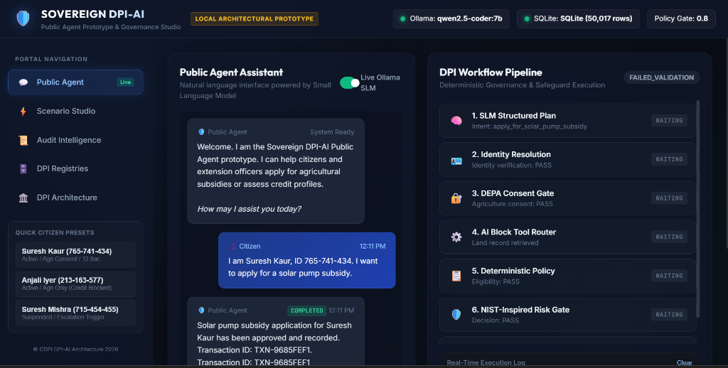
Figure 1: The Sovereign DPI-AI Public Agent Web Studio featuring conversational SLM assistance (left) and real-time 7-stage deterministic DPI governance & safeguard pipeline visualizer (right).
3. Conceptual & Regulatory Foundations
1. CDPI DPI-AI Framework 2026 & AI × DPI Policy: Implements modular AI Blocks, deterministic DPI Workflows, and the '+1 Approach' to legacy municipal writeback.
2. India DEPA Framework (Data Empowerment and Protection Architecture): Implements a 5-gate deterministic consent engine guarding protected citizen data (Status, Expiry, Granularity, Purpose limitation, and simulated SHA-256 integrity checks).
3. NIST AI RMF 1.0 (Artificial Intelligence Risk Management Framework): Implements core risk functions (GOVERN, MAP, MEASURE, MANAGE) to validate model confidence (0.80 application threshold), detect ambiguity, run prototype bias/risk filters, and generate automated human escalation dossiers.
4. System Architecture & Security Boundaries
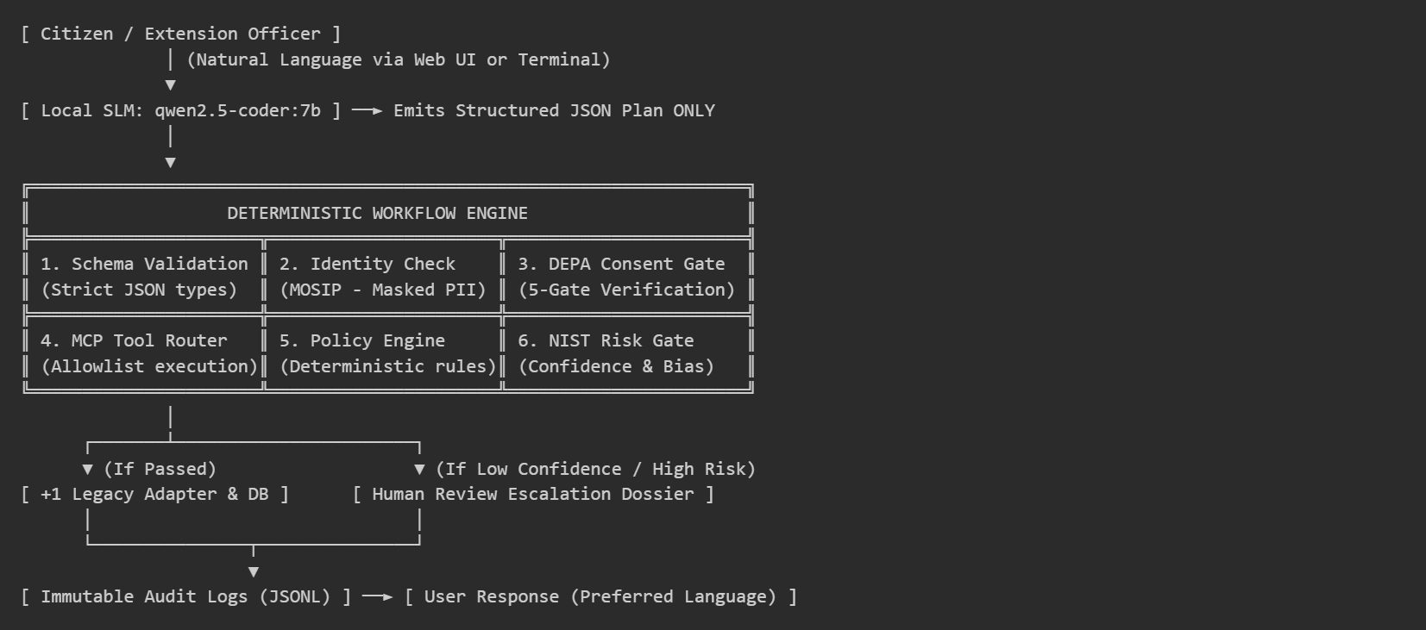
Key Engineering Safeguards:
No Arbitrary Execution: Zero arbitrary code execution; all AI Blocks are pre-defined, typed, and isolated.
Privacy by Design: Phone numbers and sensitive identifiers are masked; raw protected datasets (credit/land) are inaccessible without explicit, active, granular consent.
Full Auditability: Every consent evaluation, workflow transition, and human escalation creates an immutable, timestamped JSONL audit log.
5. System Architecture & Security Boundaries
The architecture establishes clear security boundaries dividing probabilistic reasoning from deterministic policy authorization:
- No Arbitrary Code/SQL Execution: The SLM cannot run arbitrary commands. All callable services (AI Blocks) are strongly typed, allowlisted, and isolated.
- Privacy by Design & PII Masking: Phone numbers and identifiers are masked in all outputs; protected financial and land registries are strictly unreachable without active, granular DEPA consent.
- Immutable Audit Trails: Every consent evaluation, workflow state transition, and human escalation creates an immutable, timestamped JSONL record in the audit directory.
6. Core Technical Modules & Architecture
Module Name | File | Implementation & Governance Details
Local SLM Client | model_client.py | Pluggable provider architecture (OllamaProvider, CloudProvider stub, DeterministicProvider). Temperature 0.1 for high determinism and strict structured JSON output contract.
DEPA Consent Engine | depa_consent.py | 5-Gate validation: Status (ACTIVE), Expiry (UTC timestamp), Granularity (agri_land:read, mifos_credit:read), Purpose alignment, and SHA-256 integrity check.
MCP Tool Router | mcp_tools.py | Strict schema validation and allowlisting for verify_identity, fetch_land_record, assess_credit_profile, evaluate_subsidy_eligibility, and legacy transaction creation.
NIST Safeguards | nist_safeguards.py | Confidence evaluation against application threshold (0.80), ambiguity detector, high-impact classifier, and prototype risk-indicator filter.
+1 Legacy Adapter | legacy_adapter.py | Non-invasive writeback appending to SQLite and separate output CSVs without modifying or disrupting foundational registries.
Web & CLI Interfaces | server.py, app.py, web/ | Interactive terminal CLI + Modern Glassmorphic Web Dashboard (http://localhost:8000) with real-time 7-stage visualizer and 50k-record registry browser.
7. Demonstration Scenarios & Test Verification
The system was evaluated against 79 automated unit and integration tests (100% pass rate) and demonstrated across three real-world scenarios on 50,000-record datasets:
- Scenario A — Solar Pump Subsidy (Approved End-to-End): Citizen Suresh Kaur (765-741-434) holds ACTIVE identity and ACTIVE agri consent (CON-100007). Land record confirms 12.8 acres (>= 2.0 ac minimum). NIST confidence passed at 1.0 (>= 0.80 threshold). Legacy transaction TXN-DF7BC44B generated and audited successfully.
- Scenario B — Agricultural Credit (DEPA Consent Denial): Citizen Anjali Iyer (213-163-577) requests credit assessment, but consent only permits agriculture data. DEPA gate returns DENIED (GRANULAR_PERMISSION_MISSING: mifos_credit). Credit registry is never queried, ensuring zero data leakage.
- Scenario C — Human Escalation (Safety & Oversight Gate): Citizen Suresh Mishra (715-454-455) holds a SUSPENDED identity. Automated processing is immediately halted, and a complete human review dossier (Case ESC-28f4d00f-ebc) is written to audit/escalations_log.jsonl with a transparent notification.

8. Architecture Diagram

