Planisphere & Gnomon
Color Edition — Printing, Assembly & Usage Guide
Model file: planisphere_gnomon_color.scad · 3 colors · one 250 × 250 mm print bed

1. Overview
This is a wall-hanging star wheel (planisphere) with a fold-up sundial gnomon. The color edition adds a three-color palette (white, black and yellow) and lays every piece out on a single 250 × 250 mm print bed, so one print job gives you the whole kit. You can print it as a multi-color job (three filaments, for example on an AMS) or in a single color.
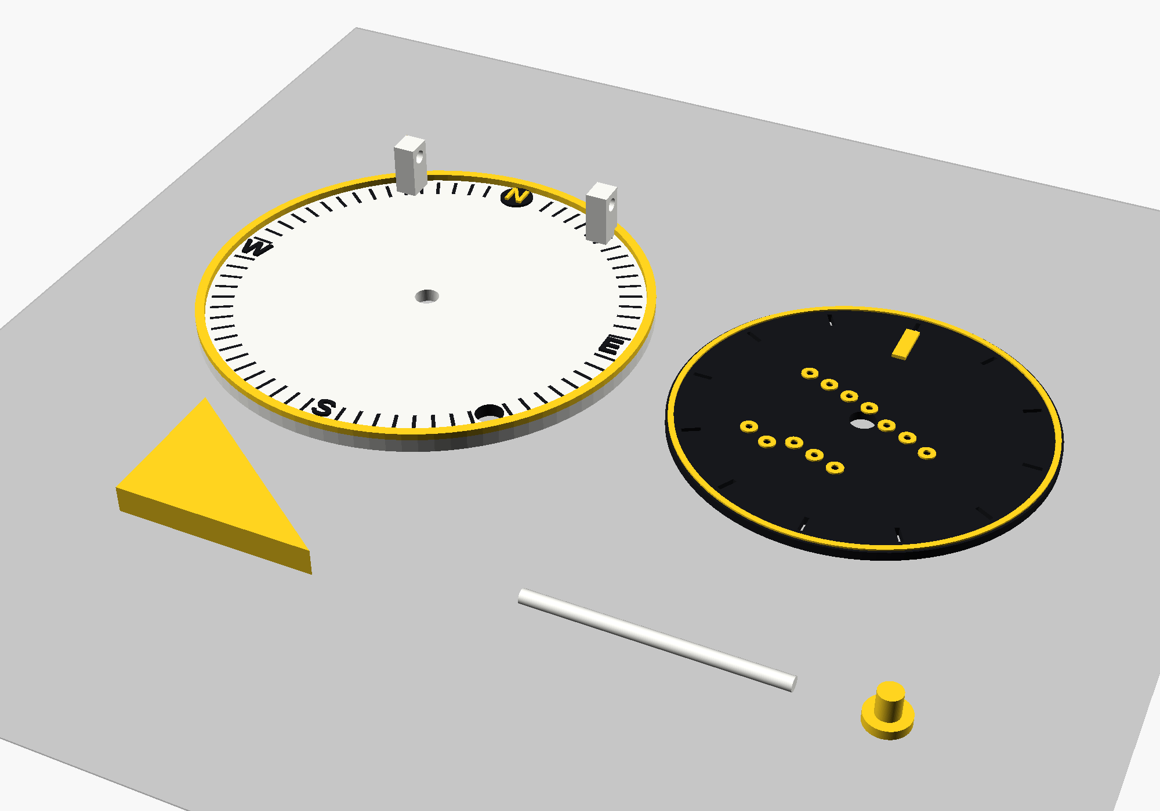
Figure 1 – Everything on one bed (OpenSCAD preview; the grey plate is the 250 × 250 mm bed outline).

2. Parts and colors

Parts
Part | Qty | Colors | Size
Base | 1 | White body · yellow rim · black degree ticks and S / E / W · yellow N on a black badge | Ø100 × 3 mm (hinge blocks rise to 15 mm)
Star disc | 1 | Black, with yellow edge ring, yellow star halos and yellow pointer | Ø80 × 2 mm (+0.8 mm pointer)
Gnomon | 1 | Yellow | 43 × 31 × 6 mm triangle
Hinge pin | 1 | White | Ø3 × 53 mm (or a piece of 3 mm filament)
Pivot pin | 1 | Yellow | Ø4.8 mm shaft, Ø9 mm head

The three colors
 | Name | Hex | Used for
 | White | #F6F6F1 | Base body and hinge pin. It is also the “starlight” you see through the star holes.
 | Black | #17181C | Star disc, degree ticks, S / E / W letters and the badge behind the N.
 | Yellow | #FFD21F | Base rim, disc edge ring, star halos, pointer mark, pivot pin, gnomon and the N letter.
Tip: The hex values are only suggestions. Any three filaments work as long as white and black contrast strongly; that pair carries all the small text and ticks. The colors in the SCAD file only affect the on-screen preview. The real colors are assigned in your slicer.

3. Bed layout
All pieces are positioned relative to the center of the base (the origin). Do not move them: the three color files share the same coordinates so they line up when imported together.
Piece | Position (x, y) mm | Notes
Base | (0, 0) | Hinge blocks at the top (north) edge
Star disc | (100, 0) | Right of the base
Gnomon | (0, −85) | Below the base
Hinge pin | (60, −75) | Lies flat on the bed
Pivot pin | (130, −75) | Head down, no supports needed

Overall footprint: 190 × 135 mm (x −50 to 140, y −85 to 50), tallest point 15 mm. That leaves 60 mm spare in X and 115 mm spare in Y on a 250 × 250 mm bed, plenty of room for a brim or a purge tower.
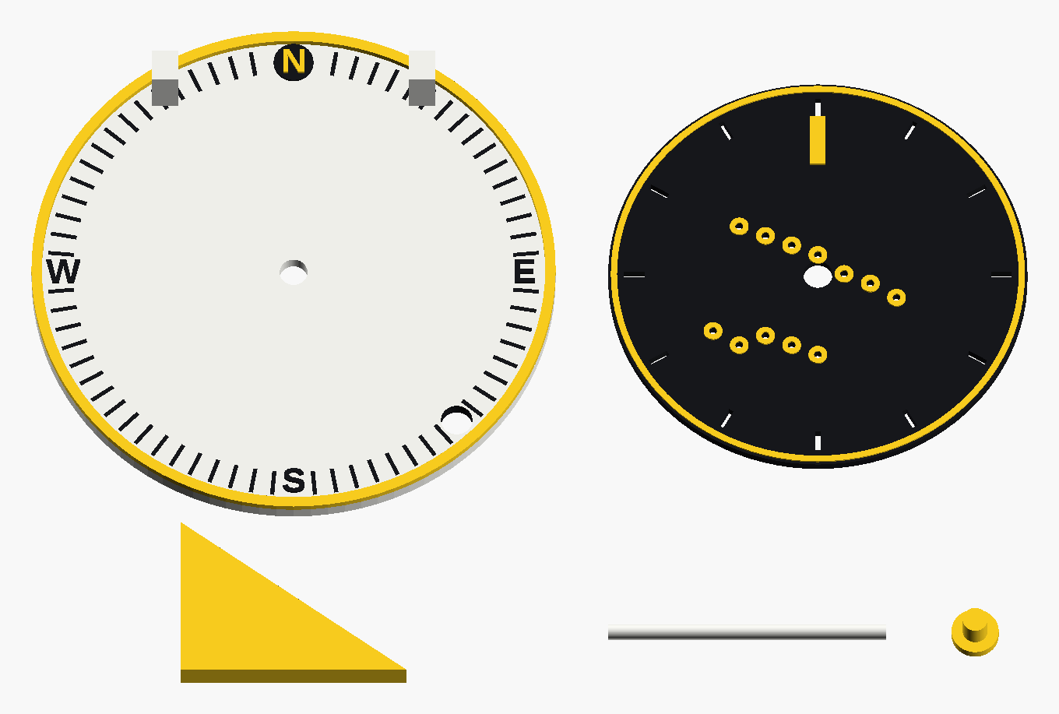
Figure 2 – Layout view (slightly tilted top view).

4. Step 1 – Export one STL per color
Multi-color printing needs one file per color. The SCAD file does this with a single setting, part.

Option A – OpenSCAD window
- Open planisphere_gnomon_color.scad in OpenSCAD (2021.01 or newer). Press F5 to preview all colors together.
- Near the top of the file change part = "all"; to part = "white";.
- Press F6 (Render), then F7 (Export as STL) and save it as white.stl.
- Repeat for "black" and "yellow". You end up with three STL files.

Option B – command line
for c in white black yellow; do
openscad -o $c.stl -D "part=\"$c\"" planisphere_gnomon_color.scad
done
On Windows (Command Prompt) run each color separately, for example:
openscad -o white.stl -D "part=\"white\"" planisphere_gnomon_color.scad
Note: The full-quality render takes only a few seconds to under a minute per color. For a faster preview while experimenting, lower $fn (for example to 64).

5. Step 2 – Slice and print
- Import all three STL files at the same time into your slicer (Bambu Studio, OrcaSlicer or PrusaSlicer). When asked, choose “Load as a single object with multiple parts” so the colors stay perfectly aligned.
- Assign one filament to each part: white, black and yellow.
- Use the settings below, then slice and print.

Setting | Suggested value | Why
Nozzle / layer height | 0.4 mm / 0.2 mm | Every raised or inlaid detail is a multiple of 0.2 mm: ticks 1.0 mm deep, letters 0.6 mm, yellow accents 0.4 mm, pointer 0.8 mm, N badge 0.6 mm.
Walls | 2–3 | Parts are thin; walls carry most of the strength.
Infill | 15–20 % | Only the hinge blocks and gnomon are thick enough to matter.
Supports | Off | No overhangs to support; the pivot pin is already printed head-down.
Outer wall speed | 40–60 mm/s | Cleaner letters and tick marks.
Brim | Optional | Helps the thin hinge pin and the small pivot pin stay put.

Good to know
- Hinge pin: you can skip printing it and use a 3 mm filament or rod cut to about 53 mm instead.
- Single-color print: set tick_inlay = false; so the degree ticks stay as engraved grooves, set part = "all"; and export one STL. Letters, rim, halos and pointer remain visible as raised relief (the N badge is a raised disc).
- Expect some purge waste. The pieces share the bed, so the lowest layers use several colors at once. The slicer’s purge tower and flush settings handle this.

6. Step 3 – Assembly
- Clean and test-fit. Remove brim and stringing. The pivot hole is Ø5.3 mm in the base and Ø5.6 mm in the disc for a Ø4.8 mm pin. The hinge holes are Ø3.2 mm for a Ø3.0 mm pin. If anything is tight, ream the hole with a drill bit or sand the pin lightly.
- Pivot. Push the pivot pin up through the base from underneath (head on the underside), then lay the star disc on the base with the yellow ring facing up. The pin tip ends about 0.2 mm above the disc.
- Keep the disc on (optional). Put a tiny drop of cyanoacrylate glue on the pin tip only, so it forms a small cap. Keep glue off the disc so it can still spin.
- Hinge. Place the gnomon between the two hinge blocks (the gnomon is 43 mm wide and the gap is 44 mm), line up the holes and slide the hinge pin through all three parts.
- Hang. Thread a cord or ribbon through the Ø6 mm hang hole, located between the S and E marks.

7. Step 4 – Using it
- Find north. Lay the base flat and turn it until the N badge points to true north (a phone compass or a known landmark works).
- Turn the star disc by the 12 grip notches around its edge. The yellow pointer on the disc reads against the 5° tick ring on the base; the letters N, E, S, W mark the cardinal directions.
- See the stars. Hold the disc up to a lamp or the sky. The two star groups (a 7-star line and a 5-star cluster) shine through the 1.5 mm holes.
- Sundial. Swing the gnomon up on its hinge. Fold it flat over the disc for storage; the hinge sits 12 mm above the base so the folded gnomon clears the disc.
- Your latitude. The gnomon’s 43 : 31 slope matches about 36° N. For another latitude, edit g_h in the SCAD file using g_h = 43 * tan(latitude) (30° → 24.8 mm, 45° → 43.0 mm), then re-export the yellow part.
Note: This is a decorative and educational model, not a precision timekeeping or navigation instrument.

8. Customizing
These settings sit at the top of planisphere_gnomon_color.scad.
Setting | Default | What it does
part | "all" | "all" shows every color for preview. "white", "black" or "yellow" outputs only that color, for STL export.
tick_inlay | true | Fills the degree ticks with black. Set to false to leave them as grooves (single-color prints).
star_halo | true | Yellow ring around each star hole on the disc.
north_badge | true | Black round badge behind the yellow N so it stays readable on the white base.
show_bed | true | Draws the 250 × 250 mm bed outline in the preview only. It is never exported.
c_white, c_black, c_yellow | see Section 2 | Preview colors. Change them to try other palettes.
g_h | 31 | Gnomon height; sets the slope for your latitude.
$fn | 128 | Smoothness of curves. Use 48–64 for quick previews.

What changed from v3
- Three-color palette (white, black, yellow) with one-setting export per color.
- Degree ticks are now inlaid in black. The ticks under the N, E, S, W letters, at the hang hole and beside the N badge were removed so nothing overlaps.
- Compass letters use a bold font for sturdier strokes.
- New yellow edge ring and star halos on the disc; the pointer is yellow. The N letter is yellow on a black badge.
- The hinge pin now rests on the bed. In v3 half of it sat below the bed surface, which would have lifted a combined multi-part import off the bed.

9. Troubleshooting
Problem | Fix
Parts are misaligned or floating in the slicer | Import all three STLs together and choose “single object with multiple parts”. Do not auto-orient or re-center the files one by one.
Letters look thin or the wrong font appears | The letters use Liberation Sans Bold. Install that font, or change the font name in the letter() module.
Preview shows no colors | Make sure part = "all";. Single-color parts are shown in OpenSCAD’s default color.
Disc spins stiffly, or pins will not go in | Clearances are about 0.25 mm per side (base) and 0.4 mm per side (disc). Ream the holes or sand the pins slightly.
Rendering is slow | Lower $fn to 48–64 for previews, and use the full value only for the final export.

