Tamil Nadu!  
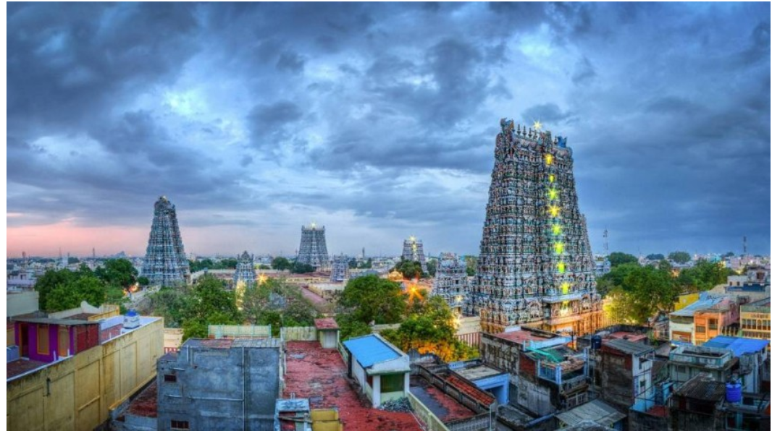

Links

Tourism:

<http://www.tamilnadutourism.org/places/placesmain.aspx>

food  
<https://www.tourmyindia.com/states/tamilnadu/cuisine.html>

shoping

<https://www.tourmyindia.com/states/tamilnadu/shopping.html>

Assam

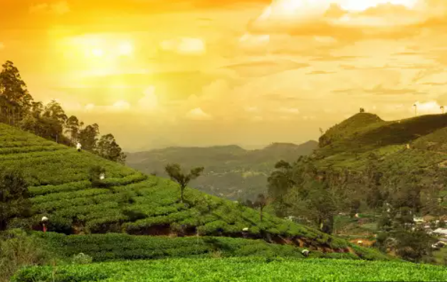

Tourist :

<https://traveltriangle.com/blog/tourist-places-in-assam/>

food

<https://traveltriangle.com/blog/assam-food/>

shoping

<https://www.magicalassam.com/2019/02/things-to-buy-in-guwahati.html>

Himachal Pradesh!

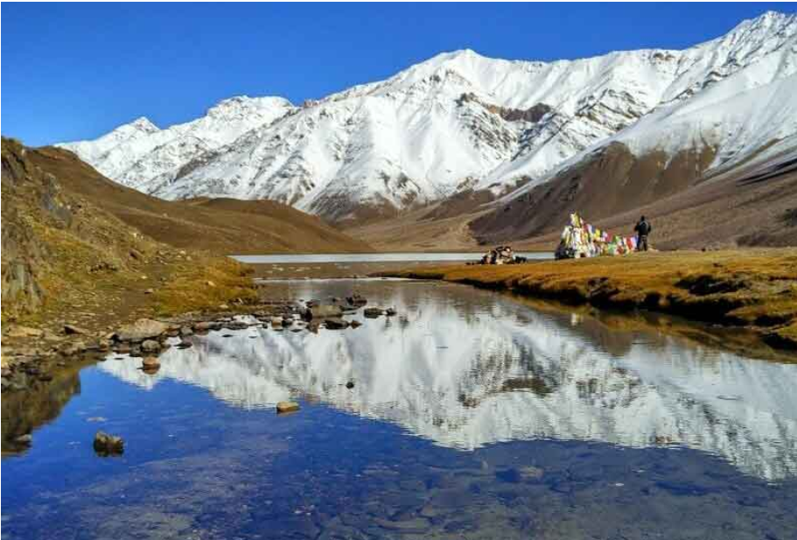

Food

<https://www.holidify.com/pages/food-of-himachal-pradesh-1647.html>

tourist

<https://traveltriangle.com/blog/best-places-to-visit-in-himachal-pradesh/>

shoping

<https://www.swantour.com/blogs/shopping-in-himachal-pradesh/#:~:text=Shopping%20in%20Himachal%20Pradesh%20is,beads%20or%20trendy%20artificial%20jewelry>.