Bug ID: SCRUM-5
Title: Error message not displayed for invalid login credentials
Module: Login
Environment:
- Browser: Chrome
- Resolution: 1366×768
- OS: Windows
Steps to Reproduce:
- Open the application URL
- Navigate to Login page
- Enter valid username
- Enter invalid password
- Click on Login button
Expected Result:
System should display an error message for invalid credentials
Actual Result:
No error message is displayed after clicking login
Priority: High
Severity: Major
Status: Open
Screenshot attached
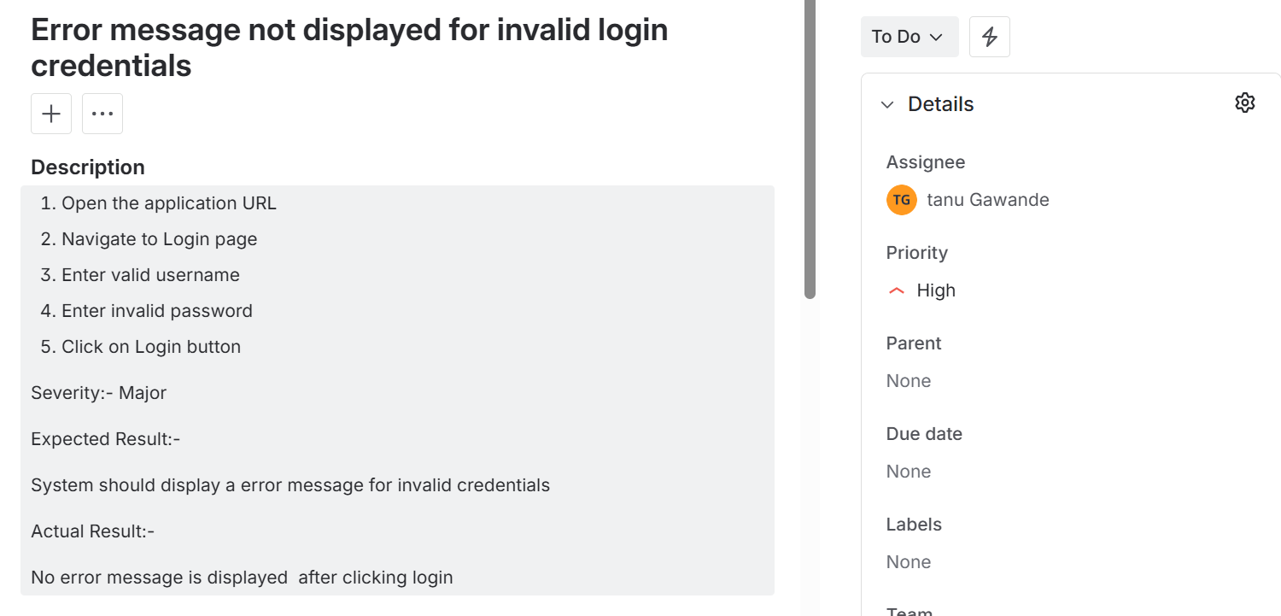

Bug ID: SCRUM-6
Title: Error message not displayed for invalid login username
Module: Login
Environment:
- Browser: Chrome
- Resolution: 1366×768
- OS: Windows
Steps to Reproduce:
- Open the application URL
- Navigate to Login page
- Enter invalid username
- Enter valid password
- Click on Login button
Expected Result:
System should display an error message for invalid username
Actual Result:
No error message is displayed after clicking login button.
Priority: High
Severity: Major
Status: Open
Screenshot attached
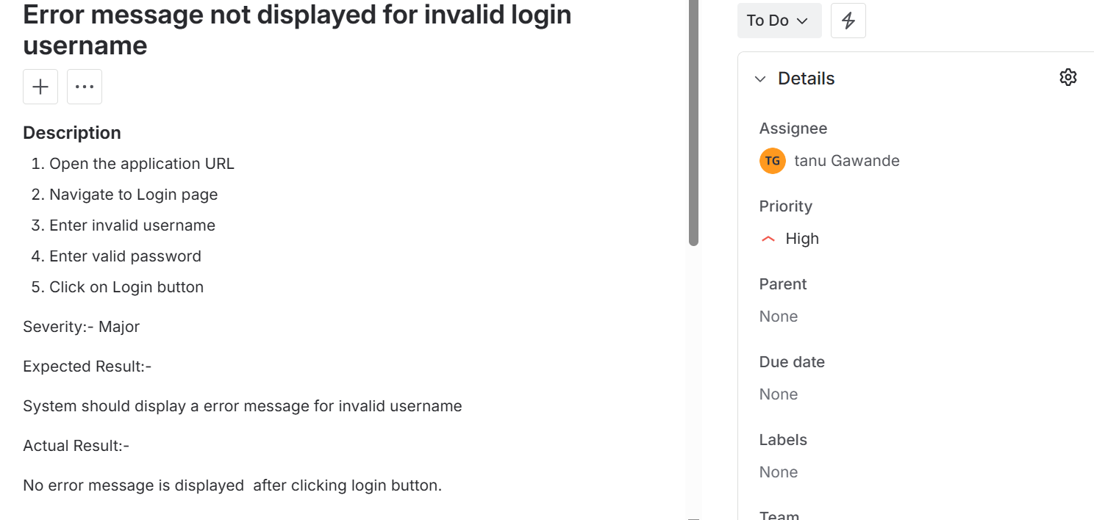

Bug ID: SCRUM-7
Title: UI misalignment on Login page
Module: Login
Environment:
- Browser: Chrome
- Resolution: 1366×768
- OS: Windows
Steps to Reproduce:
- Open application URL
- Navigate to Login page
Expected Result:
Login fields should be properly aligned
Actual Result:
Username and password fields overlap
Priority: High
Severity: Major
Status: Open
Screenshot attached
