**Plan of Attack**:

Here are the steps we used to analyze the project 11.3.

1. Compiled the “makeBlankGraph.cpp” file
   1. This creates a blank graph with every edge with weight “1”
   2. The user can specify a graph as “sparse” or “dense”
      1. Sparse graphs have 2 edges per vertex
      2. Dense graphs have (n-1) edges with n verticies
   3. A file “graph.txt” is created as the serialized graph file
2. Run “timecmd a.exe” so that the executable is timed
   1. This creates the graph from the compiled .cpp file
   2. This is the time to create a graph in the data
3. Compile the correct Dijkstra algorithem that corresponds with the right method and graph
4. Run “timecmd a.exe graph.txt” to time the algorithm
   1. This is the time to run Algorithm in the data

**Creating Graphs (charts):**

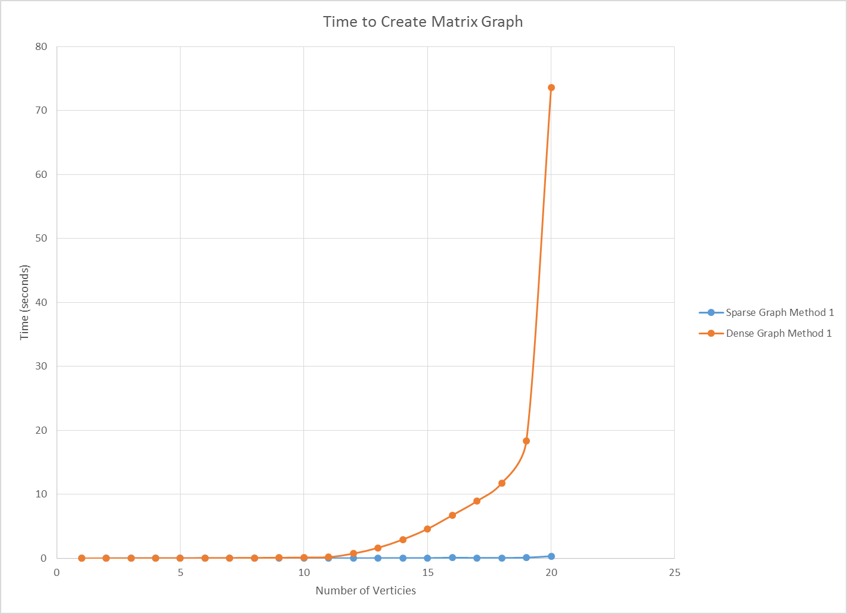

**Creating Graphs (raw data):**

|  |  |  |
| --- | --- | --- |
| Sparse Graph Method 1 | **Time to Create Graph (seconds)** | **Time to Create Graph (seconds)** |
| **Number of verticies** | List | Matrix |
| 10 | 0.02 | 0.02 |
| 25 | 0.02 | 0.02 |
| 50 | 0.02 | 0.02 |
| 75 | 0.01 | 0.02 |
| 100 | 0.01 | 0.02 |
| 125 | 0.02 | 0.02 |
| 150 | 0.02 | 0.03 |
| 175 | 0.03 | 0.02 |
| 200 | 0.01 | 0.03 |
| 250 | 0.02 | 0.03 |
| 500 | 0.01 | 0.02 |
| 750 | 0.02 | 0.05 |
| 1000 | 0.02 | 0.04 |
| 1250 | 0.02 | 0.05 |
| 1500 | 0.07 | 0.11 |
| 1750 | 0.03 | 0.07 |
| 2000 | 0.03 | 0.08 |
| 2500 | 0.04 | 0.12 |
| 5000 | 0.06 | 0.35 |
|  |  |  |
| Dense Graph Method 1 | **Time to Create Graph (seconds)** | **Time to Create Graph (seconds)** |
| **Number of verticies** | List | Matrix |
| 10 | 0.03 | 0.01 |
| 25 | 0.01 | 0.02 |
| 50 | 0.04 | 0.03 |
| 75 | 0.1 | 0.03 |
| 100 | 0.24 | 0.05 |
| 125 | 0.5 | 0.06 |
| 150 | 0.96 | 0.08 |
| 175 | 1.68 | 0.1 |
| 200 | 2.77 | 0.14 |
| 250 | 6.41 | 0.2 |
| 500 | 93.95 | 0.75 |
| 750 | 465.15 | 1.65 |
| 1000 |  | 2.95 |
| 1250 |  | 4.61 |
| 1500 |  | 6.74 |
| 1750 |  | 8.95 |
| 2000 |  | 11.78 |
| 2500 |  | 18.4 |
| 5000 |  | 73.61 |
|  |  |  |
| Sparse Graph Method 2 | **Time to Create Graph (seconds)** | |
| **Number of verticies** | List | Matrix |
| 10 | 0.02 | 0.01 |
| 25 | 0.02 | 0.02 |
| 50 | 0.02 | 0.02 |
| 75 | 0.02 | 0.02 |
| 100 | 0.01 | 0.02 |
| 125 | 0.02 | 0.02 |
| 150 | 0.02 | 0.03 |
| 175 | 0.02 | 0.02 |
| 200 | 0.02 | 0.02 |
| 250 | 0.02 | 0.02 |
| 500 | 0.03 | 0.02 |
| 750 | 0.03 | 0.03 |
| 1000 | 0.03 | 0.03 |
| 1250 | 0.03 | 0.04 |
| 1500 | 0.07 | 0.09 |
| 1750 | 0.03 | 0.05 |
| 2000 | 0.03 | 0.07 |
| 2500 | 0.05 | 0.08 |
| 5000 | 0.06 | 0.22 |
|  |  |  |
| Dense Graph Method 2 | **Time to Create Graph (seconds)** | |
| **Number of verticies** | List | Matrix |
| 10 | 0.02 | 0.01 |
| 25 | 0.02 | 0.03 |
| 50 | 0.03 | 0.03 |
| 75 | 0.08 | 0.04 |
| 100 | 0.18 | 0.07 |
| 125 | 0.38 | 0.07 |
| 150 | 0.71 | 0.1 |
| 175 | 1.24 | 0.12 |
| 200 | 2.05 | 0.15 |
| 250 | 4.71 | 0.23 |
| 500 | 93.86 | 0.84 |
| 750 | 463.31 |  |

**Running Algorithms (charts):**

**Running Algorithms (raw data):**

|  |  |  |
| --- | --- | --- |
| Sparse Graph Method 1 | **Time to Run Algorithem (seconds)** | **Time to Run Algorithem (seconds)** |
| **Number of verticies** | List | Matrix |
| 10 | 0.01 | 0.01 |
| 25 | 0.02 | 0.02 |
| 50 | 0.01 | 0.02 |
| 75 | 0.03 | 0.02 |
| 100 | 0.02 | 0.03 |
| 125 | 0.03 | 0.03 |
| 150 | 0.04 | 0.03 |
| 175 | 0.06 | 0.03 |
| 200 | 0.06 | 0.03 |
| 250 | 0.11 | 0.04 |
| 500 | 0.67 | 0.07 |
| 750 | 2.27 | 0.09 |
| 1000 | 5.86 | 0.13 |
| 1250 | 12.37 | 0.15 |
| 1500 | 22.02 | 0.18 |
| 1750 | 36.19 | 0.23 |
| 2000 | 55.04 | 0.26 |
| 2500 | 108.82 | 0.35 |
| 5000 | 980.61 | 0.94 |
|  |  |  |
| Dense Graph Method 1 | **Time to Run Algorithem (seconds)** | **Time to Run Algorithem (seconds)** |
| **Number of verticies** | List | Matrix |
| 10 | 0.01 | 0.01 |
| 25 | 0.02 | 0.02 |
| 50 | 0.05 | 0.01 |
| 75 | 0.17 | 0.01 |
| 100 | 0.48 | 0.02 |
| 125 | 1.13 | 0.02 |
| 150 | 2.3 | 0.04 |
| 175 | 4.3 | 0.04 |
| 200 | 7.37 | 0.05 |
| 250 | 18.21 | 0.06 |
| 500 | 326.18 | 0.18 |
| 750 |  | 0.37 |
| 1000 |  | 0.69 |
| 1250 |  | 1.04 |
| 1500 |  | 1.52 |
| 1750 |  | 2.17 |
| 2000 |  | 2.74 |
| 2500 |  | 4.48 |
| 5000 |  | 15.49 |
|  |  |  |
| Sparse Graph Method 2 | **Time to Run Algorithem (seconds)** | **Time to Run Algorithem (seconds)** |
| **Number of verticies** | List | Matrix |
| 10 | 0.01 | 0.01 |
| 25 | 0.02 | 0.02 |
| 50 | 0.02 | 0.02 |
| 75 | 0.02 | 0.02 |
| 100 | 0.03 | 0.02 |
| 125 | 0.03 | 0.03 |
| 150 | 0.04 | 0.03 |
| 175 | 0.06 | 0.02 |
| 200 | 0.07 | 0.03 |
| 250 | 0.11 | 0.03 |
| 500 | 0.67 | 0.06 |
| 750 | 2.3 | 0.07 |
| 1000 | 5.8 | 0.09 |
| 1250 | 12.43 | 0.12 |
| 1500 | 22.38 | 0.14 |
| 1750 | 36.43 | 0.16 |
| 2000 | 55.48 | 0.21 |
| 2500 | 112.01 | 0.24 |
| 5000 | 1008.16 | 0.54 |
|  |  |  |
| Dense Graph Method 2 | **Time to Run Algorithem (seconds)** | **Time to Run Algorithem (seconds)** |
| **Number of verticies** | List | Matrix |
| 10 | 0.01 | 0.02 |
| 25 | 0.02 | 0.02 |
| 50 | 0.05 | 0.02 |
| 75 | 0.13 | 0.02 |
| 100 | 0.36 | 0.02 |
| 125 | 0.83 | 0.04 |
| 150 | 1.7 | 0.04 |
| 175 | 3.2 | 0.05 |
| 200 | 5.57 | 0.06 |
| 250 | 13.51 | 0.08 |
| 500 | 326.33 | 0.21 |