RedBoxJava

User Manual

By: Trey (John) Ward

Brennan Kelly

Larry Mayes 12/15/2015

Table of Contents

1. General Information…………………………………………………………………….... 2
   1. System Overview……………………………………...................................... 2
   2. Organization of the Manual…………………………………………………….. 2
2. System Summary………………………………………………………………………… 3
   1. System Configuration…………………………………………………………… 3
   2. User Access Levels……………………………………………………………... 3
   3. Contingencies…………………………………………………………………..... 3
3. Getting Started…………………………………………………………………………… 4
   1. Installation and Setup…………………………………………………………… 4
   2. System Menu…………………………………………………………………..... 4
4. Using the System………………………………………………………………………… 5
   1. User Home Screen……………………………………………………………… 5
      1. Account Information: Changing Username and Password….……... 5
      2. Renting a Movie/Video Game…………………………….…………… 6
      3. Returning a Movie/Video Game……………………………….……… 7
   2. Admin Home Screen………………………………………………………….… 7
      1. Use as an Admin …………………………………………....…………. 8
      2. Editing Inventory………………………………………….…………….. 8
      3. Viewing/Deleting User Accounts……………………………………... 8-9
5. Reporting……………………………………………………………………………….…. 10
6. Developers Info…………………………………………………………………………... 11
   1. UML Diagrams…………………………………………………………………… 11
      1. Redbox GUI……………………………………………………………...11
      2. GUI Flowchart……………………………………………………………12
      3. Account Sequence……………………………………………………… 13
      4. Rent Sequence………………………………………………………….. 14
   2. CRC Cards……………………………………………………………………….. 15

**1.0 General Information**

General Information section explains in general terms the system and the purpose for which it is intended

**1.1 System Overview**

RedBox Java is an application which allows users create a login username and password which grants them the ability to rent movies and video games from a kiosk at a convenient location. Once they login, they can view and edit account info, return a movie, or rent a movie. The application saves the user database and movie/video game database locally.

**1.2 Organization of the Manual**

The user’s manual consists of five sections: General Information, System Summary, Getting Started, Using The System, and Reporting.

General Information section explains in general terms the system and the purpose for which it is intended.

System Summary section provides a general overview of the system. The summary outlines the uses of the system’s hardware and software requirements, system’s configuration, user access levels and system’s behavior in case of any contingencies.

Getting Started section explains how to get Redbox Java and install it on the device. It will explain the basics including the system menu.

Using The System section provides a detailed description of system functions.

Reporting section describes in what way information collected by the application is presented and how to access the information

**2.0 System Summary**

System Summary section provides a general overview of the system. The summary outlines the uses of the system’s hardware and software requirements, system’s configuration, user access levels and system’s behavior in case of any contingencies.

**2.1 System Configuration**

Redbox Java operates on all compatible Redbox kiosks. The application doesn’t need the Internet to save the databases however, each night it will backup the databases to the main servers.

**2.2 User Access Levels**

Users will be able to have an account where they can edit their info, return a movie, or rent a movie. Admins will be able to add and remove Users and movies.

**2.3 Contingencies**

If a power outage were to occur, the most recent data is saved to the database and then transferred to the server when there is internet**.**

**3.0 Getting Started**

The Getting Started section takes you through initialization and general setup of the Admin and first time users. This section also explains the main system menu along with information of where users can edit their account information.

**3.1 Installation and Setup**

For installation and running of the following program, download and install our execution file RedBox.java. The file comes with all the necessary scripts for the execution and use. The first login will become the Admin. New user accounts will be created by the “Register Now!” button on the Start screen.

**3.2 System Menu**

The initial system menu brings the options of logging in as an Admin or User, creating a new user, or returning a DVD. Logging in as a user will direct you to the User Home Screen and logging in as an admin will direct you to the Admin Home Screen. The new user button will direct you to a page that you will add a new user to the database. The return movie button will direct you to a page to return the rented item.

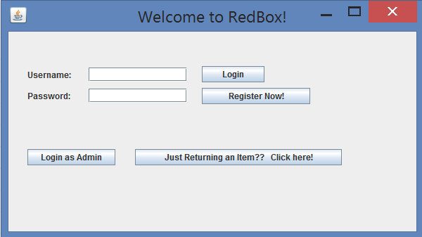

**4.0 Using the System**

This section provides a detailed description of the functionality of the system.

**4.1 User Home Screen**

User Home Screen is the screen you will see when you first log into the system. You will have the options of viewing/ editing account information, renting a movie/video game, returning a movie/video game, and logging off.

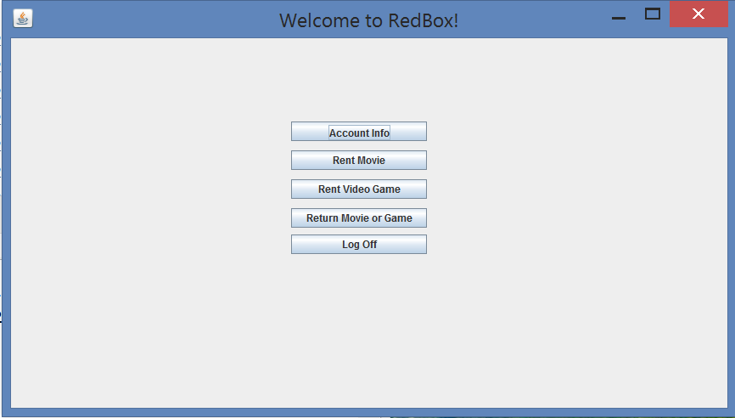

**4.1.1 Account Information: Changing Username or Password**

Users can view and edit their account information in this screen. Press the edit button, and you will have access to change all account information including username and password. When finished making edits, press the submit button and the changes will be saved. Note: If a username is already in use, that username will be unavailable for multiple use.

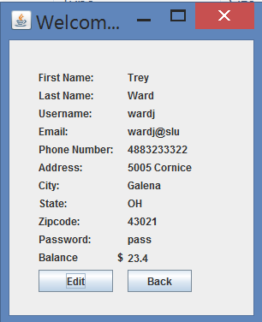

**4.1.2 Renting a Movie/Video Game**

The same process is used to rent movies and video games. On the user home screen, press the type of item you would like to rent. You are then presented with the options to sort the items based on title, genre, or rating. To rent the item, enter the movie or video game I.D. in the I.D. textbox and press the Rent button.

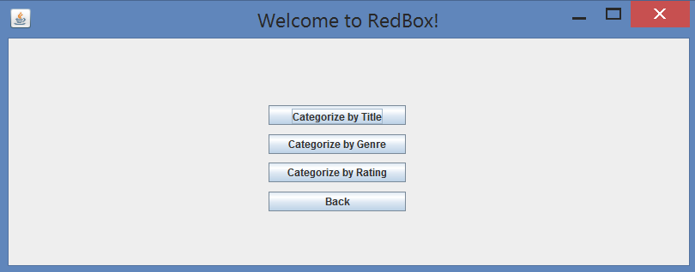

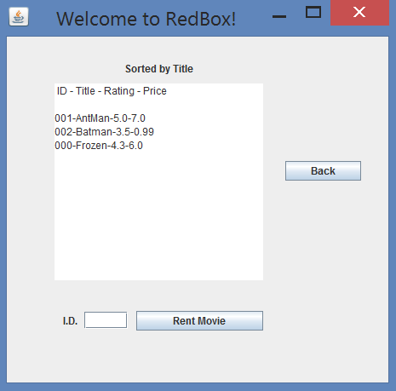

**4.1.3 Returning a Movie/Video Game**

This section is returning a movie while inside your own account. You will not need your username to return. See Section 3.2 for returning a movie/video game from the home screen.

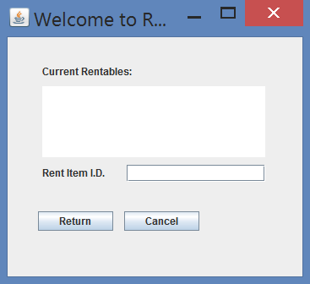

**4.2 Admin Home Screen**

While at the Admin home screen, there are three options: Edit Inventory; User Account Details; Log Off. Clicking Edit Inventory brings you to the full Inventory screen where movies and games are separated for viewing. Clicking to view User account details brings you to a list of current users and allows for the viewing of their account details.

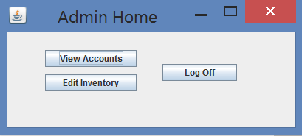

**4.2.1 Admin use**

To become an Admin, the developers must be contacted. Logging in as an Admin provides access to editing the inventory of your RedBoxJava, the viewing of certain user information, and what Items are currently rented.

**4.2.2 Editing Inventory**

Clicking Edit Inventory brings you to the full Inventory screen where movies and games are separated for viewing. Entering an item’s ID can be followed by clicking edit for correction of item details, or delete for removing the item.

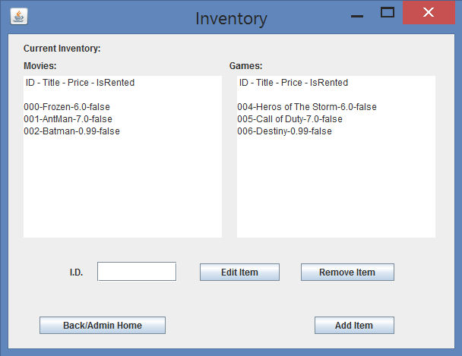

**4.2.3 Viewing/Deleting User Accounts**

Clicking to view User account details brings you to a list of current users and allows for the viewing of their account details. This includes seeing if they are currently renting any items. If a User sends a delete account request, deletion of their account can also be done through here.

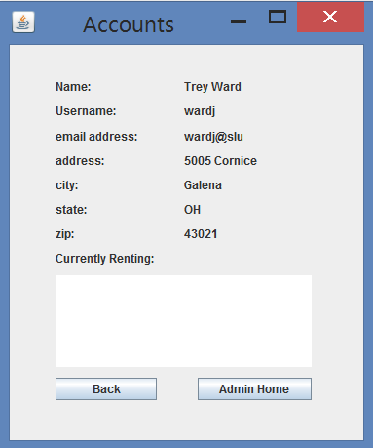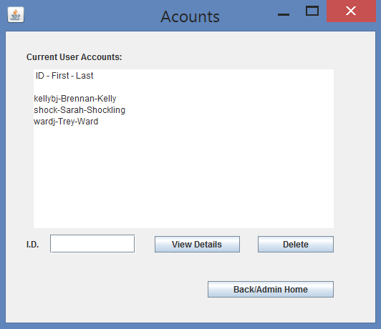

**5.0 Reporting**

The reporting section describes how the data is stored and where it is accessible.

**5.1 User/Admin Database**

When a user is created, it is stored in userData.txt file with all of the attributes when a new user is created. There is one attribute, userAdminRights, which determines whether the user is an admin or normal user. If true, then it is an Admin, and if false, then it is a User.

**5.2 Movie/Video Game Database**

When a new movie is created, the movie gets added to the database stored in the movieData.txt. When a new video game is created, the video game gets added to the database stored in the videogameData.txt.

**6.0 Developer Info**

**6.1 UML Diagrams**

**6.1.1 Redbox GUI**

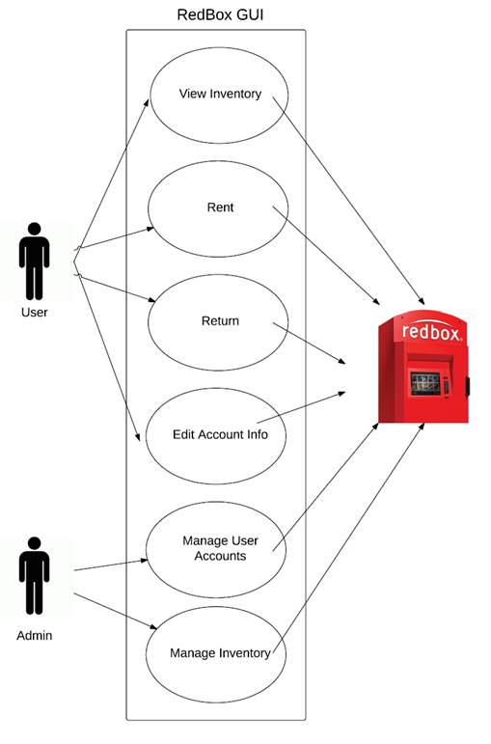

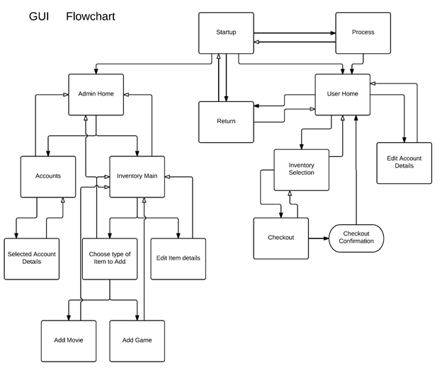**6.1.2 GUI Flowchart**

**6.1.3 Account Sequence**

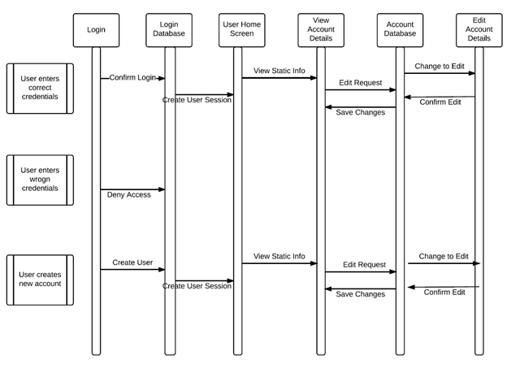

**6.1.4 Rent Sequence**

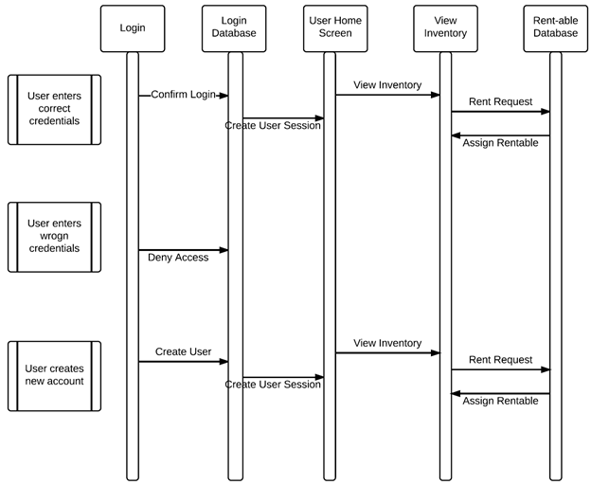

**6.2 CRC Cards**