**Introduction to database**

Problem Statement: There can be multiple customers, who can place multiple orders on the site. Now a sales person can handle these orders will distribute into multiple sales persons (One order will be assign to one salesperson only). So a sales person can have multiple orders of multiple customers

Ques 1:-Create Database

Ans 1:-

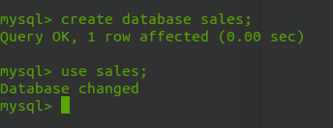

Ques 2:-Design Schema

Ans 2:-

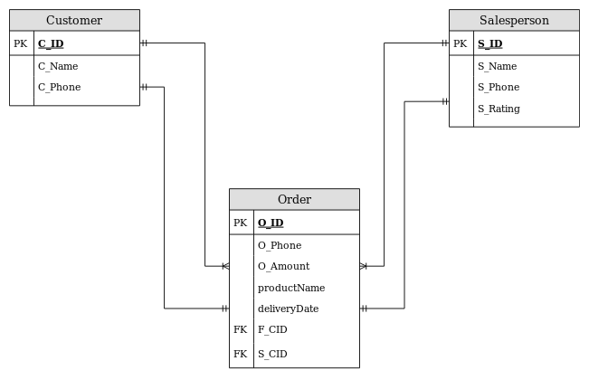

Ques 3:-Create tables

Ans 3:-

create table customer(c_id int primary key, c_name varchar(160),c_phone bigint(10));

create table sales_person(s_id int primary key,s_name varchar(160),S_phone bigint(10));

create table order_details(o_id int primary key,product_name varchar(160),o_amount float(7),delivery_date datetime,f_cid int,f_sid int,foreign key(f_cid) references customer(c_id),foreign key(f_sid) references sales_person(s_id));

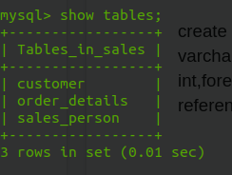

Ques 4:-Insert sample data

Ans 4:-

insert into customer values (1,"Dany",8858537901),(2,"naki",9105616702),(3,"neni",786059531),(4,"Ankur",6388779533);

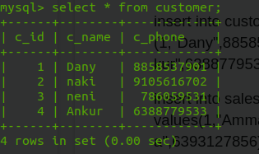

insert into sales_person values(1,"Ammar",9876123405),(2,"Shayan",78607366887),(3,"Kaushlendra",6393127856),(4,"Fahad",7851875502);

insert into sales_person values(1,"Ammar",9876123405),(2,"Shayan",78607366887),(3,"Kaushlendra",6393127856),(4,"Fahad",7851875502);

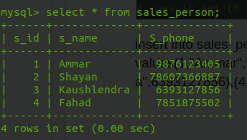

insert into order_details values(1,"Water Bottle",90.5,now(),1,3);

insert into order_details values(2,"Shoes",5590.57,now(),2,4),(3,"Dress",350,now(),1,3);

insert into order_details values(5,"Mink Blanket",8590.57,now(),1,1),(6,"Laptop",23500.00,now(),3,4),(7,"Lock",100.10,now(),4,3);

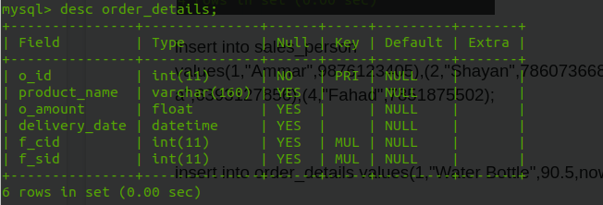

Ques 5:-Find the sales person have multiple orders.

Ans 5:- select s.s_id,s.s_name from sales_person s inner join order_details o on s.s_id=o.f_sid group by s_id having count(*)>1;

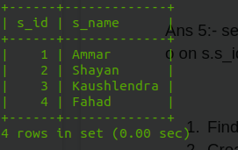

Ques 6:-Find the all sales person details along with order details

Ans 6:- select o.o_id,o.product_name,s.s_id,s.s_name from sales_person s inner join order_details o on s.s_id=o.f_sid;

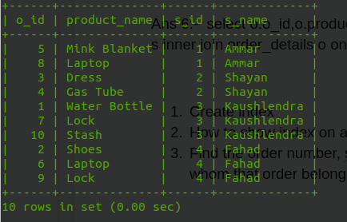

Ques 7:-Create index

Ans 7:- alter table sales_person add index salesperson_name(s_name);

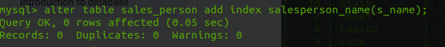

Ques 8:-How to show index on a table

Ans 8:- show index from sales_person\G;

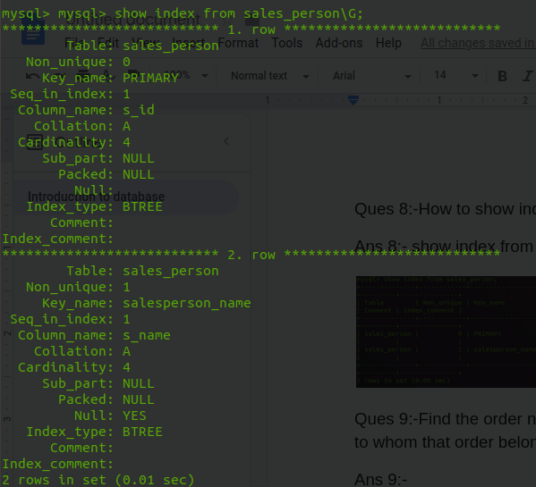

Ques 9:-Find the order number, sale person name, along with the customer to whom that order belongs to

Ans 9:- select o.o_id,s.s_name,c.c_name from sales_person s inner join order_details o on s.s_id=o.f_sid inner join customer c on o.f_cid=c.c_id;

