B-Conception: Project Conception and Design

**Project Overview**

The French Learning Chatbot is designed to help users improve their French skills through interactive conversations. It leverages OpenAI’s GPT model to simulate real-world dialogues, enhancing users' language learning experience.

**Architecture Diagram**

The project architecture consists of three main components:

1. **Frontend**: HTML, CSS, and JavaScript are used to create a user-friendly interface.
2. **Backend**: A Flask server handles user requests and integrates with OpenAI’s GPT API.
3. **OpenAI Integration**: The backend sends user inputs to the GPT model and processes the responses.

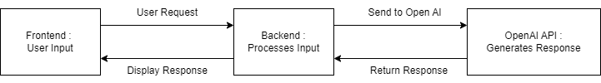

**Tasks Breakdown**

1. Set up Flask Backend.
2. Create the Frontend Layout (HTML/CSS/JS).
3. Integrate the OpenAI API for Chat Functionality.
4. Implement Additional Features (e.g., Session Management, Typing Indicator).
5. Test and Debug the Application.

**Self-Organization and Team Dynamics**

The project was managed with a focus on clear task allocation and iteration. Each major component was built sequentially, with ongoing testing to ensure smooth integration.