Introduction
A Word form is a document that contains fill-in blanks called fields. Each field is a predefined cell that stores data input.

Create a Form
Click the Developer tab and then choose the ab field from the Legacy Tools drop-down in the Controls group. Choose a form field to use (e.g. text field)
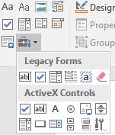

Name
Address | City | State | Zip Code

Add Macro Code
Add code by pressing Alt-F11 to launch the VB editor. Choose Module from the Insert menu. Enter the export code. Make sure to add the “Microsoft ActiveX Data Objects 6.1 Library” reference in order for the macro to successfully compile.

Restrict Editing
Click the Developer tab and then click Restrict Editing in the Protect group. In the resulting task pane, click “Allow Only This Type Of Editing In This Document.” From the drop-down, select “Filling In Forms.” Click Yes, Start Enforcing Protection. Enter a password twice. Or leave both password entries blank if you don't need password protection. Click OK.

