1. Subject

My idea is to make a website looking like reddit. people can post, read, update the news, and admin has right to delete news.

Here is address: <https://www.reddit.com/>

1. Data structure  
   Explain which kind of data you will have in the application. It is enough if you will create an ER-model about your database. If you are going to use also arrays, explain the structure of the arrays

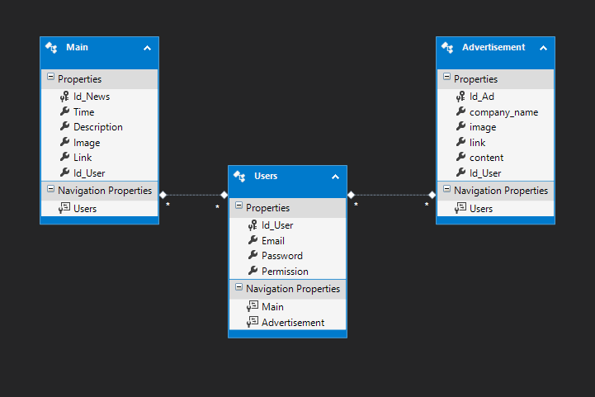

This is my ER-model. I will make 3 tables to store data, first table is for log in and register.

Table Main is for home page, users could read, post, update and delete news.

Advertisement is second page in my website, it shows business advertisement, which only admin could update and delete, but users can read and post.

Information above is my simple idea. Hope to get your advice.