Exercise: CSS & Typography
Problems for exercises and homework for the "HTML and CSS" course @ SoftUni. Submit your solutions in the SoftUni Judge system at https://judge.softuni.org/Contests/3332/CSS-Typography.

Restaurant Menu
Create a web page like the following:
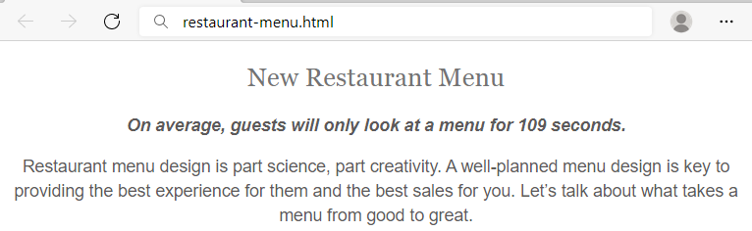

Requirements
HTML with <body> that contains: <article>, <h1>, <span> and <p>.
CSS:
- <body>:
  - Align the text to the center
- <h1>:
  - Fonts: Sentinel A, Sentinel B, Georgia, Times New Roman, Times
  - Generic Font: serif
  - Font weight 400
  - Height of the line: 1.15
  - Text color: #747474
- <span>:
  - Fonts: Graphik Semibold Web, Open Sans, Helvetica Neue, Helvetica, Arial
  - Generic Font: sans-serif
  - Font style: oblique
  - Font weight: 600
  - Font size: 16px
  - Height of the line: 1.46
  - Text color: #5c5a5a
- <p>:
  - Fonts: Graphik Regular Web, Helvetica Neue, Helvetica, Arial
  - Generic Font: sans-serif
  - Font weight 400
  - Font size: 16px
  - Height of the line: 1.46
  - Text color: #5c5a5a

Style Lists
Create a web page like the following:
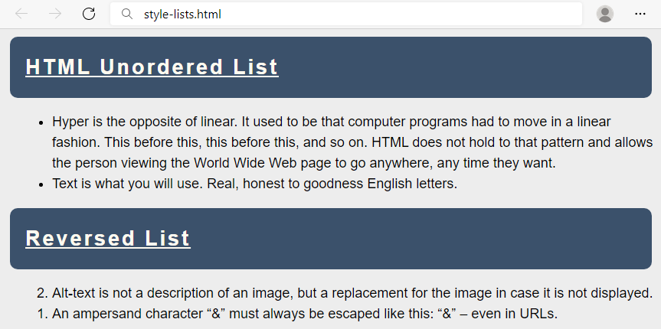

Requirements
You will be given a skeleton with filled HTML and an empty CSS file. Write the missing CSS following the guidelines in the task.
- <body>:
  - Font: Helvetica
  - Generic Font: sans-serif
  - Height of the line: 1.5
  - Font size: 18px
  - Background color: #EDEDED
- <h2>:
  - Decorate the text with underline
  - Paddings: 20px
  - Top & bottom margin 10px
  - Left & right margin 5px
  - Space between letters: 3px
  - Background color: #3B516B
  - Radius of the border: 10px
  - Text color: floralwhite
- <li>:
  - Left margin: 20px

Styling Tables
Create a web page like the following:
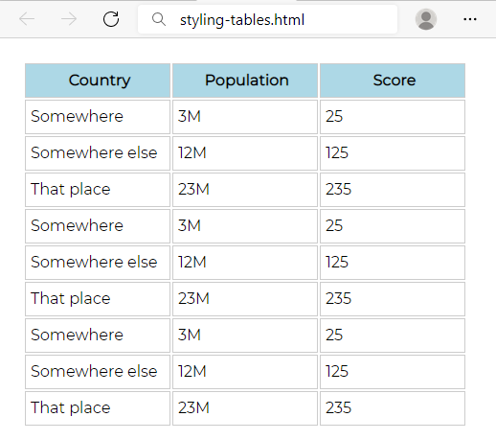

Requirements
You will be given a skeleton with filled HTML and an empty CSS file. Write the missing CSS following the guidelines in the task.
- <body>:
  - Font: Montserrat
- Use CSS import: @import 'https://fonts.googleapis.com/css?family=Montserrat';
  - Generic Font: sans-serif
  - Paddings: 16px
- <th>:
  - Background color: lightblue
- <th> and <td>:
  - Width: 144px
  - Height: 32px
  - Solid border with size 1px and color #ccc
  - Left padding: 5px

Buttons CSS
Create a web page like the following:
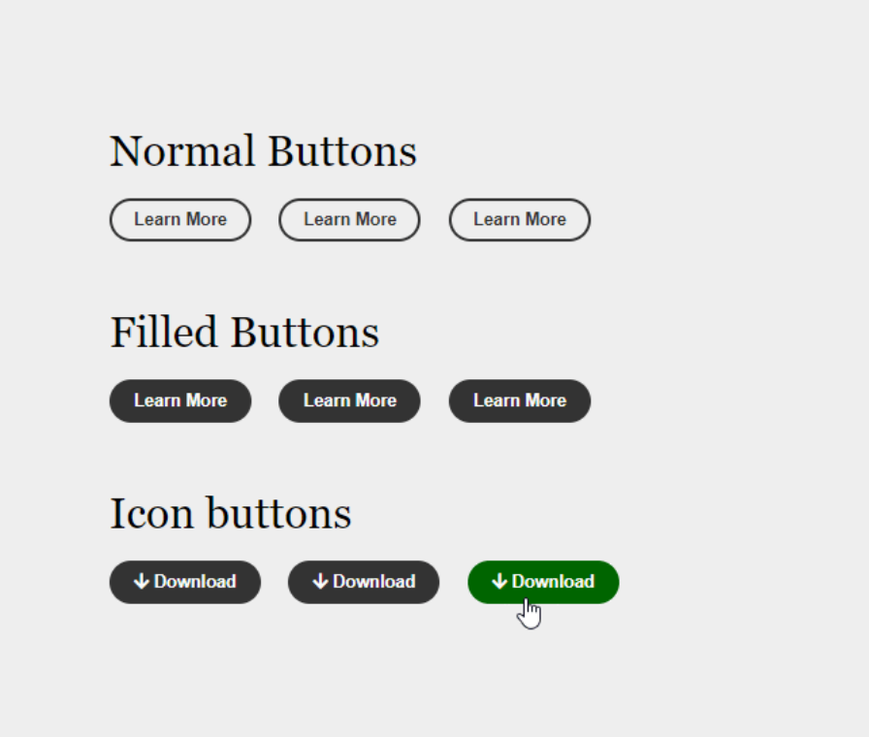

Requirements
- Create an "index.html" file with title - "Buttons CSS"
- Use h2 tag for headings
- Create 9 buttons on 3 rows with class button
  - For the first button in each row use a tag
  - For the next two buttons in the row use button tags
  - The buttons in the second and the third row should have class - fill
  - Every last button in the row should have class - hover
- You must use the following three colors:
  - green(rgb(0, 102, 0))
  - white(rgb(251, 251, 251))
  - gray(rgb(51, 51, 51))
- Use FontAwesome for this task. Import it in your CSS, with the @import rule.

Hints
- Change the cursor property to pointer
- Change the outline property to none
- FontAwesome: https://use.fontawesome.com/releases/v5.6.3/css/all.css

Fonts Speciment – Great Vibes + Raleway
Create a web page like the following:
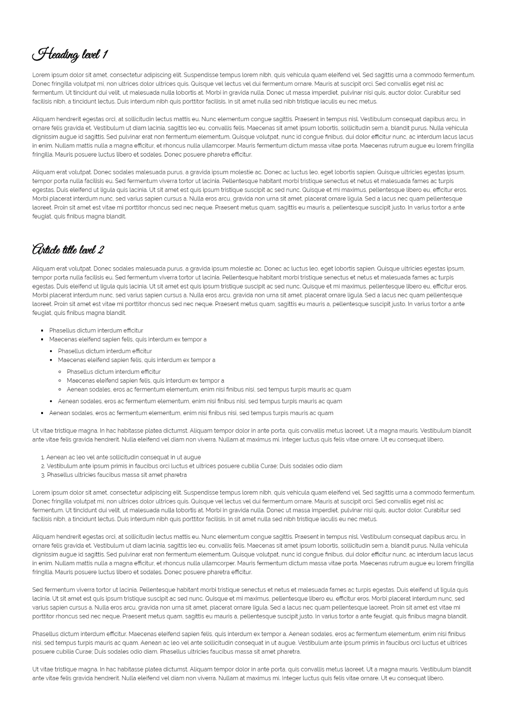

Requirements
- Create an index.html file with "Fonts Speciment Great Vibes + Raleway" title
- Use Raleway, sans-serif font-family for the document
  - Make the font-size 16px
  - Change the line-height to 1.5
- Use Great Vibes, cursive font-family for the headings
  - Change the line-height to 1.2
  - Change the font weight to bold

Contrasting Colors
Create a web page like the following:
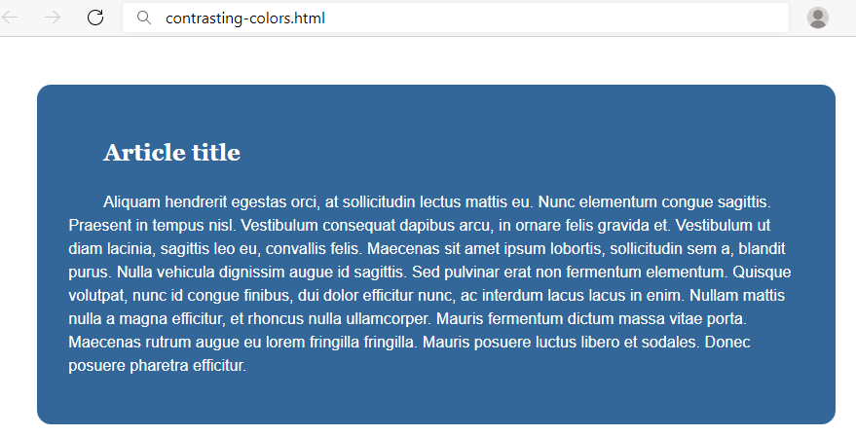

Requirements
You will be given a skeleton with filled HTML and an empty CSS file. Write the missing CSS following the guidelines in the task.
- <body>:
  - Font: Helvetica
  - Generic Font: sans-serif
  - Height of the line: 1.5
  - Font size: 18px
  - Background color: white
- <article>:
  - Margins: 54px
  - Paddings: 36px
  - Set the border radius to 16px
  - Text color: white
  - Indent text in the first line 40px
  - Background color: rgb(51, 102, 153)
- <h1>:
  - Font: Georgia
  - Generic Font: serif

The Making of a CSS Font
Create a web page like the following:
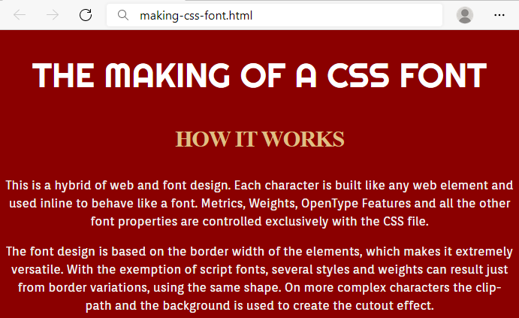

Requirements
You will be given a skeleton with filled HTML and an empty CSS file. Write the missing CSS following the guidelines in the task.
- <body>:
  - Background color: darkred
- <h1>:
  - Font: 'Righteous'
- Use CSS import: @import url('https://fonts.googleapis.com/css2?family=Righteous&display=swap');
  - Generic Font: cursive
  - Font size: 45px
  - Font weight: normal
  - Height of the line: 60px
  - Text color: #fff
  - All characters to be UPPERCASE
  - Align the text to the center
- <h2>:
  - Font size: 30px
  - Height of the line: 50px
  - Space between letters: -1px
  - Text color: #DFBF84
  - All characters to be UPPERCASE
  - Align the text to the center
- <p>:
  - Font: 'Orienta'
- Use CSS import: @import url('https://fonts.googleapis.com/css2?family=Orienta&display=swap');
  - Generic Font: sans-serif
  - Font size: 16px
  - Height of the line: 24px
  - Text color: #f6f6f6
  - Align the text to the center

Font Awesome Icons
Create a web page like the following:
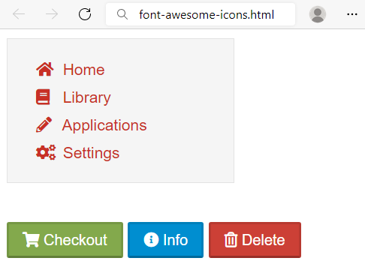

Requirements
HTML with <body> that contains: <nav> and separately <p>.
- <nav> with
  - <ul> and in it
    - <li> and in it
      - <a> and in it
        - <i> + text
- <p> with three buttons
  - <button> with class="shopping"
  - <button> with class="info"
  - <button> with class="delete"
CSS:
- Import font awesome link
- <body>:
  - Fonts: proxima-nova, "Helvetica Neue", Helvetica, Arial
  - Generic Font: sans-serif
- <nav>:
  - Width: 200px
  - Solid border with size 1px and color #e3e3e3
  - Font size: 14px
  - Height of the line: 20px
  - Background color: #f5f5f5
- <li>:
  - None list style
  - Height of the line: 25px
  - Left margin: -15px
- <a>:
  - None text decoration
  - Text color #c83025
- <i>:
  - Width: 1.14em
  - Right padding: 0.28em
For all the buttons:
- Top & bottom padding 4px
- Left & right padding 12px
- Height of the line: 20px
- Text color: #ffffff
- Border color: rgba(0, 0, 0, 0.1) rgba(0, 0, 0, 0.1) rgba(0, 0, 0, 0.25)
- Cursor: pointer
For the button.shopping:
- Background color: #83a94c
For the button.info:
- Background color: #008ed0
For the button.delete:
- Background color: #cc4036

Icon Font Buttons
Create a web page like the following:
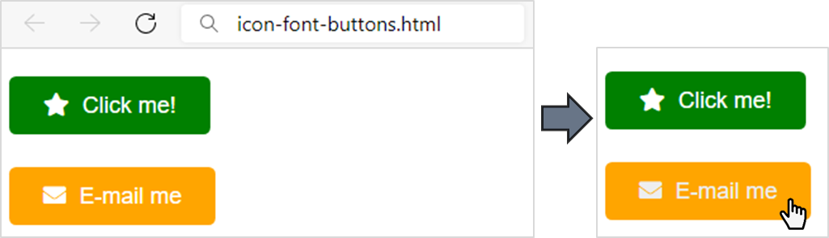

Requirements
You will be given a skeleton with HTML and an empty CSS file. Write the missing CSS and HTML following the guidelines in the task.
Add icons with the following classes in the HTML <a> tag: fas fa-star, fas fa-envelope.
- <body>:
  - Font: Arial
  - Generic Font: serif
  - Height of the line: 3
  - Font size: 18px
- <a>:
  - None text decoration
  - Text color: #fff
  - Set the border radius to 5.40px
  - Top & bottom paddings 12.6px
  - Left & right paddings 27px
- When the mouse course is over (a:hover):
  - Change the text color to #eee
- <i>:
  - Right padding: 5.40px
- The anchor with class="green"> (you can select them like that: .green)
  - Background color: green
- The anchor with class="orange"> (you can select them like that: .orange)
  - Background color: orange
- Use FontAwesome for this task. Import it in your CSS, with the @import rule

Icon Font List
Create a webpage like the following:
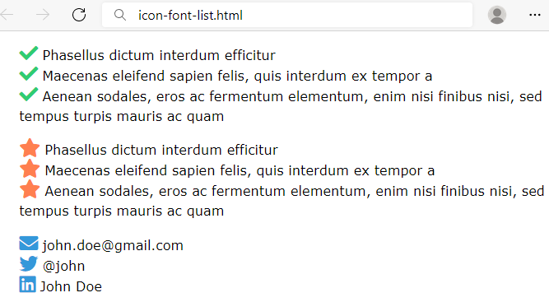

Requirements
You will be given a skeleton with HTML and an empty CSS file. Write the missing CSS and HTML following the guidelines in the task.
Add icons with the following classes in the HTML <li> tag: fas fa-check, fas fa-star, fas fa-envelope, fab fa-twitter, fab fa-linkedin.
- <body>:
  - Font: Verdana, Geneva, Tahoma
  - Generic Font: sans-serif
  - Height of the line: 1.5
  - Font size: 18px
- <ul>:
  - Set the list style type to none
- The icons in the <ul class="check"> (you can select them like that: ul.check i)
  - Color: #2fcc71
  - Font size: 25px
- The icons in the <ul class="star"> (you can select them like that: ul.star i)
  - Color: coral
  - Font size: 25px
- The icons in the <ul class="contact"> (you can select them like that: ul.contact i)
  - Color: #3498da
  - Font size: 25px
- Use FontAwesome for this task. Import it in your CSS, with the @import rule

Create Typography CSS
Create a web page like the following:
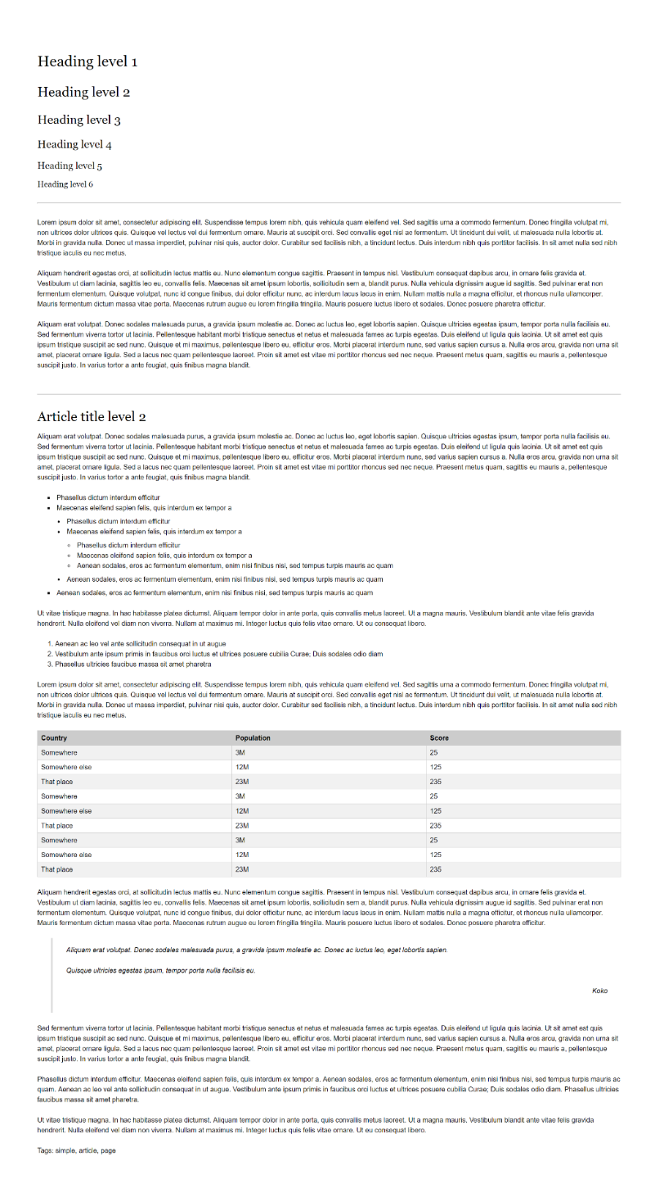

Requirements
- Create an "index.html" and "style.css" files
- Change the document title to "Typography"
- Use Helvetica, sans-serif font-family for the document
  - Make the font-size 16px
  - Change the line-height to 1.5
- Use Georgia, serif font-family for the headings
- Use headings from h1 to h6
- Create a HTML table and style it
- Use blockquote tag
  - Style its left border with rgb(221,221,221) color
  - Style its font to italic
- Use hr tag for the horizontal lines

