Exercise: Encapsulation
Problems for exercise and homework for the Python OOP Course @SoftUni.
Submit your solutions in the SoftUni judge system at https://judge.softuni.bg/Contests/1939.

Wild Cat Zoo
Create a separate file for each class as shown below and submit a zip file containing all files (zip the whole project folder/module) - it is important to include all files in the project module to make proper imports.
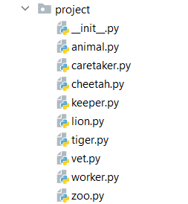
The Animal class is a base class for any type of animal in the zoo. It should receive four public attributes - a name (string), a gender (str), an age (int), and a money_for_care (int) upon initialization.
The Animal class should also have 1 additional method:
- __repr__() - returns string representation of the animal in the format: "Name: {name}, Age: {age}, Gender: {gender}"
The Lion, the Tiger, and the Cheetah classes should inherit from the Animal class. Each of these animals costs a certain amount of money to be cared for:
- A lion needs 50
- A tiger needs 45
- A cheetah needs 60
The Worker class is a base class for any type of employee in the zoo. It should receive three public attributes - a name (string), an age (int), and a salary (int) upon initialization.
The Worker class should also have one method:
- __repr__() - returns string representation of the workers in the format: "Name: {name}, Age: {age}, Salary: {salary}"
The Keeper, the Caretaker, and the Vet classes should inherit from the Worker class.
The Zoo class should receive 4 attributes upon initialization:
- Public attribute name: string
- Private attribute budget: int
- Private attribute animal_capacity: int
- Private attribute workers_capacity: int
It should also have 2 instance attributes:
- Public attribute animals: list - (empty upon initialization)
- Public attribute workers: list - (empty upon initialization)
The Zoo class should also have 8 methods:
- add_animal(animal, price)
- If you have enough budget and capacity add the animal (instance of Lion/Tiger/Cheetah) to the animals' list, reduce the budget, and return "{name} the {type of animal (Lion/Tiger/Cheetah)} added to the zoo"
- If you have the capacity, but no budget, return "Not enough budget"
- In any other case, you do not have space, and you should return "Not enough space for animal"
- hire_worker(worker)
- If you have not exceeded the capacity of workers in the zoo for the worker (instance of Keeper/Caretaker/Vet), add him to the workers and return "{name} the {type(Keeper/Vet/Caretaker)} hired successfully"
- Otherwise, return "Not enough space for worker"
- fire_worker(worker_name)
- If there is a worker with that name in the workers' list, remove him and return "{worker_name} fired successfully"
- Otherwise, return "There is no {worker_name} in the zoo"
- pay_workers()
- If you have enough budget to pay the workers (sum their salaries) pay them and return "You payed your workers. They are happy. Budget left: {left_budget}"
- Otherwise, return "You have no budget to pay your workers. They are unhappy"
- tend_animals()
- If you have enough budget to take care of the animals, reduce the budget and return "You tended all the animals. They are happy. Budget left: {left_budget}"
- Otherwise, return "You have no budget to tend the animals. They are unhappy."
- profit(amount)
- Increase the budget with the given amount of profit
- animals_status()
  - Returns the following string (Hint: use the __repr__ methods of the animals to print them on the console):
"You have {total_animals_count} animals
----- {amount_of_lions} Lions:
{lion1}
…
{lionN}
----- {amount_of_tigers} Tigers:
{tiger1}
…
{tigerN}
----- {amount_of_cheetahs} Cheetahs:
{cheetah1}
…
{cheetahN}"
- workers_status()
  - Returns the following string (Hint: use the __repr__ methods of the workers to print them on the console):
"You have {total_workers_count} workers
----- {amount_of_keepers} Keepers:
{keeper1}
…
{keeperN}
----- {amount_of_caretakers} Caretakers:
{caretaker1}
…
{caretakerN}
----- {amount_of_vetes} Vets:
{vet1}
…
{vetN}"

Examples
Test Code
from project.caretaker import Caretaker
from project.cheetah import Cheetah
from project.keeper import Keeper
from project.lion import Lion
from project.tiger import Tiger
from project.vet import Vet
from project.zoo import Zoo

zoo = Zoo("Zootopia", 3000, 5, 8)

# Animals creation
animals = [Cheetah("Cheeto", "Male", 2), Cheetah("Cheetia", "Female", 1), Lion("Simba", "Male", 4), Tiger("Zuba", "Male", 3), Tiger("Tigeria", "Female", 1), Lion("Nala", "Female", 4)]

# Animal prices
prices = [200, 190, 204, 156, 211, 140]

# Workers creation
workers = [Keeper("John", 26, 100), Keeper("Adam", 29, 80), Keeper("Anna", 31, 95), Caretaker("Bill", 21, 68), Caretaker("Marie", 32, 105), Caretaker("Stacy", 35, 140), Vet("Peter", 40, 300), Vet("Kasey", 37, 280), Vet("Sam", 29, 220)]

# Adding all animals
for i in range(len(animals)):
animal = animals[i]
price = prices[i]
print(zoo.add_animal(animal, price))

# Adding all workers
for worker in workers:
print(zoo.hire_worker(worker))

# Tending animals
print(zoo.tend_animals())

# Paying keepers
print(zoo.pay_workers())

# Fireing worker
print(zoo.fire_worker("Adam"))

# Printing statuses
print(zoo.animals_status())
print(zoo.workers_status())
Output
Cheeto the Cheetah added to the zoo
Cheetia the Cheetah added to the zoo
Simba the Lion added to the zoo
Zuba the Tiger added to the zoo
Tigeria the Tiger added to the zoo
Not enough space for animal
John the Keeper hired successfully
Adam the Keeper hired successfully
Anna the Keeper hired successfully
Bill the Caretaker hired successfully
Marie the Caretaker hired successfully
Stacy the Caretaker hired successfully
Peter the Vet hired successfully
Kasey the Vet hired successfully
Not enough space for worker
You tended all the animals. They are happy. Budget left: 1779
You payed your workers. They are happy. Budget left: 611
Adam fired successfully
You have 5 animals
----- 1 Lions:
Name: Simba, Age: 4, Gender: Male
----- 2 Tigers:
Name: Zuba, Age: 3, Gender: Male
Name: Tigeria, Age: 1, Gender: Female
----- 2 Cheetahs:
Name: Cheeto, Age: 2, Gender: Male
Name: Cheetia, Age: 1, Gender: Female
You have 7 workers
----- 2 Keepers:
Name: John, Age: 26, Salary: 100
Name: Anna, Age: 31, Salary: 95
----- 3 Caretakers:
Name: Bill, Age: 21, Salary: 68
Name: Marie, Age: 32, Salary: 105
Name: Stacy, Age: 35, Salary: 140
----- 2 Vets:
Name: Peter, Age: 40, Salary: 300
Name: Kasey, Age: 37, Salary: 280

Pizza Maker
Create a separate file for each class as shown below and submit a zip file containing all files (zip the whole project folder/module) - it is important to include all files in the project module to make proper imports.
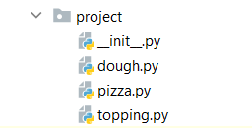
Create a class called Topping. Upon initialization, it should receive:
- topping_type: str - if the topping is an empty string, raise a ValueError with the message "The topping type cannot be an empty string"
- weight: float - if the weight is 0 or less, raise a ValueError with the message "The weight cannot be less or equal to zero"
Hint: Use Getters and Setters.
Create a class called Dough. Upon initialization, it should receive:
- flour_type: str - if the flour type is an empty string, raise a ValueError with the message "The flour type cannot be an empty string"
- baking_technique: str - if the technique is an empty string, raise a ValueError with the message "The baking technique cannot be an empty string"
- weight: float - if the weight is 0 or less, raise a ValueError with the message "The weight cannot be less or equal to zero"
Create a class called Pizza. Upon initialization, it should receive:
- name: str - if the name is an empty string, raise a ValueError with the message "The name cannot be an empty string"
- dough: Dough - if the dough is None, raise a ValueError with the message "You should add dough to the pizza"
- toppings_capacity: int – represents the maximum number of toppings the pizza should have. If the capacity is 0 or less, raise a ValueError with the message "The topping's capacity cannot be less or equal to zero"
- toppings: dict – empty dictionary upon initialization that will contain the topping type as a key and the topping's weight as a value.
The class should also have 2 instance methods:
- add_topping(topping: Topping)
  - Add a new topping to the dictionary
- If there is no space left for a new topping, raise a ValueError: "Not enough space for another topping"
- If the topping is already in the dictionary, increase the value of its weight.
- calculate_total_weight() - returns the total weight of the pizza (dough's weight and toppings' weight)

Examples
Test Code
from project.dough import Dough
from project.pizza import Pizza
from project.topping import Topping

tomato_topping = Topping("Tomato", 60)
print(tomato_topping.topping_type)
print(tomato_topping.weight)

mushrooms_topping = Topping("Mushroom", 75)
print(mushrooms_topping.topping_type)
print(mushrooms_topping.weight)

mozzarella_topping = Topping("Mozzarella", 80)
print(mozzarella_topping.topping_type)
print(mozzarella_topping.weight)

cheddar_topping = Topping("Cheddar", 150)

pepperoni_topping = Topping("Pepperoni", 120)

white_flour_dough = Dough("White Flour", "Mixing", 200)
print(white_flour_dough.flour_type)
print(white_flour_dough.weight)
print(white_flour_dough.baking_technique)

whole_wheat_dough = Dough("Whole Wheat Flour", "Mixing", 200)
print(whole_wheat_dough.weight)
print(whole_wheat_dough.flour_type)
print(whole_wheat_dough.baking_technique)

p = Pizza("Margherita", whole_wheat_dough, 2)

p.add_topping(tomato_topping)
print(p.calculate_total_weight())

p.add_topping(mozzarella_topping)
print(p.calculate_total_weight())

p.add_topping(mozzarella_topping)
Output
Tomato
60
Mushroom
75
Mozzarella
80
White Flour
200
Mixing
200
Whole Wheat Flour
Mixing
260
340
ValueError: Not enough space for another topping

Football Team Generator
Create a separate file for each class as shown below and submit a zip file containing all files (zip the whole project folder/module) - it is important to include all files in the project module to make proper imports.
Create a class called Player. Upon initialization, it should receive:
- Private attribute name: string
- Private attribute sprint: int
- Private attribute dribble: int
- Private attribute passing: int
- Private attribute shooting: int
You should create property only for the name of the player. The class should also have one additional method:
Override the __str__() method of the class so it returns:
"Player: {name}
Sprint: {sprint}
Dribble: {dribble}
Passing: {passing}
Shooting: {shooting}"
Create a class called Team. Upon initialization, it should receive:
- Private attribute name: string
- Private attribute rating: int
The class should also have a private instance attribute - players: list - empty list upon initialization that will contain all the players (objects)
The Team class have the following methods:
- add_player(player: Player)
- If the player is already in the team, return "Player {name} has already joined"
- Otherwise, add the player to the team and return "Player {name} joined team {team_name}"
- remove_player(player_name: str)
- Remove the player and return him
- If the player is not in the team, return "Player {player_name} not found"

Examples
Test Code
from project.player import Player
from project.team import Team

p = Player("Pall", 1, 3, 5, 7)

print("Player name:", p.name)
print("Points sprint:", p._Player__sprint)
print("Points dribble:", p._Player__dribble)
print("Points passing:", p._Player__passing)
print("Points shooting:", p._Player__shooting)

print("\ncalling the __str__ method")
print(p)

print("\nAbout the team")
t = Team("Best", 10)
print("Team name:", t._Team__name)
print("Teams points:", t._Team__rating)
print("Teams players:", len(t._Team__players))
print(t.add_player(p))
print(t.add_player(p))
print("Teams players:", len(t._Team__players))
print(t.remove_player("Pall"))
print(t.remove_player("Pall"))

Output
Player name: Pall
Points sprint: 1
Points dribble: 3
Points passing: 5
Points shooting: 7

calling the __str__ method
Player: Pall
Sprint: 1
Dribble: 3
Passing: 5
Shooting: 7

About the team
Team name: Best
Teams points: 10
Teams players: 0
Player Pall joined team Best
Player Pall has already joined
Teams players: 1
Player: Pall
Sprint: 1
Dribble: 3
Passing: 5
Shooting: 7
Player Pall not found

Restaurant
Create a restaurant with the following classes and hierarchy:
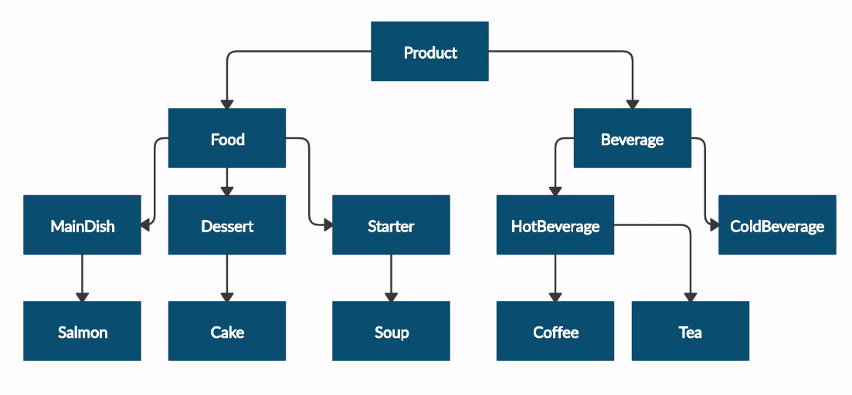
Submit in judge a zip file containing a separate file for each of the classes using the structure shown below:
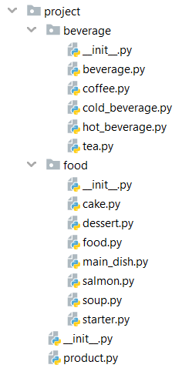
The Product class should have the following private attributes and subsequent getters:
- name: string
- price: float
Beverage and Food classes are products:
- The Beverage class should have an additional private attribute – milliliters: float and its subsequent getter
- The Food class should have an additional private attribute – grams: float and its subsequent getter
HotBeverage and ColdBeverage are beverages.
Coffee and Tea are hot beverages:
- The Coffee class should have an additional private attribute – caffeine: float and its subsequent getter. It should also have the following class attributes, which should apply to all coffees made:
- MILLILITERS = 50 (constant)
- PRICE = 3.50 (constant)
Starter, MainDish, and Dessert are food:
- The Dessert class should have an additional private attribute - calories - float and its subsequent getter
Salmon is a main dish. Also, it must have the following class attribute, which should apply to all salmons:
- GRAMS = 22 (constant)
Soup is a starter.
Cake is a dessert. Also, it must have the following class attributes which should apply to all cakes made:
- GRAMS = 250 (constant)
- CALORIES = 1000 (constant)
- PRICE = 5 (constant)

Examples
Test Code | Output
product = Product("coffee", 2.5)  print(product.__class__.__name__)  print(product.name)  print(product.price)  beverage = Beverage("coffee", 2.5, 50)  print(beverage.__class__.__name__)  print(beverage.__class__.__bases__[0].__name__)  print(beverage.name)  print(beverage.price)  print(beverage.milliliters)  soup = Soup("fish soup", 9.90, 230)  print(soup.__class__.__name__)  print(soup.__class__.__bases__[0].__name__)  print(soup.name)  print(soup.price)  print(soup.grams) | Product  coffee  2.5  Beverage  Product  coffee  2.5  50  Soup  Starter  fish soup  9.9  230

