Problem 3

Create a function called get_magic_triangle which will receive a single parameter (integer n) and it should create a magic triangle which follows those rules:
- We start with this simple triangle [[1], [1, 1]]
- We generate the next rows until we reach n amount of rows
- Each number in each row is equal to the sum of the two numbers right above it in the triangle
- If the current number has no neighbor to the upper left/rigth, we just take the existing neighbor
After you create the magic triangle, return it as a multidimensional list. Here is an example with n = 5
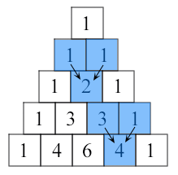
Note: Submit only the function in the judge system

Input
- There will be no inputs
- The function will be tested by passing different values of n
- You can test your function with the test code below

Constraints
- N will be in range [2, 100]

Examples
Test Code | Output
get_magic_triangle(5) | [[1], [1, 1], [1, 2, 1], [1, 3, 3, 1], [1, 4, 6, 4, 1]]

