Exercise: HTML Structure
You can check your solutions here: https://judge.softuni.org/Contests/3331/HTML-Structure.

Navigation Bar
Create a Web page, holding like the following navigation bar:
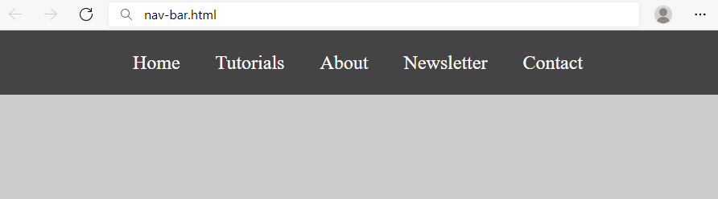
Use the texts from the file site-texts.txt.
Create two files: nav-bar.html and nav-bar.css.

Requirements
- <body>
  - Margin: 0px;
  - Padding: 0px;
  - Background Color: #CCCCCC;
- <nav> tag as container
- <ul> tag for unordered list
  - Background Color: #444;
  - Center the text
  - Padding: 0px;
  - Margin: 0px;
  - list-style:none;
- <li> tag for list item
  - Text size: 24px;
  - Line Height: 40px;
  - Height: 40px;
  - Padding: 20px;
- <a> tag for hyperlink
  - text-decoration: none;
  - Text-Color: #ffffff;

Hints
Use:
- <li> with display: inline-block;

Page Content
Create a Web page like the show below, using the text from the file site-texts.txt.
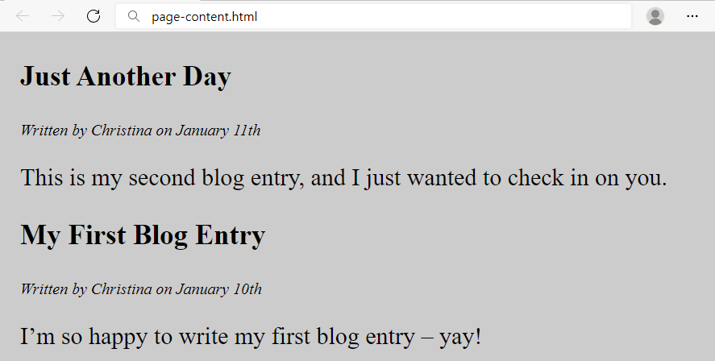
Create two files: page-content.html and page-content.css.

Requirements
- <section> as a container
- <article> tag for content
  - <header> with:
    - <h1> Text size: 28px;
    - <p> Font Style: italic;
- Paragraph
  - Text size: 24px;
- <body>
  - Margin: 0px;
  - Padding: 0px;
  - Background color: #CCCCCC;
- <section>
  - Margin Left: 20px;

Semantic Tags
Create a web page like the following:

Use the texts from the file site-texts.txt.
Create files: index.html and styles.css.

Requirements
HTML:
- The title should be "Semantic Tags"
- Add header tag for the header section
  - Use h1 tag for the heading
- Add main tag for the main content
  - Create two paragraphs inside (p tag)
- Use footer tag for the last section
  - Create two paragraphs inside (p tag)
The CSS in the example above uses:
- padding: 15px, 5px 15px
- background colors: #f9f7cf, #f2dcbb
- width: 480px

Hints
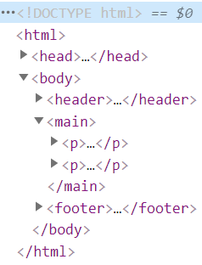

Semantic Article Page
Create a web page like the following:
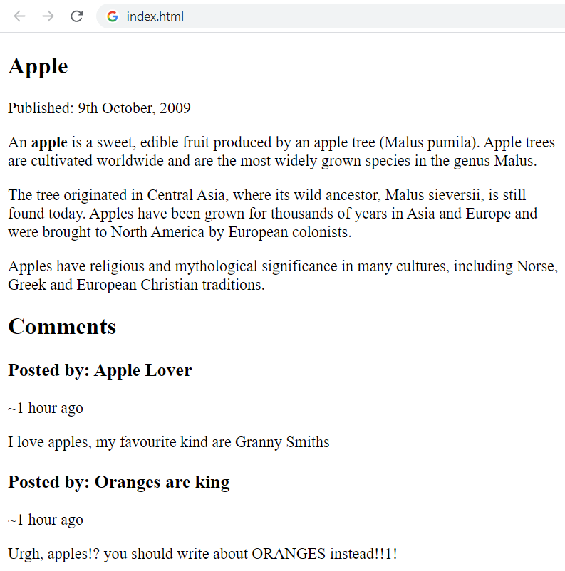
Add CSS to make the Web page look better, like this:
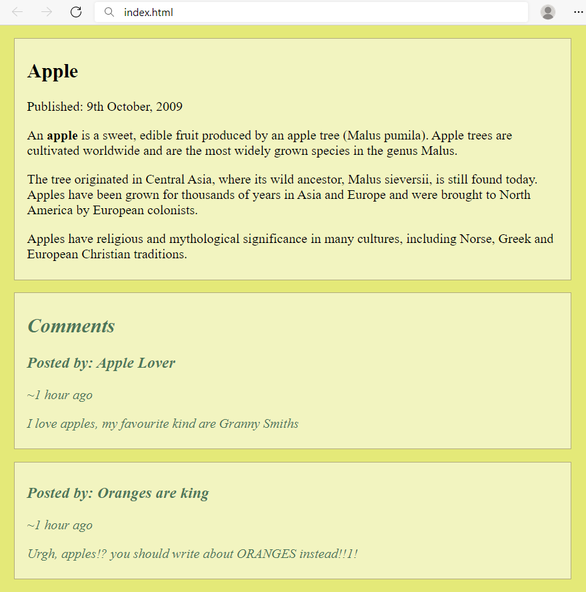
Use the texts from the file site-texts.txt.
Create files: index.html and styles.css.

Requirements
- The title should be "Semantic Article Page"
- Use article tag to create an article
  - The article has header with h1 heading and a paragraph for the published date inside
- Use p tag to create 3 paragraphs after the header.
  - The paragraphs contain the article content (info for apple)
  - Use b tag where is needed
- Use section tag to create the "Comment section"
  - Add two articles inside the section
  - Each article has a heading (h2) for the title
  - Each article has two paragraphs for the time and the comment
Used CSS in the example above:
- padding: 5px 15px;
- font-style: italic
- color: #5c6e91
- background colors: #f2f4c0, #e4e978, #4c7658;
- width: 700px
- border: 1px solid #b2ad7d;
- margin: 15px 10px;

Simple Website
Using the navigation bar and page content from the previous two exercises, create a Web page like the following:
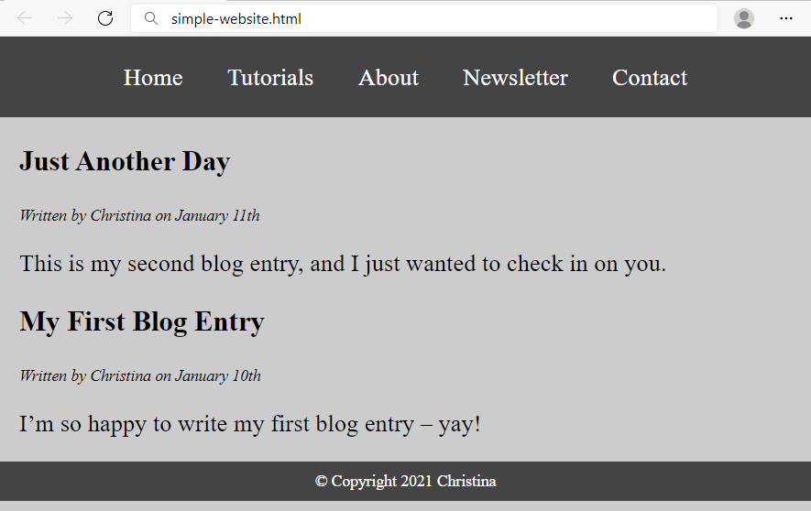
Use the texts from the file site-texts.txt.
Create two files: simple-website.html and simple-website.css.

Requirements
- Use the HTML and CSS from previous two problems
- <footer> tag
  - Background color: #444;
  - <p> tag for text
  - Text Color: #fff;
  - Center the text
  - Padding: 10px

Hints
Use:
- &copy; for copyright symbol

Semantic Blog Layout
Create a blog layout page, which holds header, footer and main. The main should hold two sections, each holding two articles. It should look like this (without any styling):
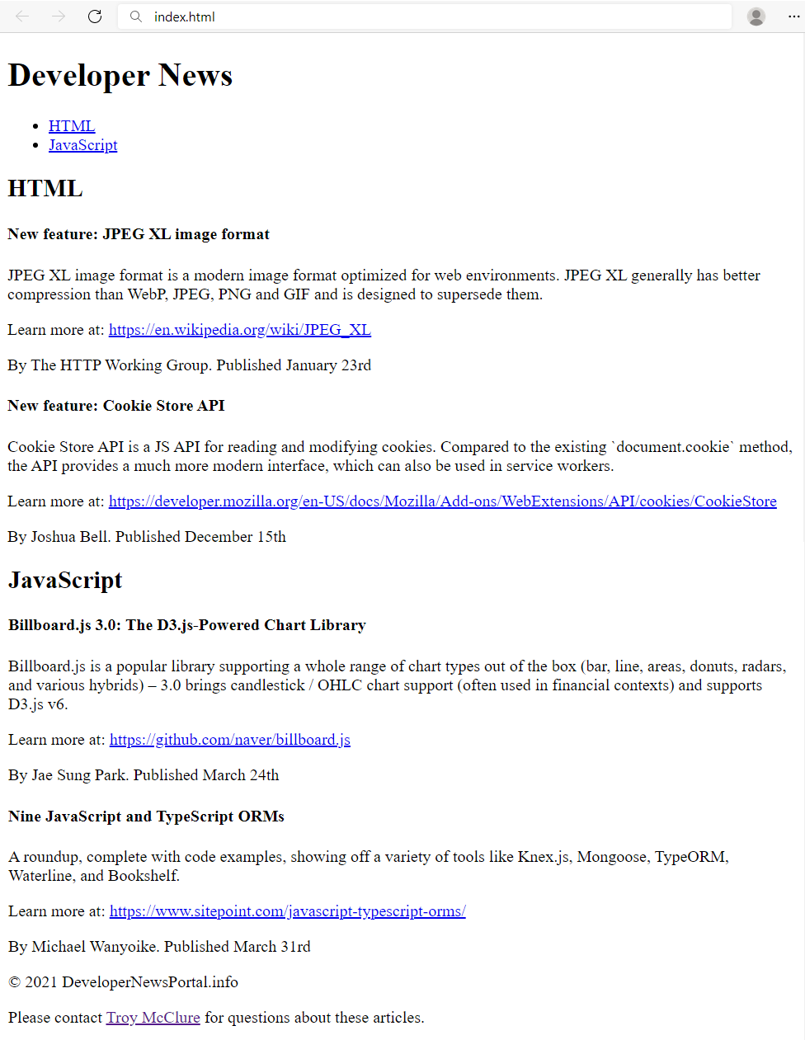

Use the texts from the file site-texts.txt.
Create files: index.html and styles.css.

Requirements
- The title should be "Semantic Blog Layout"
- Use header tag for the header section
  - Use h1 tag for the heading
  - Use nav tag for the navigation with an unordered list (ul) inside
    - Create two list items with anchor (a) tags inside
- Use main tag for the page main content
  - Create two sections in the main. Each section has:
    - A header with h2 heading
    - Two articles with h4 heading and three p tags inside
    - For the dates use time tag
- Use footer tag with two paragraphs Inside
  - Use anchor tag for the name in the last sentence

Add CSS Styling
Add CSS styling to make the blog look better, like at the following screenshot:
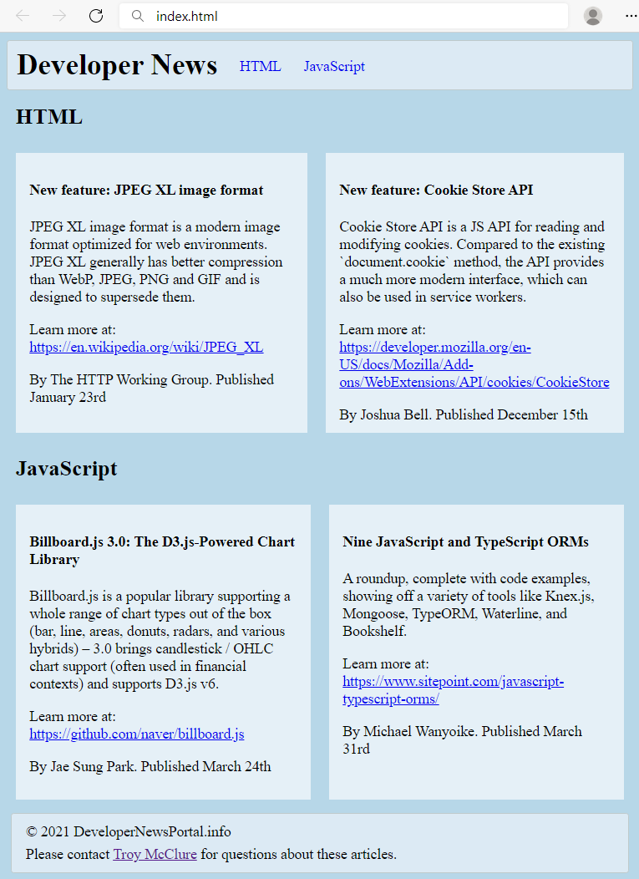
Create files: index.html and styles.css.
Use the following CSS styles to make your HTML look like at the screenshot:
header {
border-radius: 3px;
padding: 8px 10px;
background-color: #dceaf4;
border: 1px solid #bfcacb;
}
header * {
display: inline;
vertical-align: middle;
}
nav ul {
margin: 0;
padding: 10px;
}
nav li {
margin:10px;
}
nav li a {
text-decoration: none;
}

body{
background-color:#b7d7e8;
}

section h2 {
margin: 15px 10px;
}

article {
display: table-cell;
width: 50%;
padding: 10px 15px;
background-color: #e5f0f7;
border: 10px solid #b7d7e8;
}

footer {
margin: 5px;
padding: 5px 10px;
border-radius: 3px;
background-color: #dceaf4;
border: 1px solid #bfcacb;
}

footer p {
margin: 5px;
}

