Exercise: CSS Box Model
Problems for exercises and homework for the "HTML and CSS" course @ SoftUni. Submit your solutions in the SoftUni Judge system at https://judge.softuni.org/Contests/3333/CSS-Box-Model.

Box Model Container
Create a web page like the following:
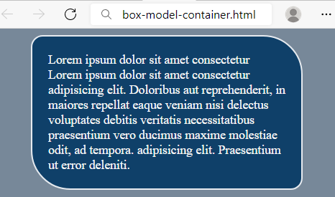

Requirements
You will be given a skeleton with filled HTML and an empty CSS file. Write the missing CSS following the guidelines in the task.
- <body>:
  - Background color: lightslategray
- <p>:
  - Width: 300px
  - Paddings: 20px
  - Auto margins
  - Background color: #0F4069
  - Text color: whitesmoke
  - Solid border with size 2px and color #e6eaef
  - Top left and bottom right border radius: 15px
  - Top right and bottom left border radius: 50px

Scrolling Article
Create a web page like the following:
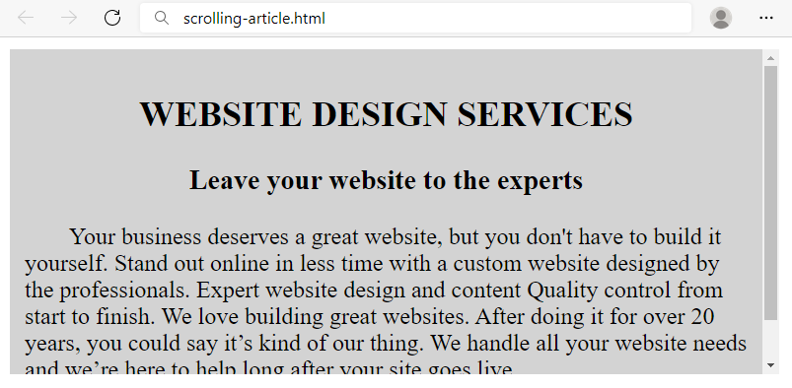

Requirements
HTML with <body> that contains: <section> with <article> which has <h2>, <h3> and <p>.
CSS:
- <article>:
  - Width: 500px
  - Height: 200px
  - Background color: lightgray
  - Paddings: 10px
  - Auto overflow
- <h2>:
  - All characters to be UPPERCASE
  - Align the text to the center
- <h3>:
  - Align the text to the center
- <p>:
  - Indent text in the first line 30px

Brazil Coffee
Create a web page like the following:
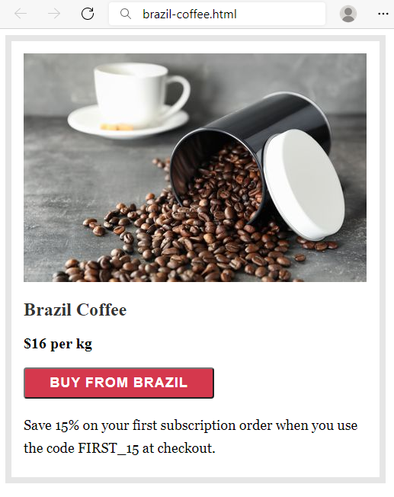

Requirements
HTML with <body> that contains: <section> which has <img>, <h2>, <div>, <button> and <p>.
CSS:
- <section>:
  - Solid border with size 8px and color #e6e6e6
  - Paddings: 16px
  - Width: 451px
  - Height: 540px
- <h2>:
  - Font: Merriweather
  - Generic Font: serif
  - Font weight 700
  - Top & bottom margin 1.2rem
  - Left & right margin 0
  - Color: rgb(51, 51, 51)
- <div>:
  - Font weight 600
  - Font size: 20px
- <button>:
  - Width: 250px
  - Font : Work Sans
  - Generic Font: sans-serif
  - Font weight 600
  - Font size: 18px
  - Border radius: 4px
  - Background color: #d5384d
  - Text color: #fff
  - Letter spacing: 1px
  - Align the text to the center
  - Top & bottom padding 8px
  - Left & right padding 16px
  - Top margin: 20px
  - Bottom margin: 20px
- <p>:
  - Fonts: Georgia, Cambria, Times New Roman, Times
  - Generic Font: serif
  - Font size: 18px
  - Height of the line: 30px
  - Top margin: 0

Article
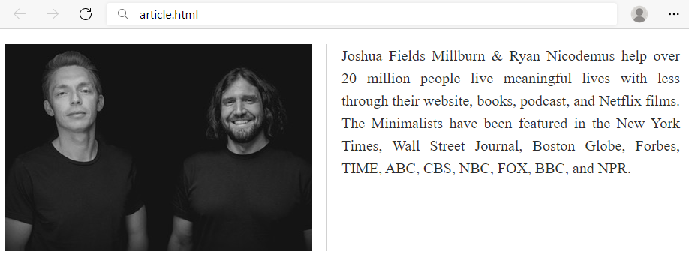

Requirements
You will be given a skeleton with filled HTML and an empty CSS file. Write the missing CSS following the guidelines in the task.
- <main>:
  - Width: 900px
  - Height: 140px
- <img>:
  - Solid right border with size 1px and color #d1d1d1
  - Float the images on the left
  - Right margin: 19px
  - Right padding: 19px
- <p>:
  - Font size: 20px
  - Height of the line: 30px
  - Text color: #2e2e2e
  - Text align: justify

Blog Article
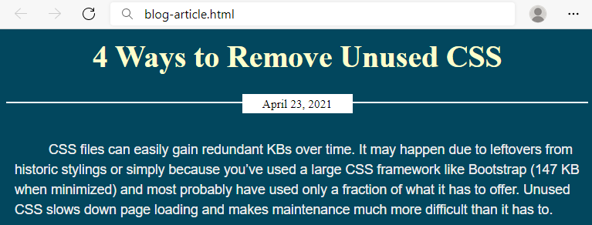

Requirements
You will be given a skeleton with filled HTML and an empty CSS file. Write the missing CSS following the guidelines in the task.
- <body>:
  - Background color: #02475e
- <article> :
  - <h2>:
    - Font size: 36px
    - Text color: #fefecc
    - Margins: 12px
    - Align the text to the center
  - <p>:
    - Text color: #eee
    - Font: Arial
    - Generic Font: sans-serif
    - Height of the line: 24px
    - Paddings: 10px
    - Indent text in the first line 30px
  - <div>:
    - Bottom margin: 30px
    - Solid top border with size 2px and color #fff
    - Relative position
    - Top coordinates: 20px
  - <span>:
    - Width: 120px
    - Font size: 14px
    - Align the text to the center
    - Top & bottom paddings 3px
    - Left & right paddings 5px
    - Top & bottom margins 0
    - Left & right margins auto
    - Background color: #fff
    - Display the span as block
    - Relative position
    - Top coordinates: -11px

Navigation Inline Block
Create a web page like the following:
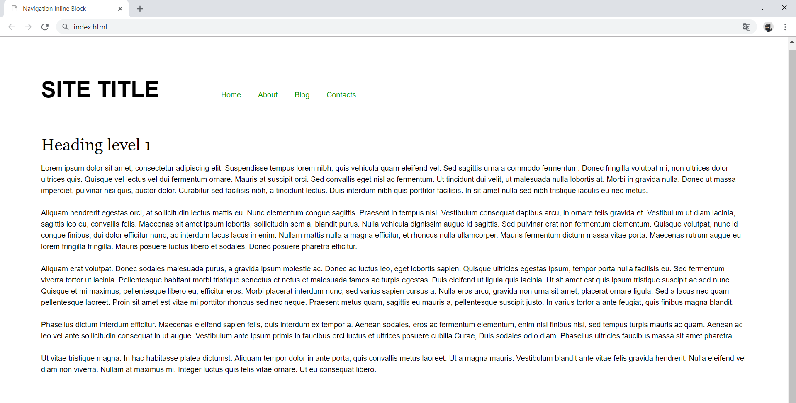

Requirements
- Change the document title to "Navigation Inline Block"
- Divide your content into header and main tags
- Add font to the document: Helvetica, sans-serif
- Create a navigation bar
  - Add four list items in nav tag with a tags inside
  - Add display: inline-block; style for each item in the nav

Make Your Own Website
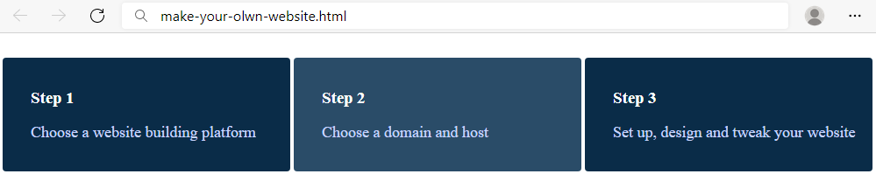

Requirements
You will be given a skeleton with filled HTML and an empty CSS file. Write the missing CSS following the guidelines in the task.
- <div>:
  - Width: 280px
  - Display the divs as inline-block
  - Padding top, right and bottom: 16px
  - Padding left: 32px
  - Top margin: 20px
  - Background color: #0A2C48
  - Text color: #fff
  - Radius of the border: 4px
- <div> on mouse hover:
  - Background color: #2A4C68
- <p>:
  - Text color: #c9d6ff
  - Font size: 18px

Photo Gallery Inline Block
Create a web page like the following:
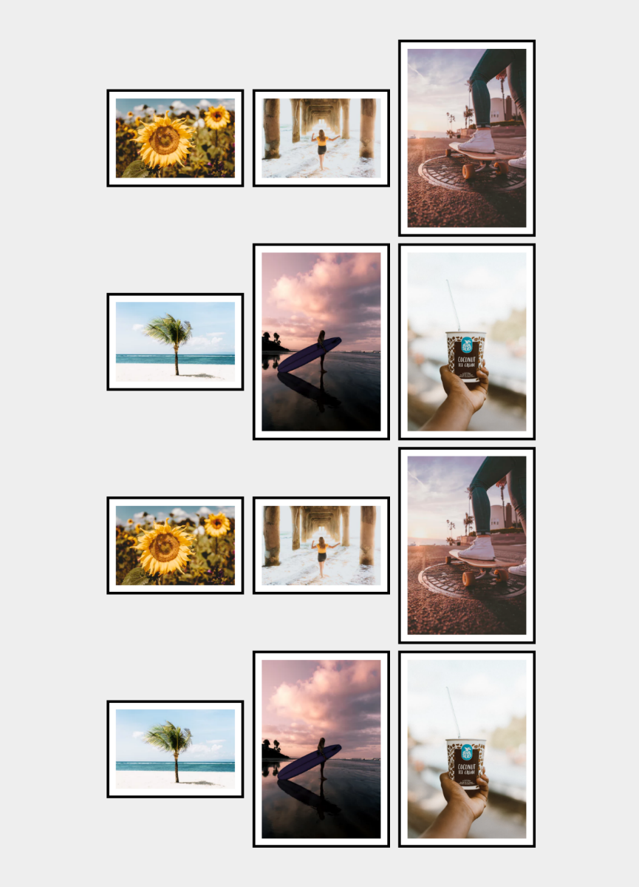

Requirements
- Change the document title to "Photo Gallery - Inline Block"
- Create unordered list with class gallery (ul.gallery)
- Add list items with images inside
- <body>
  - Padding: 5rem
  - Background color: #eee
- .gallery
  - Width: 100%
  - Margin: 0 auto
  - Align the text to the center
- li
  - Width: 18rem
  - Display the list as inline-block
  - Background color: #fff
  - Solid border with size 0.4rem and color #000
  - Padding: 1rem
  - Vertical align: middle
  - Margin: 0.5rem
- img
  - display: block
  - width: 100%
  - height: auto

Blog Layout Inline Block
Create a web page like the following:
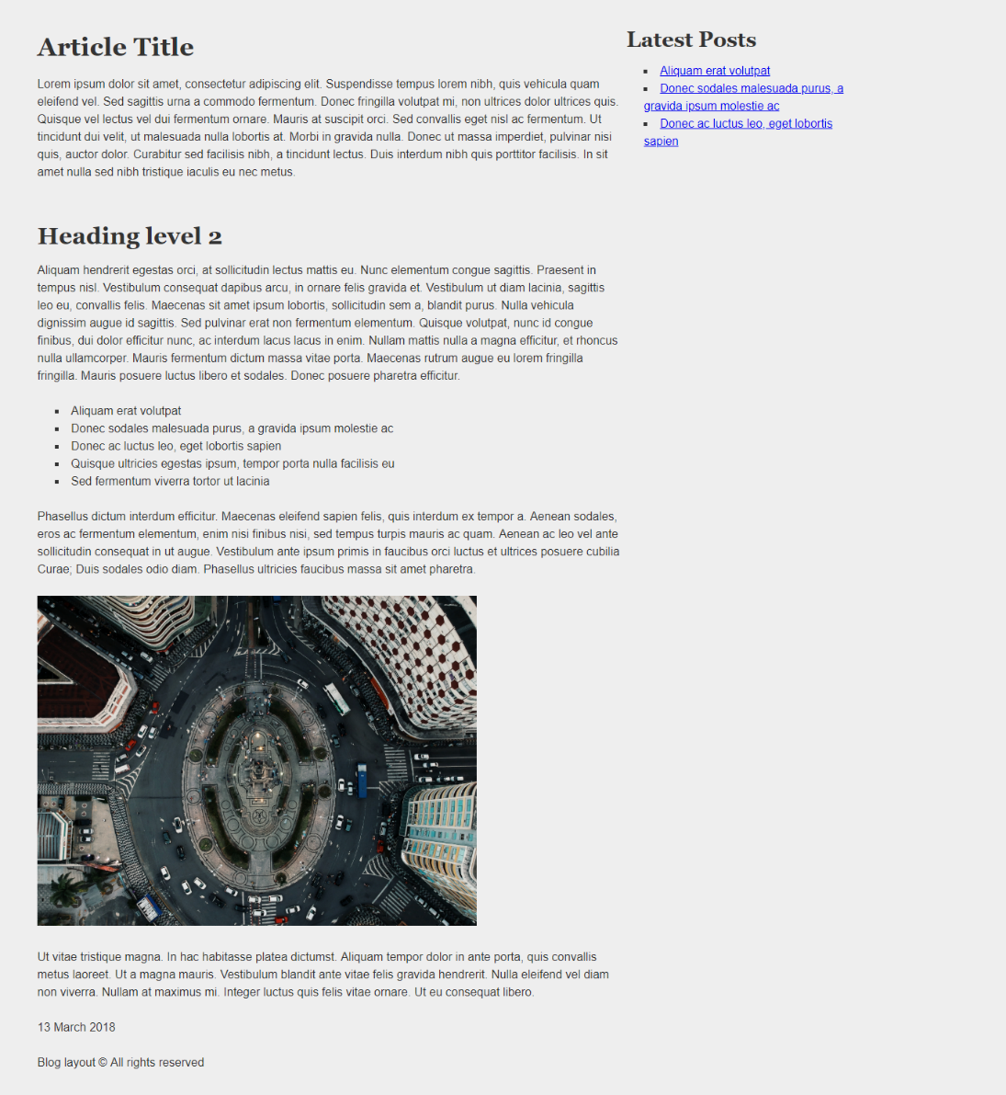

Requirements
- Change the document title to "Blog Layout Inline Block"
- Add font to the document: Helvetica, sans-serif
- Use article tag to create an article
  - Divide the article content into header, section and footer tags
- Use aside tag to create aside for the Latest Posts
- Use background with color - rgb(238, 238, 238)
- Use rgb(51, 51, 51) color for the text

