Exercise: Introduction to HTML and CSS
Problems for exercises and homework for the "HTML and CSS" course @ SoftUni. Submit your solutions in the SoftUni Judge system at https://judge.softuni.org/Contests/3330/Introduction-to-HTML-and-CSS.

Install and Configure Visual Studio Code for HTML
Install VS Code by using the guide in the resources of that lab.
- Start with Visual Studio Code.
- Create and select the working folder in which we will create our first HTML page.
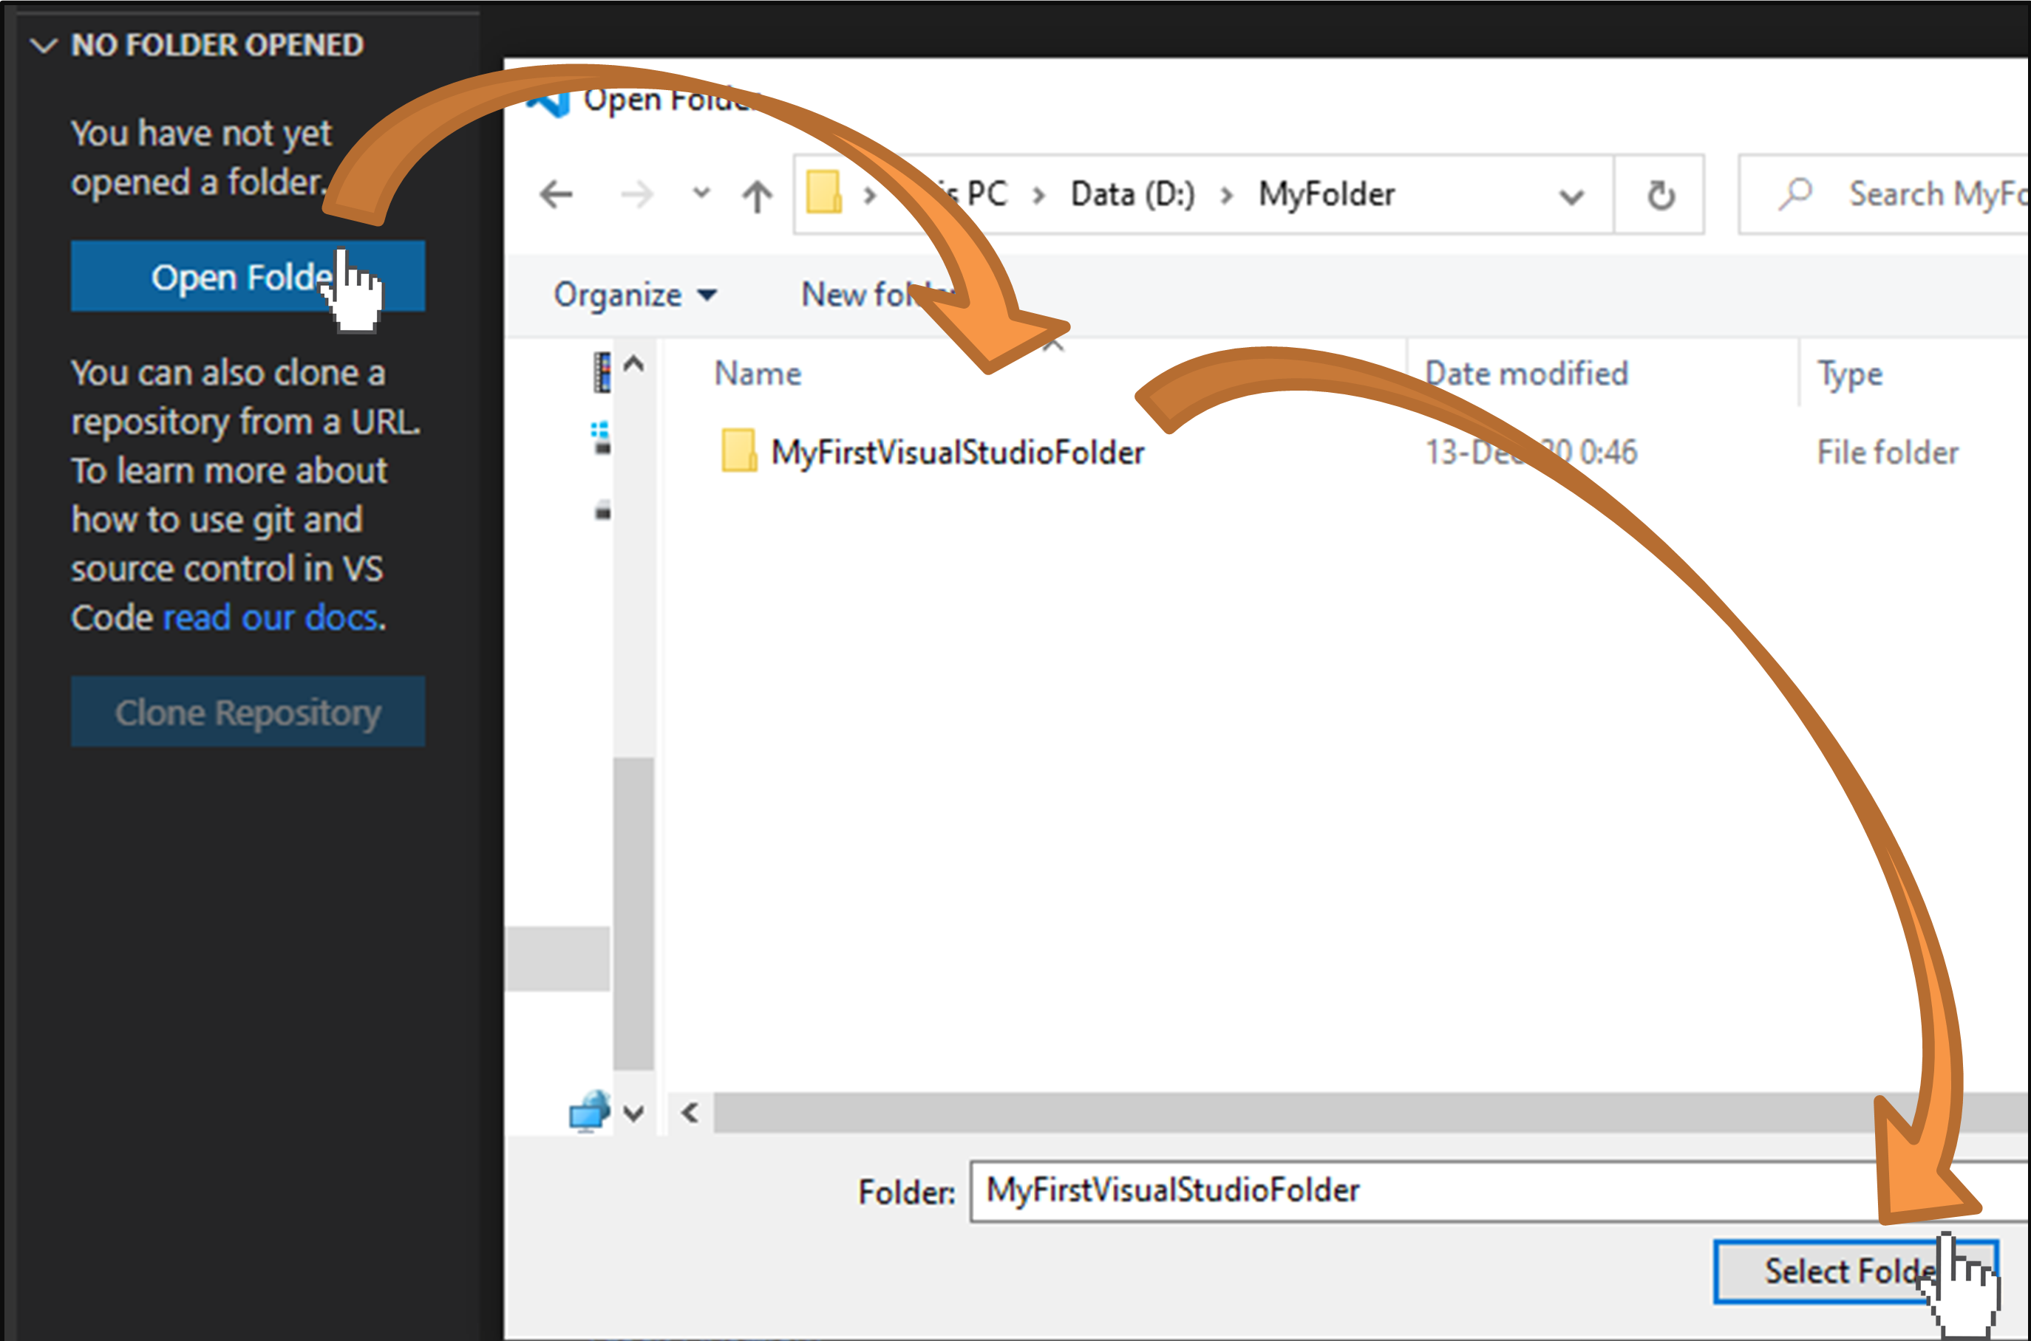
- Create a new HTML file:
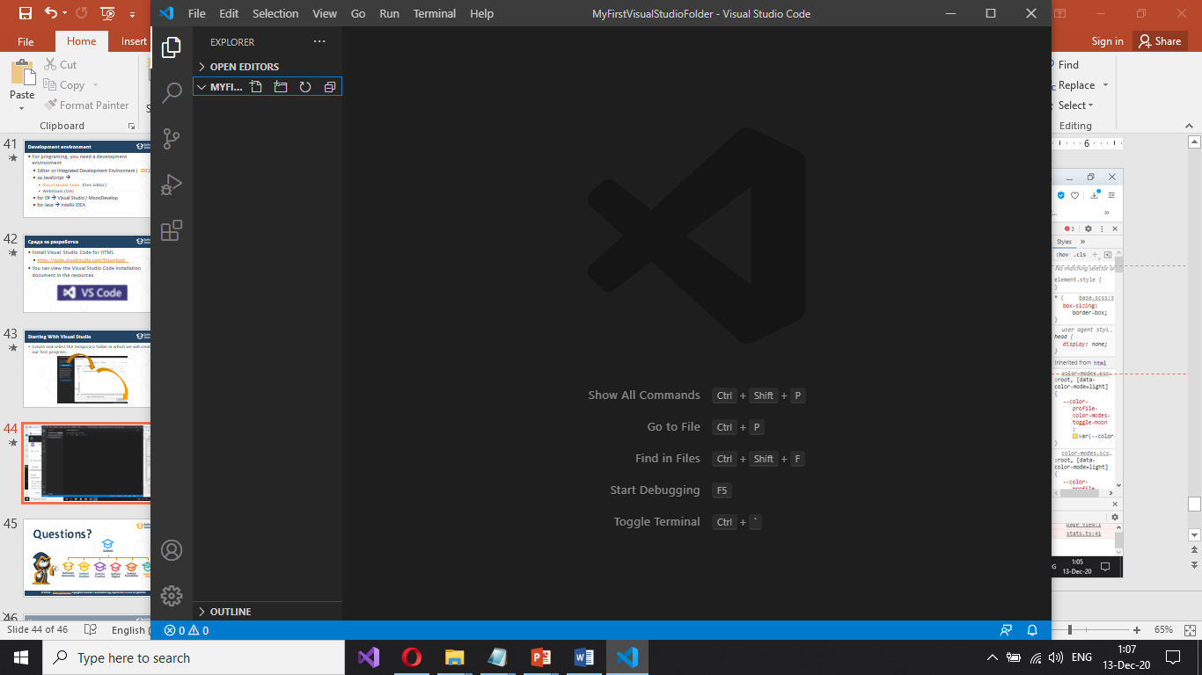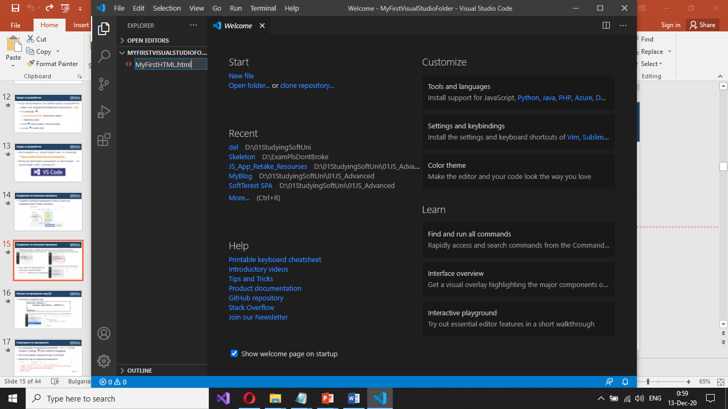
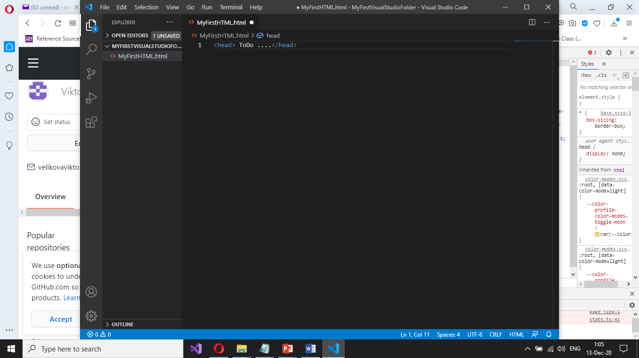
- Install the extension “Live Server”:
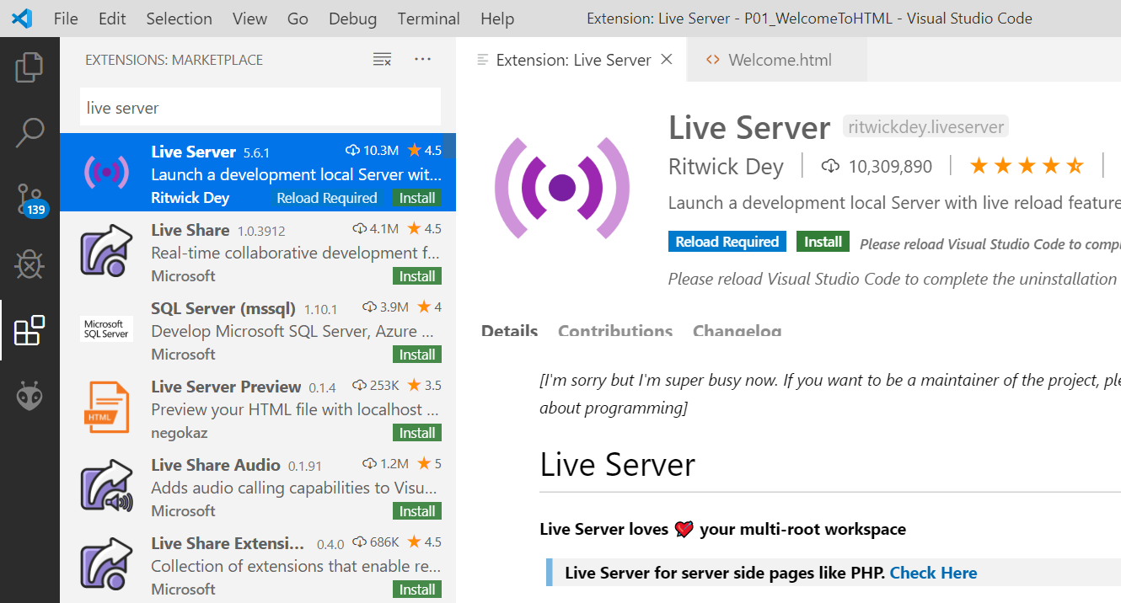
- Тo see the result of the written code in a browser, right-click on the project and select [Open with Live Server].
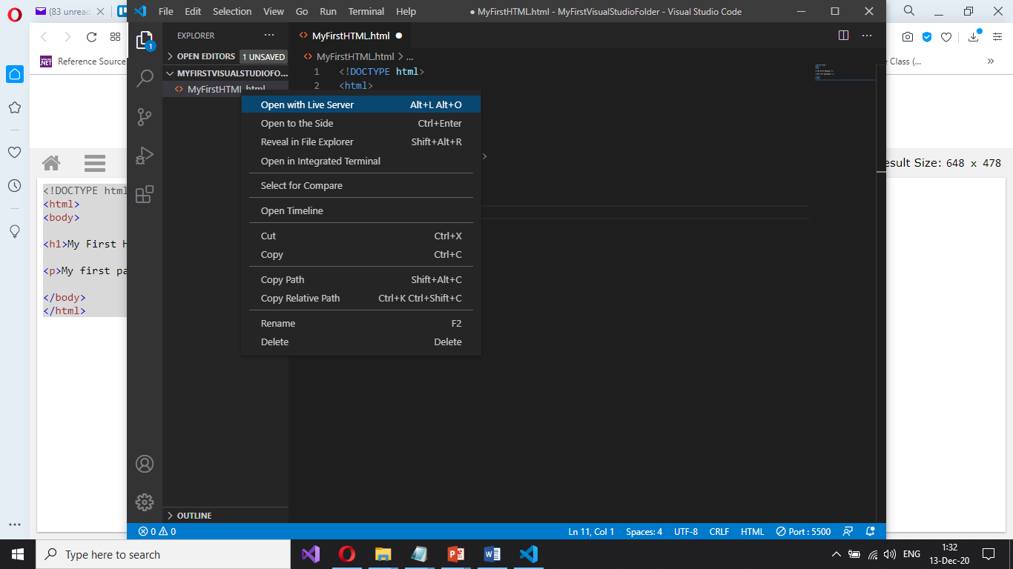
You will see the output from your HTML code in the Web browser:
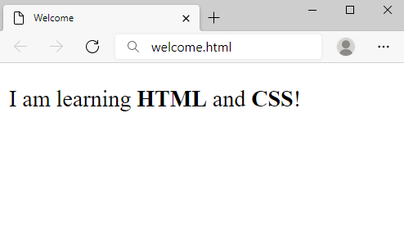

How to Send Solutions in Judge?
Make a zip archive of your solution by right-click on the HTML file > [Send to] > [Compressed (zipped) file].
Drag the zipped file to judge over the button [Select files] and drop it. After that hit [Submit] button.
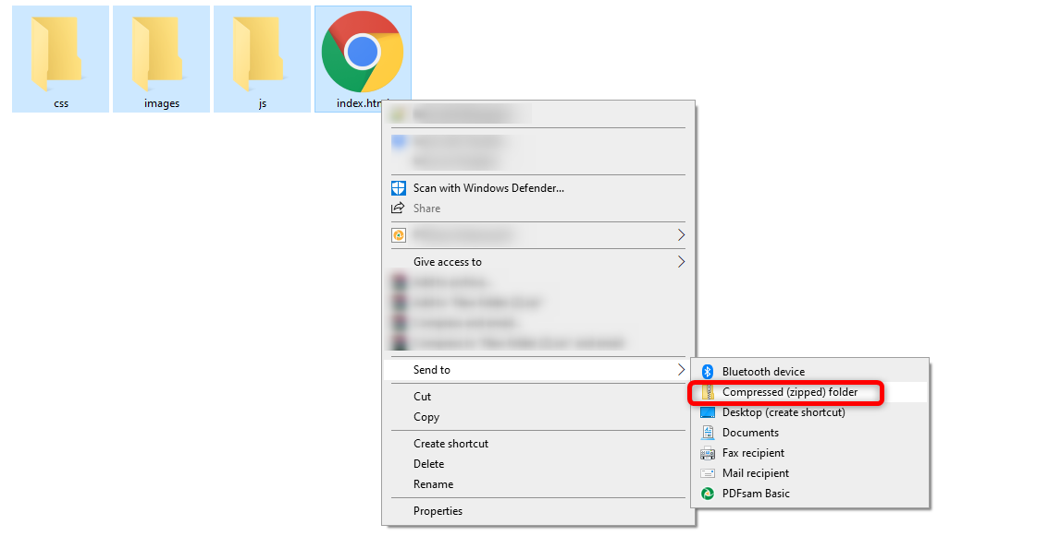
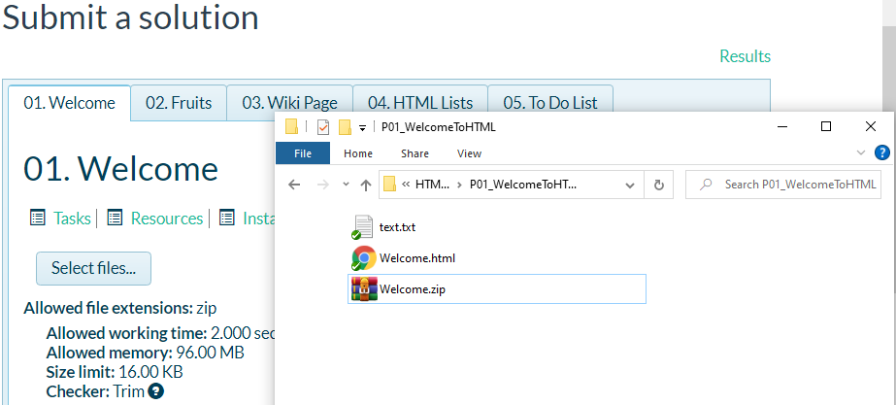

Welcome to HTML
Create a Web Page like the following:
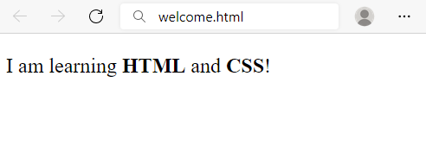
Create file named welcome.html. Use the texts from the file site-texts.txt.

Requirements
- Title: Welcome
- <strong> tag for bold text
- <p> tag for paragraph

Fruits
Create a Web Page like the following:
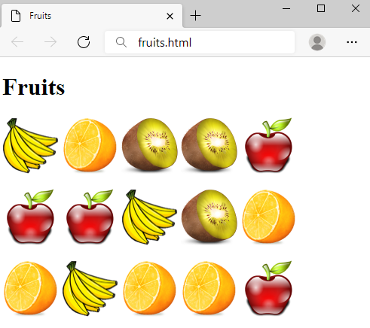
Create a file fruits.html.

Requirements
- Titile: Fruits
- <h1> tag for heading
- <img> tag for images

Hints
- Use 3 paragraphs, each holding 5 images

Wiki Page
Create a Web Page like the following:
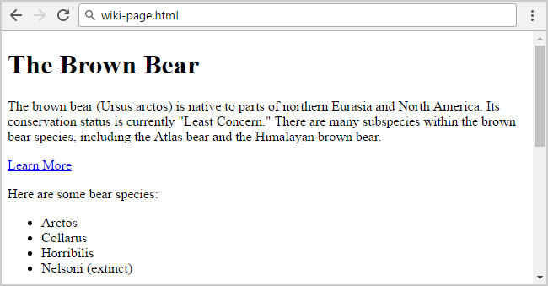
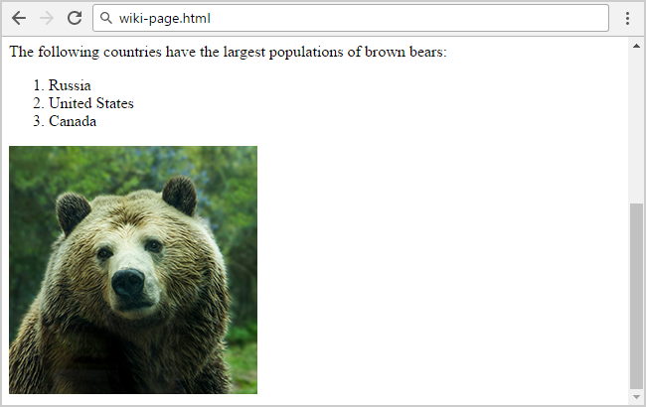
Create file: wiki-page.html. Use the texts from the file site-texts.txt.

Requirements
- Title: The Brown Bear
  - <h1> for heading
- Hyperlink: https://en.wikipedia.org/wiki/Brown_bear
- Text: use paragraph
- List: use ordered list and unordered list
- Image: bear.jpg

To Do List
Create a Web Page like the following:
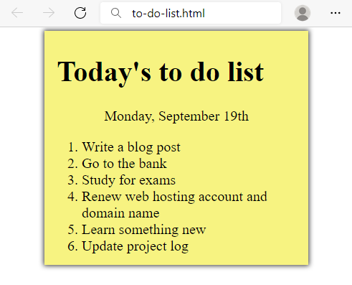
Create two files: to-do-list.html and to-do-list.css. Use the texts from the file site-texts.txt. Use the texts from the file site-texts.txt. Set the html title to be the same as the task name.

Requirements
- <main> with class="my-list" as container
  - Background Color: #f7f381;
  - Padding: 8px 24px;
  - Width: 500px;
  - Text size: 30px;
  - Border: 1px solid #f7f381;
  - box-shadow: 0 0 10px 2px #333333;
- <ol>
  - Margin: 12px;
- <p>
  - Center the text

Hints
- Center the container
- Heading: use <h1>
- Date: use <p> + center it
- List: use <ol>

HTML Lists
Create a Web Page like the following:
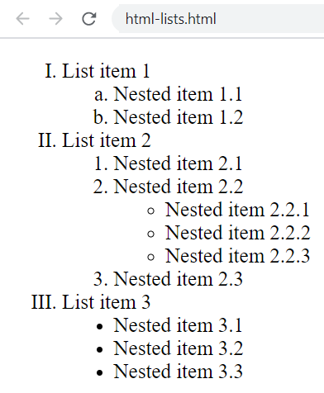
Create file: html-lists.html. Use the texts from the file site-texts.txt. Use the texts from the file site-texts.txt. Set the html title to be the same as the task name.

Hints
Use: <ol>, <ul> and <li>. You need to use nested lists.

Definition Lists
Create a Web Page like the following:
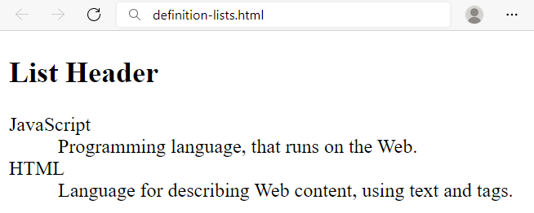
Create a file named definition-lists.html. Use the texts from the file site-texts.txt. Set the html title to be the same as the task name.

Requirements
- <h2> tag for heading
- <dl> + <dt> + <dd> tags for definition list

Reversed List
Create a Web Page like the following:
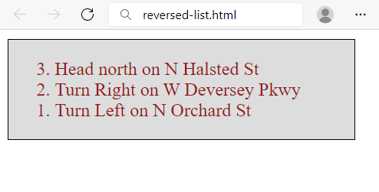
Create two files: reversed-list.html and reversed-list.css. Use the texts from the file site-texts.txt. Set the html title to be the same as the task name.

Requirements
- <main> with id=wrapper as a container
  - Background color: #dddddd;
  - Text color: #95191a;
  - Width container: 300px;
  - Border: 1px solid #000000;

Hints
Use:
- <ol> with reversed attribute
  - <ol reversed="reversed">
- Submit only reversed-list.html + reversed-list.css in ZIP archive file

The Modern JavaScript
Create a Web Page like the following using the texts from site-texts.txt.
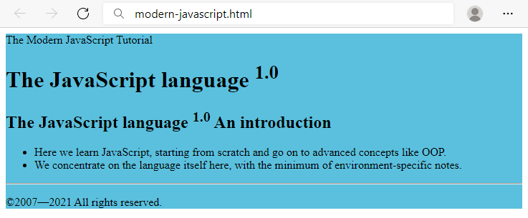
Create two files: modern-javascript.html and modern-javascript.css. Set the html title to be the same as the task name.

Requirements
- <main> with id=wrapper as a container
  - Background color: #5bc0de;

Hints
Use:
- <h1> and <h2> tags for headings
- <sup> tag for superscript text
- <p> tag for paragraphs and <span>
- <ul> tag for list items
- <hr /> for horizontal line
- <footer> tag for copyright part + &copy; for copy right symbol

Book Story
Create a Web Page like the following using the texts from site-texts.txt. Set the html title to be the same as the task name.
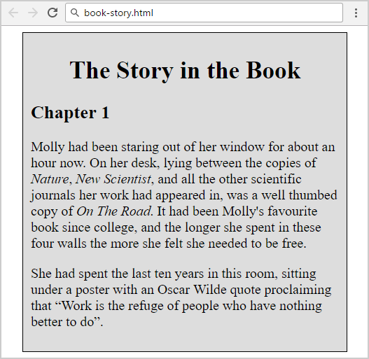
Create two files: book-story.html and book-story.css. Set the html title to be the same as the task name. Set the html title to be the same as the task name.

Requirements
- <main> for the main container
  - Width container: 400px;
  - Background color: #dddddd;
  - Border: 1px solid #000000;
  - Margin Left: 20px;
  - Padding: 10px;
- <p> tag for paragraph + font-size: 18px;
- <em> tag for italic text

Hints
Use:
- <h1> tag for heading + center the text
- <q> tag for quotation text
  - q::before {
content: open-quote;
}
  - q::after {
content: close-quote;
}

World Cup News
Create a Web Page like the following.
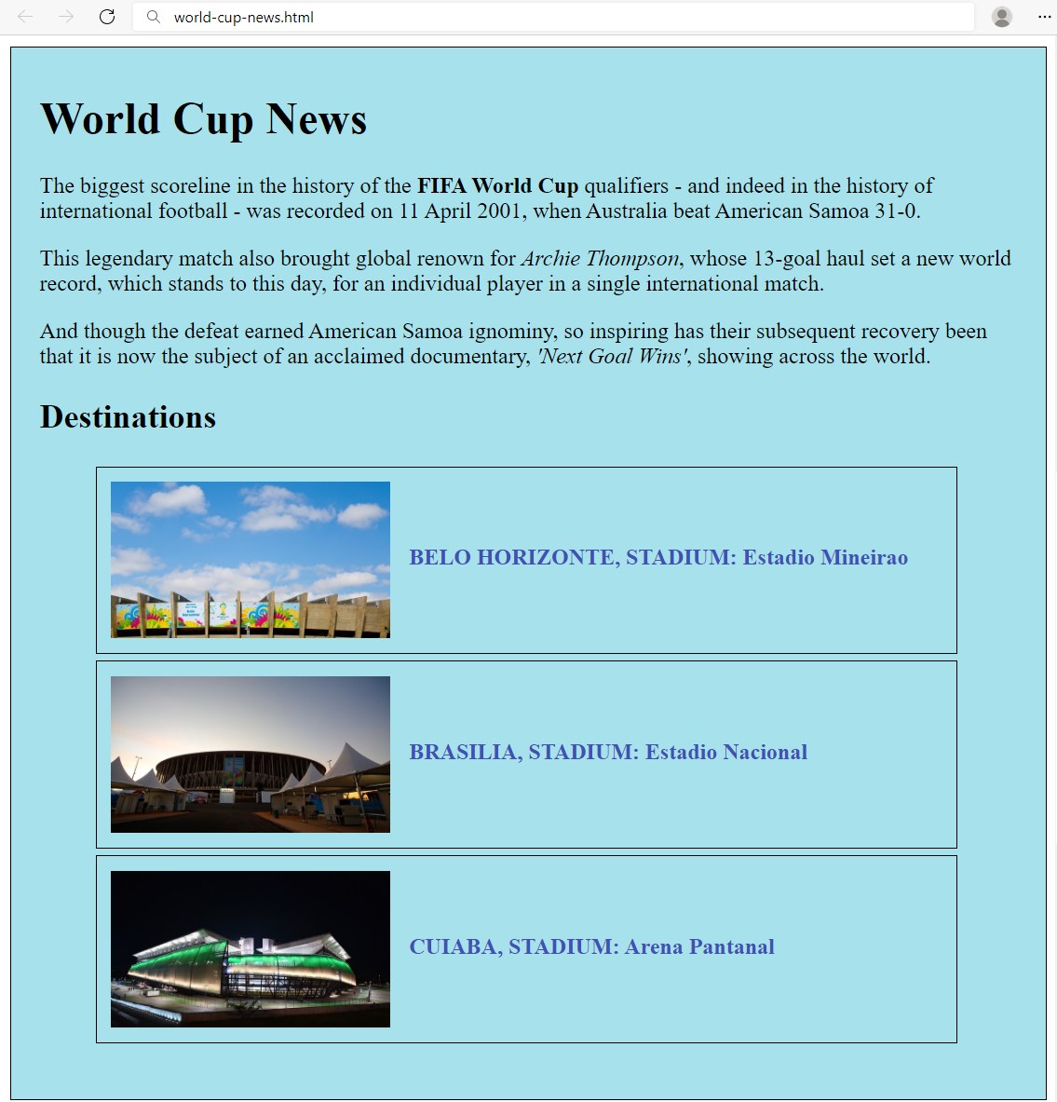
Create two files: world-cup-news.html and world-cup-news.css. Use the texts from the file site-texts.txt. Set the html title to be the same as the task name.

Requirements
- <main> with id= "wrapper" as a container
  - Width container: 700px;
  - Height container: 730px;
  - Border: 1px solid #000000;
  - Center the container
  - Padding: 10px 20px;
  - Background Color: #a6e1ec;
- <h1> and <h2> tags for headings
- <p> tag for paragraph
- <strong> tag for bold text
- <em> tag for italic text
- <img> tag for images
  - Width: 200px;
  - Margin Right: 10px;
  - Vertical Align: middle;
- <span class= "text"> for the text next to images
  - Text color: #3f51b5;
- <li> tag
  - Width: 595px;
  - Padding: 10px;
  - Margin Bottom: 5px;
  - Font Size: 14px;
  - Border: 1px solid #000000;

