Exercise: Position & Grid
Problems for exercises and homework for the "HTML and CSS" course @ SoftUni. Submit your solutions in the SoftUni Judge system at https://judge.softuni.org/Contests/3334/Position-and-Grid.

Simple Site Layout
Create a Web page, holding like the following:
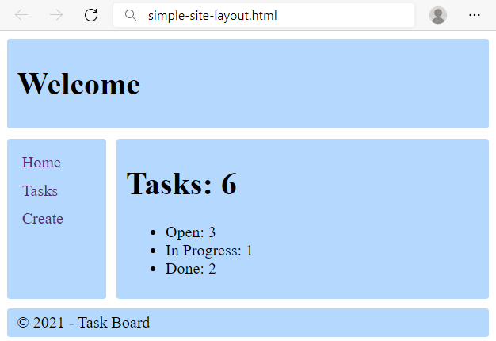
Use the texts from the file site-texts.txt.
Create two files: simple-site-layout.html and styles.css.
Change the document title to "Simple Site Layout"
Requirements
<body> that contains: header, aside, main, footer all with:
- border-radius: 3px;
- background: rgb(181, 216, 255);
- padding: 5px 10px;
The elements into the body:
- <header> with
  - <h1> text that is displayed as inline block and is vertically aligned in the middle;
- <aside> tag that contains:
  - <ul> tag for unordered list
    - list-style-type: none;
    - margin: 0px;
    - padding: 5px;
    - <li> tag for list item
      - <a> tag for hyperlink
        - display: block;
        - padding: 5px 0px;
        - color: rgb(86, 40, 129);
        - text-decoration: none;
- <main> tag that contain:
  - <h1> text title for the tasks
  - <ul> tag with:
    - <li> for the tasks with their status
- <footer> tag that contain:
  - <div> with copyright sign and text

CSS Grid
In the styles.css:
- Make the body grid container by displaying the grid.
- Define two grid columns and their size. 100px for the first column and auto for the second.
- Define the grid areas: header, main, aside, footer.
- Reference the grid areas: "header header", "aside main", "footer footer".
- Set gap: 10px.

Hints
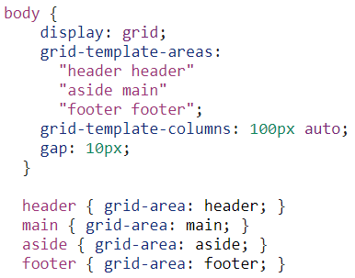

Position Playground
Create a web page like the following:
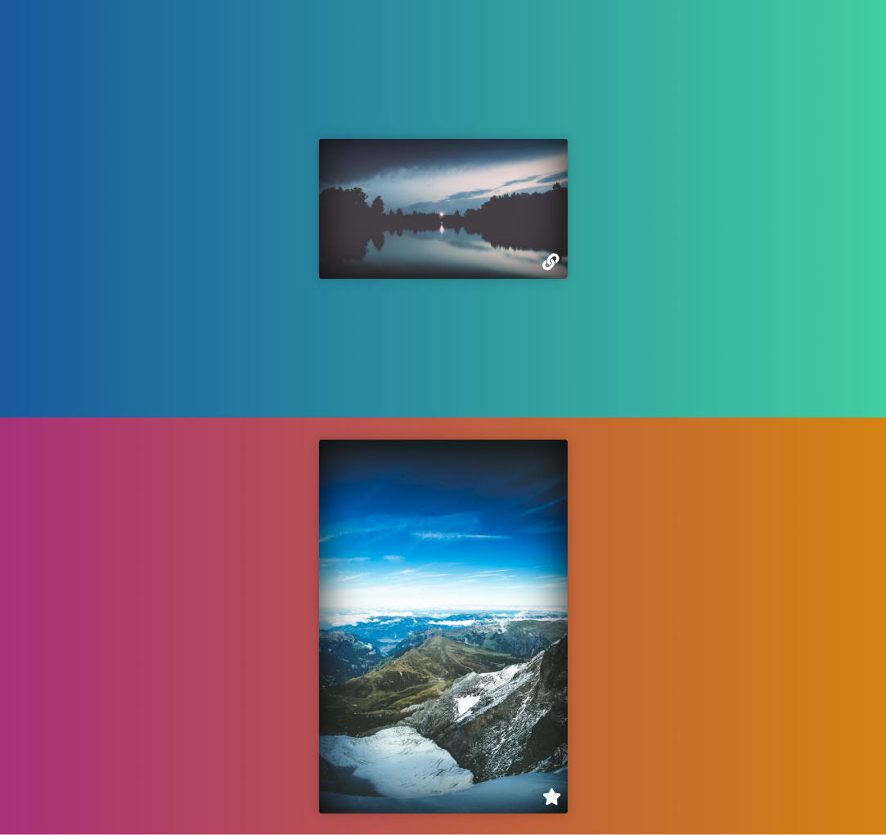
- Change the document title to "Positioning Playground"
- Import Font Awesome into your CSS file
Requirements
- Add two container units (divs) with class viewport inside the body
  - Inside each one adds section with class card (section.card)
    - Change the display property to block
    - Try to center the section with position property absolute

Center Position and Transform
Create a web page like the following:
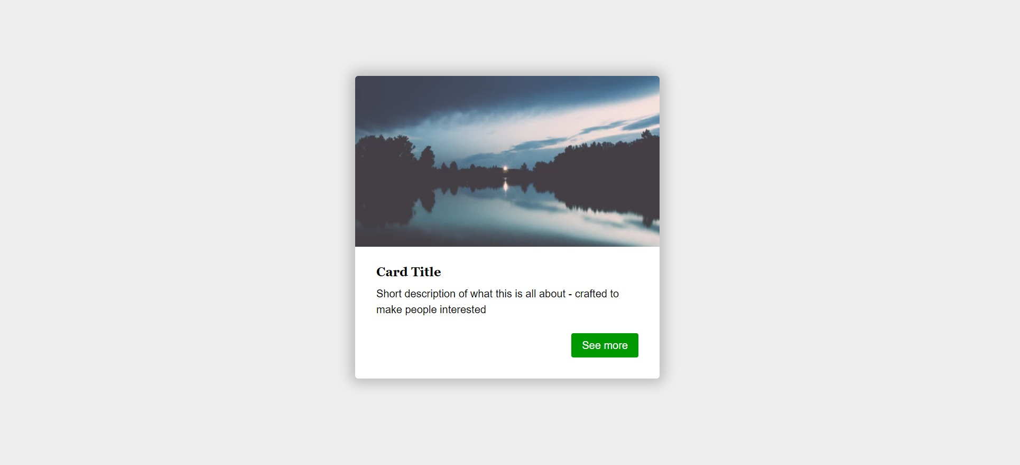
- Change the document title to "Center Position and Transform"
Requirements
- Section tag must have class="card"
- Create section with two divs
  - First div contains image
  - Second div contains: <h3>, <p> and a tags
- Use rgb(238, 238, 238) for body background
- Use rgb(255, 255, 255) for card background
- Use rgb(0, 153, 0) for card button background
- Use font Georgia, serif with size 1em/1.2 for the headings
- Set the image position property to absolute

Navigation
Create a web page like the following:
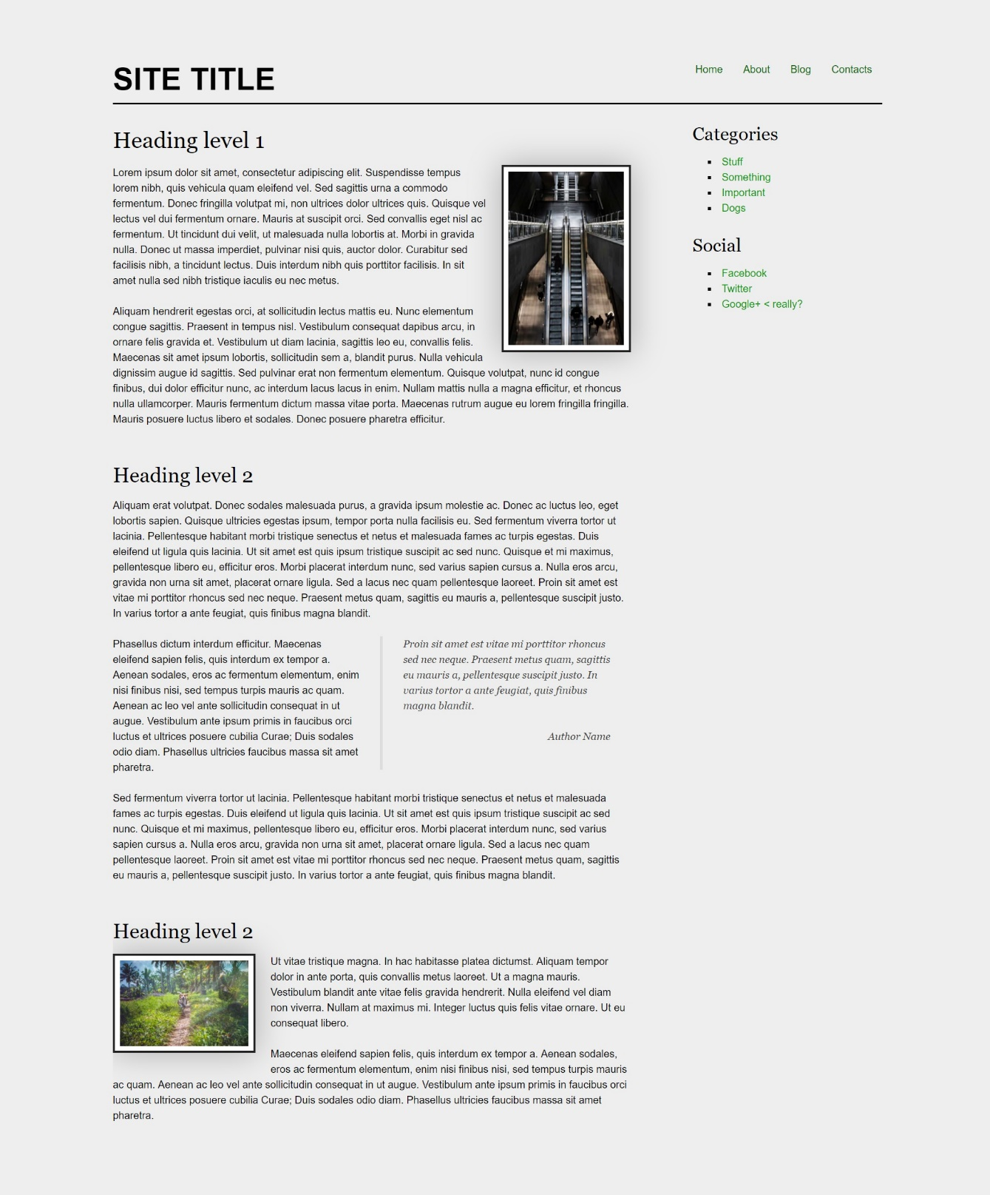
- Change the document title to "Navigation"
Requirements
- Create a header with a p for as title
  - Inside the header add a nav with a ul and 4 li elements
- Create a main, which contains an article with a header and h1 heading
  - Add a section inside the article
- Create an aside element with two sections inside
  - The sections should have a h3 heading and a navigation - nav with ul, li and a elements
- Use rgb(0, 102, 0) for the anchors
- Use rgb(238, 238, 238) for body background
- Use rgb(255, 255, 255) for image background and rgba(0, 0, 0, 0.25) for image box shadow
- Use font Georgia, serif for the blockquote
- Use font Georgia, serif with size 1em/1.2 for the headings

New Offer
Create a web page like the following:
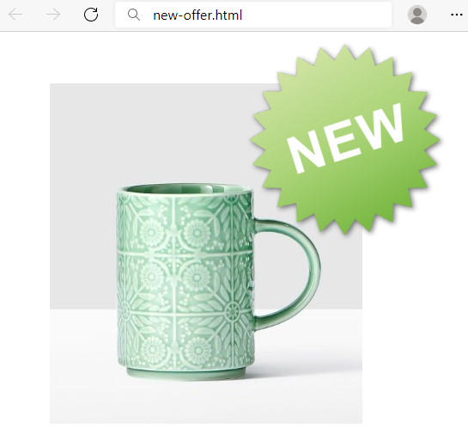
Requirements
HTML with <body> that contains <main> and two <img>.
<img> with new.png need class="new".
CSS:
- <main>:
  - Width: 700px
  - Height: 500px
  - Margins: 60px
- img.new:
  - Relative position
  - Top coordinates: -200px
  - Right coordinates: 150px

Social Media Icons
Create a web page like the following:

- Change the document title to "Social Media Icons"
- Use FontAwesome to add social icons
Requirements
- All you need for your HTML are ul, li and a tags
- Change the ul display property to inline-block
- Remove list items default style
- Each a tag must have border-radius: 50%;
- Check the provided screenshots to see the hover effects

Interior Design Studio
Create a webpage like the following:
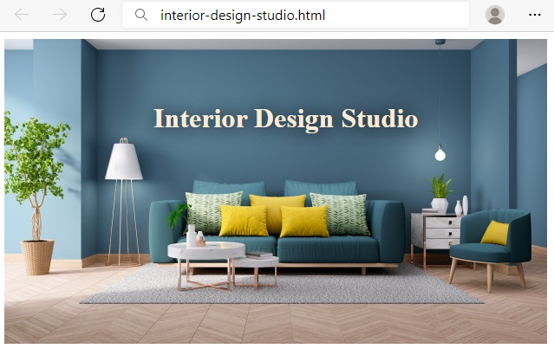
Requirements
HTML with <body> that contains <h1> and <img>.
CSS:
- <h1>
  - Absolute position
  - Top coordinates: 60px
  - Left coordinates: 180px
  - Text color: antiquewhite
  - text-shadow: 1px 1px 20px black;

Jewellery Website
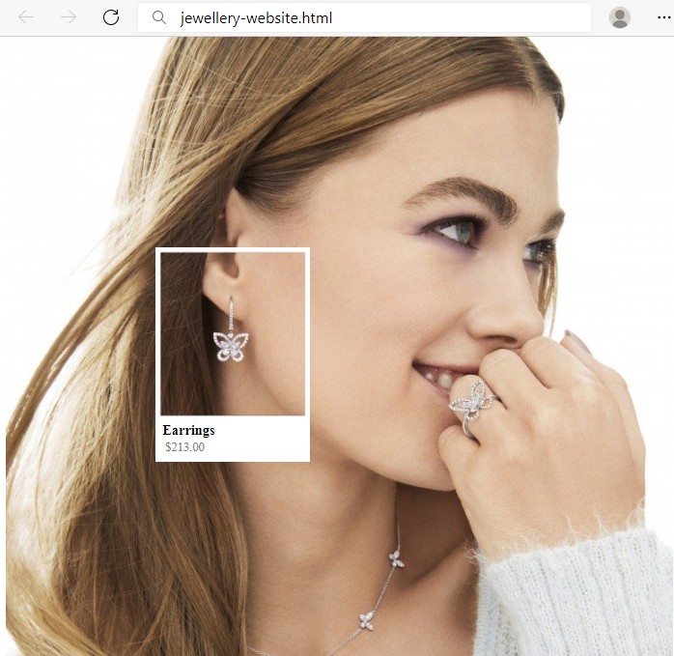
Requirements
You will be given a skeleton with filled HTML and an empty CSS file. Write the missing CSS following the guidelines in the task.
- <section>
  - Set the position to absolute
  - Use the coordinates: 250px and 180px to position the frame correctly
- <h3>
  - Font size: 16px
  - Margin: 0px
- <span>
  - Padding left: 3px
  - Text color: gray
  - Font size: 14px
- <div>
- Set the position to relative
- Use the coordinates: 50px and 8px to position the text correctly

