VELLORE INSTITUTE OF TECHNOLOGY, VELLORE
SCHOOL OF COMPUTER SCIENCE AND ENGINEERING

BCSE307P – COMPILER DESIGN LAB
PROJECT REPORT

Learned Spill Heuristics: A Machine Learning Approach to Register Allocation in Compiler Backends

Submitted by
Shaurya Sood - 24BCT0279
Parth – 24BCE0913

Under the guidance of
Nithya K,
Assistant Professor Senior Grade II

OCTOBER, 2026

BONAFIDE CERTIFICATE
This is to certify that the project work titled Learned Spill Heuristics: A Machine Learning Approach to Register Allocation in Compiler Backends is a bonafide record of work carried out by Parth(24BCE0913) and Shaurya Sood (24BCT0279), submitted in partial fulfilment of the requirements for the course BCSE307P – Compiler Design Lab, School of Computer Science and Engineering, VIT Vellore, during the academic year 2026 - 2027.

Faculty Guide: ________________________________
Date: ________________________________

DECLARATION
We hereby declare that the project report titled Learned Spill Heuristics: A Machine Learning Approach to Register Allocation in Compiler Backends submitted by us to VIT Vellore in partial fulfilment of the requirement for the award of the degree/course BCSE307P – Compiler Design Lab is a record of bona fide work carried out by us under the supervision of Nithya K. The contents of this report, in full or in part, have not been submitted to any other institute or university for the award of any degree or diploma.

Place: ________________________________
Date: ________________________________

[Signatures of all team members]

ABSTRACT
This project investigates whether machine learning can improve spill-candidate selection in graph-coloring register allocation. It implements a pipeline for three-address code (TAC) with assignments, arithmetic, print operations, branches, and loops. The system performs liveness analysis, builds an interference graph, and compares a classical optimistic graph-coloring allocator with an allocator whose random-forest regressor predicts the static pseudo-load/store cost of spilling a value. The model uses interference degree, live-range length, use frequency, and definition frequency; its training labels are measured by the spill-rewrite pass. The benchmark uses three fixed seeds, with 240 training and 60 held-out programs per seed, evaluated at two, three, and four registers. Across seeds, the learned allocator slightly reduces mean spill counts and added pseudo-TAC instructions, but takes about 22 ms per allocation decision versus about 0.06-0.08 ms for the classical allocator. Allocation constraints and rewritten-program output equivalence pass for the evaluated corpus. These results support a small, reproducible improvement in static rewrite overhead on generated TAC, not a claim of faster native execution or production readiness.

TABLE OF CONTENTS
Abstract
Chapter 1 – Introduction: Background; Problem Statement; Objectives & Novelty
Chapter 2 – Literature Survey: Existing Systems / Related Work; Research Gap
Chapter 3 – System Design: Proposed Architecture; Module Description; Implemented Phases
Chapter 4 – Implementation Details: Evidence; Current Progress and Challenges; Conclusion and Future Enhancements
References

CHAPTER 1

INTRODUCTION

1.1 Background
Register allocation maps temporary values to a limited number of processor registers. Values that are simultaneously live cannot share a register; the interference graph represents these conflicts, and graph coloring assigns registers as colors. If the graph cannot be simplified with the available number of registers, a spill candidate is selected and its value is represented in memory. Spill choices can add loads and stores. This project compares a hand-designed classical spill-cost heuristic with a learned estimate based on measured spill-rewrite operations.

1.2 Problem Statement
The project asks whether a model trained to predict the static rewrite cost of spilling a variable can improve spill choices over a classical optimistic graph-coloring baseline. It measures spill counts, added pseudo-TAC instructions, and allocator decision time on held-out generated programs. It also checks that allocations respect interference constraints and that rewriting preserves interpreted program output.

1.3 Objectives & Novelty
• Parse TAC programs with assignments, arithmetic, branches, and loops.
• Compute liveness over control-flow successors, including loop back-edges.
• Build an interference graph and implement optimistic simplify-and-select allocation.
• Extract degree, live-range length, use frequency, and definition frequency.
• Generate separate training and held-out corpora across fixed random seeds.
• Train a Random Forest regressor on spill load/store counts measured by rewriting.
• Compare spill counts, added TAC instructions, and allocation decision time for 2, 3, and 4 registers.
• Validate register assignments and compare original and rewritten TAC outputs.
• Present cross-seed and per-program results in a React dashboard.
Contribution: an end-to-end, reproducible experiment that trains against measured spill-rewrite overhead and evaluates the learned and classical policies on separate held-out programs. It does not claim a new graph-coloring algorithm or a production compiler.

CHAPTER 2

LITERATURE SURVEY

2.1 Existing Systems / Related Work
Graph-coloring register allocation models simultaneously live values as adjacent vertices that must receive different registers. Chaitin established a foundational graph-coloring formulation [1], and Briggs, Cooper, and Torczon developed optimistic coloring for handling graphs that cannot be fully simplified using the low-degree rule alone [2]. Standard compiler texts and teaching materials cover register allocation, liveness, interference, and spill decisions [3], [5]. MLGO is a published example of using learned policies in compiler optimization [4]. These works provide context for this project, which focuses on learning a spill-cost estimate within an explicit graph-coloring allocator.
The project uses supervised regression for a narrower decision: estimating the spill-rewrite cost of a candidate. Unlike a classifier trained to imitate the classical allocator, the current model predicts a numeric target measured by applying the spill-rewrite pass to training variables. The target is the number of pseudo-load and pseudo-store instructions inserted. Model validation measures prediction of this target; the held-out allocator comparison measures whether candidate ordering improves allocation outcomes.

2.2 Research Gap
A model can fit its training target accurately without improving the allocator. This project addresses that gap by evaluating spill choices on programs excluded from training, over multiple seeds and register limits. It reports both allocation outcomes and model inference time, and validates rewritten-program semantics. The measured target is still a static pseudo-instruction count, so results do not establish lower native-code size or faster program execution.

CHAPTER 3

SYSTEM DESIGN

3.1 Proposed System Architecture
Overall workflow:
Generated TAC → parser and control-flow structure → liveness analysis → interference graph → feature extraction → classical or learned graph coloring → spill rewriting → allocation and semantic checks → benchmark CSV summaries and dashboard data.
The model-training workflow is separate:
Training TAC → per-variable feature extraction and spill rewrite → measured pseudo-load/store labels → grouped validation by program → Random Forest regression model → learned allocator evaluated on held-out TAC.
The Python prototype supports a defined TAC subset and provides interpreted semantic checks. It does not emit native machine code or integrate with LLVM or GCC. The React frontend presents generated benchmark reports; it does not run training or allocation itself.

3.2 Module Description
• TAC parser and control flow (src/tac_parser.py): reads supported operations, conditional branches, labels, jumps, and loop back-edges.
• Liveness analysis (src/liveness.py): computes use/definition sets and solves live-in/live-out over control-flow successors.
• Interference graph (src/interference.py): connects values whose live ranges overlap.
• Feature extraction (src/features.py): computes degree, live-range length, use frequency, and definition frequency.
• Classical allocator (src/classical_allocator.py): uses an optimistic simplify/select graph-coloring policy with a hand-designed spill cost.
• Corpus and dataset generation (src/generate_programs.py, src/dataset.py): generates varied TAC and labels each training variable with measured spill-rewrite instruction count.
• Model training (src/train_model.py): validates by program group, refits a Random Forest regressor on training data, and saves the model.
• Learned allocator (src/ml_allocator.py): ranks spill candidates by predicted static rewrite cost while retaining graph coloring for assignments.
• Spill rewriting and TAC interpreter (src/spill_rewrite.py): inserts pseudo-load/store operations and compares rewritten outputs with original outputs.
• Validation, benchmarks, and dashboard (src/validate_allocator.py, src/evaluate.py, src/run_benchmarks.py, src/export_dashboard_data.py, web/): checks allocations, writes per-program and cross-seed reports, and presents results in the React frontend.

The implemented phases form an experimental register-allocation pipeline rather than a complete compiler backend.
1. Input and control-flow parsing: TAC is parsed into instructions with labels, branches, jumps, and loops.
2. Liveness analysis: use/definition information is propagated to a fixed point across control-flow edges, including loop back-edges.
3. Interference construction: simultaneously live values are connected in the interference graph.
4. Feature and target generation: four variable features are extracted; training targets are obtained by counting pseudo-load/store operations from spill rewriting.
5. Model training: a Random Forest regressor is validated using program-grouped splits, then fit on the full training corpus.
6. Allocation and spill rewriting: the classical and learned spill-candidate orderings are evaluated for 2, 3, and 4 registers; selected spills are rewritten with pseudo-memory operations.
7. Validation and reporting: graph constraints and rewritten outputs are checked; benchmark summaries are exported to CSV and JSON for the React dashboard.

CHAPTER 4

IMPLEMENTATION DETAILS

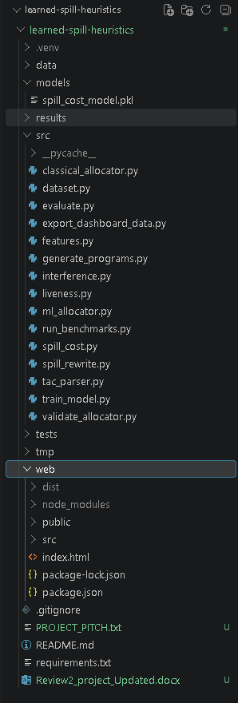
Figure 1: Current project structure showing the compiler analysis, spill-rewrite, benchmark, and React dashboard components.

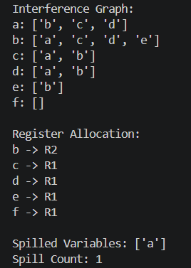
Figure 2: Example interference graph and classical register assignment, with one value selected for spilling.

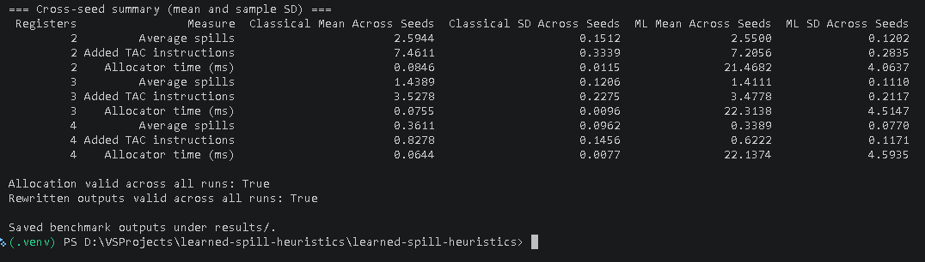
Figure 3: Cross-seed benchmark means and standard deviations, with allocation and rewritten-output checks passing across all runs.

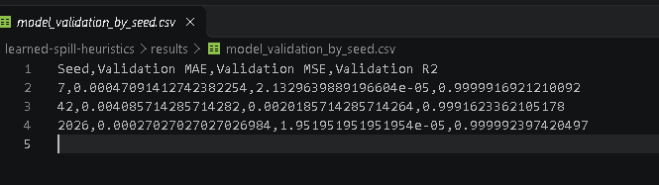
Figure 4: Grouped model-validation metrics (MAE, MSE, and R-squared) for seeds 7, 42, and 2026.

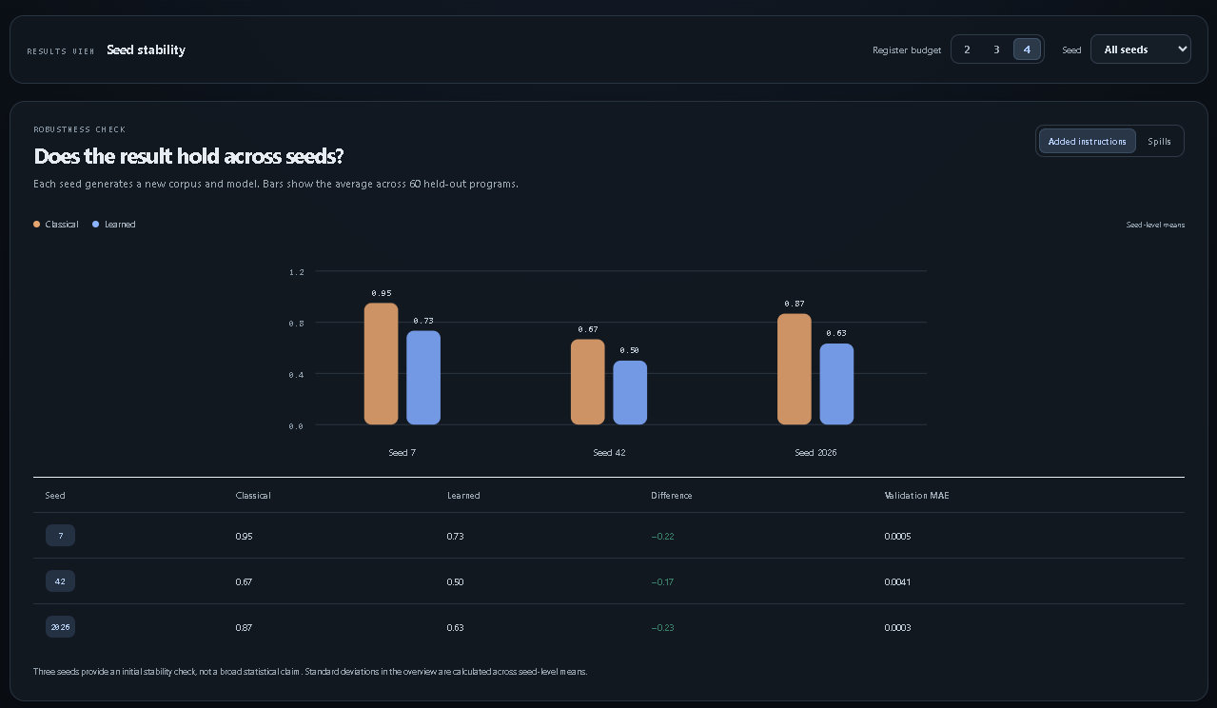
Figure 5: Seed stability comparison of added TAC instructions at four registers across three seeds, using 60 held-out programs per seed.

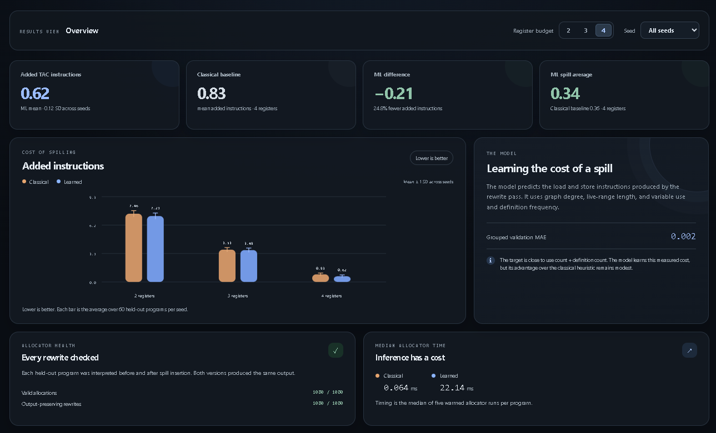
Figure 6: Dashboard overview at four registers, showing cross-seed instruction overhead, allocator timing, and validity totals.
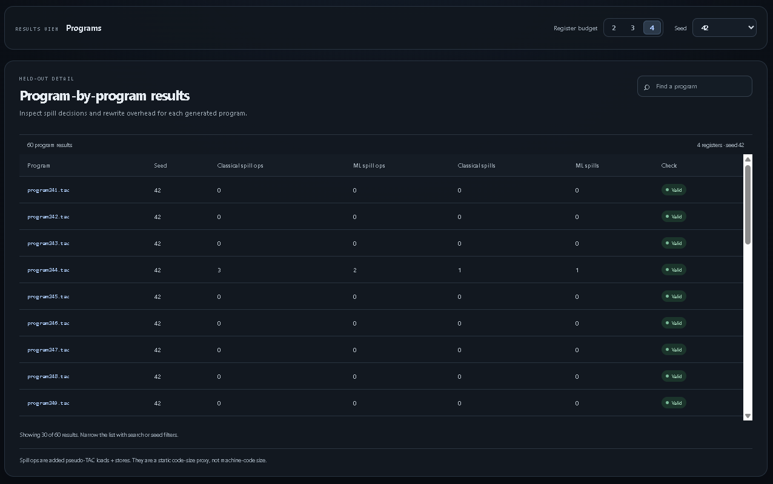
Figure 7: Held-out per-program results for seed 42 at four registers, including spill counts and allocation validity.

Completed:
• TAC parsing, control-flow liveness, interference construction, and optimistic graph-coloring allocation.
• Random Forest regression trained on measured pseudo-load/store rewrite counts for four variable features.
• Three fixed seeds, each with 240 training and 60 held-out generated programs; evaluation at 2, 3, and 4 registers.
• Spill rewriting and TAC interpretation for output-equivalence checks, in addition to allocation validation.
• React dashboard with Overview, Seed stability, and Programs views, backed by exported benchmark data.
Current cross-seed means (classical / learned):
For k = 2: spills 2.5944 / 2.5500; added TAC instructions 7.4611 / 7.2056; allocator time in ms 0.0846 / 21.4682.
For k = 3: spills 1.4389 / 1.4111; added TAC instructions 3.5278 / 3.4778; allocator time in ms 0.0755 / 22.3138.
For k = 4: spills 0.3611 / 0.3389; added TAC instructions 0.8278 / 0.6222; allocator time in ms 0.0644 / 22.1374.
All recorded allocation-validity and rewritten-output checks pass. The learned policy modestly reduces static spill overhead but has a substantially higher decision time. The regressor's grouped validation R-squared exceeds 0.999 for each seed; this measures fit to the generated rewrite-cost target, not program speed.

Challenges and limitations:

• Benchmarks are synthetic and use a defined TAC subset; the project is not a production compiler or LLVM/GCC integration.
• Added pseudo-TAC instructions are a static spill-overhead proxy, not native code size, dynamic spill traffic, or execution time.
• The learned allocator averages about 22 ms per allocation in this Python prototype, compared with about 0.06-0.08 ms for the classical baseline.
• High regression validation scores only show prediction of generated spill-rewrite labels; they do not establish generalization to real workloads.
• Results do not include machine-code generation, target-specific register constraints, or runtime measurements.

REFERENCES
- G. J. Chaitin, “Register Allocation & Spilling via Graph Coloring,” Proceedings of the ACM SIGPLAN Symposium on Compiler Construction, pp. 98–105, 1982.
- P. Briggs, K. D. Cooper, and L. Torczon, “Improvements to Graph Coloring Register Allocation,” ACM Transactions on Programming Languages and Systems, vol. 16, no. 3, pp. 428–455, 1994.
- A. V. Aho, M. S. Lam, R. Sethi, and J. D. Ullman, Compilers: Principles, Techniques, and Tools, 2nd ed., Pearson, 2006.
- Y. Qian, M. Trofin, E. Brevdo, Z. Lin, K. Choromanski, and D. Li, "MLGO: A Machine Learning Framework for Compiler Optimization," Google Research Blog, 2022. [Online]. Available: https://research.google/blog/mlgo-a-machine-learning-framework-for-compiler-optimization/
- M. Rinard and S. Amarasinghe, "Register Allocation," Lecture Notes, 6.035 Computer Language Engineering, MIT OpenCourseWare, Fall 2005. [Online]. Available: https://ocw.mit.edu/courses/6-035-computer-language-engineering-sma-5502-fall-2005/1e4d5a57621a64b308ddb52e61cff46c_13_registeralloc.pdf

