**Tutorial for TipTracker evaluation scripts**

*Siqi Tian, Nov 2014*

**Procedures**

1. Load the saved .mat workspace file. For example, use:

cd ~/Documents/MATLAB/20140919_002_MCAK;

load('roi_1/meta/projData.mat');

It is recommended to stay in the current working directory while running the scripts, i.e. MATLAB/20140919_002_MCAK. You should see a variable named projData in your current MATLAB session if the loading is successful:

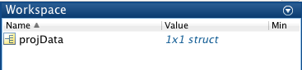

1. Use plots_custom to visualize the results.

This script takes all the (x, y) coordinates, calculates the speeds and distances of each track between each 2 neighboring frames, calculates the averaged speed and displacement (total) of each track over all frames, and reports life time span (number of frames) of each track.

* 1. Arguments needed as input:
     1. (x, y) coordinates of each track at each frame. These are available in projData.mat;
     2. Microscopy parameters: seconds per frame, and pixel size. Default is set to 5 seconds per frame and 150 um/pixel.
  2. An easy hands-on would be just type the following

plot_customs(projData.xCoord, projData.yCoord, projData.secPerFrame, projData.pixSizeNm);

* 1. For advanced usage, all calculation results can be pulled out. Use help plots_custom for full details.

[vel_all, vel_means, dist_all, dist_sum, life_times] = plot_customs(projData.xCoord, projData.yCoord, projData.secPerFrame, projData.pixSizeNm);

There will be 5 figures displayed on the screen, and they are automatically saved to Figures/ folder for future reference.

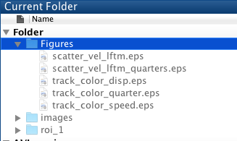

1. **Figure 1** (scatter_vel_lftm.eps) is a scatter plot of speed vs. lifetime for all the tracks identified. Data points are classified into 4 categories by mean speed and mean lifetime.

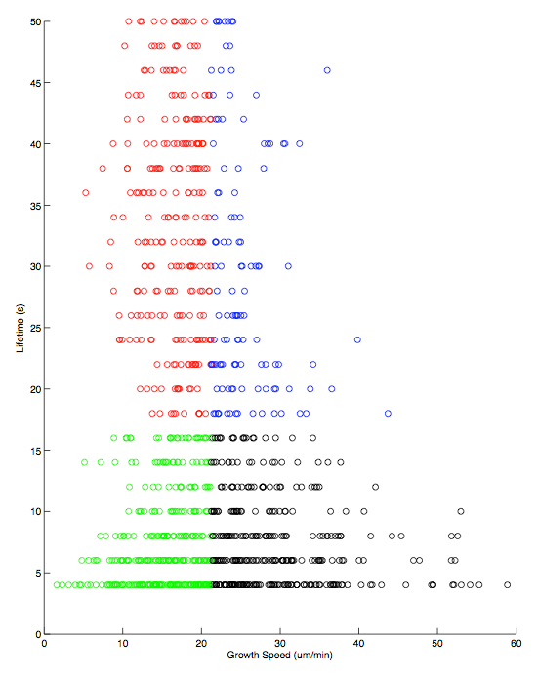

Quarters are color coded by red, green, blue and black.

1. **Figure 2** (scatter_vel_lftm_quarters.eps) separates all tracks into 4 panels according to the classifier of **Figure 1**, and have the traces of all tracks drew in 2D space. Color is same as **Figure 1**, and the x,y-axes are same as original images.

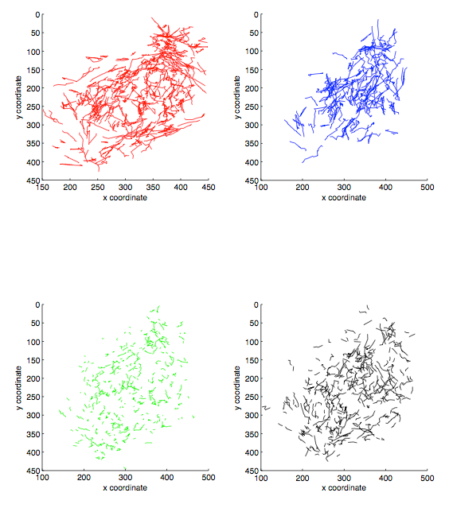

1. **Figure 3** (track_color_quarter.eps) plots all tracks in one panel using same color code as **Figure 1&2**. It’s basically overlaying all 4 panels from **Figure 2**.

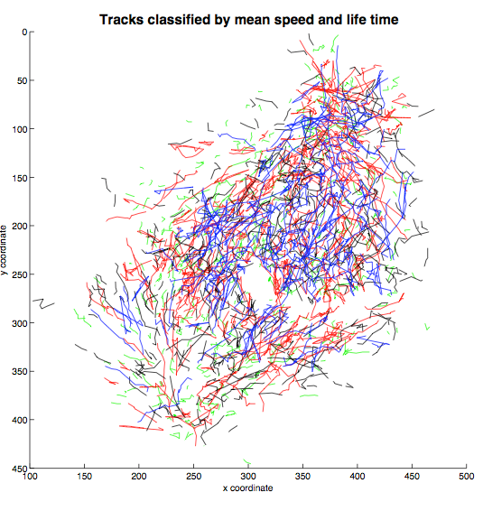

1. **Figure 4** (track_color_speed.eps) plots all tracks in on panel, using speed as color code. The color is scaled from min (blue) and max (red) of all observed speeds in the dataset. Each interval is colored independently and is not averaged.

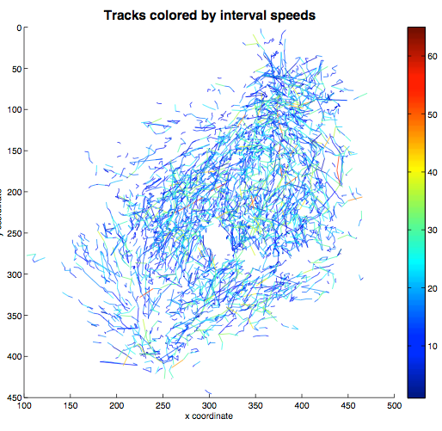

1. **Figure 5** (track_color_disp.eps) plots all tracks in on panel, using displacement as color code. The color is scaled from min (blue) and max (red) of all observed displacements in the dataset. Each track is plotted as one trace using its total displacement.

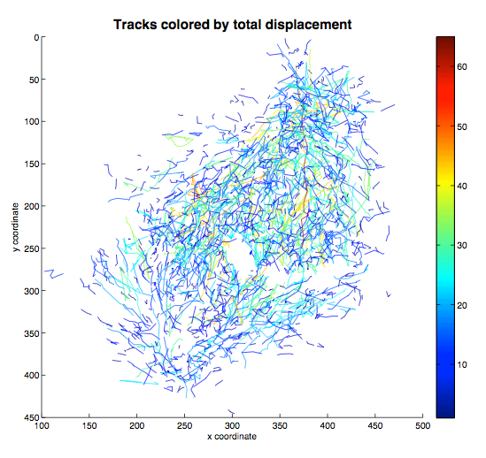

1. Use check_tracks to manually evaluate tracking quality.

This script randomly pick a number of tracks from the saved data, and label the picked ones by colored circle in the original movie, enabling manual evaluation of the tracking performance.

6 different tracks will be circled in one movie file with colors {'red','blue','green','yellow','magenta','cyan'}. Movie files named as check_picks_#.avi will be saved to current directory.

* 1. Arguments needed as input:
     1. (x, y) coordinates of each track at each frame. These are available in projData.mat;
     2. Number of tracks to pick. Default is set to 30;
     3. Name of directory of TIFF files. Default is set to ‘images/’ ;
     4. Shape parameters: circle size and movie fps. Default is set to radius of 5 pixels, and 3 frames per second (slow);
     5. Microscopy parameters: seconds per frame, and pixel size. Default is set to 5 seconds per frame and 150 um/pixel.
  2. An easy hands-on would be just type the following

check_tracks(projData.xCoord, projData.yCoord);

* 1. For advanced usage, statistics of picked tracks can be calculated and visualized. This is helpful for comparison between automatic and manual annotations. Use help check_tracks for full details.

To enable this feature, microscopy parameters (section 3.a.v above) are required. Example usage (specifying deltaT and microns, but bypassing others using []):

check_tracks(projData.xCoord, projData.yCoord, [], [], [], [], 5, 150);

For each movie file, there will be a figure displayed on the screen, and automatically saved to Figures/ folder for future reference.

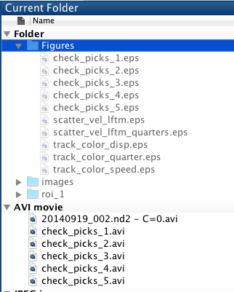

In this figure, the 1st panel plots the speed of picked tracks (total of 6) over all frames in their corresponding color in the movie. The 2nd and 3rd panels display their averaged speed over all frames, and their life time span, respectively.

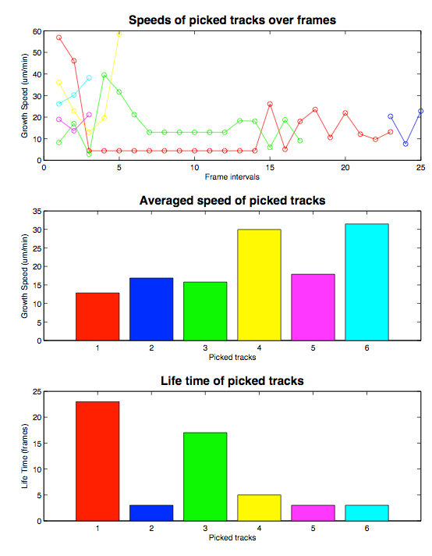

**Notes:**

1. Due to video quality, the contrast and brightness of output video files are adjusted. It makes the tips easier to see, but also increases the overall background noise level.