AWS - Amazon Web Services
Solution Architect - Associate
Study Notes by Ahmed T

Overview
Cloud Computing | On-demand delivery over the Internet of IT resources with pay-as-you-go pricing  Advantages:  Trade CAPEX for OPEX  Benefit from Economies of Scale  No need to predict capacity requirements  Go global in minutes (leverage regions)  Agility to apply changes to environment  No money spent on running and maintaining a data center
CAF - Cloud Adoption Framework | Provide guidance and support for organizations to move to cloud  Perspectives:  Business  People  Governance  Platform  Security  Operations
History of AWS | 2003 – Paper by Chris Pinkman and Benjamin Black about SQS  2004 – Launch of SQS  2006 – Launch of AWS  2007 – Launch of EC2 and 108,000 developers signed on  2012 – First Re:Invent conference  2013 – Introduction of certifications  2020 – Renewable energy to power all AWS data centers worldwide
Global Infrastructure | Data Center (DC): is the facility that houses the servers, storage devices, network elements, security devices, and other AWS infrastructure. No AWS DC is "cold". All devices are ODM - Original Design Manufacturer, which is custom for AWS. AWS even uses their own network protocol stack.  Availability Zone (AZ): made up of one or more DCs, exist within a region, are representations of physically seperated data centers with low latency, private links between them. Designed for fault isolation and no single points of failure. All AZs are connected with redundant links to multiple Tier-1 transit providers.  Regions: geographical areas where Amazon data centers are located and represents the georgraphical location of where the data will reside. Made up of two or more AZs. Communication between regions uses the AWS backbone, a private global network. The public regions are listed in the console, then there are private regions (e.g. US GovCloud) and local regions (e.g. Asia Pacific Osaka that are not listed.  As of June 2018, there are 18 regions worldwide and 55 AZs. There are 4 new regions and 12 AZs that are announced.  Edge Locations  AWS has 107 Points of Presence (PoPs)  96 Edge Locations and 11 Regional Edge Caches in 55 cities across 24 countries.  These are used for Route53 and CloudFront  Edge Locations is NOT equivalent to a region or an AZ
Business Challenges in IT | Budget, time to market, scalability, infra management, security and compliance
Security | Is a shared responsibility between Amazon and the Admin  Amazon act as a trusted advisor  You have AWS Global Infrastructure (Regions, AZs, Edge Locations) and Foundation Services (Compute, Storage, Database, Networking) at your disposal  AWS caters for  1. Physical security of DCs  2. Hardware infrastructure: servers and storage  3. Software infrastructure: host OS, service apps, virtualization isolation  4. Network infrastructure: routers, switches, LBs, FWs, network monitoring at external boundaries, intrusion detection  You cater for  1. Instance OS including patching and maintenance  2. Application security and access  3. Security groups  4. OS/Instance firewalls including IDS and IPS  5. Network configuration (of VPC)  6. Account management and seperation of delegation  7. User data: client/server side encryption
High Availability vs Fault Tolerance | HA: Always serves purpose despite failure of elements  FT: still operates at stable capacity and without any performance degredation  HA and FT: DynamoDB and Route53  HA only: EC2 and S3  Example: Your app needs 6 instances for stable performance, how do you achieve HA and FT?  Answer: run 6 instances in each of at least two different AZ's
Managed vs Unmanaged Services | Managed Services: HA and FT are responsibility of AWS  e.g. DynamoDB and Route53  Unmanaged Services: HA and FT are the responsibility of the Admin
Disaster Recovery | Policy is a Cost vs Risk activity of RTO and RPO  Backup & Restore  Pilot Light: replicated VM are in other AZ/region but are powered off, DB is being mirrored  Warm Standby: replicated online environment but with lower capacity, DB is being mirrored  MultiSite: active-active configuration of equal capacity
Support Plans | Basic: 7 core Trusted Advisor health checks  Developer: business hours access to Cloud Support Associates via email, 7 core Trusted Advisor health checks  Business: 24x7 access to Cloud Support Engineers via email, chat & phone, Full set of Trusted Advisor health checks  Enterprise: 24x7 access to Sr. Cloud Support Engineers via email, chat, and phone, Full set of Trusted Advisor health checks
Billing | Cost Explorer: graph, visualize, and analyze your spending.  Budgets: create custom budgets with automated alerts for usage, forecast, and thresholds  Reports: detailed data to better analyze where the costs are per AWS service  Cost Allocation Tags: has to be activated, is associated with AWS service and can be tracked throughout the billing pipeline  Simple Monthly Calculator: http://calculator.s3.amazonaws.com/index.html
Summary

RTO - Recovery Time Objective
How quickly will the systems recover?
RPO - Recovery Point Objective
How much data can you afford to lose?

Compute
EC2 - Elastic Cloud Compute | Virtual computing environment (instances) that you can launch and manage from a GUI or from CLI code  Supports most OS (Windows, RedHat, SUSE, Ubuntu, Amazon Linux)  Instances are scalable and optimizable  Consider the following before you create: core count, memory size, storage size and type, network performance, and CPU architecture  Pricing Models  1. On-demand: pay as you go compute resources. Low cost, flexible.  2. Spot instances: bidding on instances based on supply/demand, pay the price per instance-hour set at the start of each instance-hour for the entire hour (spot price). Gives 2 minute prior notification before stopping an instance for someone with a higher bid. Good for large scale, dynamic workloads.  3. Reserved instances: full upfront, partial upfront, and no upfront payment options for 1 and 3 year contract durations. Good to predict costs and know available capacity needed.  4. Dedicated Host: you rent the underlying hardware, single-tenancy model, pay hourly, can be upto 75% cheaper than on-demand. You can control licensing. Good for compliance and regulatory requirements.  Per Second Billing:  Minimum increment is 60 seconds, so even if you run for 10 seconds, you will be charged for 60  Available for On-Demand, Reserved, Spot instances, all regions and AZs, only on Amazon Linux and Ubuntu. Everything else is per-hour.
AMI – Amazon Machine Image | An image of your EC2 instance OS and application configuration  Selection of operating systems with pre-installed software packages  Regional specific object with an AMI-ID that is unique within a Region  To replicate, copy snapshot to S3, move regions, create AMI from snapshot (gives different ID)  AMI's exist on S3
Instances | Instance Families: Gen purpose, etc..,  Type: T2  Class: Micro  EBS Optimized  Network Performance optimized  Choosing the correct instance type will help with your application performance  Limit: 20 instances per account
C5 Instances | Use the latest Intel Skylake  Optimized for compute-instensive workloads and for EBS  Use Cases:  High performance web servers  Scientific modeling  Batch processing  Distributed analytics  High-performance computing (HPC)  Machine/deep learning  Ad serving  Multiplayer gaming  Video encoding
H1 Instances | Optimized for storage-instensive workloads (magnetic disk)  For applications that require low-cost, high disk throughput and high sequential disk I/O access to large data sets  Use Cases:  MapReduce  Distributed file systems (HDFS, MapR-FS)  Network file systems  Log or data processing apps (Kafka)  Big data workloads
F1 Instances | Gives direct access to FPGA hardware  For custom hardware accelerators using FPGA algorithms
R4 Instances | For memory intensive applications  Economical price per GB of RAM
T2 Instances | Baseline of CPU performance with ability to burst  For workloads that don't use full CPU often
I3 Instances | Non-Volatile Memory Express (NVMe) SSD backed instanced  Low latency and high random I/O performance, high sequential read throughput  High IOPS at a low cost  3.3 millions random IOPS at 4-KB block size, 16 Gbps disk throughput
Tagging | Always TAG instances in order to keep management and administration simple
Lambda | Event driven or scheduled functions that interact with AWS services  Functions written in different languages (e.g. Python)  Limits on functions: 3GB memory, 5 minute runtime  Charged on count of function invokes  Usually run within a single region, can also be invoked within a VPC to run a private function  Can also be used with IAM rules
Meta-Data | #curl http://169.254.169.254/______  Can find all details about your instance via running the curl command on the instance CLI  2-min spot notification is sent here, so you have to constantly poll thid directory  Here you can also find the Public IP of your instance (instead of going through the console)
Summary
Reserved Instances: is just a billing scheme, can purchase at Region Level or at AZ level, Regional level is better because if you buy an xlarge instance then you can run 2 large ones. Also can do a "Scheduled" Reserve i.e. 1 year reserved, compute between 01:00 and 03:00. Halfway towards serverless. You can re-sell your instances in the AWS marketplace if you don't need them anymore but the contract didn't expire. You can upgrade your reserved host model.

Spot instance hibernation:
You can basically pause an EBS backed instance, resumed by the Spot service when your defined max price is less than the Spot price. Crucial to have a hybernation agent and to have an encrypted Root volume. Instance memory is stored on the root volume when hybernated

Enhanced Networking: We currently support enhanced networking capabilities using SR-IOV (Single Root I/O Virtualization). SR-IOV is a method of device virtualization that provides higher I/O performance and lower CPU utilization compared to traditional implementations. For supported Amazon EC2 instances, this feature provides higher packet per second (PPS) performance, lower inter-instance latencies, and very low network jitter.

Network and Content Delivery
Load Balancers | Application Load Balancer  -> Works at Application Layer, can read the URI in the Request (Layer 7), advanced load balancing of HTTP/S traffic and containers  Network Load Balancer  -> makes decisions based on TCP/IP Layer (Layer 4), uses a single static IP (and DNS name) per AZ. Can handle millions of requests per second at extremely low latencies  Classic Load Balancer  -> legacy methodoly, also works on TCP/IP layer, can have poor performance, if so, you can ask AWS helpdesk to "Pre-Warm" the LB for you
LB Metrics | Search Queue Length  Spill Over Count  Both are used to check if packets are dropped.
EIP - Elastic IP | Public IP address  Limit: 5 per region
ELB - Elastic Load Balancer | A regional specific object that load balances traffic to instances within an AZ, or cross-zone to instances between AZ's  An ELB is referenced by its DNS name. You should use an A Alias to map your own name to it.  Within an ELB, an Elastic Network Interface (ENI) is created that points to an EC2 instance. You configure the instances across AZ's and the ELB can effectively ensure High Availability of your instances.  Target Group: resource pool, logical clustering of instances that serve the same purpose  Features are better than Route53:  High Availability: automatically distributed traffic to multiple targets  Health Checks: can be used to maintain status of instances, and traffic is only routed to healthy targets  Security: can be used with SGs  SSL Offloading: the LB will handle HTTP<-->HTTPS translation and encryption instead of the browser or the server  Sticky Sessions: two methods:-  -> 1. Using cookies to control the user experience  -> 2. Duration based sessions using TTL  Proxy Protocol: aces as a transparent proxy, so the user-data (source IP, etc..) can be sent to the instance  Can work over L4 or L7  Connection Draining: wait until sessions are completed before allowing an instance to de-register from a resouce pool  Can be enabled through the console, API, CLI, or CloudFormation  Limit: 20 ELBs per region, 5 SGs per ELB
Routing Tables | 172.16.0.0/16 local -> private IP's of instances  0.0.0.0/0 default route, Internet Gateway of instances with internet accessible  Main RT: always assumes to be a Private RT with "Local" private route  1. Routing Tables are automatically created upon creation of a VPC  10.0.0.0/16 is added and cannot be modified (Main RT)  All other RTs are more specific in routes than the Main RT  2. Create a subnet and associate it with an AZ  e.g. 10.0.2.0/24  3. Create default route as Internet Gateway  4. Create other Routing Tables to split subnets as PRIVATE or PUBLIC  Associate a subnet with differnet RTs  5. Associate Private Subnet with new RT  6. Add default route from private subnet to a NAT gateway  You can use a NAT instance to temporarily allow a private instance to access the internet for patches, upgrades, etc.  Only allows outbound traffic from private instance  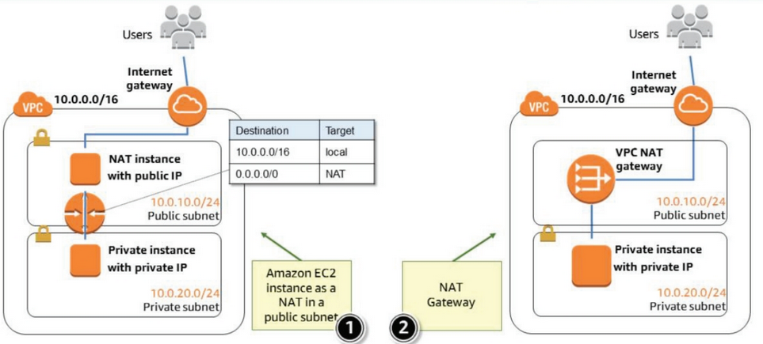
NAT Gateway vs NAT Instance | NAT Gateway  Managed by AWS, highly available, bursts to 10Gbps, no port forward  For NAT Gateway HA, create in each AZ and point resources to it.  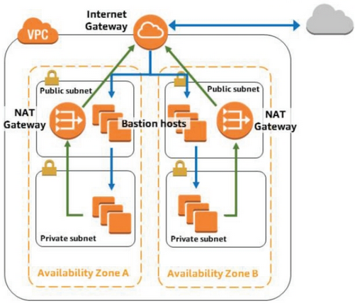  NAT Instance  Managed by you, you design HA, bandwidth based on instance type, can do port forwarding
Auto-Scaling | Launches or terminates instances based on specific conditions  Automatically registers new instances with LBs  Can launch across AZs  Set policy for AutoScalingGroup where instances are created and destroyed based on parameters such as:  Desired count of instances, Minimum and Maximum instance count  One LC corresponds to One ASG.  Correct setup of AutoScalingGroup and LC can protect you from DDoS and high fees ($)  Instance are configured in Launch Configuration (LC) or by custom AMI  Console Status Checks are used to make Auto-Scaling decisions (can be accessed via CloudWatch).  CloudWatch alarms have Auto-Scaling controls built in and can be customized per use case  Launch Configs cannot be altered after creation  Using ASG to manage Software Releases  1. Create a new AMI with your latest application  2. Create new ASG with new LC  3. From LB based on new sessions, switch over ASG's  Make sure to change the ASG "Health Check Type" from "EC2" to "ELB"  Limit: 200 ASGs and 200 LCs per region
Route 53 | Global Object, Tier 0 service  Highly Available and Fault Tolerant service  Can route traffic between regions based on DNS.  Fast: worldwide anycast, fast propagation of changes  Reliable: redundant service, 100% SLA  Can achieve load balancing of traffic based on  1. Simple: standard DNS declarations,  2. Weighted Round Robin: assign weights to resource records  3. Geo-Location: resources served from closest region  4. Geoproximity: route traffic based on physical distance to users  5. Latency: resources served from quickets region  6. Health Check and Failover capability  7. Multivalue answers: gives more than one IP to the client to try  A Record Alias: is a CNAME feature by AWS (URL to URL mapping)  ELB, S3, RDS are all assigned DNS endpoints  Best practice to use A Alias to map them to your own naming convention
VPC - Virtual Private Cloud | Regional level object  A comprehensive set of virtual networking capabilities that allow customers to provision logically isolated virtual network to host AWS resources.  You can create multiple VPCs within the same region and you can include resources in more than one AZ withing a single VPC  You can connect VPCs in different regions to each other without going through the Public Internet  Within a VPC there are multiple subnets that technicall map to the AZ's within the region.  For example, the North Virginia region has 6 AZ's and a default VPC with 6 subnets. You can create new subnets and assign them to be PUBLIC or PRIVATE. The default subnet inside a VPC is publicly accessible.  You configure the following within a VPC:  1. IP Subnets  2. Routing tables - upon creation of a VPC, it is associated with the main RT which has a local route. Instances are associated with the main RT by default.  3. Gateways  4. Security settings  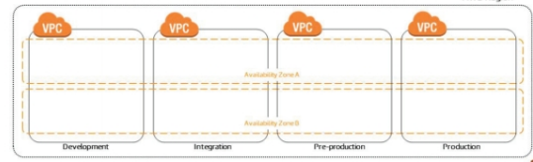
VPC Peering | A one-to-one relationship between two VPCs, without any transitive connections. Can be inter and intra region.  Can't have overlapping subnets  Once established, traffic will flow between peer VPCs using private IP addresses  Keep RT and SGs in check.  Always keep track of data transfer charges.  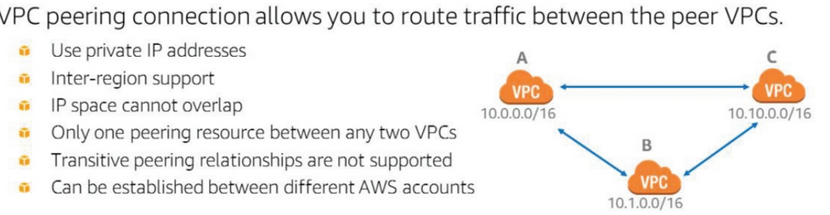
Security | Security is maintained by Security Groups and NACL (Network Access Control List)  Stateless: have to explicitly define inbound and outbound rules within a policy  Stateful: maintains inbound and outbound session mapping
Security Group | At VPC level, stateful virtual firewall that control inbound and outbound traffic of associated instances  Implicit deny all,  Filters based on TCP, UDP, and ICMP protocols  Source/Target can be CIDR or other SGs  By default, all new SGs allow all OUTBOUND traffic to all dests  Best practice: create INBOUND rules per tier (web/app/data)  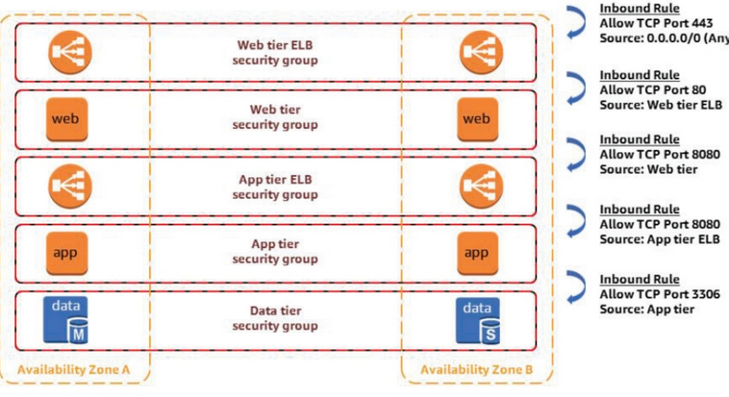
Network Access Control List (NACL) | At subnet level, stateless, by default is ALLOW ALL so should have explicit deny statements
Cloud Front | A CDN service to deliver access to high bandwidth content from sources closer to the user and thereby saves on bandwidth to the origin servers.  Akamai call Edge Servers as ‘Surrogates’  Inherently protects against DDoS (for app stress testing you need special approvals from AWS support team)  Typically, CloudFront serves an object from an edge location until the cache duration that you specified passes—that is, until the object expires. After it expires, the next time the edge location gets a user request for the object, CloudFront forwards the request to the origin server to verify that the cache contains the latest version of the object. The response from the origin depends on whether the object has changed:  - If the CloudFront cache already has the latest version, the origin returns a 304 status code (Not Modified).  - If the CloudFront cache does not have the latest version, the origin returns a 200 status code (OK) and the latest version of the object.  If an object in an edge location isn't frequently requested, CloudFront might evict the object—remove the object before its expiration date—to make room for objects that have been requested more recently.  By default, each object automatically expires after 24 hours. For web distributions, you can change the default behavior in two ways:  -TTL of all objects at the same time  -TTL of objects individually
Summary

DDoS Mitigation using Edge Locations, WAF, and ELB

Each VPC has one and only one Internet Gateway
Subnets are associated with one Route Table only

VPC now supports dual-stack of IPv4 and IPv6

Stateful Rules: if you initiate an ICMP ping from your home computer to your instance, and your INBOUND SG allows ICMP, response traffic is tracked as an established connection and is allowed even if you have an explicit deny on OUTBOUND ICMP.

Cross-zone LB: traffic is distrubuted across registered targets in ALL AZs, enabled by default on APL, disabled on NLB. If disabled, each LB will only sent traffic to its own AZs.

If you don't want users to access content on S3 using S3 URLs, and instead only use CloudFront, then create an Origin Access Identity (OIA) and grant access from S3 to the OIA only. Protects you when you want to use signed URLs to check who can access the content (e.g. paid content)

Databases
RDS - Relational Database Service | Managed Service that offers Fixed Schema databases (columns and rows) with automated redundancy and backup  Supports: Maria, Aurora, PostgreSQL, SQL, MSSQL, Oracle  Use Cases:  Complex transactions and queries  Medium-high qeury/write rate  No more than single worker node/shard  High durability  NOT for:  Massive read/write rates (150K write/second)  Sharding due to high data size or throughput demands  Simple GET/PUT requests and NoSQL qeuries (dynamoDB is better)  RDBMS customization  Instead use an EC2 instance to host the DB  Scalability Methods:  Sharding: split data into multiple DB's to increase query efficiency, highly depends on schema structure  ElastiCache: MemcacheD or Redis  Read Replica: create a copy of READ ONLY data of a DB and make that accessible to the front end  Scale Up the instance  Scale Out the instance  Achieve HA by replicating across multiple AZ's manually, AWS does Master/Secondary replication for you after you set it up
Non-Relational Database | Data exists as "Item:Attribute" key-value pair schema, written in JSON or YAML (MongoDB, DynamoDB)
Data warehouse | Redshift
DynamoDB | Managed service for NoSQL DB offers consistent, single-digit millisecond latency at any scale  Built-in HA and Auto-Scaling  Usually used to maintain session/state data  No table size or throughput limits  Global Tables allow you to replicate data between regions and resolve update conflicts  Can be used for ElastiCache/Memcache  Data automatically replicated to 3 facilities on SSD drives  Has on-demand backup  Provisioned Throughput  Read Capacity  EVENTUAL and STRONG CONSISTENCY options for items as large as 4KB  -> eventual has better throughput but may not reflect latest written data  -> strong ensures that all data read is at the latest version  Write Capacity  one write per second for items as large as 1KB  Data defined as Document or as Item:Attribute key-value pairs (YAML/JSON format)  1. Partition Key - for single attributes  2. Partition Key and Sort Key for multiple attributes  All keys are unique  Any "Query" needs a Partition Key, if you don't and use a SCAN function you will impact the throughput of your DB  Re-Indexing  1. Global Secondary Index: can change partition and sort keys  2. Local Secondary Index: can change sort key only, only done during creation of DB table  Stream: captures all changes done to a table in 24 hours  Global Tables: enable cross-region replication, needs same partition keys, and Stream enables on both sides  DynamoDB Accelerator (DAX):  -> cache layer for DB reads  -> automatically populated  Compare it with ElastiCache, which is for Relational DBs, and DB Admin must configure cache data manually)
ElastiCache | developers have to code the function to move data to cache and that it is serving requests, it is not an automatic service
Multi-AZ | feature AWS provides which will automatically replicate (asynchronously) your database to other RDB instances in other AZ’s
Database Performance Optimization Techniques | 1. Elastic Cache  Caching layer for DB’s  Memcached and Redis  2. Read Replica  a DB with another DNS name for only READ data  can be in another AZ or Region  needs sync with PRIMARY DB  sync latency of Aurora is 60ms  use cases: data warehouse, DB migrations (create RR, point requests there, migrate PRIMARY, sync, revert DNS pointer  3. Elastic Load Balancer  4. Scale Up DB instance
Summary
Example of JSON
{ UID: 007
Name: Bond, James
}
{ UID: M
Location: London
Work: MI6
}
The fields do not have the same attributes, can't be achieved with a Relational DB

Storage
EBS - Elastic Block Storage | AZ level object  Directly attached to one EC2 instance at a time and offers low latency between instance and volume  Supports a Root Volume (location of the OS)  Capacity of volume has to be provisioned upon instance creation  Data is automatically replicated across multiple DC's within the same AZ and can be backed up to S3  Use Cases:  Boot volumes and storage for EC2  Data storage of a file system  Database hosts  Enterprise applications  EBS types:  1. General Purpose (gp2) - SSD  For boot volumes, VDI, dev/test, low-latency interactive apps  Gp2 volumes support up to 10,000 IOPS and 160 MB/s of throughput  2. Provisioning IOPS (io1) - SSD  For I/O intensive workloads, RDS, NoSQL  Io1 volumes support up to 32,000 IOPS and 500 MB/s of throughput  3. Throughput Optimized (st1) - HDD  Streaming services, big data, data warehouse, log processing, cannot be a boot volume  4. Cold (sc1) - HDD  Throughput intensive storage for large volumes of infrequent access, cannot be boot volume  5. Magnetic disk (standard)  Limit: 5000 EBS volumes, 10,000 snapshots, 200K IOPS, 100TB storage on gp2  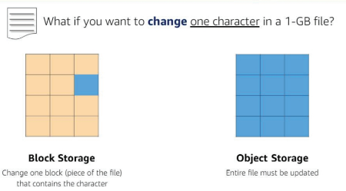
EFS - Elastic File Service | Managed file share service at AZ level  Can be shared across multiple EC2 instances like a file share at Petabyte scale  Offers strong consistency and file locking features of an NFS  Not suitable for installing OS  More expensive than EBS  Does not require any privisioning, scales elastically  Can be accessible by multiple instances at the same time, offers consistent performance  Mount Target: to access your file system in a VPC  -target ID  -subnet ID  -file system ID  -IP address  -target state  Tags: help to organize your file systems (meta-data), key-value pair  Creation Steps  1. Create EC2 instance  2. Create EFS  3. Create mount target in the correct subnet  4. Connect instance to mount target  5. Clean up and protect account  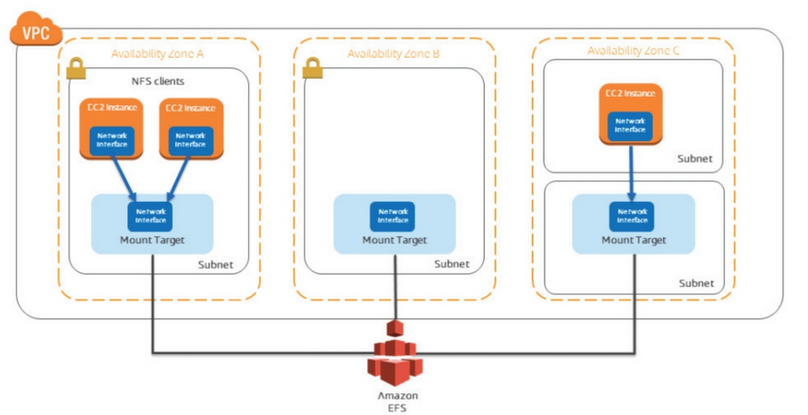
S3 - Simple Storage Service | Managed Object storage service using Buckets  Bucket names are uniquely identified  S3 is its own service, cannot be defined within a VPC  Soft limit of 150 buckets, to increase contact AWS support  Max object size is 5TB  Max upload size is 5GB, for bigger objects, use multi-part upload tool  Multi-Part upload also runs faster because of parallel upload threads  HA service that replicates data in 3 facilities  You pay for storage space and throughput  READ after WRITE Consistency for a PUT of a new object  EVENTUAL Consistency for a MODIFIED PUT or DELETE  Event Notifications: set up to notify when new upload or delete. Sent via SNS or to Lambda.  Storage Classes:  Standard: 99.999999999% durability, 99.99% availability  High availability requirements should use cross-region replication  Infrequent Access: 99.999999999% durability, 99.99% availability  Lower cost per GB, higher cost per PUT/COPY/POST/GET reqs  30-day storage minimum  Reduced Redundancy: 99.99% durability, 99.99% availability. For non-critical data that can be reproduced  Glacier: 99.999999999% durability, 99.99% availability. For archiving, takes 3-5 hours to retrieve data, has auto-encryption  Path URL http://S3.<aws-region>.com/<bucket>/<object>  Host URL http://<bucket>.s3.aws.com/<object>
Glacier | Data archiving service designed for security, durability and extremely low cost  Supports SSL/TLS encryption of data in-transit and at rest  Has a Vault Lock feature for compliance  Ideal for long-term archives  Three options for access  1. Expedited retrieval within 1-5 minutes  2. Standard retrieval within 3-5 hours  3. Bulk retrievals within 5-12 hours
Storage Lifecycle Policy | set actions for data to be automatically moved between S3 offerings (Standard → Infrequent → Glacier after 6 months)  Can be applied to current and previous versions of the files within a bucket  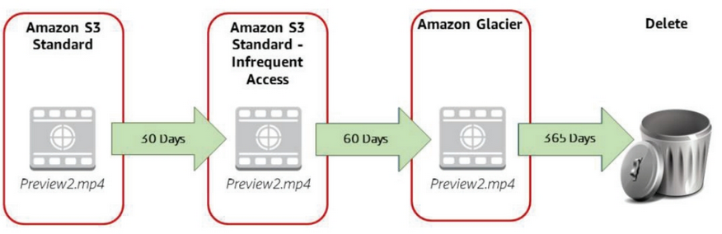
Billing | Pay for:  1. Storage space (GB per month)  2. Throughput of requests (transfers OUT of region)  3. PUT/COPY/POST/LIST/GET requests  Don't pay for:  1. Transfer IN to S3  2. Transfer from S3 to CloudFront  3. Transfers within region  Keep in mind that it is a cost benefit analysis when designing the system, select items in Standard and others in Infrequent Access
Versioning | Can define file versions  Can define Multi Factor Authentication (MFA) before DELETE  Can define Cross Region Replication (one step replication only, can't daisy chain region to region to region, you have to explicitly upload to one region first, then replication happens once)  Versioning needs to be enabled first before MFA DELETE or CRR
Security | Buckets are inherently PRIVATE, to access you need to define an ACL in the Bucket Policy  Can enable logging to see which user did what  Can't install an application or an OS, doesn't do any data integrity check after uploads (i.e. no md5 checksum), does not check for viruses either  To protect data in transit while uploading:  1. Use HTTP/SSL/TLS  2. Use a VPN between On-Prem and VPC, then use a VPC Endpoint  (VPC Endpoints use the AWS Backbone to transfer data between a VPC and S3)  Data at Rest on S3 can be protected  1. Server-Side Encryption  2. Client-Side Encryption  You can achieve Server Side Encryption (SSE)  1. SSE-S3  2. SSE-KMS  3. SSE-C (Client Side, where you encrypt on-prem then transfer)  Client Side Master Key  Cloud HSM (Hardware Security Module) - create instance with a master key that you manage yourself, used for Regulatory purposes
Storage Gateway | Connects on-premise software appliance with cloud-based storage  File Gateway: provides access to S3 from on-prem NFS  Volume Gateway: provides S3 storage volume as iSCSI device  Cached Volume: all data is stored on S3, and frequently access data is stored on-prem  Stored Volume: all data is on-prem, asynchronously backed up to S3  Tape Gateway: archive our backup data to Glacier
Summary
You have to explicitly turn on "Termination Protection" since EBS backed instances have a default "Delete on Termination" setting on the instance that will delete the Root Volume

You can enable Root Volume Encryption on certain instance types only.

If you are hosting a static web page on S3, use an A Alias to point to the Host URL

Management Tools
AWS Management Console | Password access by user  Access Key and Secret Access Key are used for Programmatic (CLI) access  Instance Health Checks  System Check and Instance Check  2/2 means healthy underlying host  Stop and Start will move an instance to other underlying host  Use when System Check failure to switch host hardware  e.g. if you have an EBS you can preserve your data and start the instance on another host  The public IP of the instance will change, but the private IP will stay the same  Reboot will start the instance on the same underlying host  Use when VM/instance has an issue
CloudWatch | A Managed performance monitoring service of AWS services  By default on Hyper-Visor level (CPU, Network, Disk I/O, Instance and System Status Check)  Can define custom metrics for Memory (RAM is not Hyper-Visor level)  Standard: free service, poll every 5minutes  Detailed: paid service, poll every minute  Can cater for application logs (e.g. apache, sql)  Can do analysis and notifications (i.e. detect when increased number of 404 errors)  Collect (storage) --> Analyze(storage) --> Visualize  Metrics are stored for 15 months by default  Can trigger Auto-Scaling based on CloudWatch metrics
CloudFormation | Service that offers fine grained control for Infrastructure as Code  Continuous Integration Continuous Delivery (CICD)  Template: script to instruct CloudFormation written in YAML/JSON  Engine: CloudFormation service to interpret template into stack  Stack: the overall components  Stack Policy: only applied when updating the stack (e.g. current is t2.micro and moving to t2.large)  Policy "allow changes to EC2 instance type"  Policy "deny changes to EBS and ELB"  Templates should execute in any region, nothing should be hard coded (i.e. bucket names)  Before a template is run, there is a Resource Ordering stage that checks available capacity on the AWS account  Templates Structure  {  AWSTemplateFormatVersion  Description  Meta-Data  Parameters - for user input  Mappings - uses a HASH to ensure templates are not region specific  Conditions  Transform  Resources (mandatory)  Output  }  "Ref" is an intrinsic function that takes user input from parameters into the function name  "DependsOn" attribute lets CF know to wait on a task until a specific resource has launched  "WaitCondition" pause the creation of the stack until a signal is sent, used when the config depends on something external to AWS (uses URL's, timeout is 4500 seconds)  Deletion Policy: by default, all resources are to be deleted  All or Nothing: if the template doesn't fully deploy, all changes are rolled back  Now comes with drag and drop functionality!
Elastic Beanstalk | Automated deployment and scaling service for web applications  Accepts Java, .NET, PHP, Node.js, Python, Ruby, Go, or Docker  Deploys on Apache, Nginx, Passenger, IIS servers  Can automatically handle:  Load balancing  Health checks  Auto-Scaling  Application platform management  Code deployment  Concept of Blue-Green deployment where Blue is live production, and green is a match to the production env.  Used to ease the transition from final test stage and live production
OpsWork | Configuration management service  Integrates with Chef and Puppet  Defines application architecture including:  Package installation  Software configuration  Resources  Can be used as a lifecycle tool to:  Simplify management of application  Reduce number of deployment cycles
Systems Manager | Automated configuration and ongoing management of systems at scale  Across Windows and Linux workloads  Runs of EC2 or on-premise  Automatically collects software inventory  Applied OS patches  Creates system images  Run Command  "Run Command" will securely manage configuration of instances  Simpler way to automate tasks such as  -execute shell scripts  -run powershell commands  -install patches  -document management and sharing  Works across multiple instances  Has verbose visibility into results  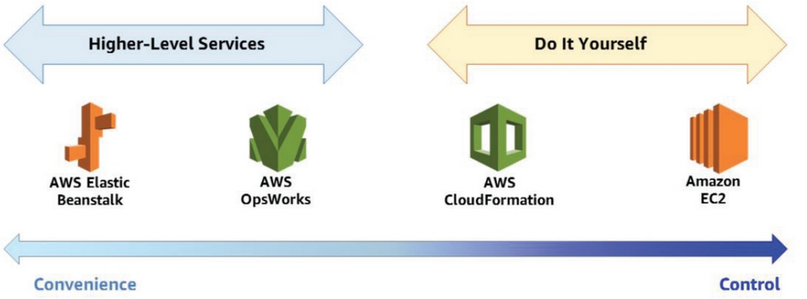
3rd Party Options | Chef  Puppet  Ansible  Salt  Terraform: Open source IaC, can manage AWS, GCP, and Azure
Example

Example CF Template
{
"AWSTemplateFormatVersion": "2018-05-30";
"Description" : "Create S3 Bucket";
"Parameters" :
{
"YourBucketName" :
{
"Type" : "String";
"Description" : "Please Insert a Bucket Name";
}
}
"Resources" :
{
"S3Bucket" :
{
"Type" : "AWS::S3::Bucket";
"Properties" :
{
"BucketName" : { "Ref" : "YourBucketName"; }
}
}
}

CF Workflow

1. Upload template
2. Syntax check
3. Stack name + Parameter ingestion
4. Start stack creation
5. Resource ordering
6. Resource creation
7. Output generation
8. Stack creation complete

Resources are created in parallel
AWS has built-in dependency mechanisms (e.g. VPC before subnet before EC2)
For more complex dependencies you can manage it yourself using the "Depends On" intrinsic attribute

Summary

Examples of custom metrics:
1. time web pages take to load
2. Request error rates
3. Number of simultaneous connections is greater than 10 for one minute (RDS)
4. Number of healthy hosts is less than 5 for 10 minutes (ELB)
5. if CPU is greater than 60% for 5 minutes (EC2)

Security, Identity, and Compliance
IAM - Identity and Access Management | Centrally manage access and athentication of users to AWS resources  Free of charge service.  Define credentials based on context (who is accessing which service and what are they trying to do?)  IAM Entities that exist within an AWS Account:  Users (mapped to people or applications, no default credentials)  Groups (no default group, no nesting, user can be in multiple groups)  Roles (temporary delegation of access, attached to permissions)  Policy - policy document  Identity Provider (idP) - provides credentials to federated users  Best practice: least privilege principle  All permissions are implicitly denied by default  Any explicit deny takes precedence over an allow  For policies, attach a policy to a group and add the user to the group  Policy: formal statement of one or more permissions  Attach policy to IAM entity: user, group, or role  Enabled fine grained access controls  Single policy can be attached to multiple entities  Singe entitiy can have multiple policies  Types of Access:  Users with AWS accounts (email address and password)  Assign Role to AWS services (STS)  Delegate to other AWS accounts  Federation Access
STS - Secure Token Service | Temporary credentials (access key, secret access key, token, and expiration time) that are generated for a specific service to use another service (role)  Details can be found in the meta-data
SAML 2.0 Federation | Secure Assertion Markup Language  SAML Endpoint: doesn't need an IAM user, acts as a broker between the AD and the on-prem user  [add diagrams for further details]  Directory Services:  Active Directory group mapped to an IAM Role  or Custom Federated Policy mapped to an IAM User  or AWS Direct Connect: which is initiated by an AWS service as opposed to an on-prem user, AD is on-prem  or Simple AD: initiated by AWS since AD is on AWS
Roles | Trust Policy (e.g. EC2) - specifies who is allowed to assume the role  Access Policy (e.g. S3 Full Access Read Only) - defines what actions and resources the principal is allowed access to  Provides access to externally authenticated users and to third parties  Switch roles to access resources in your account or another AWS account (cross-account access)
SSH Login | You need an Access Key (.pem file) to login via SSH  If you face a "PRIVATE KEY ERROR" that means you did not CHMOD the .pem file  Both CHMOD 400 and 600 will work (r-------- or rw-------)
Web Identity | Assume role with web identity call, only handles one web identity
Cognito | AWS service to handle multiple web identities, also support unauthenticated "guest" access
KMS - Key Management Service | A managed service that makes it easy for you to create and control the encryption keys used to encrypt your data. AWS Key Management Service is integrated with other AWS services including Amazon EBS, Amazon S3, Amazon Redshift, and others to make it simple to encrypt your data with encryption keys that you manage. AWS Key Management Service is also integrated with AWS CloudTrail to provide you with logs of all key usage to help meet your regulatory and compliance needs
CloudHSM - Hardware Security Module | Used in cases where there is strict contractual or regulatory requirements.  Consider it for when you need:  Keys to be stored in dedicated, third-party validated hardware modules under your control  FIPS 140-2 compliance  Integration with applications using PKCS#11, Java JCE, and Microsoft CNG interfaces  High-performance in-VPC cryptographic acceleration (bulk crypto)
CloudTrial | Web service that records API calls to your account even ones made via the Console  Enabled by default on on all customers, provides visibility into past 7 days of account activity with option to view and download last 90 days  Use Cases:  1. Security Analysis: use log files as input into log management solution for analysis  2. Track Changes: creation, modification, and deletion of resources  3. Troubleshoot Operational Issues: quickly identify recent changes  4. Compliance Aid: supporting info for regulatory standards to demonstrate resources are managed accordingly  5. use with AWS Config  Can integrate with Splunk, AlertLogic, and SumoLogic
AWS Config | Provides snapshot of AWS resource inventory, configuration history, and configuration change notifications (via SNS)  Continuous details on all config changes  Enabled compliance auditing, security analysis, resource change tracking, and troubleshooting  Views relationships between resources
Summary

Best Practices on Day 1
1. Stop using the root account: create an IAM user and group with full admin access, then disable root account keys and store them in a safe place.
2. Use Multi Factor Authentication (MFA) to a sign in using software or hardware tokens
3. Enable billing reports (e.g. Cost and Usage Report)
4. Configure CloudTrial to log all API requests to your account and store it in a bucket that only CloudTrial has permissions for

Application Integration
SQS - Simple Queue Service | The first AWS service  Allows decoupling of hardware and software, similar to what a buffer would do  High throughput service  Data is replicated over many servers while in the queue  Can also use SSE  Has a Producer engine and a Consumer enginer  Once a message is consumed, a VISIBILITY TIMER starts where a consumer has to write the message in the DB and issue a a DELETE request for the msg from the queue before the timer completes  SQS is a Best Effort service, does not support FIFO because messages are stored in distributed servers  -> AWS guarentees that messages will be delivered "at least once"  -> the application has to ensure that duplicated are deleted and messages are in order  If the message is corrupted and can't be pulled by the consumer, then the visibility timer expires, after it expires 5 times then the message is sent to a DEAD LETTER QUEUE  Short Polling: constant polling by consumers  Long Polling: 20 seconds then close the TCP connection  Visibility Timer: default is 30 seconds, max is 12 hours  Queue: messages kept by default for 4 days, max 14 days  If your SQS is not used within 30 days, AWS will delete it  SQS uses a "weighted random distribution algorithm" to select a group of servers to query for messages, sometimes these set of servers don't contain all the messages that you need so you will get back incomplete data
SQS FIFO | New service launched in 2017  Guarentees FIFO and no duplicates  Same price as SQS but has less throughput since it has to analyze more  It achieves it by using less servers for replication (simpler)
SNS - Simple Notification Service | Subscribers -> Public Topic to:  - Email  - SMS  - SQS  - HTTP/HTTPS  - Lambda
SWF - Simple Work Flow | Actors:  1. Workflow Starters: application that can initiate a workflow  2. Deciders: controls the flow of activity tasks  3. Activity Workers: carry out activity tasks
Summary

Analytics
Kinesis | AWS service to process data in streams  Stream: sharding to defined capacity  Firehose: no sharding, auto-scale  Analytics done on both Stream and Firehose using SQL type logs by the client  Data is retained for 24 hours by default, max upto 7 days  Agent will produce stream of records which contain Sequence ID, Partition ID, and Blob  Kinesis shard supports 1 Mbps IN, 2 Mbps OUT @ 1000 PUTS
Big Data | Analyze cold data in batches (after storage), and hot data in streams (instant)
Hadoop | distrubuted operating system for Big Data clusters
Tools | Elastic Map Reduce, Kinesis for streaming data, RedShift data warehouse, QuickSight BI tool
Summary

Guided Steps
Steps to create a basic VPC with Public and Private pools | 1. Create VPC, assign main CIDR block, Main RT automatically created with defualt SG  2. Create subnets, assign IP ranges, gets automatically associated with Main RT  3. Ceate iGW and associate with VPC  4. Create RT with public route  5. Associate subnets with RT  6. Use NAT Gateway or NAT Instance in the public subnet  7. Add default route of private subnet as the NAT instance
Steps to create private subnet with iNet access using a NAT instance | 1. Create VPC, assign CIDR, allow Public IP assignment  2. Create Public and Private subnets  3. Create IGW  4. Create Public RT, add default route to IGW  5. Associate Private Subnet with Private RT, and Public Subnet with Public RT  6. Create NAT instance, SG, and assign Public IP  7. Create EC2 instances in Public and Private subnets  8. Copy NAT instance ID and add it as the default route of the Private Subnet  10. Disable Source/Destination Check in order to allow the NAT instance to use its own IP to establish the session
Create an instance and attach an additional EBS volume to it, migrate the volume to another instance in the same AZ | 1. Create instance, add volume other than the root volume obviously  2. Format the volume #mkfs -t ext4 dev/xvdb/  3. Show mount points #lsblk  4. Mount volume to /data #mkdir /data, #mount /dev/xvdb/ /data  5. Confirm the mount point #df -h --total  6. Add files to /data  7. Unmount #unmount /data  8. From the console, under the EC2 instance "Block Devices" copy the "EBS-ID"  9. From the console, DETACH volume from EC2  10. From the console, ATTACH the volume to an instance in another AZ  11. Mount the volume from the CLI, #mount /dev/xvdf /data  12. Check files are there #ls /data .. MAGIC!
Upgrade volume while keeping data | 1. Create snapshot from existing volume  2. Upgrade attached volume (e.g. from General to Optimized SSD)  3. Create volume from the snapshot  4. Attach volume to the instance
Mount an EBS volume across AZ's  (hint: have to use a Regional Level Object i.e. S3) | 1. Create snapshot from Volume via the console  2. Copy snapshot-ID  3. Go to an instance in another AZ, attach volume based on snapshot-ID
Mount an EBS volume across Regions | ?
Summary

Source/Destination Check - by default, EC2 instances check that their own IP is the source and destination for all traffic sent and received. This has to be disabled if the instance is going to perform a NAT service.

Best Practices
Security | Establish credential management policies and procedures for creating, distributing, rotating, and revoking access credentials. Seperate access by role.  Ensure that instances are only accessible from specific IPs addresses and other resources by using Security Groups.  Usder the shared responsibility model, you are responsible for securing the instance OS and applications. Make sure the latest OS updates are installed, save your IAM, and use that for your application.
Storage | Know the difference between instance storage and volume backed.
Resource Management | Always use meta-data and tags to track and identify your instances  Certain resources have soft limits, plan to request limit increases in advance as they take time to be reviewed by AWS.
Backup and Recovery | Take regular backup  Deploy critical apps across multiple AZs  Design your apps to handle dynamic IP's for when instances restart  Monitor and respond to events (with CloudWatch)  Ensure you have proper failover controls  Regularly test your recovery process
Choosing a region | 1. Data sovereignty and compliance to governance requirements  2. Proximity of data to users  -consider latency and region specific costs  3. Service and feature availability per region  4. Cost effectiveness of design (e.g. cross region replication)
Working with AZs | Recommendation: start with two AZs per region for HA  Spot instances are priced by AZs, so you can have more than one option  DB's can be used in active/standby config across two AZs  Applications like Cassandra or MongoDB can achieve HA over two AZ  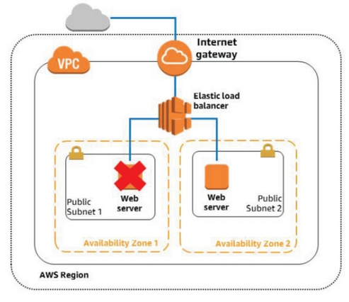
Using VPCs | Limited cases when one VPC is appropriate:  HPC, identity management, small/single applications for a small team  Otherwise deploy Multi-VPC and Multi-Account  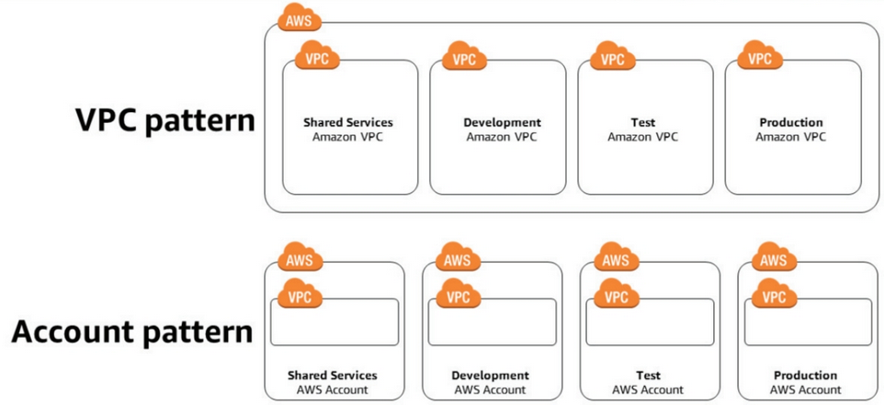
AWS Organization | Hierarchical grouping of accounts  Integration and support with IAM and other services  Eventually consistent data replication  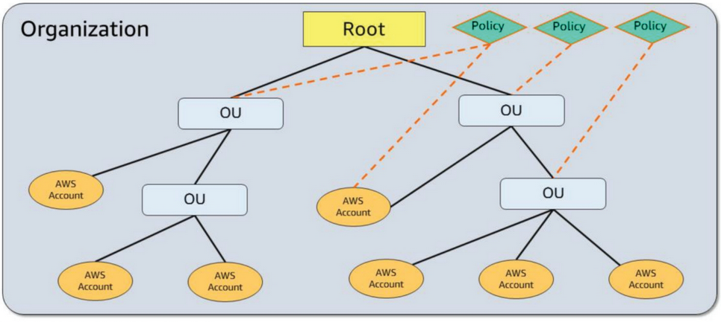  Organizational Unit (OU): container of accounts within a root  Root: parent container of all accounts under your organization. Policy applies to all OUs.  Master Account: the account that creates the organization and the member accounts, and is responsible for paying all charges. sends an "Invitation" to add member accounts, and a "Handshake" as the underlying implementation for invitations.
Extending on-premise network to AWS | Option 1: VPN Connection between on prem and VPC Virtual Gateway  -Hardware VPN  -Instance with Software VPN launched from the marketplace  Option 2: Direct Connect  Private network connection between AWS and your DC  Good for hybrid cloud, improved app performance, transfering large data sets, security, and compliance.  Alternative to IPSec VPN.  Supports BGP peering.  Requires telecom partner to provision the circuit.
Summary

Section Title
Summary

