Chingari Trust
Bhopal

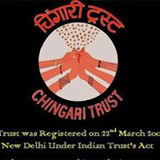

Annual Report 2023-24

Index
Sr. No. | Content | Page Number
1 | About Us | 3
2 | Healthcare for Children | 4
3 | Brief Summary of the activities of the Trust in the Year 2023-24 | 5

ABOUT US
The women of Bhopal have been playing a leading role in the struggle for justice and livelihood waged by the gas victims. Time and again, it has been seen that women pursue any task they take up with single-minded purpose and diligence.

The Goldman Environmental Award prize money received by Rashida Bee and Champa Devi Shukla jointly had been donated for the welfare of the gas victims for this purpose. They set up the Chingari Trust to formulate a blueprint for utilizing the money and administer its implementation. To preserve its gender identity, it was decided that all its trustees would be women. The trust was registered in New Delhi on March 22, 2005.

Chingari Trust is a non-political, non-profit earning organisation that utilises all the resources it generates for the welfare of the people. A charitable trust, it does not participate in political activities, its main purpose being to work with the victims of the Bhopal gas tragedy and other pollution-affected communities. Specifically, it supports women and children victims, without discriminating on the basis of caste, creed or religion. Its main functions are as follows:

- To provide medical treatment and rehabilitation for the congenitally disabled children born in the families affected by Bhopal Gas Tragedy and subsequent ground water contamination

- To extend economic and other livelihood support to gas-affected women and their families.

3. To institute the Chingari Award, this will be given annually to a woman activist who is working specifically to fighting to deliver justice to the victims of such disasters.

Healthcare for children:

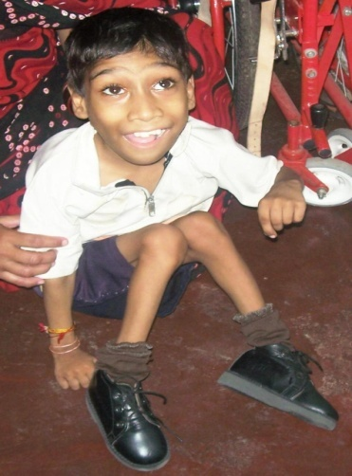
Children born to victims of the gas disaster continue to pay for the negligence of Union Carbide and India’s politicians. Many have congenital birth defects and physical malformations, or are brain damaged. The contamination of water sources by chemicals leaking from the abandoned factory has only exacerbated the problem.

These children have special needs, in terms of long-term medical care and rehabilitation within their communities. However, nothing was being done for them or their families till the Trust took matters into their own hands. Chingari Trust is bringing much needed medical help and counselling to these children to help them lead dignified and self-reliant lives.

Chingari Trust operates a clinic committed to helping children in Bhopal born with various psychological and physical disabilities.
The children who visit Chingari are supported, stimulated, and encouraged—all of this makes them happy and leaves them feeling “normal”, an experience they do not often encounter at home and in their neighborhoods. Almost all of these children come from families that are impoverished and one can only imagine how much poverty compounds their existing health problems. This is a major reason why the free care and therapy that is given at the Chingari Rehabilitation center is so crucial.
The staff at Chingari are made up of skilled therapists and Special educators along with supporting staff, who every day take on the challenging task of working with these children. Not only do they work with the children, but they also counsel and instruct their mothers on how to best care for and stimulate their children when they are at home.
Chingari envisions a society that is sensitive to people with special needs. It is trying to set parameters for sensitive and humanistic healthcare of such people, and force the government to make such care available to all the affected children. It believes that its work among children affected by Carbide’s poisons will help raise social awareness about the deadly impacts of the toxic chemical industry.
Brief Summary of the activities of the Trust in the year 2023-2024
Number of special children registered with Chingari Trust has increased from 1233 on 1st April 2023 to 1300 on 31st March 2024. However due to lack of adequate resources, we are able to provide three hundred children with following facilities free of cost this year:
- Physiotherapy
- Speech Therapy
- Special Education
- Occupational Therapy
- Mid-Day Meal
- Pick and Drop facility
Following Staff is working with Chingari Trust, who every day takes on the challenging task of working with these children:
- Seven Physiotherapists
- Two Occupational Therapist
- Six Speech Therapist
- Six Special Educators
- Eight Van Drivers
- Six Caretakers
- Five Community health workers
- Two Accountant
- One Admin Officer
- One M.I.S. Manager
- One Cook
Not only do they work with the children, but they also counsel and instruct their mothers on how to best care for and stimulate their children when they are at home. They also maintain the quarterly progress report of children receiving Therapies and Special Education at Chingari Trust to track their development.
The children who visit Chingari are supported, stimulated, and encouraged—all of this makes them happy and leaves them feeling “normal”, an experience they do not often encounter at home and in their neighborhoods. Almost all of these children come from families that are impoverished and one can only imagine how much poverty compounds their existing health problems.
Also, a team of Community Health workers help in raising awareness about disabilities in the gas and water affected areas. Every fortnight a community meeting is organized to educate people about pregnancy precautions and early identification of disabilities.

With intentions to integrate children with normal stream, various events were organized at Chingari Trust this year from time to time, apart from regular therapy and education sessions like:
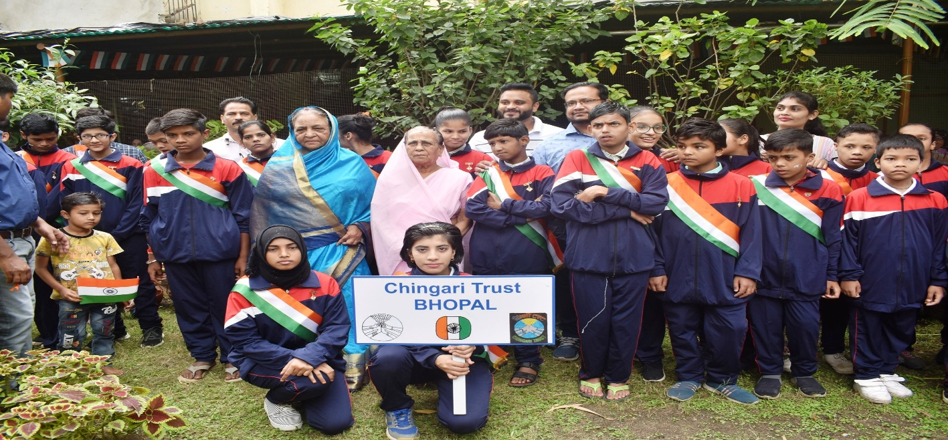
Independence Day Celebration

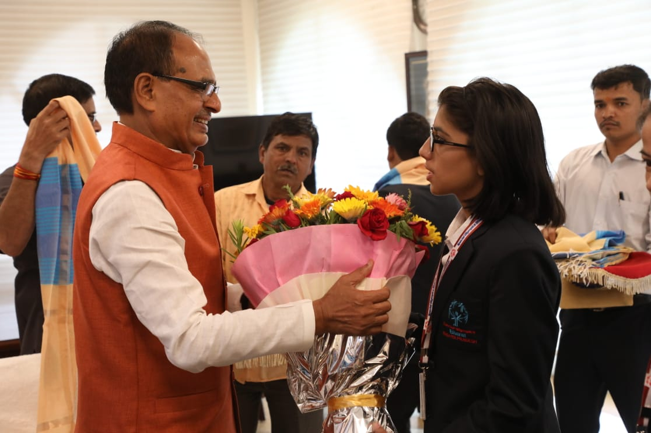
Disha Tiwari (Silver Medallist in Special Olympics Berlin 2023) With then Chief Minister Shivraj Singh Vhauhan
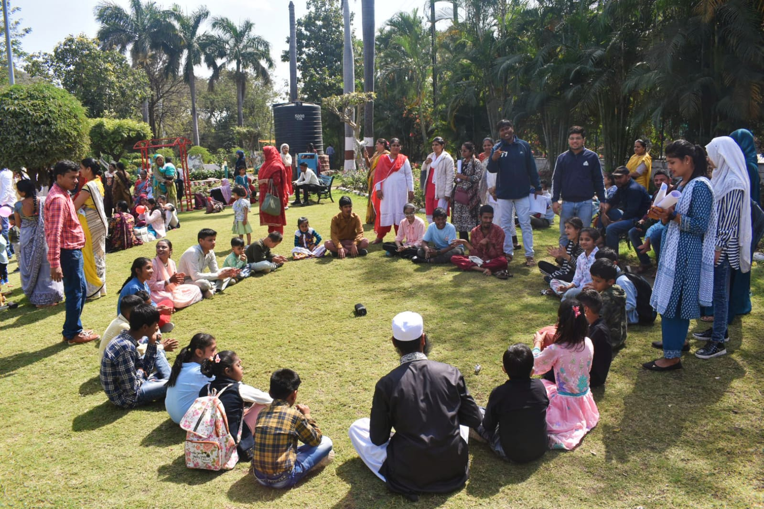
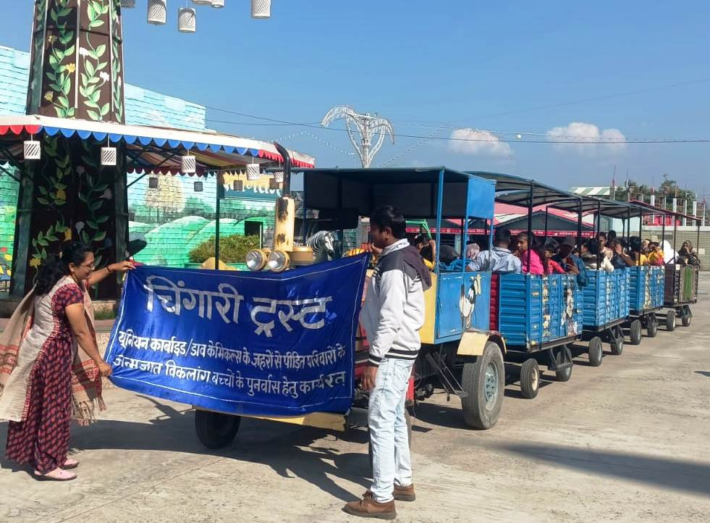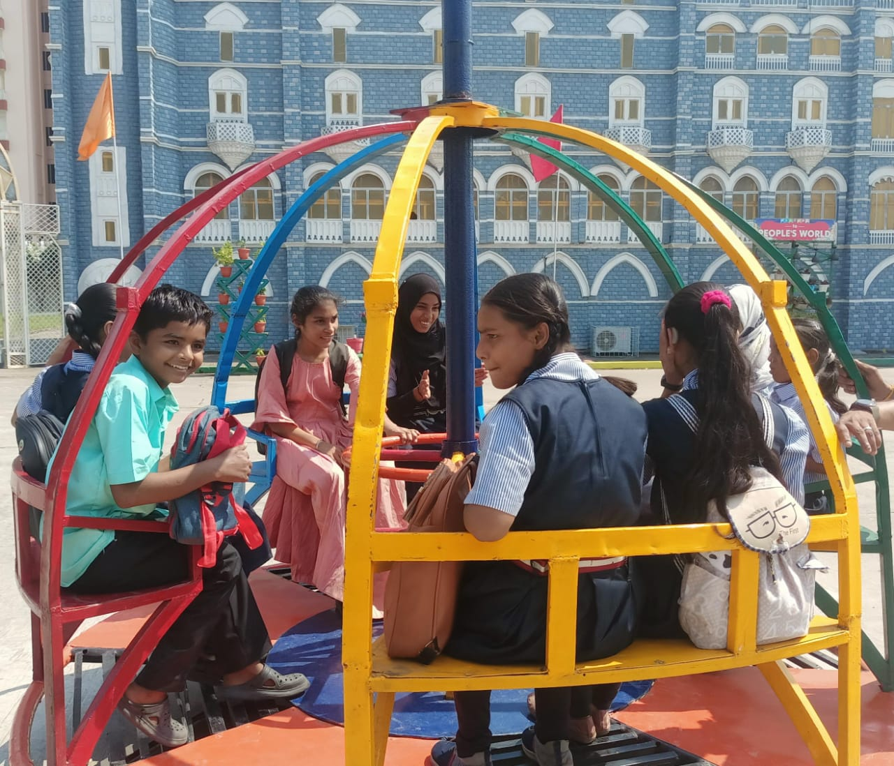
Fun Time: Picnic

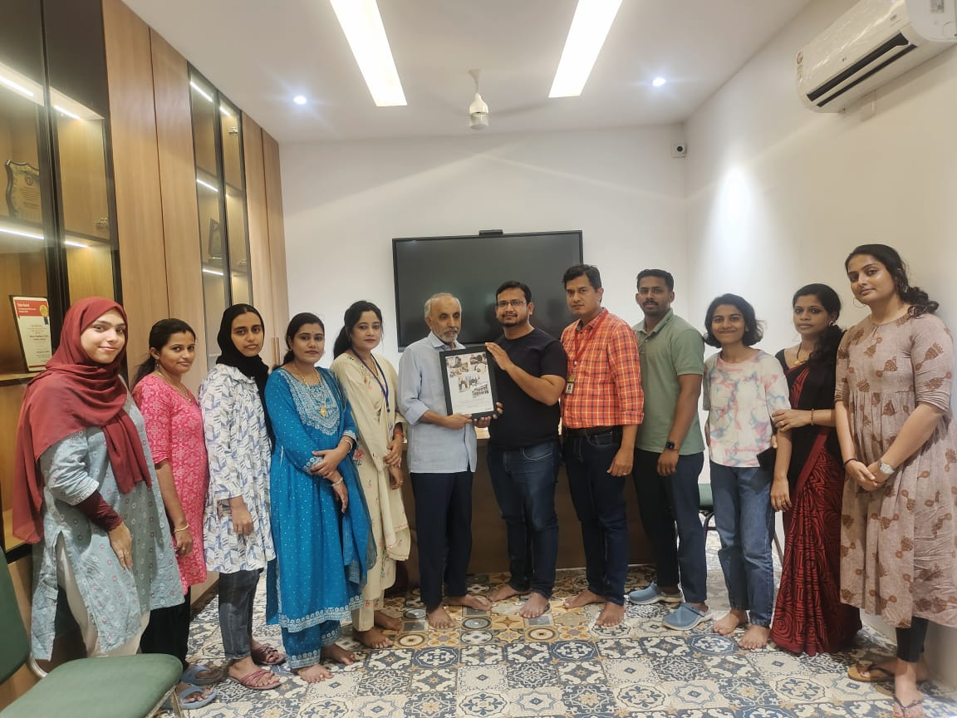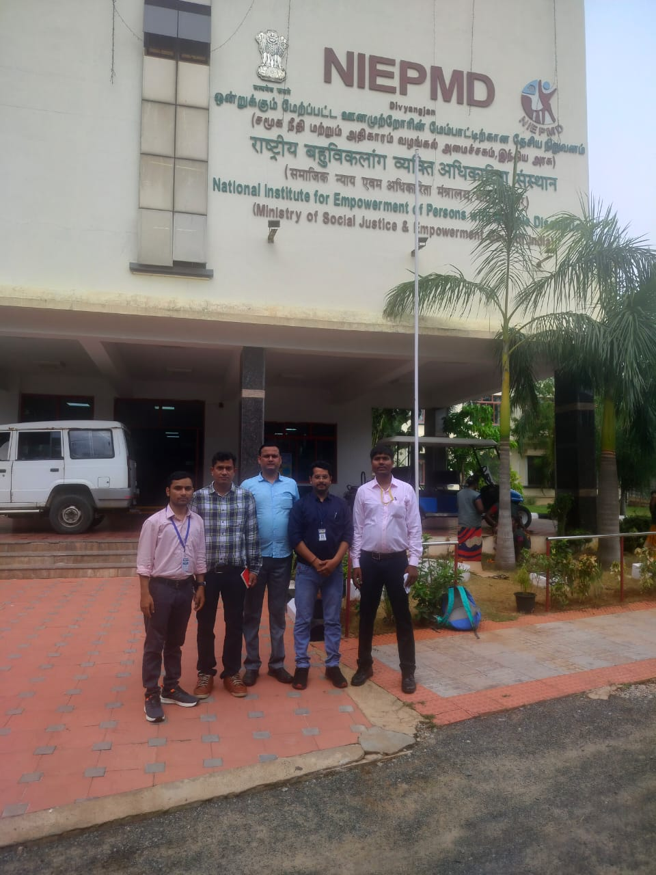
Institute Visit

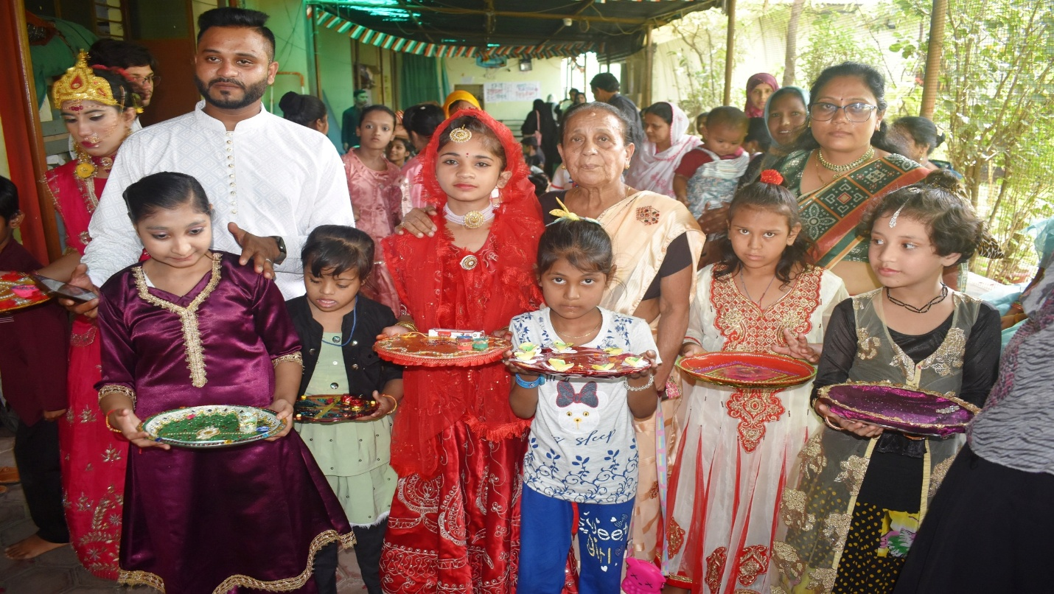
Rakshabandhan Celebration

We are really thankful to the staff of Chingari Trust, Bhopal Medical Appeal, Azeem Premji Foundation, PSR Wisconsin, Bhopal todays and tomorrows and all our supporters for helping us this year.

