PREPARATION OF PAPERS FOR JACoW CONFERENCES*

*Work supported by … THIS INFORMATION MUST BE WITHIN
#cee@aps.anl.gov THIS TEXT & COLUMN MARGINS
J. Poole, C. Petit-Jean-Genaz, CERN, Geneva, Switzerland
C.E. Eyberger#, ANL, Argonne, IL 60439, USA
V.R.W. Schaa, GSI, Darmstadt, Germany
T. Satogata, JLab, Newport News, VA 23606, USA
I. Andrian, Elettra, Trieste, Italy
Abstract
Many conference series have adopted the same standards for electronic publication and have joined the Joint Accelerator Conferences Website (JACoW) collaboration for the publication of their proceedings. This document describes the common requirements for the submission of papers to these conferences. Please consult individual conference information for page limits, method of electronic submission, etc. It is not intended that this should be a tutorial in word processing; the aim is to explain the particular requirements for electronic publication at www.JACoW.org.
Submission of Papers
Each author should submit the PostScript and all of the source files (text and figures), to enable the paper to be reconstructed if there are processing difficulties.
Manuscripts
Templates are provided for recommended software and authors are advised to use them. Please consult the individual conference help pages if questions arise.
General Layout
These instructions are a typical implementation of the requirements. Manuscripts should have:
- Either A4 (21.0 cm x 29.7 cm; 8.27 in x 11.69 in) or US letter size (21.6 cm x 27.9 cm; 8.5 in x 11.0 in) paper.
- Single-spaced text in two columns of 82.5 mm (3¼ in) with 5.3 mm (0.2 in) separation. More recent versions of Word have a default spacing of 1.5 lines; authors must change this to 1 line.
- The text located within the margins specified in Table 1.

Table 1: Margin Specifications
Margin | A4 Paper | US Letter Paper
Top | 37 mm (1.46 in) | 0.75 in (19 mm)
Bottom | 19 mm (0.75 in) | 0.75 in (19 mm)
Left | 20 mm (0.79 in) | 0.79 in (20 mm)
Right | 20 mm (0.79 in) | 1.02 in (26 mm)

The layout of the text on the page is illustrated in Fig. 1. Note that the paper’s title and the author list should be the width of the full page. Tables and figures may span the whole 170 mm page width, if desired (see Fig. 2), but if they span both columns, they should be placed at either the top or bottom of a page to ensure proper flow of the text (Word templates only: the text should flow from top to bottom in each column).
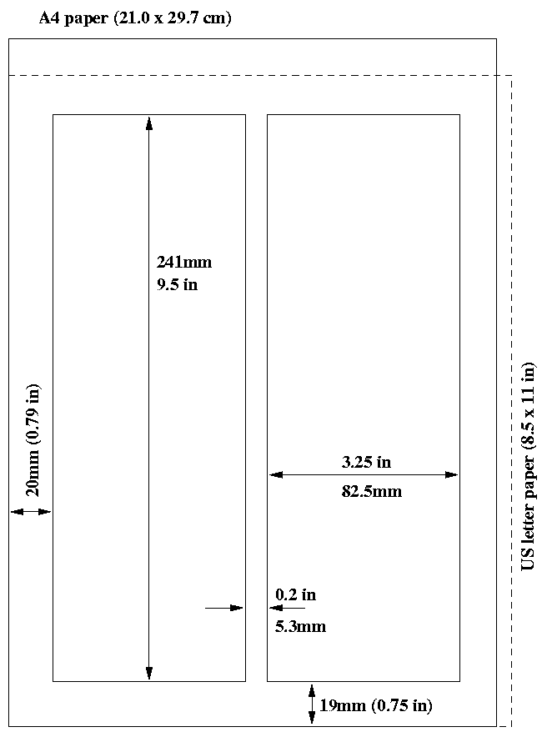
Figure 1: Layout of papers.
Fonts
In order to produce good Adobe Acrobat PDF files, authors using a LaTeX template are asked to use only Times (in roman [standard], bold or italic) and symbols from the standard set of fonts. In Word use only Symbol and, depending on your platform, Times or Times New Roman fonts in standard, bold or italic form.
Title and Author List
The title should use 14 pt bold uppercase letters and be centered on the page. Individual letters may be lowercased to avoid misinterpretation (e.g., mW, MW). To include a funding support statement, put an asterisk after the title and the support text at the bottom of the first column on page 1—in Word, use a text box; in LaTeX, use \thanks.

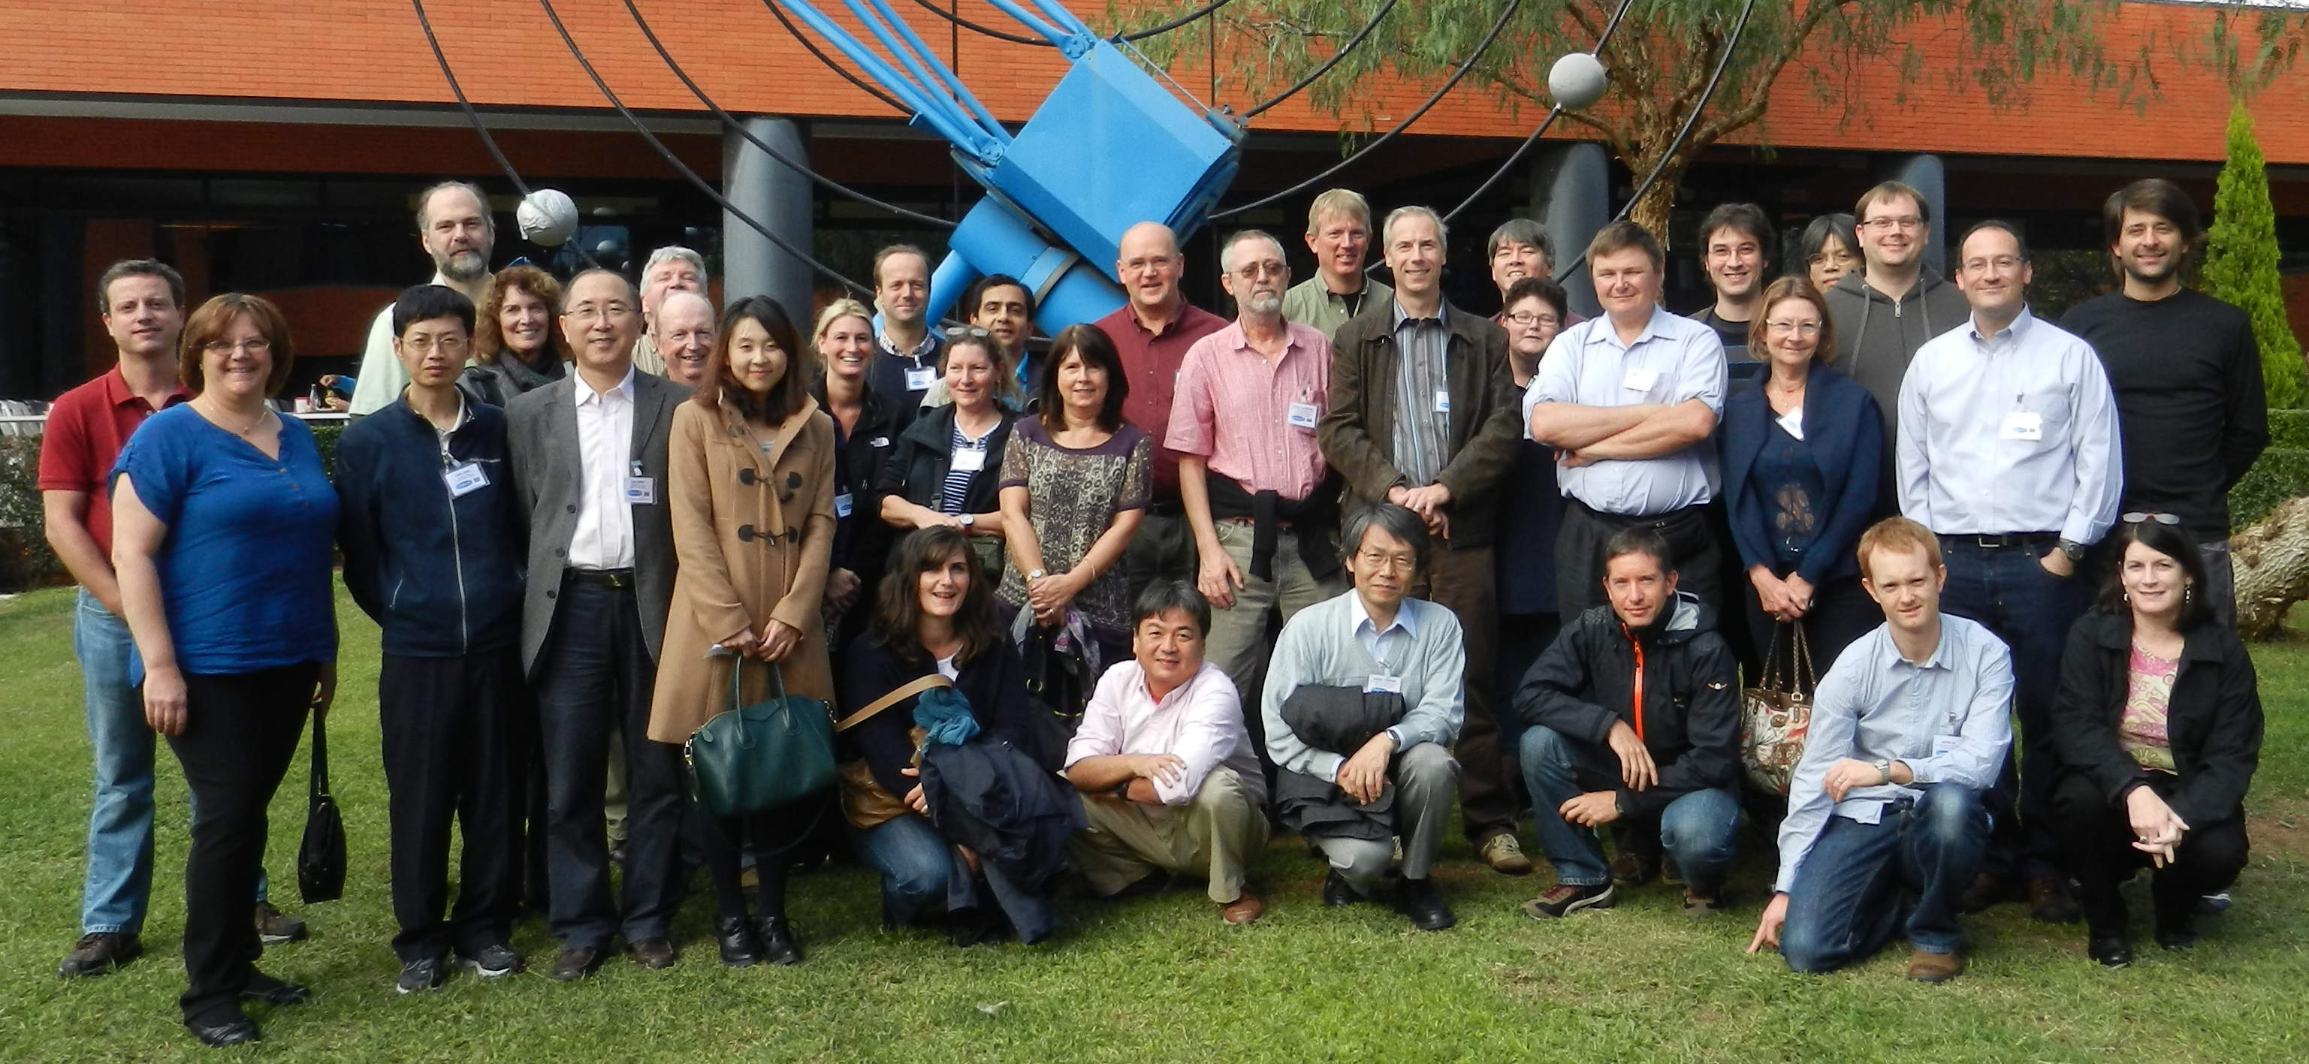
Figure 2: Example of a full-width figure showing the JACoW Team at their annual meeting in 2012. This figure has a multi-line caption that has to be justified, rather than centered.
The names of authors, their organizations/affiliations and mailing addresses should be grouped by affiliation and listed in 12 pt upper- and lowercase letters. The name of the submitting or primary author should be first, followed by the co-authors, alphabetically by affiliation.
Section Headings
Section headings should not be numbered. They should use 12 pt bold uppercase letters and be centered in the column. All section headings should appear directly above the text—there should never be a column break between a heading and the following paragraph.
Subsection Headings
Subsection headings should not be numbered. They should use 12 pt italic letters and be left aligned in the column. Subsection headings use Title Case (or Initial Caps) and should appear directly above the text—there should never be a column break between a subheading and the following paragraph.
Third-level Headings should use 10 pt bold letters and be run into the paragraph text. In LaTeX these headings are created with LaTeX’s \subsubsection command. In the Word templates authors must bold the heading text themselves, This heading should be used sparingly. See Table 2 for its style details.
Paragraph Text
Paragraphs should use 10 pt font and be justified (touch each side) in the column. The beginning of each paragraph should be indented approximately 3 mm (0.13 in). The last line of a paragraph should not be printed by itself at the beginning of a column nor should the first line of a paragraph be printed by itself at the end of a column.
Figures, Tables and Equations
Place figures and tables as close to their place of mention as possible. Lettering in figures and tables should be large enough to reproduce clearly. Use of non-approved fonts in figures can lead to problems when the files are processed. LaTeX users should be sure to use non-bitmapped versions of Computer Modern fonts in equations (Type 1 PostScript or OpenType fonts are required. Their use is described in the JACoW help pages [1]).
Each figure and table must be numbered in ascending order (1, 2, 3, etc.) throughout the paper. Figure captions (10 pt font) are placed below figures, and table captions are placed above tables. Single-line captions are centered in the column, while captions that span more than one line should be justified. The LaTeX template uses the ‘booktabs’ package to format tables.
A simple way to introduce figures into a Word/Writer document is to place them inside a table that has no borders. This is done in Writer as described below.
- menu Insert → Table, single column, two rows, no border table;
- paste the figure in the first row and adjust the size as appropriate (we suggest to anchor it “as character” and center it using the paragraph alignment properties);
- paste/type the caption in the second row and apply JACoW figure caption style;
- menu Table → Table Properties... → Alignment → Center;
- if necessary play with the cell spacing and other parameters to improve appearance.

If a displayed equation needs a number (i.e., it will be referenced), place it flush with the right margin of the column (see Eq. 1). The equation itself should be indented (centered, if possible). Units should be written using the roman (standard) font, not the italic font:
(1)
References
All bibliographical and web references should be numbered and listed at the end of the paper in a section called REFERENCES. When citing a reference in the text, place the corresponding reference number in square brackets [2]. The reference citations in the text should be numbered in ascending order.
A URL may be included as part of a reference, but its hyperlink should NOT be added. Multiple citations should appear in the same bracket [3,4] or with ranges, e.g., [3]-[4] or [1-4,10].
Examples of correctly formatted references can be found at the JACoW website (http://JACoW.org). Once there, click on the ‘for Authors’ link at the top and then on the ‘Formatting Citations’ link in the left-hand column.
Footnotes
Footnotes on the title and author lines may be used for acknowledgments, affiliations and e-mail addresses. A non-numeric sequence of characters (*, #, †, ‡) should be used. Word users—DO NOT use Word’s footnote feature (Insert, Footnote) to insert footnotes, as this will create formatting problems. Instead, insert the title or author footnotes manually in a text box at the bottom of the first column with a line at the top of the text box to separate the footnotes from the rest of the paper’s text. The easiest way to do this is to copy the text box from the JACoW template and paste it into your own document. These “pseudo footnotes” in the text box should only appear at the bottom of the first column on the first page.
Any other footnote in the body of the paper must be created using the text box procedure described in the paragraph above using the normal numeric sequencing (i.e., 1, 2, 3) and appearing at the bottom of the same column in which it is used.
Acronyms
Acronyms should be defined the first time they appear.
Styles
Table 2 summarizes the fonts and spacing used in the styles of a JACoW template (these are implemented in the LaTeX class file).
Page Numbers
DO NOT include any page numbers. They will be added when the final proceedings are produced.
Templates
Templates and examples can be retrieved through web browsers such as Firefox, Chrome and Internet Explorer by saving to disk.
Template documents for the recommended word processing software are available from the JACoW website (http://JACoW.org) and exist for LaTeX, Microsoft Word (Mac and PC) and LibreOffice/OpenOffice for US letter and A4 paper sizes.
Use the correct templates for your paper size and version of Word. Do not transport Microsoft Word documents across platforms, e.g., Mac↔PC. When saving a Word 2010 file (PC), be sure to click ‘Embed fonts’ in the Save options. Fonts are embedded by default when printing to PDF on MAC OSX.
Please see the information and help files for authors on the JACoW.org website for instructions on how to install templates.
Table 2: Summary of Styles
Style | Font | Space  Before | Space  After
Paper Title | 14pt  Uppercase except for  required lowercase letters  Bold | 0pt | 3pt
Author list | 12pt  Upper- and lowercase | 9pt | 12pt
Abstract Title | 12 pt  Initial caps  Italic | 0pt | 3pt
Section  heading | 12pt  Uppercase  Bold | 9pt | 3pt
Subsection  heading | 12pt  Initial caps  Italic | 6pt | 3pt
Third-level Heading* | 0 pt  Initial cap  Bold | 6pt | 0pt
Figure  captions | 10pt | 3pt | 6pt
Table  captions | 10pt | 3pt | 3pt
Equations | 10pt base font | 12pt | 12pt
References | 9/10pt, justified with  0.25” hanging indent | ≥0pt | ≥0pt
* Authors must bold and format this heading themselves.
Checklist for electronic Publication
- Use only Times or Times New Roman (standard, bold or italic) and Symbol fonts for text—10 pt minimum except references, which can be 9 pt or 10 pt.
- Figures should use Times or Times New Roman (standard, bold or italic) and Symbol fonts when possible—6 pt minimum.
- Check that citations to references appear in sequential order and that all references are cited [10].
- Check that the PDF file prints correctly.
- Check that there are no page numbers.
- Check that the margins on the printed version are within ±1 mm of the specifications.
- LaTeX users can check their margins by invoking the boxit option.
CONCLUSION
Any conclusions should be in a separate section directly preceding the ACKNOWLEDGEMENT, APPENDIX or REFERENCES section, in that order.
Acknowledgement
Any acknowledgment should be in a separate section directly preceding the REFERENCES or APPENDIX section.
APPENDIX
Any appendix should be in a separate section directly preceding the REFERENCES section. If there is no REFERENCES section, this should be the last section of the paper.
References
[1] JACoW.org website: http://jacow.org/index.php?n= Authors.UsingLaTeX {no hyperlink, no period after URL}
[2] A.N. Other, “A Very Interesting Paper,” EPAC’96, Sitges, June 1996, p. 7984 (1996); http://www.JACoW.org
[3] F.E. Black et al., This is a Very Interesting Book, (New York: Knopf, 2007), 52.
[4] G.B. Smith et al., “Title of Paper,” MOXAP07, IPAC’13, to be published.
. . .
. . .
. . .
[10] B. Gnats, A. Jones, Phys. Rev. ST Accel. Beams 1, 011502 (1998).

