PREPARATION OF PAPERS FOR JACoW CONFERENCES*

*Work supported by …
#cee@aps.anl.gov
J. Poole, C. Petit-Jean-Genaz, CERN, Geneva, Switzerland
C. Eyberger#, ANL, Argonne, IL 60439, U.S.A.
Abstract
APAC, EPAC and PAC have adopted the same standards for electronic publication and have created the Joint Accelerator Conference Website (JACoW) [1] for the publication of their proceedings. This document describes the common requirements for the submission of papers to these conferences. Please consult individual conference pages for information on numbers of pages, method of electronic submission, etc. It is not intended that this should be a tutorial in word processing; the aim is to explain the particular requirements for electronic publication at these conference series.

Submission of Papers
Each author should submit all of the source files (text and figures), the postscript file and a hard copy version of the paper. This will allow the editors to reconstruct the paper in case of processing difficulties and compare the version produced for publication with the hard copy.

Manuscripts
Templates are provided for Microsoft Word (Mac and PC) and LaTeX. Authors are advised to use the templates provided. The JACoW Styles and Macros menu, available in the Microsoft Word .dot templates, is designed to help authors format their papers correctly. Please consult the individual conference help pages if questions arise.
General Layout
These instructions are a typical implementation of the requirements. Manuscripts should be prepared for one side of the paper and have:
- Either A4 (21.0 cm x 29.7 cm; 8.27 in x 11.69 in) or US letter size (21.6 cm x 27.9 cm; 8.5 in x 11.0 in) paper.
- Single-spaced text in two columns of 82.5 mm (3¼ in) with 5.3 mm (0.2 in) separation.
- The text located within the margins specified in Table 1 to facilitate electronic processing of the postscript file.
Table 1: Margin Specifications
Margin | A4 Paper | US Letter Paper
Top | 37 mm | 19 mm (0.75 in)
Bottom | 19 mm | 19 mm (0.75 in)
Left | 20 mm | 20 mm (0.79 in)
Right | 20 mm | 26 mm (1.0 in)

The layout of the text on the page is illustrated in Fig. 1. Note that the paper’s title and the author list should be the width of the full page. Tables and figures may span the whole 170 mm page width, if desired (see Fig. 2), but full-width figures should be placed at either the top or bottom of a page to ensure proper flow of the text (Word templates only).
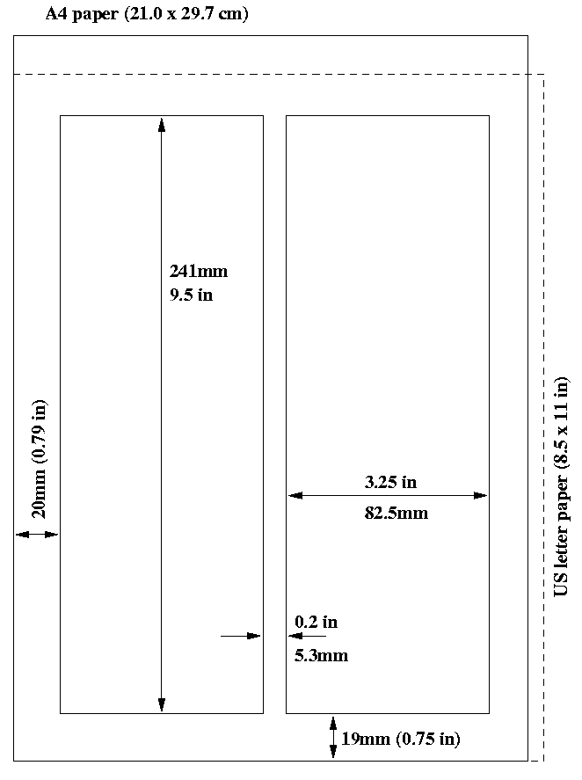
Figure 1: Layout of papers.
Fonts
In order to produce good Adobe Acrobat PDF files, the editorial staff asks authors using a Word template to use only Times New Roman (in bold or italic) and Symbol from the standard postscript set of fonts. The editorial staff is aware of problems processing Asian and Cyrillic fonts and will have experts in these matters available at the conference.

Title and Author List
The title should use 14pt bold uppercase letters and be centred on the page. Individual letters may be lowercase to avoid misinterpretation (e.g., mW, MW). To include a funding support statement, put an asterisk after the title and a footnote at the bottom of the first column on page 1.
The names of authors, their organisations/affiliations and mailing addresses should be grouped by affiliation and listed in 12pt upper and lowercase letters. The name of the submitting or primary author should be first, followed by the co-authors, alphabetically by affiliation.

Figure 2: Example of a full-width figure showing the distribution of problems commonly encountered during paper processing. This figure is labeled with a multi-line caption which has to be justified, rather than centered.

Section Headings
Section headings should not be numbered. They should use 12pt bold uppercase letters and be centred in the column. All section headings should appear directly above the text—there should never be a column break between a heading and the following paragraph.

Subsection Headings
Subsection headings should not be numbered. They should use 12pt italic letters and be left aligned in the column. Subsection headings should appear directly above the text—there should never be a column break between a subheading and the following paragraph.

Paragraph Text
Paragraphs should use 10pt font and be justified (touch each side) in the column. The beginning of each paragraph should be indented approximately 3 mm (0.13 in). The last line of a paragraph should not be printed by itself at the beginning of a column nor should the first line of a paragraph be printed by itself at the end of a column.

Figures, Tables and Equations
Place figures and tables as close to their place of mention as possible. Lettering in figures and tables should be large enough to reproduce clearly. Use of non-approved fonts in figures can lead to problems when the files are processed. Please use the approved fonts when possible [2].
All figures and tables must be given sequential numbers (1, 2, 3, etc.) and have captions (10pt font) placed below figures and above tables being described. Captions that are one line should be centred in the column, while captions that span more than one line should be justified.
Text should not be obscured by figures. For more information on working with figures in Microsoft Word (including how to insert them in the most efficient manner), see the Microsoft Word help files.
If a displayed equation needs a number, place it flush with the right margin of the column (see Eq. 1). The equation itself should be centered, if possible. Units should be written using the roman font, not the italic font.
(1)

References
All bibliographical and web references should be numbered and listed at the end of the paper in a section called “References.” When referring to a reference in the text, place the corresponding reference number in square brackets [3]. A URL may be included as part of a reference, but its hyperlink should NOT be added.

Footnotes
Footnotes on the title and author lines may be used for acknowledgements, affiliations and e-mail addresses. A nonnumeric sequence of characters (*, #, †, ‡) should be used. All other footnotes should be included in the reference section and use the normal numeric sequencing.
Word users—do not use Word’s footnote feature (Insert, Footnote) to insert footnotes, as this will create formatting problems. Instead, insert footnotes manually in a text box at the bottom of the first column. Footnotes should only appear at the bottom of the first column on the first page.

Acronyms
Acronyms should be defined the first time they appear.

Styles
The following table summarizes the fonts and spacing used in the styles of a JACoW template.
Table 2: Summary of Styles
Style | Font | Space  Before | Space  After
Title | 14pt  Uppercase except for  required lowercase letters  Bold | 0pt | 3pt
Author list | 12pt  Upper- and Lower case | 9pt | 12pt
Section  heading | 12pt  Uppercase  bold | 9pt | 3pt
Subsection  heading | 12pt  Initial caps  Italic | 6pt | 3pt
Figure  captions | 10pt | 3pt | 6pt
Table  captions | 10pt | 3pt | 3pt
Equations | 10pt base font | 12pt | 12pt
References | 10pt, justified with  0.25” hanging indent | 0pt | 0pt

Page Numbers
DO NOT include any page numbers. The editorial staff will add them when they produce the final proceedings.

Templates
Templates and examples can be retrieved through Web browsers like Netscape and Internet Explorer by loading to disk. See your local documentation for details about how to do this.
Template documents for the recommended word processing software are available from the JACoW Website and exist for LaTeX, Microsoft Word (Mac and PC) and OpenOffice.org for US letter and A4 paper sizes.
Authors are required to use templates for the correct paper size and advised to use the template corresponding to the correct version of Word. Do not transport the document across different platforms e.g. Mac↔PC.
Please see the help files for instructions on how to install templates in your Microsoft templates folder.

Checklist for electronic Publication
- Use only Times New Roman (bold or italic) and Symbol fonts for text—10pt minimum.
- Figures should be in Times New Roman (bold or italic) and Symbol fonts when possible—6pt minimum.
- Check that the postscript file prints correctly.
- Check that there are no page numbers.
- Check that the margins are correct on the printed version. There may be differences of ±1 mm on the margins from one printer to another.

References
[1] C. Petit-Jean-Genaz and J. Poole, “JACoW, A Service to the Accelerator Community,” EPAC’04, Lucerne, July 2004, THZCH03, p. 249 (2004); http://www.JACoW.org.
[2] A. Name and D. Person, Phys. Rev. Lett. 25 (1997) 56.
[3] A.N. Other, “A Very Interesting Paper,” EPAC’96, Sitges, June 1996, MOPCH31, p. 7984 (1996); http://www.JACoW.org.

