There are five links in the home page of my assignment. All the links are kept in other new pages to. The links are set in a way that they will open in the same tab but not in new tab.

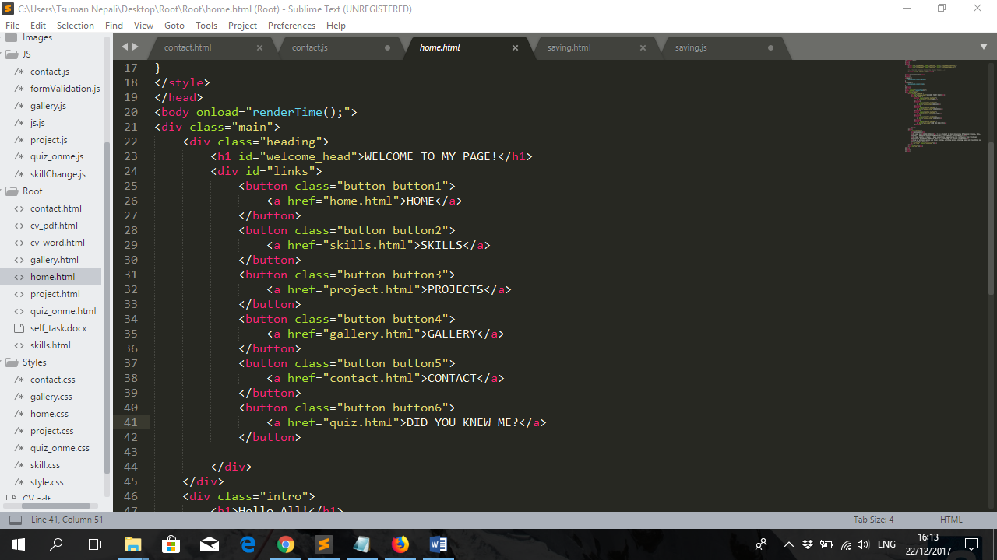

All the buttons hovering properties, backgrounds, headlines are set in CSS file called style.css where as the paragraph and for time showing clock their properties are stated in home.css.

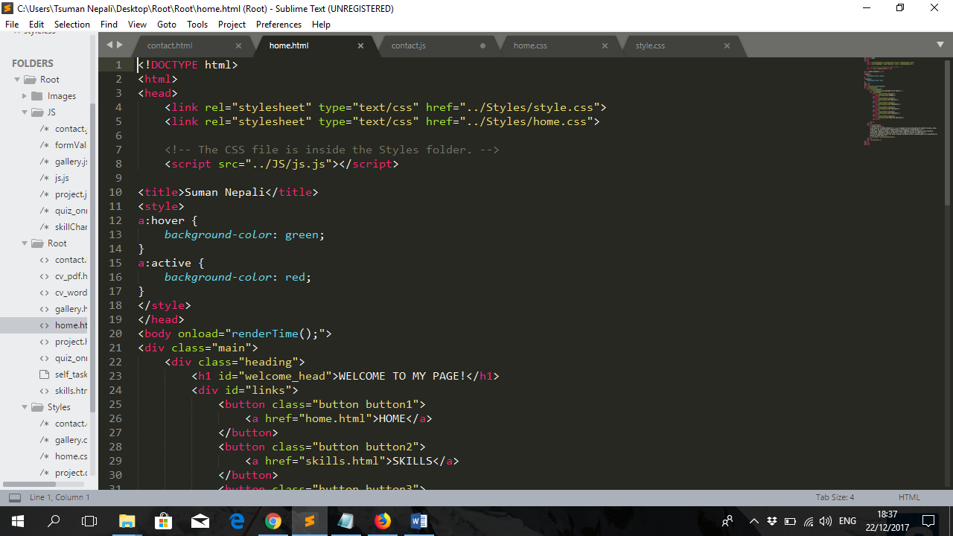

At the below of page there comes current time and date. The function defined on <body> tag "renderTime() loads the time on loading of the page.

After Home button, there comes Skill button. This page will lead you to my skill.html page. Here you can add one skill and this skill will be displayed at top of list and the last one will automatically get deleted. For this I uses combination of two javascript functions myCreateFunction() and myDeleteFunction() in my code. myCreateFunction will add the inputs in the first row where as another function will delete the existing last row. Also there are link for my CV in word as well as pdf format, where you can download it.

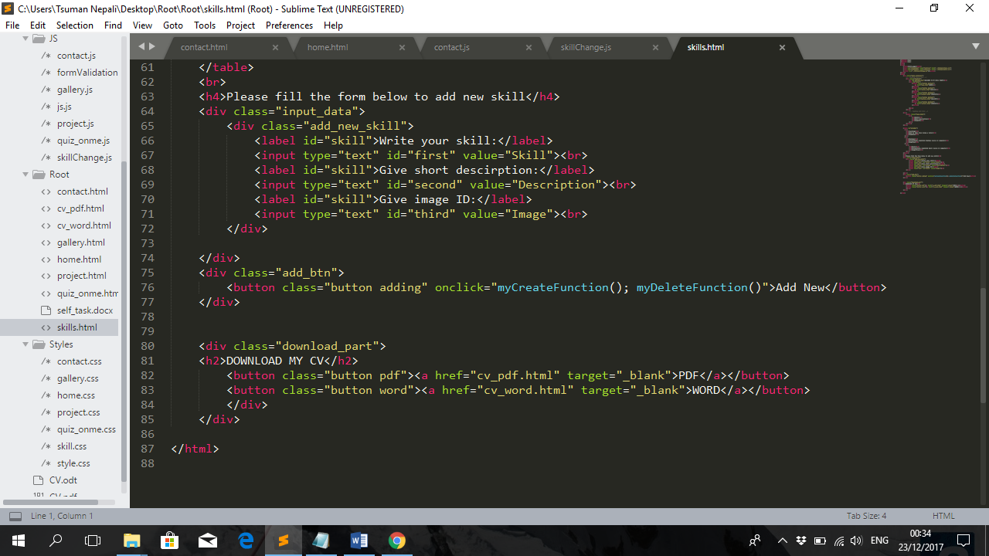

Another button in my home page is Projects. In this page you can see the list of my projects. Here when your pointer is at my first project there appears an alert box saying, “You are at my first project” similarly on scrolling it says, “You have scrolled the page”. For all these effects I have used javascript. For first case I have made a division and inside it I set a function that reacts on hovering mouse inside the div. Here is the way I defined it. <div onmouseover="first_div()">.

Similarly for scrolling, <body onload="project_part()" onscroll="message()" > .

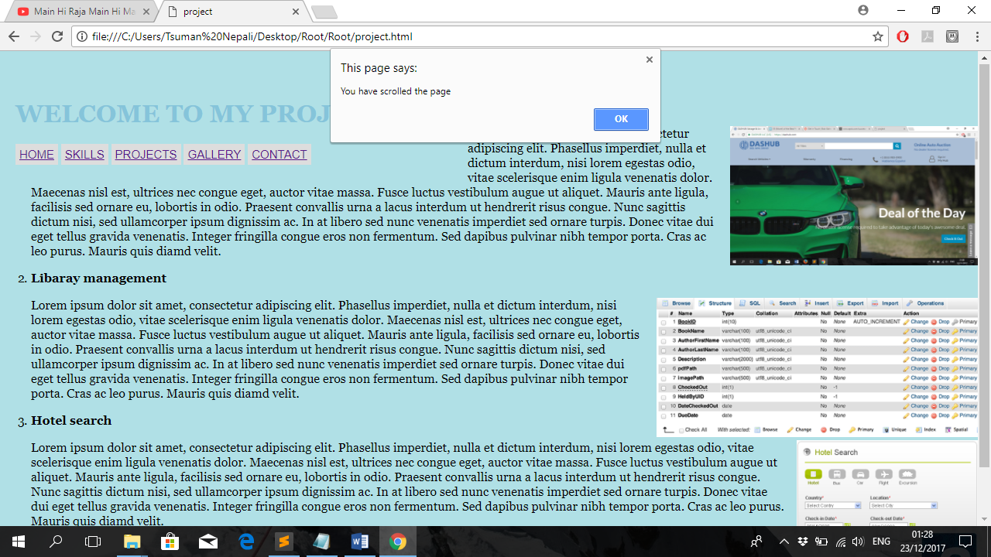

In Gallery you can see my selected photos. There is description at the bottom part of photo. You can change the photo with the arrow button present in both side of photo.

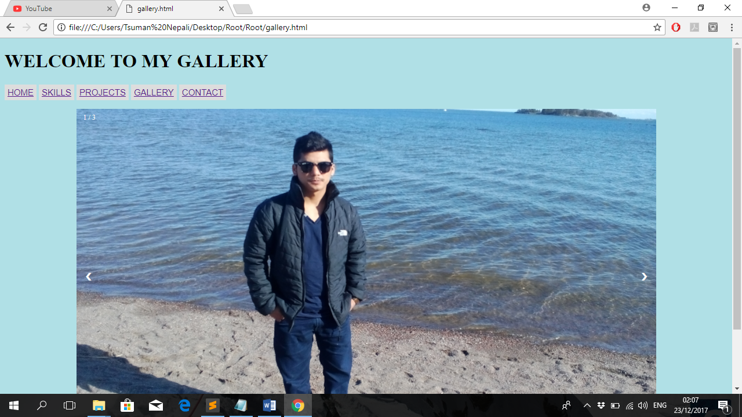

At last there is contact button. On clicking this button, you will reach the section from where you can take my contact detail. You can leave a message by filling up the available form there. There are two functions myFunction and check_info. myFunction reset all the inputs where as check_info does the validation part.

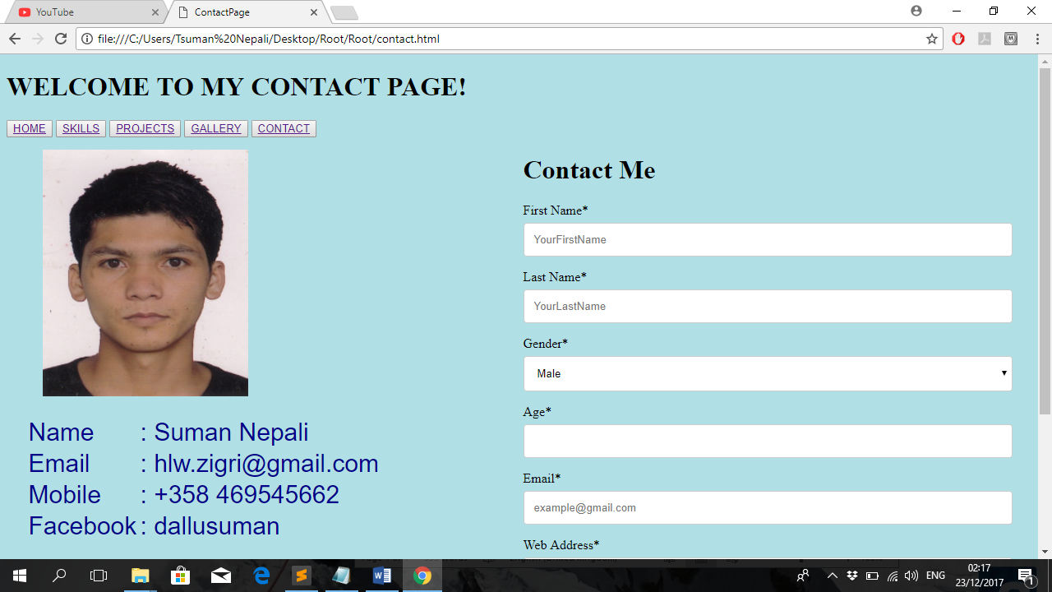

**How it went**

Well the course was interesting. I tried my best to perform the best. However, while comparing the course content and the level of project is vast difference. Well course content is almost perfect it has covered every part related to HTML and CSS. But while doing project there still comes a situation where we need to google for the topic.