1. Object

* Object is simply saying that “instance” of class.

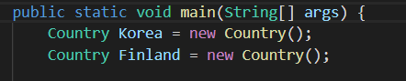

1. Class

* Class is description of object features.

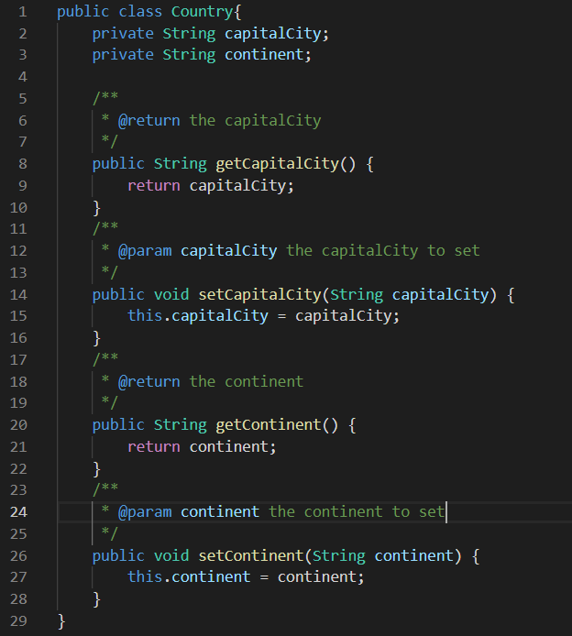

1. Instantiation of object (Creating an object)

* Instantiation of object is that declaring the class type object with reference.

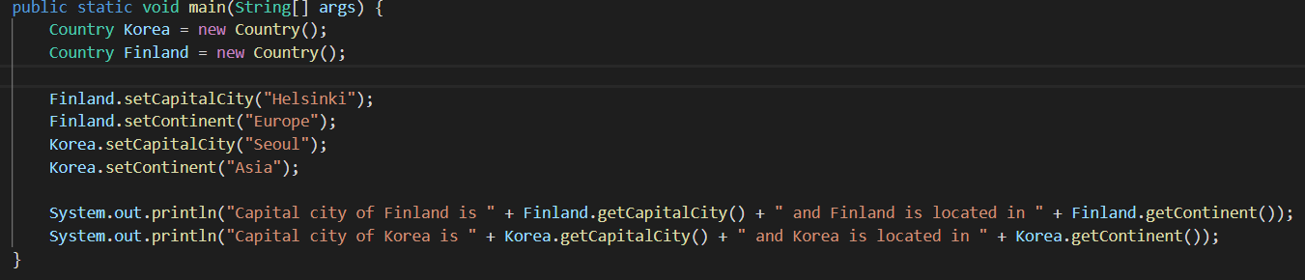

1. Visibility (public/ private /protected)

* Visibility is more like accessibility. if class, method or data field were declared public then that is able to get accessed from other class which means outside of class.

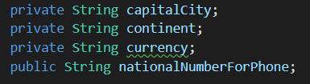

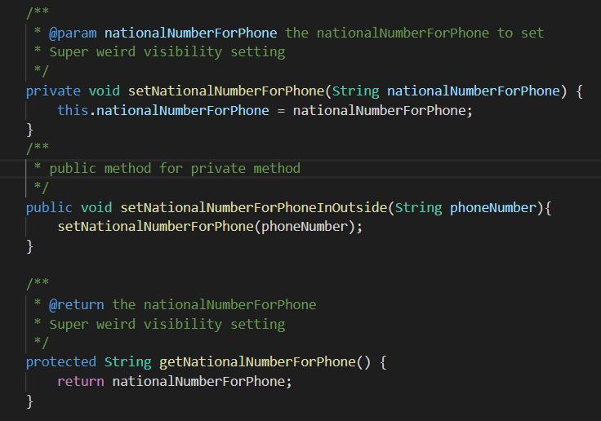

1. Member data / methods

* Member data / methods are feature that class includes for using or saving.

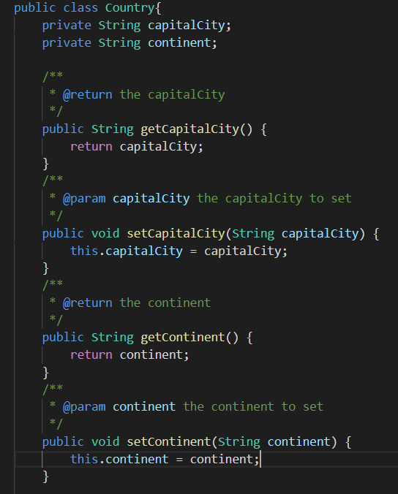

1. Inheritance

* Inheritance is that inherits the features of parent class so that child class would have features to use as same as parent class has.

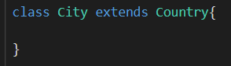

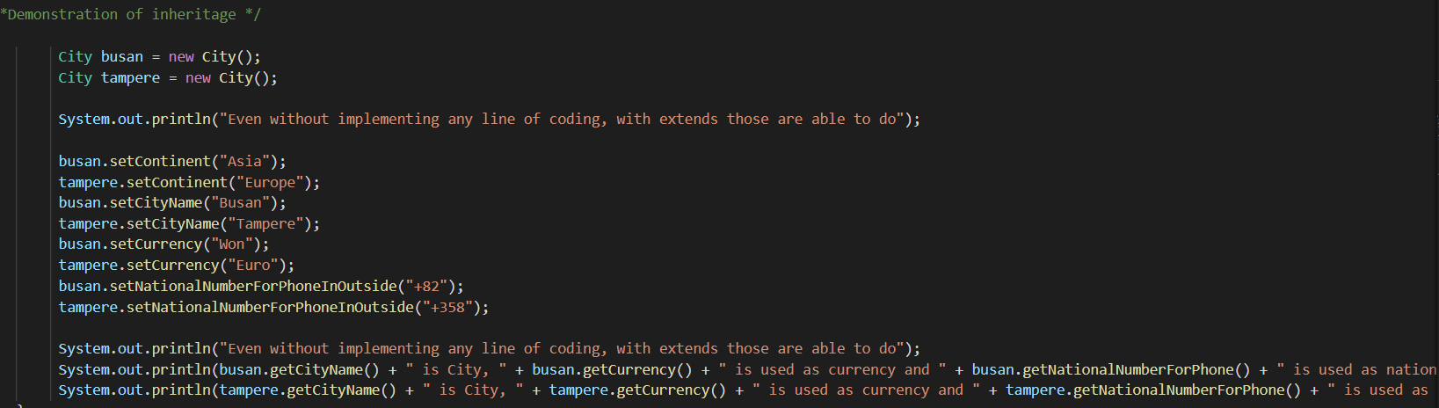

1. Interface

* Interface is that describing blueprint of class so when other class implements the interface class, it must follow the interfaces described methods and normally it is explaining itself what it expected to behave.

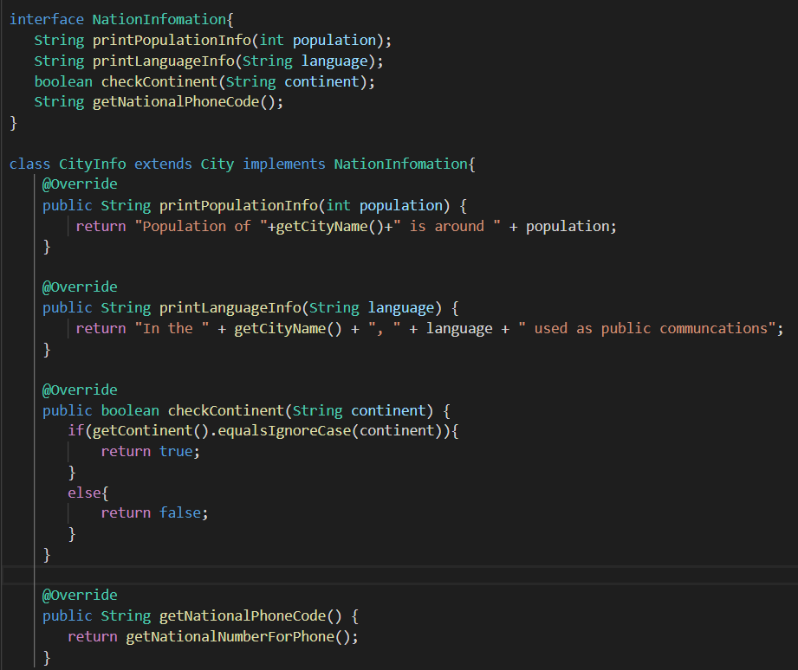

1. Polymorphism

* Polymorphism is the ability of an object to take on many forms like if one class is inheriting the parent class then parent class reference is used to refer to a child class object.

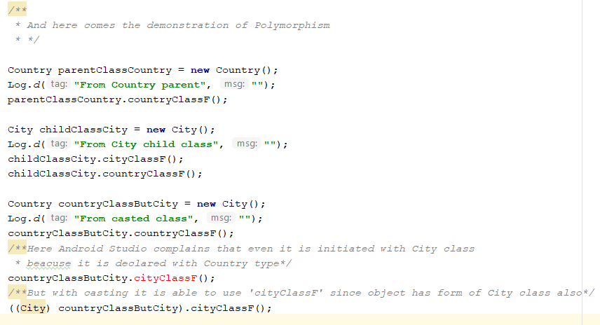

1. Overriding

* Overriding is when inheriting the parent class, child class could modify the inherited methods for own use.

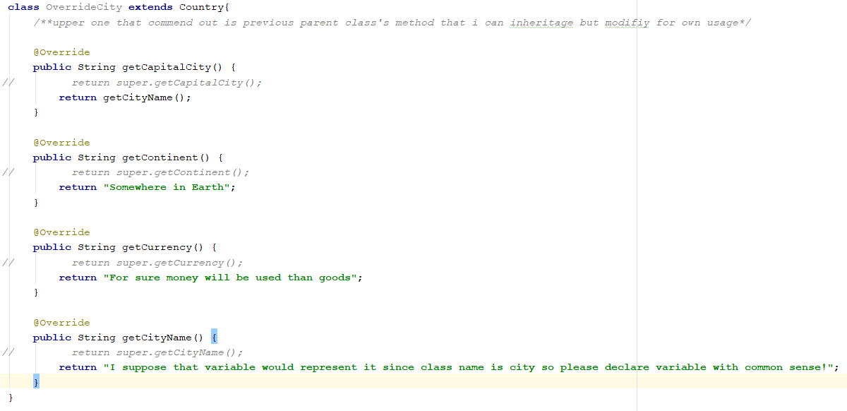

1. Abstract classes

* Abstract classes are that class declared with abstract keyword with describing the only basic big frame. It can not be instantiated.

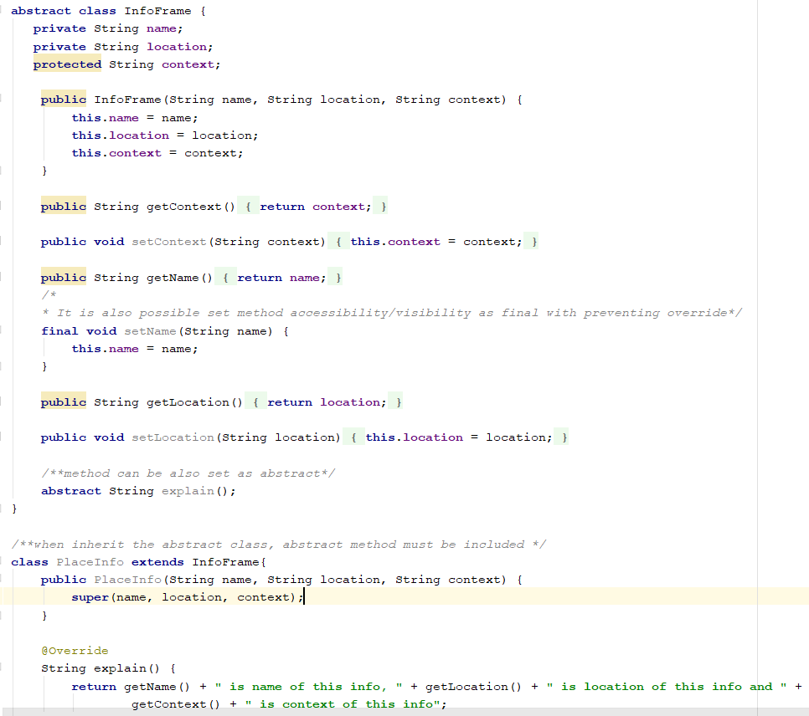

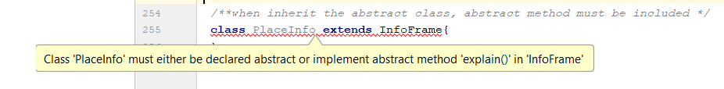

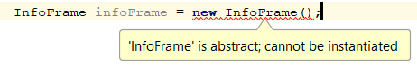

1. What programming languages you can use for Android app development?

- Kotlin, Java and C++ languages

1. What is .apk file?

- File that includes all the Android app contents, installer, codes, data and resources used when the SDK tool compiles.

1. How Android system runs apps?

* Basically, app runs in its own Linux process in own VM, Android system assigns every apps own files’ permission with each apps own unique Linux user ID so that only allowed app can access the files that restrained by Linux permission setting. Basic principle of Android system is that it must recover memory with running the process whenever it required such as apps components need to be executed unless it stops for other apps.

1. Name four types of Android components. Describe each.

* **Activities** / User interface component that monitors current screen so that make system keep prioritize the processes among users’ activities.
* **Services** / General purpose component that runs in the background for all kinds of reasons. It is for operations that runs long or remote processes.
* **Broadcast** **receivers** / Gateway component that bridge the components with enabling the Android system to execute tasks to the app extended range of basic user’s boundary, allowing app to interact with Android system wide broadcast announcements.
* **Content** **Provider** / Data component that manages shared app data which user can store in the file system so that other apps can query or modify the data if the content provider allows it.

1. What is manifest file and what is its purpose?

* It is a file that saved all the information for the app such as app’s all components, minimum API level that app supports, permissions that app needed to use, hardware or software feature that app needed to use and API libraries the app needs to be linked against.

1. What are resources? Why they are needed?

* Resources are files that required to use for app’s visual presentation. such as images, audios, xml files that defined all values for user interface.
* They are needed for many reasons but one of important reason is that ability to support proper configuration responsively even in many different devices.