**Project Work – Math tools_DevBasicSkills2017-8**

Kihun Han

Oulu University of Applied Sciences

contents

1 Introduction 3

2 THE WORK ENVIRONMENT 3

3 Definition 4

4 Implementation 4

5 Testing 7

6 POSSIBILITIES OF FURTHER DEVELOPMENT 10

7 conclusion 10

# 1 Introduction

In 2017, second periods of study year, Developer Basic Skills courses finish with a project work. Task is that design and implement a web based mathematics tool for number system conversions, number system outputs chart, combinatorics calculator, basic operations’ truth table, random number creator, and design own.

**2 THE WORK ENVIRONMENT**

There was no problem for mathematic conceptions as project subject because number system conversions, combinatorics and truth table are all studied conceptions in mathematic course of current period of study year and random value was handled little in last periods’ basic programming course. As own design, i chose most familiar conception for me trigonometric function values.

For planning and controlling the schedule, Microsoft Office (Project, Excel, Words) are used and as basic wireframing, Balsamiq is used and for editing images, Windows basic Paint is used.

Mainly, for implementation Visual Studio Code is used for constructing html pages and Javascript functions and for controlling task files and backup, Github is used.

For testing Javascript functions and inspecting the html pages’ layout on the progress, Chrome browser’s Developer’s tool function is used and as final test, Chrome web browser and Firefox web browser is used.

**3 Definition**

Project work “Mathematics tool” has 6 functions.

Firstly, “Number system conversions” converts from one numbering system to the other numbering system among decimal, binary, octal, and hexadecimal.

Secondly, “Number system outputs” print the table that shows decimals from 0 to 50 in binary, octal, and hexadecimal.

Thirdly, “Combinatorics” provides calculator for combinations and permutations with replacement or not when knowing number of elements and number of events.

Fourthly, “Truth Tables” shows basic operations’ truth tables.

Fifthly, “Random Values” creates the random numbers with options

Lastly, “Trigonometric Function Values” calculates Sin, Cos, Tan degree as number values.

For running “Mathematics tool”, minimum requirement is PC or Laptop which is able to run Chrome browser or Firefox browser. For the best performing, recommend to use monitor size as use 15.6” or bigger, internet connection for video instruction and Chrome browser.

**4 Implementation**

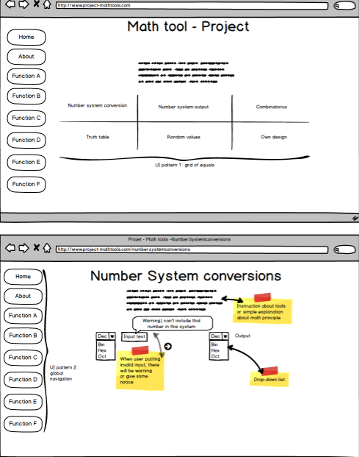Started with making basic user interface with balsamiq then started to figure out Javascript functions constructions.

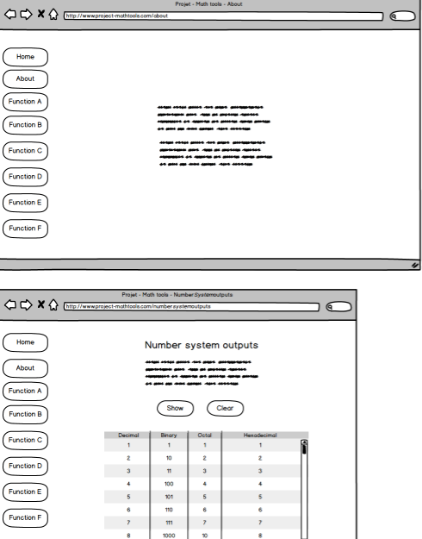

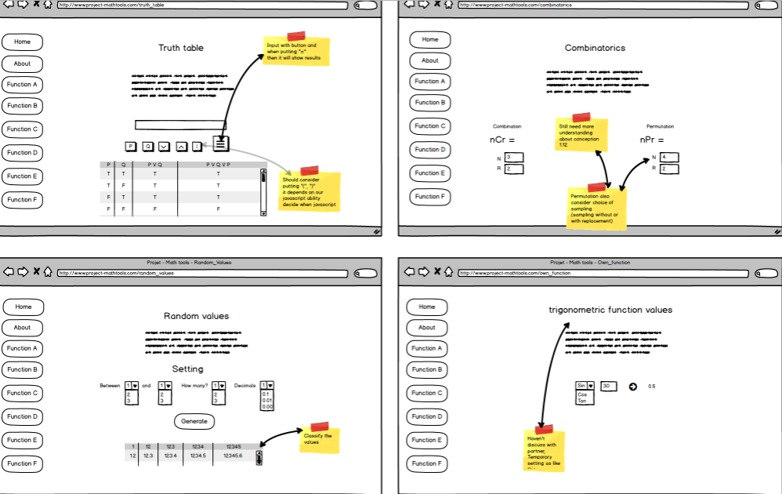

In the number system conversion function, prefix is used because when trying to figure out function for it, found out that in Javascript object Number reads number with different prefixes as different number systems. So with document object’s “getElementsById()” method get user’s choice of number system from selection then put prefix for number system of users’ choice on beginning of input box. Then document object’s “getElementsById()” method will take value as string from input box because for hexadecimal number system, users need to write also letter so set input type as text. After getting value then change as number value which is decimal value with Javascript object Number, at this point users’ input with prefix will be read as different number system by Javascript object Number. Then with decimal values it will be converted with “toString” method as users’ choice of destination number system with getting document object’s “getElementsById()” method from selection.

In the number system outputs, tried to print inside of Html page directly with using document object “write”. In Html page, middle of table row I put “script” section directly with “for loop” also making another table row and data cell.

In combinatorics, set most common factorial function first then used in other function as simple rules of combination and permutation without replacement. In permutation with replacement, used “Math.pow” method for rule of permutation with replacement.

In truth table, I’ve difficulty for figuring out how to express operations’ variables. So I set array in advance for operations with two variables and with three variables. In this function, tried inserting methods for table. Put empty table with “id” then set the “for loop” for taking variables from pre-set arrays with index and then put two variables with operation mark in truth value’s data cell.

In random values, I could learn how to make random number with “Math.random” method within range setting as ”random method x (Max_number – Min_num + 1) + Min_num“ then for expressing as integer used “floor” method, for expressing decimal points used “toFixed” method then with “push” method added to empty array for arranging in order. After getting all numbers to array then it will print sorted values with using “sort” method. In middle of progress for preventing more bigger number I set as if value were more bigger than maximum arrange then made it go to function itself first but there came error so I got advice from teacher and after beta test, tester pointed out there are no repetition and arranged number doesn’t give truly random number impression so added option for it.

In own design, I chose trigonometric function values, if users gave degree number as value it would change as radians with multiplying “π/180” then change as numeric value with Javascript Math object’s methods(sin, cos, tan). But there was error that it gave wrong result at specific value. I found out that “π” is infinite number so it wouldn’t give exact number as result so I got advice from teacher that I should round up for it so I used “toFixed” method.

Then, trying to set layout following the very first design but I noticed that it’s so simple and couldn’t learn so many things from it. So I decided to learn with trying to look similar with popular other websites’ style. Also tried to make it practical layout so that it would be useful when users make half screen size(from 15.6” which is mine) and other half for mathematics’ quiz or tasks that needed tools.

**5 Testing**

When making plan at beginning, planned to have 4 days of test but it was for extra dates with flexible schedule because expected to take more time in constructing Javascript functions and Html pages layout.

Didn’t set specific way of test at very beginning when planning but middle of progress planned first α-test after completing construction of Javascript functions with basic Html pages layout, second α-test after completing also Html pages layout, β-test with students in same year as users after second α-test and then final test after β-test.

Couldn’t perform proper first α-test because of uncompleted part of Javascript functions’ construction.

Managed to perform second α-test and β-test on time following changed schedule plan. Performed second α-test with two different web browsers Google Chrome and Firefox for focusing Html pages’ overall layout and Javascript functions’ functionality and got positive results.

Then performed β-test to students in same year as users with quiz form for checking functionality to check.

Got positives results but users could find few functionality defect and gave feedbacks about functions and layout. Then final test will be performed last day of scheduled test day 15.12 at evening after this report.

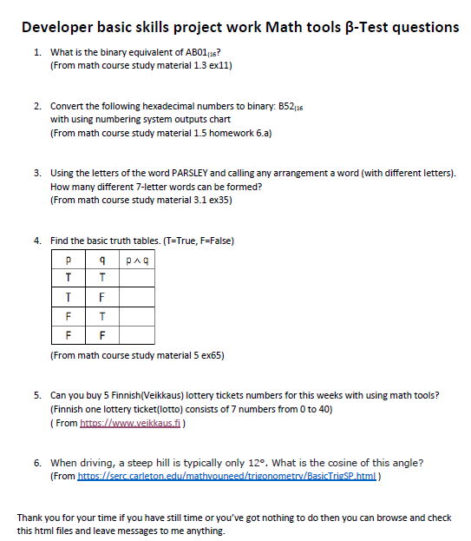

**Beta-Test Result Feedback Report**

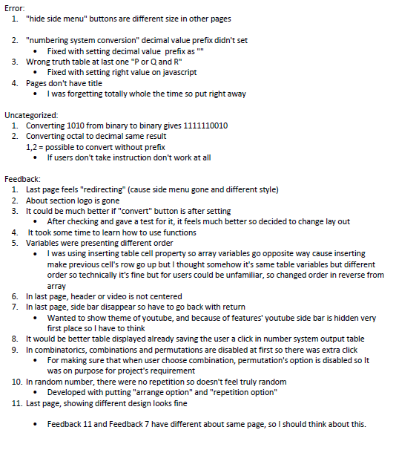

**6 POSSIBILITIES OF FURTHER DEVELOPMENT**

Number system conversions can be better because if user removes prefix, function wouldn’t work so instead of using prefix it would be better with taking values from input box to array and making “for loop” that taking value one by one from array with index and value will be chosen number system’s power value with using “Math.pow” method then it will be decimal value after added altogether and then with “toString” method it can be converted as destination number system value.

Number system outputs can be also better with using movable CSS style so users can put wherever they want to see so it will be more useful in aspect of space and with hovering CSS style, users can mark with cursor noticeably which values they want to see or they’re checking.

Combinatorics can be also nice if Html page’s layout were arranged better. Instead of arranging the contents with “table”, later I found it out that can be expressed like “table” with “div” tag.

If I could find out, I would try to make it better truth table as designed very first with taking input values from users and print truth table as users choice with better algorithm for making variables depends on users’ choice.

**7 conclusion**

I could learn many things about Html page layout and CSS style and understand better than before about Javascript. For Html page layout, I noticed that begin with setting reasonable and proper layout structure is important and when writing Html elements in html file, again I noticed that clear indents are important so it wouldn’t look confuse. And for CSS style, there are many ways for expressing specific things so I felt that I need more exercises. For Javascript, I felt that my scripts are too long so doesn’t feel so ideal because personally, short scripts are better. Lastly, could experience that test is important that could get unexpected feedback when constructing and different point of views.