**PROJECT PHOTOBOOTH**

PROJECT CLOSING REPORT VERSION 0.01

THE VERSION HISTORY OF THE DOCUMENT

|  |  |  |  |
| --- | --- | --- | --- |
| VERSION No. | DATE | REASON FOR CHANGE | AUTHOR/ACCEPTOR |
|  |  |  |  |
| 1.0 | 29.5.2015 | Approved | MEST |
| 0.1 | 28.5.2015 | Initial version | MEST |

LIST OF CONTENTS

1 THE DESCRIPTION OF THE PROJECT 4

2 RESULTS OF THE PROJECT 4

2.1 Description of the System 4

2.2 Description of the Hardware 5

2.3 Description of the Software 6

3 GENERAL EVALUATION OF THE PROGRESSION OF THE PROJECT 9

4 THE EXPERIENCES OF THE USED TOOLS AND METHODS 9

5 PERSONAL EXPERIENCES AND LEARNING 10

5.1 Agent Kaisa's experiences 10

5.2 Agent Kalle's experiences 10

5.3 Agent Lotta's experiences 10

5.4 Agent Niina’s experiences 10

6 SELF-EVALUATION OF THE STUDY MODULE 11

6.1 Agent Kaisa's self-evaluation 11

6.2 Agent Kalle's self-evaluation 11

6.3 Agent Lotta's self-evaluation 11

6.4 Agent Niina’s self-evaluation 11

# THE DESCRIPTION OF THE PROJECT

In this project the aim was to connect Raspberry Pi Camera Module V2 and a button to Raspberry Pi computer board, and create small application, which uses Camera Module and button to take a picture which also saves it on the cloud.

Projects criteria was to implement Python 3 application works on Raspberry Pi, which uses database on the cloud for storing data, or it uses some Web API with the data of a Raspberry Pi application.

# RESULTS OF THE PROJECT

## Description of the System

The system diagram of the product is shown in Figure 1. The hardware system that we worked on, consisted of a Raspberry Pi computer board, Raspberry Pi Camera Module and a button. Together with this we are using MySQL database, which connects to our Android application.

Raspberry Pi updates taken picture data to the MySQL database, where the picture is accessible. Android application shows the wanted picture as in last result, which works as our Web API on the context.

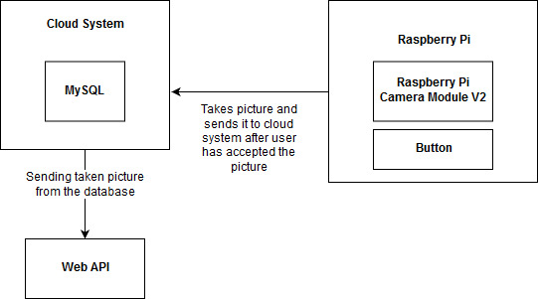

FIGURE 1. System diagram of the product

## Description of the Hardware

First, the Camera module was connected to Raspberry Pi and a button with jumper wires as shown in Figure 2. The corresponding schematic diagram is in Figure 3.

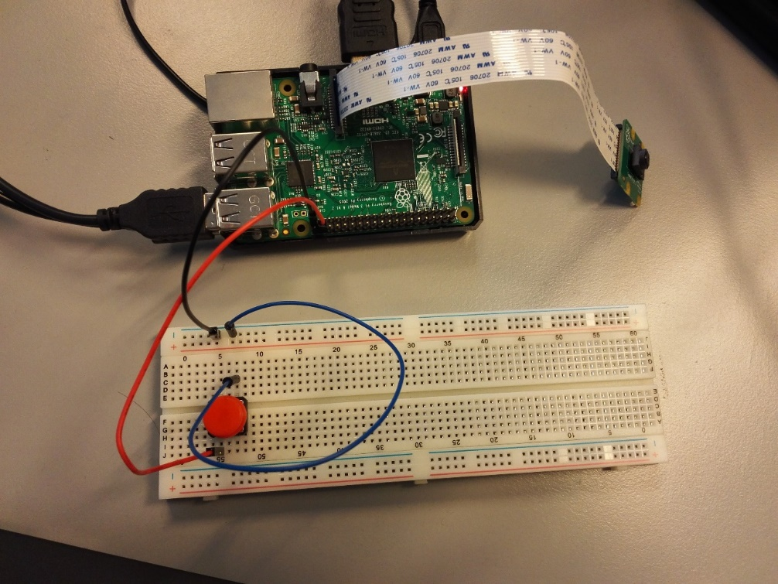

FIGURE 2. Connecting camera and button to Raspberry Pi

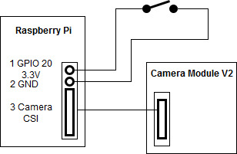

FIGURE 3. Schematic diagram of the connection of the button and Camera Module to Raspberry Pi

## Description of the Software

The programs run in Raspberry Pi and on the MySQL cloud system were developed using Visual Studio and Thonny development tools.

For the picture taking program called photobooth.py was written, which made GUI for picture taking and button to send it to the MySQL. The activity diagram of the program is in Figure 4.

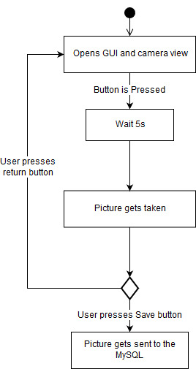



FIGURE 4. Activity diagram of the photobooth.py program

Another program was written to display taken picture on Web API. The program was written using Node JS and React. The activity diagram of the acceleration measurement software is in Figure 5.

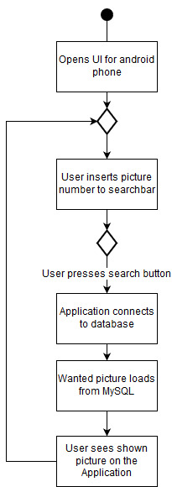

FIGURE 5. Activity diagram of the Web API program

# GENERAL EVALUATION OF THE PROGRESSION OF THE PROJECT

The project was progressed during the classes on this period. This project went rather closely according to the original plan with Raspberry Pi, as well with building the hardware, but Web API planning and building went in a rush. Web API was the only delay in finishing the project. Fortunately, the project was finished on the presentation week.

# THE EXPERIENCES OF THE USED TOOLS AND METHODS

The hardware tools were easy to use, and we had no problems in building the Hardware setup. The software development environment was easy to use, but all the programming would have gone way smoother if we had more experience with using cloud database together with Raspberry Pi or if we had more simpler instructions how to use it all together.

There appeared issues with the documentation, since the project was limited in some spectrum. Lack of time and instruction information the project was a bit rushed and we could have spent way more time on it. Maybe a 6 credit Raspberry Pi with Databases course would be a good idea.

# PERSONAL EXPERIENCES AND LEARNING

## Agent Kaisa's experiences

The project was quite simple but had enough new things to learn to make it a decent exercise. I enjoyed working with the Raspberry Pi and Python code. Python wasn’t very familiar to me before this project, so I learned a lot about it. I also learned how to use Python to update MySQL databases.

## Agent Kalle's experiences

Working with external databases with Android was new thing and proved to be more difficult than expected. Raspberry and python coding did not provide anything new. Creating a database was good reminder on how it is done.

## Agent Lotta's experiences

At start I didn’t know anything about Python, now it’s more familiar and comfortable to use. Also, Raspberry Pi was new to me, and I found it very interesting. Project idea was simple but had a lot new things to learn for me.

## Agent Niina’s experiences

This was experimental project. I liked to build the hardware system and work with python coding. I believe after this project I can confidentially work with Raspberry Pi together with Thonny. Having programmed a bit before, there was a new information to learn about the programming. I found this project as a decent exercise.

# SELF-EVALUATION OF THE STUDY MODULE

## Agent Kaisa's self-evaluation

I think we succeeded pretty well in this project. It could have been better if we had more time, since some of the code had to be rushed. The project was still completed in time, and I did learn about Python, so I’m pleased about the outcome.

## Agent Kalle's self-evaluation

I learned a lot about handling an external database in Android and web sites. With more time, I could have succeeded on getting right data out from database. I am going to look more and dig deeper on this problem later. Working with raspberry did’ t provide a lot of challenge since most of the thing I did, I was familiar with.

## Agent Lotta's self-evaluation

I think we learned a lot about coding and working with Raspberry Pi, and at those parts we succeeded. Code was rushed, but in given time I think we did well.

## Agent Niina’s self-evaluation

If evaluated based on the final outcome, we succeeded alright. The project was completed in the allocated time with Raspberry Pi code, but the Application code was rushed on the last weeks of the project. As well the work repost were of good quality. I learned some coding with Raspberry Pi, which I’m quite happy about.

REFERENCES

1. Laiteläheinen ohjelmointi tehtäväannon kriteerit. 2018.
2. git.code.sf.net/p/llo/code llo-code