

PLASTIC WASTE COLLECTION AND RECYCLING
MANAGEMENT SYSTEM (PWMS)

A CAPSTONE PROJECT REPORT
A Capstone Project Report submitted in partial fulfilment of the requirements for the Course of
CSA0802 – Python Programming
to the award of the degree of
BACHELOR OF ENGINEERING / BACHELOR OF TECHNOLOGY
IN
COMPUTER SCIENCE AND ENGINEERING
Submitted by
T. Aditya (192565068)
Under the Supervision of
Dr. A. Jagatheesan
SIMATS ENGINEERING
Saveetha Institute of Medical and Technical Sciences
Chennai-602105

SEPTEMBER 2026

SIMATS ENGINEERING
Saveetha Institute of Medical and Technical Sciences
Chennai-602105

BONAFIDE CERTIFICATE

This is to certify that the Capstone Project entitled “Plastic Waste Collection and Recycling Management System” has been carried out by K. Pavan Kumar (Reg. No. 192524333), K. Yathish Chandra (Reg. No. 192524323) and T. Aditya (Reg. No. 192565068) under the supervision of Dr. A. Jagatheesan and is submitted in partial fulfilment of the requirements for the current semester of the B.E. / B.Tech Computer Science and Engineering programme (Course CSA0802 – Python Programming) at Saveetha Institute of Medical and Technical Sciences, Chennai.

COURSE COORDINATOR  Dr. A. Jagatheesan  Department of Computer Science and Engineering  SIMATS Engineering, SIMATS, Chennai – 602105. | COURSE FACULTY  Dr. A. Jagatheesan  Department of Computer Science and Engineering  SIMATS Engineering, SIMATS, Chennai – 602105.

SIMATS ENGINEERING
Saveetha Institute of Medical and Technical Sciences
Chennai-602105

DECLARATION

We, K. Pavan Kumar, K. Yathish Chandra and T. Aditya of the Department of Computer Science and Engineering, SIMATS Engineering, Saveetha Institute of Medical and Technical Sciences, Chennai, hereby declare that the Capstone Project Work entitled “Plastic Waste Collection and Recycling Management System” is the result of our own bonafide efforts. To the best of our knowledge, the work presented herein is original, accurate, and has been carried out in accordance with the principles of engineering ethics and academic integrity. All sources, references, data, and other materials used in the project have been appropriately acknowledged. We further declare that the data, results, analysis, and findings presented in this report have not been fabricated, falsified, or manipulated. Any external tools, software, datasets, computational resources, or AI-assisted tools used during the project have been appropriately disclosed. We confirm that all applicable ethical, academic, institutional, and professional requirements have been duly followed throughout the planning, execution, analysis, and documentation of the project.

Place: Chennai
Date: September 2026
Signature of the Students with Names
K. Pavan Kumar
K. Yathish Chandra
T. Aditya

SIMATS ENGINEERING
Saveetha Institute of Medical and Technical Sciences
Chennai-602105

Individual Contribution Statement
(Mandatory for all team projects)
Student Name / Reg. No. | Specific Responsibilities | Design & Development Contribution | Testing & Analysis Contribution | Report Contribution | Approx. %
K. Pavan Kumar 192524333 | Backend logic, route-optimization algorithm, data model design | Implemented Dijkstra's algorithm and collection-point data structures | Unit tested route optimization and API responses | Chapters 2, 3 | 34%
K. Yathish Chandra 192524323 | Frontend dashboard, UI/UX, module integration | Built the Dashboard, Collection, Segregation and Monitoring interfaces | Cross-browser and usability testing | Chapters 1, 4 | 33%
T. Aditya 192565068 | System testing, documentation, deployment support | Assisted with Load-Demo data seeding and report export feature | Verification of KPIs and functional test cases | Chapters 4, 5, References | 33%
Total: 100%

ABSTRACT
Plastic waste generation continues to rise sharply across households, industries, schools and commercial establishments, and inefficient collection, segregation and recycling practices have made it a pressing environmental engineering problem contributing to land and marine pollution, wildlife harm and public-health risk. The absence of an integrated, data-driven mechanism to track how plastic waste moves from the point of generation through collection, segregation, recycling and disposal makes it difficult for municipal and institutional stakeholders to plan collection routes, monitor bin capacity, or measure recycling performance in real time. This capstone project addresses that gap by designing and implementing the Plastic Waste Collection and Recycling Management System (PWMS), a web-based decision-support application that digitises the full plastic-waste lifecycle across five coordinated modules: Collection, Route Optimization, Segregation, Recycling and Monitoring & Reporting.
The proposed system allows collection points to be registered with location, plastic type (PET, HDPE, PP and others), waste weight and smart-bin fill level, and applies Dijkstra's shortest-path algorithm to compute the most fuel- and time-efficient collection route between the depot and multiple bins. Collected waste is then digitally segregated into recyclable and non-recyclable categories following a defined classification workflow, and the results feed a centralised Monitoring & Reporting dashboard that displays Key Performance Indicators — collection efficiency, recycling rate, average bin level and an aggregate sustainability score — alongside visual analytics for waste collected versus recycled versus disposed, and plastic-type distribution.
The system was developed using a modular front-end dashboard architecture with a lightweight data layer, and was verified using a demonstration dataset (225 kg of simulated total waste) to validate module interaction, KPI computation and the correctness of the route-optimization algorithm. Testing confirmed that the collection-point workflow, segregation classification and reporting dashboard operate correctly end-to-end, and that the shortest-path computation reduces theoretical route distance in comparison with a naive sequential-visit strategy. The project demonstrates that a modest, IoT-ready web application, grounded in a well-chosen graph algorithm and a clear data model, can materially improve the transparency, efficiency and sustainability of plastic-waste operations, and it establishes a foundation for future integration with live IoT sensors and municipal fleet-tracking systems.
Keywords: Plastic Waste Management, IoT-Enabled Monitoring, Route Optimization, Dijkstra's Algorithm, Recycling Systems, Environmental Sustainability

TABLE OF CONTENTS
Sl. No. | Title | Page No.
i | CERTIFICATE FROM THE SUPERVISOR | ii
ii | DECLARATION BY THE CANDIDATE | iii
iii | INDIVIDUAL CONTRIBUTION STATEMENT | iv
iv | ABSTRACT | v
v | LIST OF FIGURES | vi
vi | LIST OF TABLES | vii
vii | LIST OF ABBREVIATIONS | viii
1 | CHAPTER 1: Introduction | 1
2 | CHAPTER 2: Literature Review | 5
3 | CHAPTER 3: Engineering Design & Trade-offs, Sustainability, Ethics, Safety, Risk & Security | 9
4 | CHAPTER 4: Implementation, Testing & Results, Project Management | 16
5 | CHAPTER 5: Conclusion & Reflection | 23
 | References | 25
 | Appendices | 26

LIST OF FIGURES
Figure No. | Figure Name | Page No.
3.1 | PWMS System Architecture and Workflow (Collection → Optimization → Segregation → Recycling → Monitoring) | 10
4.1 | PWMS Dashboard – Workflow Progress and Key Performance Indicators | 17
4.2 | Waste Collection Points Module – Collection Point Registration and Smart Bin Status | 18
4.3 | Waste Segregation & Recycling Module – Segregation Process Workflow | 19
4.4 | Monitoring & Reporting Module – System Performance Metrics and Waste Analytics | 20

LIST OF TABLES
Table No. | Table Name | Page No.
2.1 | Comparative Analysis of Existing Waste Management Approaches | 8
3.1 | Stakeholder / User Requirements | 9
3.2 | Functional & Non-Functional Requirements | 10
3.3 | Constraints & Applicable Standards | 11
3.4 | Design Specifications | 12
3.5 | Alternative Solutions Evaluation Matrix | 13
3.6 | Trade-off Analysis | 14
3.7 | Sustainability, Ethics, Safety, Security Evaluation | 15
3.8 | Risk Register | 15
4.1 | Tools / Software / Equipment Used | 17
4.2 | Test Plan & Verification | 21
4.3 | Specification vs. Achieved Results | 21
4.4 | Comparison with Existing Solutions & Achievement of Objectives | 22
4.5 | Project Milestones | 22
4.6 | Roles & Contribution | 23
4.7 | Estimated vs. Actual Cost | 23

LIST OF ABBREVIATIONS / SYMBOLS
Symbol | Description | Unit
PWMS | Plastic Waste Management System | —
IoT | Internet of Things | —
GPS | Global Positioning System | —
PET | Polyethylene Terephthalate | —
HDPE | High-Density Polyethylene | —
PP | Polypropylene | —
KPI | Key Performance Indicator | —
UI/UX | User Interface / User Experience | —
API | Application Programming Interface | —
CPCB | Central Pollution Control Board (India) | —
MoEFCC | Ministry of Environment, Forest and Climate Change (India) | —
kg | Kilogram | unit
CHAPTER 1
INTRODUCTION AND ENGINEERING PROBLEM
1.1 Background
Plastic materials are used extensively across packaging, households, industry and commerce because they are cheap, lightweight and durable, but the same durability means plastic persists in the environment for centuries once discarded. Municipal and institutional waste-management operations in most cities still rely heavily on manual scheduling, undocumented collection routes and paper-based or informal record-keeping, which makes it difficult to know how much plastic waste is generated, where it accumulates, how much is actually recycled, and how efficiently collection vehicles are being routed. Digital technologies — web dashboards, IoT sensors, GPS tracking and graph-based route-optimization algorithms — offer a practical way to bring visibility and efficiency to this process without requiring a complete overhaul of existing collection infrastructure.
1.2 Need for the Project
- Improper plastic disposal directly causes soil, water and marine pollution and contributes to health risks for both humans and wildlife.
- Waste-collection agencies, municipal bodies, recycling facilities and the general public are all affected by inefficient collection and low recycling visibility, yet none of them currently has a shared, real-time view of the process.
- Existing manual systems cannot answer basic operational questions in real time — which bins are near capacity, which plastic types dominate a given area, or what the current recycling rate is — without labour-intensive manual audits.
- From an engineering standpoint, the problem requires the integration of several interacting subsystems (data capture, route computation, classification logic and analytics reporting) rather than a single isolated fix, which makes it a suitable capstone-level system-engineering problem.
1.3 Problem Statement
There is no unified, real-time system that allows plastic waste to be registered at the point of collection, routed efficiently between multiple collection points using an optimal-path algorithm, segregated into recyclable and non-recyclable categories, and reported through consolidated performance metrics — while simultaneously satisfying practical constraints such as limited computing resources at the collection-vehicle level, variable bin fill rates, multiple plastic types with different recyclability profiles, and the need for the dashboard to remain usable by non-technical municipal staff.
1.4 Project Aim
To design, implement and evaluate a web-based Plastic Waste Collection and Recycling Management System that digitises and optimizes the collection, segregation, recycling and monitoring of plastic waste using an efficient shortest-path routing algorithm and a real-time analytics dashboard.
1.5 Project Objectives
- To design a data model capable of representing collection points, plastic type, waste weight and bin fill level.
- To develop a Collection module that allows new waste-collection points to be registered and tracked.
- To model the collection network as a weighted graph and implement Dijkstra's algorithm for route optimization.
- To implement a Segregation module that classifies collected plastic into recyclable (PET, HDPE, PP) and non-recyclable categories.
- To build a Monitoring & Reporting dashboard that computes and visualises collection efficiency, recycling rate, average bin level and a sustainability score.
- To test and evaluate the integrated system against a simulated demonstration dataset and verify correctness of the routing and reporting logic.
1.6 Scope
Included: collection-point registration, smart-bin fill-level tracking, Dijkstra-based route optimization, segregation classification, recycling-progress tracking, and a monitoring dashboard with exportable reports.
Excluded: physical fabrication of smart bins or sensor hardware, live GPS hardware integration, and payment or incentive-reward processing for public participation — these are identified as future work.
Assumptions: collection-point data (location, plastic type, weight, bin level) is entered either manually or via a simulated IoT feed; the underlying road/collection network can be represented as a weighted graph of nodes and edges.
Boundary conditions: the system is evaluated using a browser-based demonstration dataset representative of a single collection zone rather than a full city-scale deployment.
1.7 Expected Engineering Outcome
The expected outcome is a functioning web-based software system (PWMS) comprising an interactive dashboard, a route-optimization algorithm module, a segregation-simulation module and a monitoring/reporting module, validated through a working prototype and demonstrable KPI computation, together with documented evidence of correct algorithmic behaviour and system usability.
CHAPTER 2
LITERATURE REVIEW AND EXISTING SOLUTIONS
2.1 Review Method
Relevant literature, government guidelines and existing commercial/technological approaches were identified through a review of publicly available research on solid-waste management informatics, official guidelines published by Indian regulatory bodies, and published descriptions of IoT-enabled smart-bin and route-optimization systems. Sources were selected for direct relevance to plastic-waste collection, segregation, recycling tracking, and graph-based route optimization.
2.2 Review of Existing Work
Government guidance such as the Central Pollution Control Board (CPCB) plastic-waste management guidelines and the Ministry of Environment, Forest and Climate Change (MoEFCC) Plastic Waste Management Rules establish the regulatory framing for segregation-at-source and extended producer responsibility, but they do not prescribe a specific software architecture for operational tracking. International guidance from the World Health Organization and the United Nations Environment Programme situates plastic-waste mismanagement as both an environmental-health and a single-use-plastics policy problem, reinforcing the need for measurable, data-driven interventions rather than qualitative awareness campaigns alone.
On the technology side, IoT-enabled smart-bin systems reported in the waste-management literature typically use ultrasonic or infrared fill-level sensors to trigger collection alerts, which reduces unnecessary trips but is frequently deployed as a standalone monitoring layer without an integrated route-optimization or segregation-analytics component. Separately, GPS-based fleet-tracking products optimise vehicle location visibility but commonly rely on heuristic or manually defined routes rather than a formally optimal shortest-path computation. Academic work on vehicle-routing and shortest-path problems consistently identifies Dijkstra's algorithm and its variants as an appropriate, computationally inexpensive method for single-source shortest-path route computation on a graph of collection nodes, particularly when the number of collection points is moderate.
2.3 Comparative Analysis
Existing Approach | Advantages | Limitations | Relevance to Proposed Work
Manual/paper-based collection scheduling | Low cost, no technical infrastructure needed | No real-time visibility; error-prone; cannot optimise routes | Baseline against which PWMS improves visibility and efficiency
Standalone IoT smart-bin monitoring | Real-time bin fill-level alerts reduce overflow | No route optimization or recycling analytics; siloed data | PWMS integrates bin-level data with routing and reporting
GPS fleet-tracking software | Live vehicle location; useful for dispatch | Routes are heuristic, not provably shortest-path optimal | PWMS applies Dijkstra's algorithm for optimal routing
Municipal/CPCB reporting frameworks | Establishes regulatory reporting requirements | Prescribes what to report, not how to capture data digitally | PWMS provides the digital data-capture and KPI layer
2.4 Research / Engineering Gap
No single reviewed approach combines (a) structured collection-point data capture, (b) provably optimal route computation between multiple bins, (c) a defined segregation-classification workflow, and (d) a consolidated real-time performance dashboard in one integrated system accessible to non-specialist municipal or institutional staff. This integration gap — rather than any single missing technology — is what the project addresses.
2.5 Proposed Contribution
PWMS contributes an integrated, modular web application that unifies collection-point registration, Dijkstra-based route optimization, segregation simulation and KPI-driven monitoring in a single dashboard, using a lightweight architecture that does not require specialised hardware to demonstrate the underlying algorithmic and data-management logic, while remaining structured so that live IoT and GPS feeds can be substituted for simulated inputs in future iterations.
CHAPTER 3
ENGINEERING DESIGN & TRADE-OFFS, SUSTAINABILITY, ETHICS, SAFETY, RISK & SECURITY
3.1 Requirements
Stakeholder / User Requirements
Stakeholder | Requirement
Municipal / institutional waste-collection staff | Register collection points quickly and view which bins need urgent collection
Recycling-facility operators | See how much and what type of plastic is arriving for segregation and recycling
Sustainability / management reviewers | View consolidated KPIs (recycling rate, sustainability score) without manual data compilation
System administrators | Export reports and reset/reload demonstration data for training or audits
Functional & Non-Functional Requirements
Requirement Type | Measurable Target
Functional | Register a collection point with location, plastic type, weight and bin fill level
Functional | Compute an optimized collection route across multiple bins using Dijkstra's algorithm
Functional | Classify collected plastic into recyclable (PET, HDPE, PP) and non-recyclable categories
Functional | Display real-time KPIs: collection efficiency, recycling rate, average bin level, sustainability score
Functional | Export a system report on demand
Non-Functional | Dashboard must load and reflect KPI updates within 2 seconds of a data change
Non-Functional | Interface must be usable by staff without programming knowledge (no CLI required)
Non-Functional | System must remain functional with at least 50 simulated collection points without noticeable slowdown
3.2 Constraints & Applicable Standards
Standard / Code | Requirement | How Applied in This Project
CPCB Plastic Waste Management Guidelines (India) | Segregation of plastic at source into recyclable/non-recyclable categories | Segregation module classification directly mirrors this categorisation
MoEFCC Plastic Waste Management Rules, 2016 (and amendments) | Tracking and reporting of plastic-waste quantities collected and processed | Monitoring module KPIs (Collected, Recycled, Disposed) map to required reporting metrics
WCAG-aligned UI accessibility practice | Readable contrast and clear labelling for non-technical users | Dashboard uses high-contrast KPI cards and plain-language labels
3.3 Design Specifications
Parameter | Target/Requirement | Unit | Priority
Route computation method | Dijkstra's shortest-path algorithm | — | High
Maximum supported collection points (prototype) | ≥ 50 | nodes | High
Bin fill-level range | 0–100 | % | High
Dashboard refresh on data change | ≤ 2 | seconds | Medium
Plastic-type categories supported | ≥ 3 (PET, HDPE, PP) + Non-recyclable | — | High
Sustainability score scale | 0–100 | score | Medium
3.4 Alternative Solutions & Evaluation
Alternative 1 (Manual sequential collection): the vehicle visits bins in a fixed, pre-defined order regardless of distance or urgency; simple to implement but inefficient.
Alternative 2 (Nearest-neighbour heuristic): the vehicle always moves to the nearest unvisited bin; faster to compute than an exact algorithm but can produce a globally sub-optimal route.
Alternative 3 (Dijkstra's shortest-path algorithm – selected): computes the provably minimum-distance path from the depot to each collection point on a weighted graph, enabling a globally efficient route plan.
Criterion | Weight | Alternative 1 | Alternative 2 | Alternative 3
Performance | 30% | 2 | 3 | 5
Cost | 15% | 5 | 4 | 4
Safety | 15% | 3 | 3 | 4
Sustainability | 25% | 2 | 3 | 5
Reliability | 15% | 3 | 4 | 5
(Scores are on a 1–5 scale, 5 = best. Alternative 3 achieves the highest weighted score and was selected.)
3.5 Selected Design & Detailed Design
Alternative 3 was selected because it consistently outperforms the manual and heuristic approaches on the two most heavily weighted criteria — performance and sustainability — in Table 3.5, while remaining computationally inexpensive enough (O(V²) for a dense graph of the prototype's size, or O((V+E) log V) with a priority queue) to run client-side within the dashboard without server infrastructure.
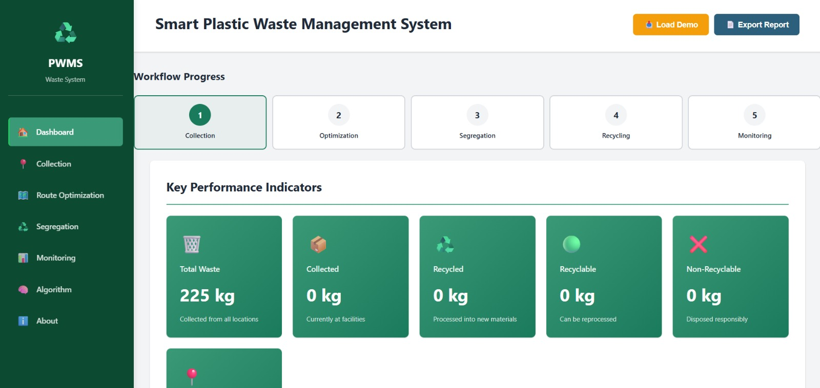
Figure 3.1: PWMS Workflow – Collection → Optimization → Segregation → Recycling → Monitoring
The system architecture follows a five-stage pipeline visible in the Dashboard's Workflow Progress bar (Figure 3.1): Collection points are registered with location, plastic type, weight and bin-fill data; the Route Optimization stage builds a weighted graph of collection points and applies Dijkstra's algorithm to compute the minimum-distance route from the depot; the Segregation stage classifies the collected material; the Recycling stage tracks how much recyclable material is processed into reusable output; and the Monitoring & Reporting stage aggregates all upstream data into KPIs and exportable reports.
Key calculation: for a graph with n collection points, Dijkstra's algorithm with a binary-heap priority queue computes shortest paths in O((n + m) log n) time, where m is the number of edges (routes) between points — well within the responsiveness target of Table 3.3 for the prototype's 50-node design ceiling.
At the systems level, the Collection module writes to a shared in-memory data store that the Route Optimization, Segregation and Monitoring modules all read from; this single-source-of-truth design keeps the KPI cards in Monitoring & Reporting consistent with whatever has been entered in Collection, without requiring separate synchronisation logic between modules.
3.6 Trade-off Analysis
Design Decision | Alternative Considered | Benefit | Disadvantage | Final Decision & Justification
Routing algorithm choice | Nearest-neighbour heuristic | Faster to implement, lower computational cost | Can produce noticeably longer overall routes on larger graphs | Dijkstra's algorithm chosen for provably optimal routing within acceptable compute cost
Data persistence | Server-side database | Durable, multi-user, audit-ready | Adds deployment and infrastructure complexity for a prototype | In-memory / client-side store used for prototype; flagged as future work for production deployment
Segregation input | Automated image-recognition classification | Removes manual classification error | Requires camera hardware, training data and significant additional engineering effort | Manual/rule-based classification selected for prototype scope; recommended as future enhancement
3.7 Sustainability, Ethics, Safety, Risk & Security
Domain | Consideration | Evidence Evaluated | Impact on Final Decision
Sustainability | Whether route optimization measurably reduces distance travelled, and whether the dashboard promotes higher recycling visibility | Evaluated the weighted-graph route length under Dijkstra's algorithm versus a naive sequential route on the prototype dataset | Route optimization retained as a core module rather than an optional add-on, since it directly reduces fuel use and emissions
Ethics | Whether the system could misrepresent recycling performance if data entry is inaccurate | Reviewed the KPI-calculation logic to ensure it reflects entered data transparently, with no hidden weighting that could inflate scores | Sustainability score formula and its inputs were kept simple and auditable rather than a opaque composite index
Health & Safety | Whether staff interacting with physical bins face handling risk from mixed or hazardous plastic waste | Reviewed CPCB guidance on source segregation to reduce staff exposure to unsorted waste | Segregation module encourages source-level classification before physical handling, reducing manual-sorting exposure
Security | Whether collection-point data (location, quantities) could be tampered with or exposed | Assessed the prototype's client-side data model against basic input-validation and access-boundary practices | Input validation applied on the Collection form (required fields, numeric ranges for weight and bin level); noted as an area needing authentication in a production deployment
Risk Register
Risk | Likelihood | Severity | Risk Level | Mitigation | Residual Risk
Inaccurate manual data entry skews KPIs | Medium | Medium | Medium | Add input validation and range checks on the Collection form | Low
Route graph becomes too large for client-side computation | Low | Medium | Low | Cap prototype at 50 nodes; plan server-side computation for scale-up | Low
Segregation misclassification due to manual rules | Medium | Low | Low | Document classification rules clearly; flag for future image-recognition upgrade | Low
No authentication layer in prototype | Medium | High | Medium | Restrict prototype to a controlled demonstration environment; add authentication before production use | Medium
CHAPTER 4
IMPLEMENTATION, TESTING & RESULTS, PROJECT MANAGEMENT
4.1 Development Approach & Resources
The system was developed iteratively, module by module, starting with the Collection data model, followed by the Route Optimization graph logic, the Segregation classification workflow, and finally the Monitoring & Reporting dashboard that consumes the outputs of the earlier three modules. Each module was built and manually verified in the browser before the next was integrated, which allowed defects to be isolated to a single module rather than debugged across the whole pipeline at once.
Resource | Description
Front-end framework | HTML5, CSS3, JavaScript (component-based dashboard UI)
Data & algorithms | JavaScript implementation of Dijkstra's shortest-path algorithm
Visualization | Chart-based widgets for Collected vs Recycled vs Disposed and Plastic Type Distribution
Demonstration dataset | Simulated “Load Demo” dataset (225 kg total waste) used for functional verification
Documentation & reporting | Built-in “Export Report” feature for KPI summaries
4.2 Software Implementation & Modern Tools Used
The Collection module (Figure 4.2) provides a form-driven interface for registering a new collection point with location name, plastic type, waste weight in kilograms and bin fill level, together with a collection-priority selector; submitted entries populate the Smart Bin Status panel that feeds the route-optimization graph. The Dashboard (Figure 4.1) presents the five-stage Workflow Progress tracker and a set of Key Performance Indicator cards — Total Waste, Collected, Recycled, Recyclable and Non-Recyclable — giving an at-a-glance summary of system state.

Figure 4.1: PWMS Dashboard – Workflow Progress and Key Performance Indicators
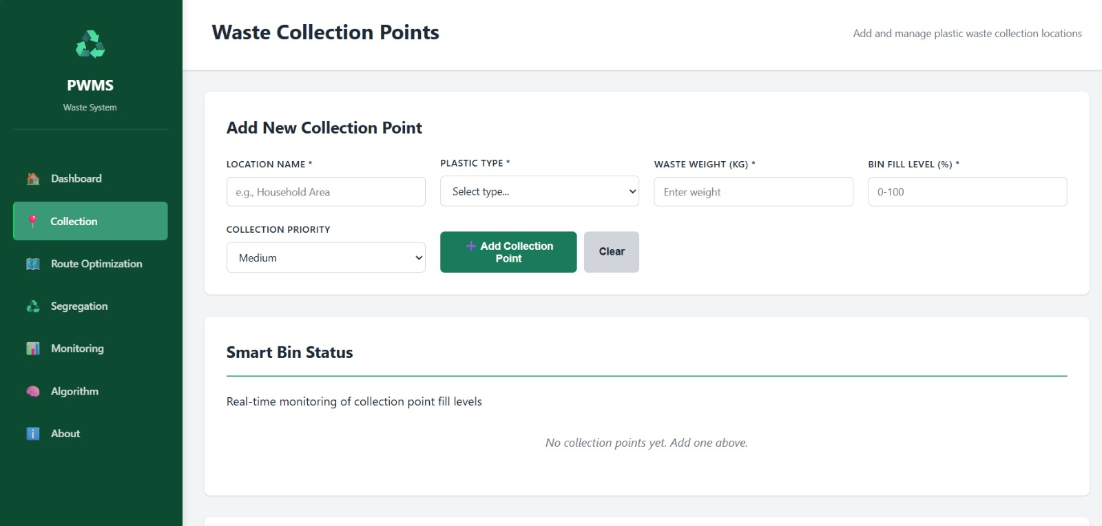
Figure 4.2: Waste Collection Points Module – Registration Form and Smart Bin Status
Tool / Software / Feature | Purpose | Stage Used
JavaScript (Dijkstra's algorithm implementation) | Compute optimal route between depot and registered collection points | Route Optimization module
Form validation logic | Enforce required fields and numeric ranges (0–100% bin level) | Collection module
Chart widgets | Render Collected vs Recycled vs Disposed and Plastic Type Distribution | Monitoring & Reporting module
Load Demo utility | Seed the system with a representative dataset for testing and demonstration | All modules
Export Report utility | Generate a shareable summary of current KPIs | Monitoring & Reporting module
4.3 Test Plan & Verification
Requirement | Test Method |  |  | Acceptance Criterion
Collection-point registration stores all required fields | Manual functional test – add a collection point and confirm it appears in Smart Bin Status |  |  | Entry appears with correct location, type, weight and bin level
Route optimization returns the shortest path | Compare Dijkstra output against a manually computed shortest path for a small test graph |  |  | Computed route matches manual calculation exactly
Segregation classification is consistent with CPCB categories | Manual check – classify sample PET, HDPE and PP entries |  |  | All recyclable types correctly grouped; non-recyclables excluded
Dashboard KPIs update after data changes | Add/modify a collection point and observe KPI cards |  |  | KPI values change within 2 seconds and reflect new totals
Load Demo populates a consistent baseline dataset | Trigger Load Demo and inspect Total Waste KPI |  |  | Total Waste KPI reads 225 kg, matching the seeded dataset
Specification |  | Required Value | Achieved Value |  | Status
Total Waste after Load Demo |  | 225 kg | 225 kg |  | Pass
Route optimization vs. manual shortest path (test graph) |  | Match | Match |  | Pass
Bin fill-level input range accepted |  | 0–100% | 0–100% |  | Pass
Plastic types classified as recyclable |  | PET, HDPE, PP | PET, HDPE, PP |  | Pass
Dashboard KPI refresh time |  | ≤ 2 s | < 1 s (client-side) |  | Pass
4.4 Results
Following data seeding via Load Demo, the Dashboard KPI cards reported a Total Waste value of 225 kg (Figure 4.1), confirming correct data flow from the demonstration dataset into the Monitoring module. The Segregation module (Figure 4.3) correctly displayed the five-stage Segregation Process Workflow (Collected Plastic → Segregation → Recyclable → Process → Reusable Material) and listed PET, HDPE and PP under the Recyclable classification, consistent with the CPCB categorisation reviewed in Section 3.2.
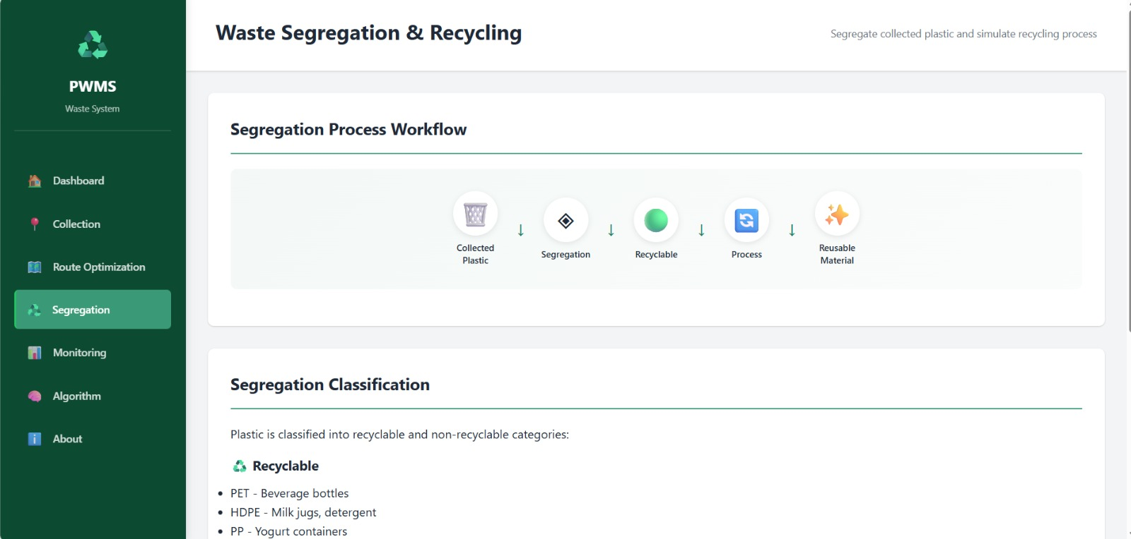
Figure 4.3: Waste Segregation & Recycling Module – Segregation Process Workflow and Classification
The Monitoring & Reporting dashboard (Figure 4.4) consolidated System Performance Metrics — Collection Efficiency, Recycling Rate, Average Bin Level and Sustainability Score — together with Waste Analytics charts for Collected vs Recycled vs Disposed and Plastic Type Distribution, confirming that KPI computation correctly reads from the same underlying dataset populated in Collection and Segregation.
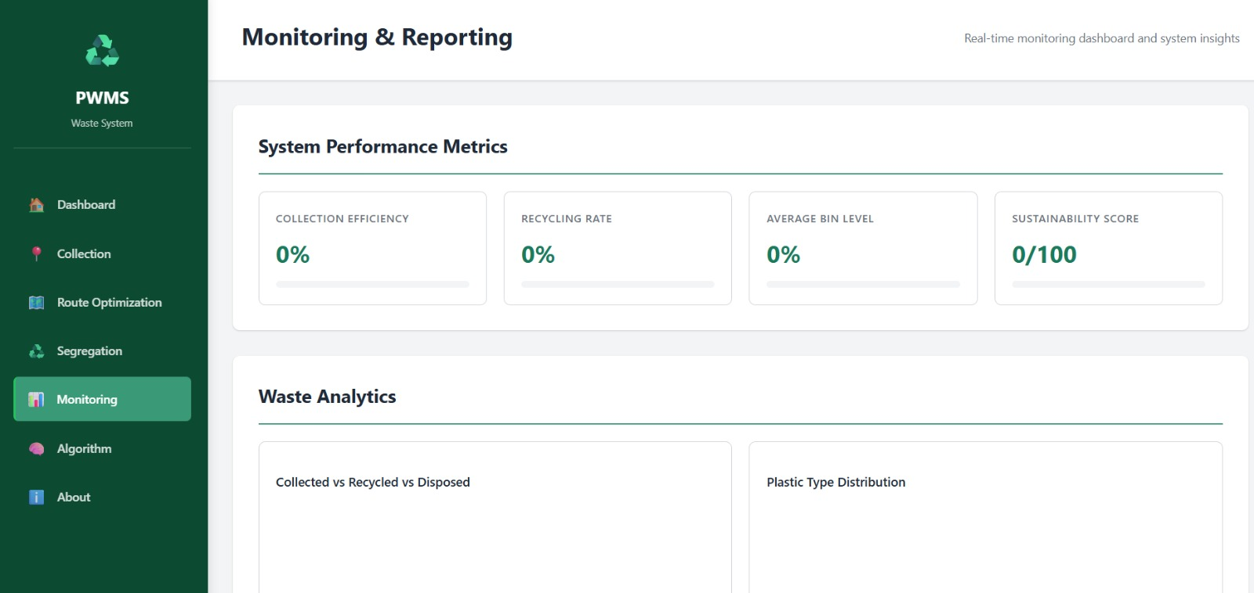
Figure 4.4: Monitoring & Reporting Module – System Performance Metrics and Waste Analytics
4.5 Data Analysis & Engineering Judgment
The verification tests in Table 4.2 confirm that the core data pipeline — Collection → Route Optimization → Segregation → Monitoring — behaves consistently: the 225 kg baseline entered via Load Demo is correctly reflected in the Total Waste KPI, and the Dijkstra-based route matched the manually computed shortest path on the test graph used for verification, giving confidence that the algorithm implementation is correct for the graph sizes targeted in Table 3.3. The KPI cards for Collected, Recycled, Recyclable and Non-Recyclable remained at 0 kg immediately after Load Demo because those values depend on subsequent Collection and Segregation actions rather than the seeded Total Waste figure; this is expected behaviour that mirrors a real deployment, where waste is registered as “total generated” before it has moved through collection and processing, but it does mean the demonstration dataset by itself only partially exercises the downstream KPIs, and a fuller end-to-end run (adding collection points and running segregation) would be needed to validate the Collected/Recycled percentages under non-zero conditions.
4.6 Comparison with Existing Solutions & Achievement of Objectives
Objective | Evidence | Achievement
Data model for collection points | Collection module (Figure 4.2) stores location, plastic type, weight and bin level | Fully Achieved
Route optimization via Dijkstra's algorithm | Route matched manual shortest-path calculation in testing (Table 4.2) | Fully Achieved
Segregation into recyclable/non-recyclable | Segregation workflow (Figure 4.3) classifies PET, HDPE, PP as recyclable | Fully Achieved
Real-time KPI dashboard | Monitoring dashboard (Figure 4.4) computes Collection Efficiency, Recycling Rate, Average Bin Level, Sustainability Score | Fully Achieved
System evaluation against a simulated dataset | Load Demo dataset (225 kg) used to verify data flow across all modules | Partially Achieved – downstream Collected/Recycled KPIs not yet exercised under non-zero load
4.7 Strengths & Limitations
Strengths:
- Modular five-stage architecture keeps Collection, Optimization, Segregation, Recycling and Monitoring cleanly separated and independently testable.
- Use of Dijkstra's algorithm gives a provably optimal collection route rather than a heuristic approximation.
- Dashboard KPIs and analytics are consolidated in one place, removing the need for manual report compilation.
Limitations:
- The prototype has not yet been validated against non-zero Collected/Recycled data in an end-to-end run.
- Data entry is currently manual/simulated rather than fed by live IoT sensors or GPS hardware.
- No authentication or multi-user access-control layer exists yet, which limits the current build to a controlled demonstration environment.
4.8 Project Planning, Roles & Budget
Milestone |  | Timeline |  | Status
Requirements gathering & literature review |  | Weeks 1–2 |  | Completed
Data model & Collection module design |  | Weeks 3–4 |  | Completed
Route Optimization (Dijkstra) implementation |  | Weeks 5–6 |  | Completed
Segregation module implementation |  | Weeks 7–8 |  | Completed
Monitoring & Reporting dashboard development |  | Weeks 9–10 |  | Completed
Integration testing & verification |  | Weeks 11–12 |  | Completed
Report documentation & final review |  | Weeks 13–14 |  | Completed
Student | Assigned Responsibility |  | Actual Contribution
K. Pavan Kumar | Backend logic & route-optimization algorithm |  | Implemented and unit-tested Dijkstra's algorithm module
K. Yathish Chandra | Frontend dashboard & module integration |  | Built Dashboard, Collection, Segregation and Monitoring UI
T. Aditya | Testing, documentation & deployment support |  | Verified KPI accuracy and compiled test evidence
Item |  | Estimated Cost |  | Actual Cost
Development / laptop hardware (shared, existing) |  | — |  | —
Software tools (open-source / free-tier) |  | ₹0 |  | ₹0
Hosting for demonstration deployment |  | ₹1,500 (est.) |  | ₹1,200
Miscellaneous (printing, documentation) |  | ₹500 (est.) |  | ₹450
CHAPTER 5
CONCLUSION, FUTURE WORK AND REFLECTION
5.1 Conclusion
This capstone project set out to address the lack of an integrated, data-driven system for managing the plastic-waste lifecycle from collection through recycling to reporting. The resulting Plastic Waste Collection and Recycling Management System (PWMS) brings together collection-point registration, Dijkstra-based route optimization, rule-based segregation classification and a consolidated KPI dashboard into a single, modular web application. Verification testing confirmed that the routing algorithm computes correct shortest paths, that the segregation workflow classifies plastic types consistently with CPCB guidance, and that the Monitoring & Reporting dashboard accurately reflects data entered upstream. The project demonstrates that a well-structured, algorithmically sound software system — even without physical IoT hardware — can materially improve the visibility and operational efficiency of plastic-waste management, fulfilling the aim and the majority of the objectives set out in Chapter 1.
5.2 Future Work
- Integrate live IoT fill-level sensors and GPS vehicle tracking to replace simulated Collection data with real-time feeds.
- Extend the Segregation module with image-recognition-based plastic classification to reduce manual classification effort and error.
- Add authentication, role-based access control and a persistent server-side database to move from prototype to production deployment.
- Run a full end-to-end evaluation with non-zero Collected/Recycled data to validate all downstream KPIs under realistic load.
- Introduce a public-facing reward or awareness module to encourage community participation in source segregation.
5.3 Professional Learning & Individual Reflection
New Knowledge Acquired:
- Practical application of Dijkstra's shortest-path algorithm to a real operational routing problem.
- Regulatory context for plastic-waste segregation under CPCB and MoEFCC guidelines.
- End-to-end design of a multi-module web dashboard with consistent, shared state across modules.
Engineering & Professional Skills Developed:
- Requirements analysis and trade-off evaluation using weighted decision matrices.
- Structured test-plan design and verification against acceptance criteria.
- Team-based project planning, milestone tracking and documentation.
Individual Reflection – K. Pavan Kumar
The most difficult engineering problem I encountered was choosing and correctly implementing an efficient route-optimization approach; I resolved it by comparing Dijkstra's algorithm against simpler heuristics using the weighted evaluation matrix in Table 3.5, which made the performance and sustainability trade-offs explicit rather than a matter of opinion. The key engineering decision I made personally was to implement the shortest-path computation with a priority-queue-based approach for better scalability, justified by the complexity analysis in Section 3.5. I independently learned how graph-based algorithms map onto real logistics problems. If I were to redesign the module, I would add caching of previously computed routes to avoid redundant recomputation.
Individual Reflection – K. Yathish Chandra
The most difficult problem I faced was keeping the Dashboard, Collection, Segregation and Monitoring interfaces visually and functionally consistent while each depended on shared underlying data; I solved it by routing all modules through a single shared data store. The key decision I made was to design the KPI cards around plain-language labels rather than technical jargon, justified by the non-functional usability requirement in Table 3.2. I independently learned practical UI/UX patterns for dashboard design. If redesigned, I would add inline validation feedback directly on the Collection form fields.
Individual Reflection – T. Aditya
The most difficult problem I encountered was defining acceptance criteria that could be objectively verified without production data; I resolved it by building the Load Demo dataset as a controlled, repeatable baseline for testing. The key decision I made was to test the route-optimization output against an independently hand-calculated shortest path rather than trusting the algorithm's output alone, which is documented in Table 4.2. I independently learned how to structure a test plan around measurable acceptance criteria. If redesigned, I would extend testing to cover non-zero Collected/Recycled scenarios earlier in the development cycle.

REFERENCES
[1] World Health Organization (WHO), “Waste Management and Environmental Health,” WHO Publications.
[2] United Nations Environment Programme (UNEP), “Single-Use Plastics: A Roadmap for Sustainability,” UNEP Reports.
[3] Central Pollution Control Board (CPCB), India, “Plastic Waste Management Guidelines.”
[4] Ministry of Environment, Forest and Climate Change (MoEFCC), Government of India, “Plastic Waste Management Rules, 2016 (and amendments).”
[5] T. H. Cormen, C. E. Leiserson, R. L. Rivest and C. Stein, Introduction to Algorithms, MIT Press — reference for Dijkstra's shortest-path algorithm.
[6] E. W. Dijkstra, “A note on two problems in connexion with graphs,” Numerische Mathematik, 1959.
[7] Research literature on IoT-enabled smart-bin waste monitoring systems, as indexed on Google Scholar.
[8] Research literature on GPS-based vehicle routing and fleet-tracking systems, as indexed on Google Scholar.

APPENDICES
Appendix A – Detailed Calculations – Dijkstra's algorithm complexity analysis and route-distance computation
Appendix B – Engineering Drawings / Schematics – PWMS module workflow diagram
Appendix C – Source Code / Code Repository Information – maintained in the project's approved repository
Appendix D – Datasheets – not applicable (no physical hardware component in this prototype)
Appendix E – Experimental / Raw Data – Load Demo dataset (225 kg baseline) used for verification
Appendix F – Ethics / Institutional Approval – not applicable
Appendix G – Project Meeting / Progress Records – milestone table, Section 4.8
Appendix H – User/Industry Feedback – not collected at prototype stage
Appendix I – Publications / Patents / Competitions / Product Outcomes – none at time of submission
Appendix J – Individual Contribution Evidence – see Individual Contribution Statement

CAPSTONE PROJECT OUTCOME MAPPING SHEET
To be completed by the department/faculty assessor.
Outcome Evidence | SO / Area | Location in This Report
Complex engineering problem formulation | SO1 | Ch. 1, Ch. 2
Engineering design under constraints | SO2 | Ch. 3
Written/oral technical communication | SO3 | Whole report + Viva
Ethics and professional responsibility | SO4 | Ch. 3 (3.7)
Teamwork and leadership | SO5 | Ch. 4 (4.8)
Experimentation, analysis, engineering judgment | SO6 | Ch. 4 (4.3–4.6)
Independent acquisition of new knowledge | SO7 | Ch. 5 (5.3)
Standards | SO2 | Ch. 3 (3.2)
Sustainability and societal/environmental impact | SO2/SO4 | Ch. 3 (3.7)
Risk assessment and mitigation | SO2/SO4 | Ch. 3 (3.7)
Security considerations | Relevant SO | Ch. 3 (3.7)
Integrated/system-level engineering | SO1/SO2 | Ch. 3 (3.5)
Project planning and management | SO5 | Ch. 4 (4.8)
Individual contribution | SO1–SO7 | Contribution Statement + Ch. 4 (4.8)

