|  |
| --- |
| Some Notes on Installation |
| Installation Notes |

|  |
| --- |
|  |

# Introduction

The course requires 4 virtual box instance. These are as follows:

1. Box 1 contains the DNS Master, Jenkins and Puppet Master to be installed
2. Box 2 contains docker from where 2 containers are spawned off for performing acceptance and web tests.
3. Box 3 contains a puppet agent which ensures tomcat 7 and production version of application is installed.
4. Box 4 contains docker which spawns off Nagios and which ensures that Box 3 is being monitored.

The rest of the document will cover the basics of installation of the required software. The instructions are specific to Windows 10 and Ubuntu 14.04 (both 64 bit). Please adjust instructions accordingly.

# Install Virtual Box

**Step 1**: Download VirtualBox from- <https://www.virtualbox.org/wiki/Downloads>

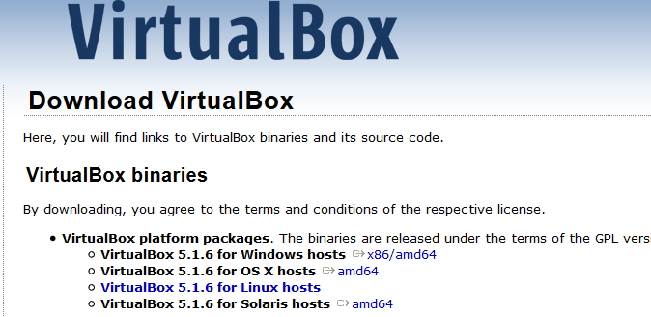

**Step 2**: Run the setup

Run the downloaded file as an administrator. Keep default settings. There is no need to change any settings.

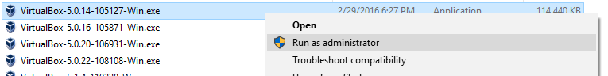

**Step 3**: Click “Next”. ©

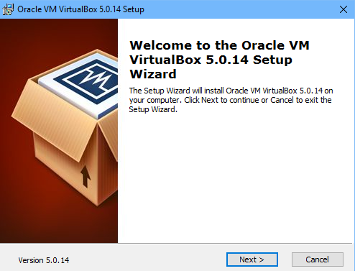

**Step 4**: Select the way you want your features to be installed and click “Next”. Keep the default settings – unless you want to change them.

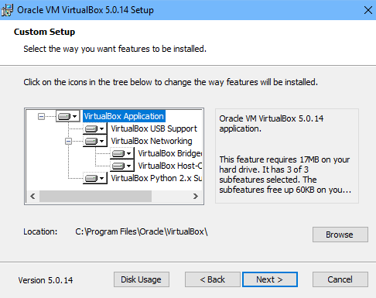

**Step 5**: Chose all the options and click “Next”.

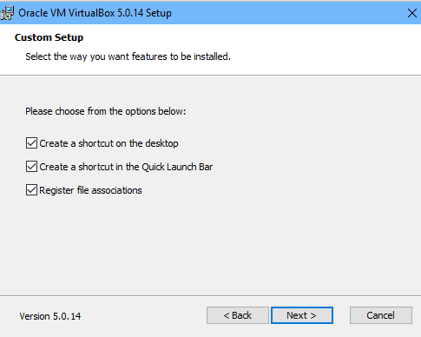

**Step 6**: Click “Yes” to install Virtual box.

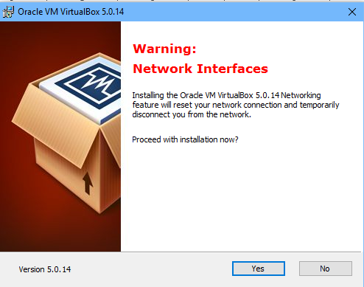

**Step 7**: Click “Install” to begin the installation.

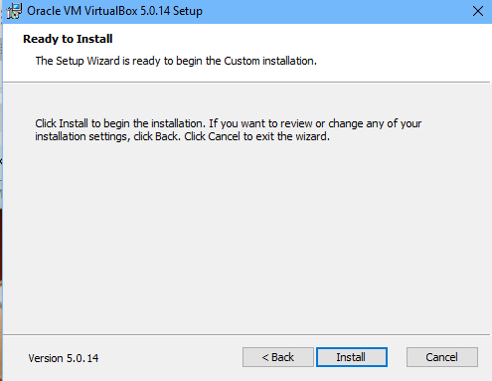

**Step 8**: Click “Install” on windows security popup. (You may or may not get this message Also note that on Window 10, the message will come from UAC, not Windows Security).



**Step 9**: Select “Start Oracle VM VirtualBox 5.0.14 after installation and click “Finish”.

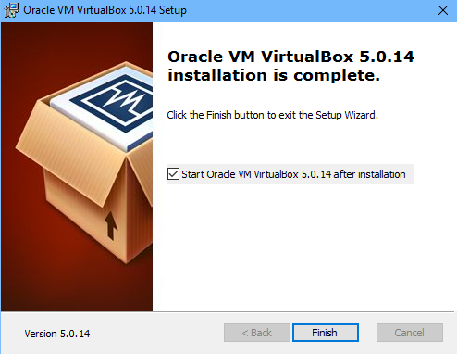

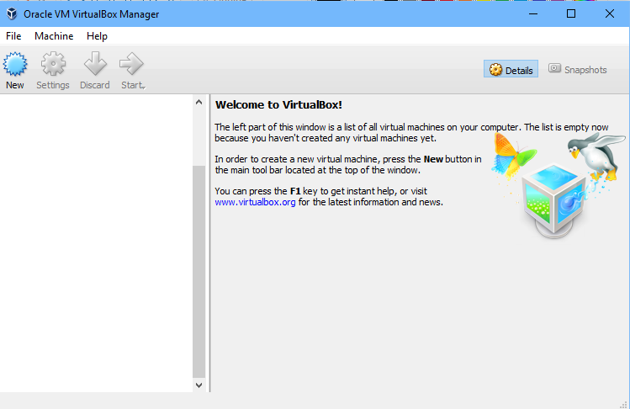

Congratulations! Oracle Virtual Box Manager is successfully installed.

# Installing Vagrant

**Step 1**: Download Vagrant from- <https://www.vagrantup.com/downloads.html>



**Step 2**: Double click on installer or select and Chose install



**Step 3**: Click on Next.

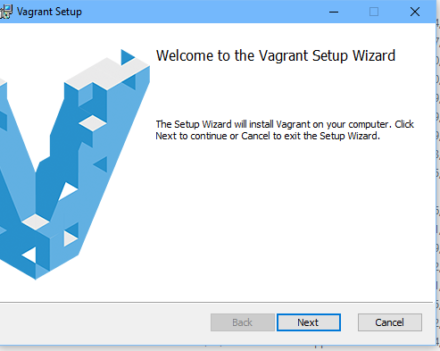

**Step 4**: Accept the license text and click on Next.

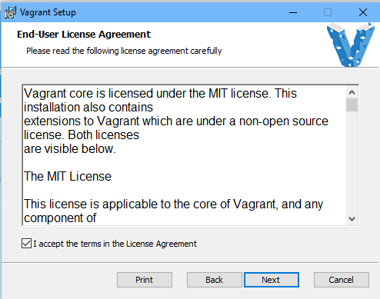

**Step 5: (optional)** – Change installation folder and click on Next. We recommend the defaults be kept as is.

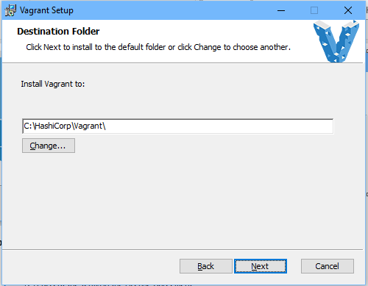

**Step 6:** – Click on install button.

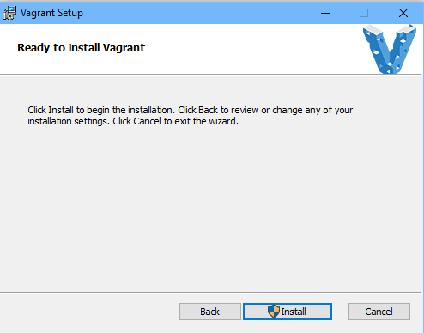

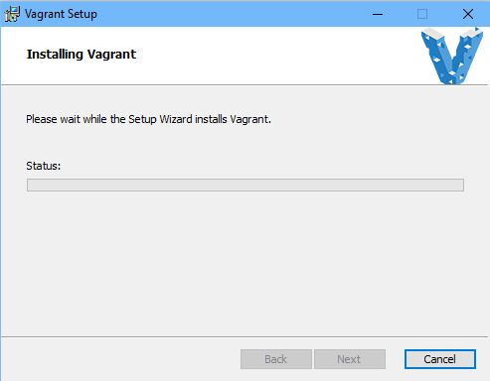

**Step 7:** – Accept to run software from Hashicorp.

**Step 8**: Click on finish.

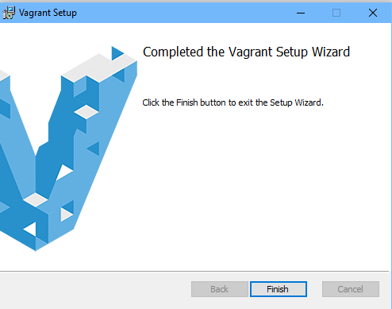

**Step 9:** Restart your machine. Congratulations! Vagrant is now setup on your machine.

