|  |
| --- |
| Course: DEVOPS |
| Installation Notes |

|  |
| --- |
|  |



© Brain4ce Education Solutions Pvt. Ltd.

# Introduction

The course requires 4 virtual box instance. These are as follows:

1. Box 1 contains the DNS Master, Jenkins and Puppet Master to be installed
2. Box 2 contains docker from where 2 containers are spawned off for performing acceptance and web tests.
3. Box 3 contains a puppet agent which ensures tomcat 7 and production version of application is installed.
4. Box 4 contains docker which spawns off Nagios and which ensures that Box 3 is being monitored.

The rest of the document will cover the basics of installation of the required software. The instructions are specific to Windows 10 and Ubuntu 14.04 (both 64 bit). Please adjust instructions accordingly.

# Install Virtual Box

**Step 1**: Download VirtualBox from- <https://www.virtualbox.org/wiki/Downloads>

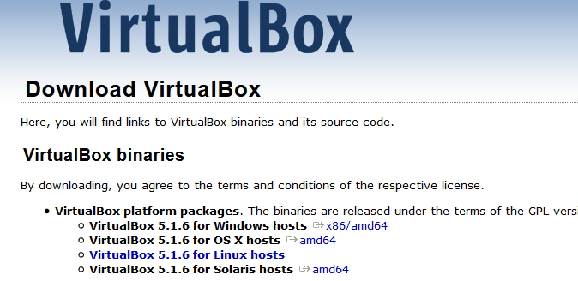

**Step 2**: Run the setup

Run the downloaded file as an administrator. Keep default settings. There is no need to change any settings.

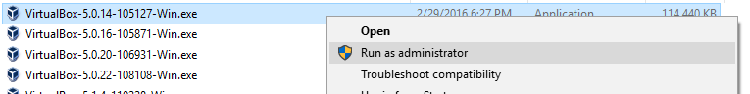

**Step 3**: Click “Next”. ©

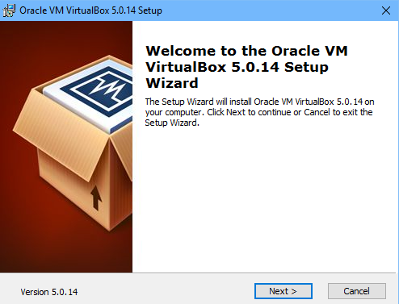

**Step 4**: Select the way you want your features to be installed and click “Next”. Keep the default settings – unless you want to change them.

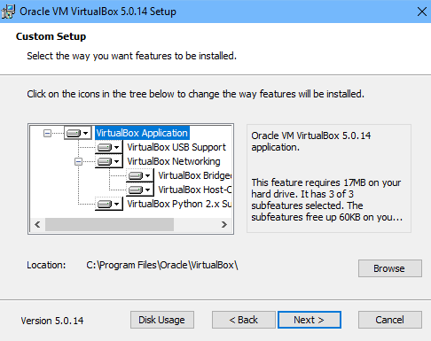

**Step 5**: Chose all the options and click “Next”.

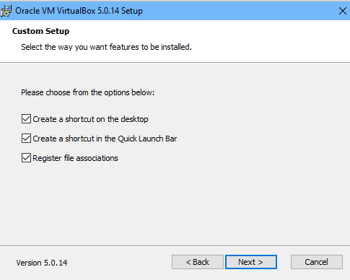

**Step 6**: Click “Yes” to install Virtual box.

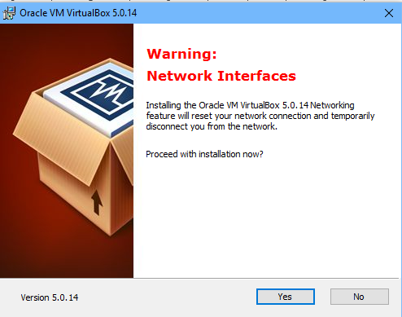

**Step 7**: Click “Install” to begin the installation.

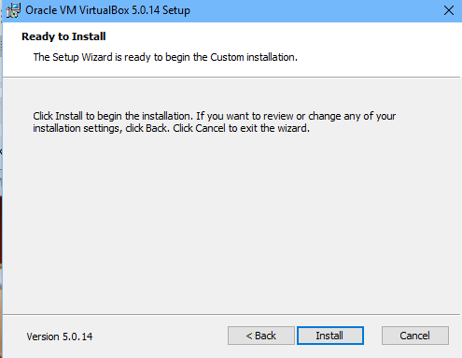

**Step 8**: Click “Install” on windows security popup. (You may or may not get this message Also note that on Window 10, the message will come from UAC, not Windows Security).



**Step 9**: Select “Start Oracle VM VirtualBox 5.0.14 after installation and click “Finish”.

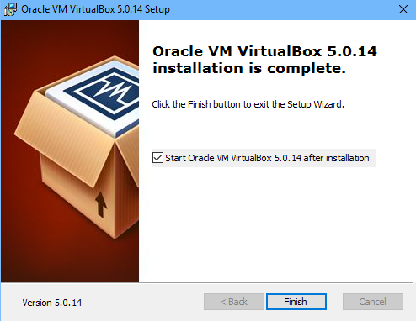

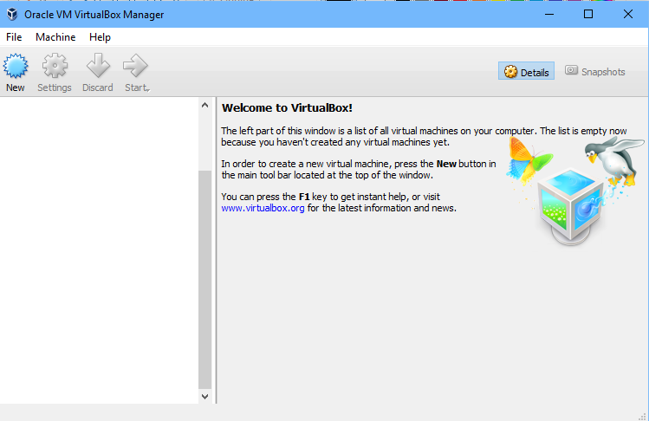

Congratulations! Oracle Virtual Box Manager is successfully installed.

# Installing Vagrant

**Step 1**: Download Vagrant from- <https://www.vagrantup.com/downloads.html>



**Step 2**: Double click on installer or select and Chose install



**Step 3**: Click on Next.

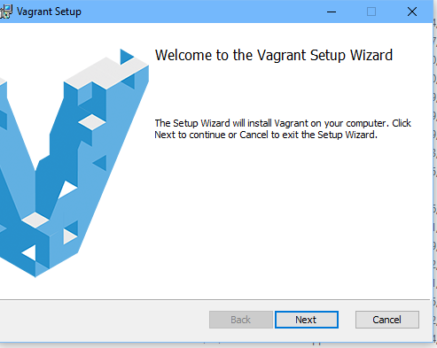

**Step 4**: Accept the license text and click on Next.

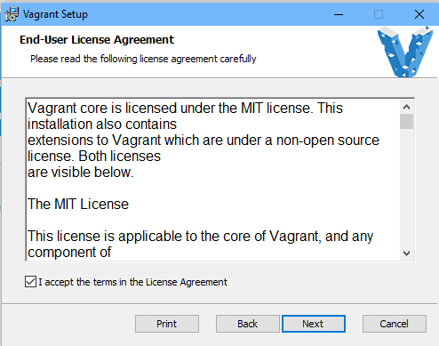

**Step 5: (optional)** – Change installation folder and click on Next. We recommend the defaults be kept as is.

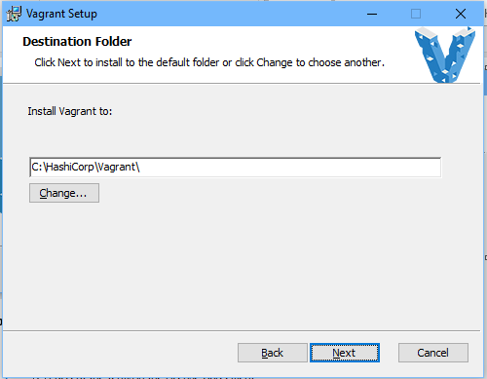

**Step 6:** – Click on install button.

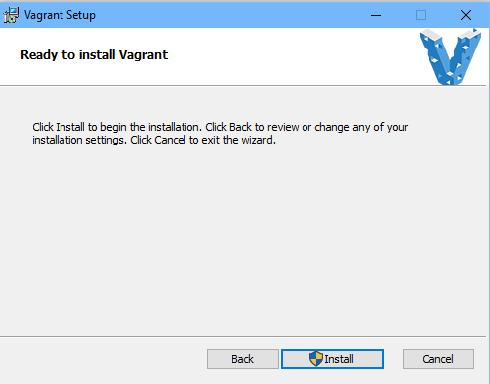

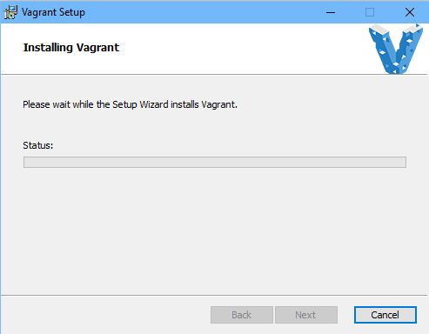

**Step 7:** – Accept to run software from Hashicorp.

**Step 8**: Click on finish.

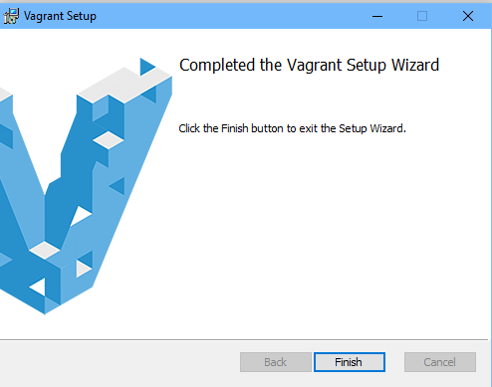

**Step 9:** Restart your machine. Congratulations! Vagrant is now setup on your machine.

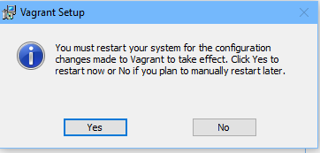

# Setup of the instances

The details of the 4 instances are as follows:

|  |  |  |  |  |
| --- | --- | --- | --- | --- |
| Machine | IP | OS | SSH Port | Purpose |
| test01.demo.org | 192.168.33.20 | Ubuntu 14.04 | 8222 | DNS Server, Puppet Master |
| test02.demo.org | 192.168.33.21 | Ubuntu 14.04 | 9222 | Jenkins Slaves |
| test03.demo.org | 192.168.33.22 | Ubuntu 14.04 | 10222 | Production Tomcat Server |
| test04.demo.org | 192.168.33.23 | Ubuntu 14.04 | 11222 | Nagios Server |

Initially you will create a folder structure similar to the following:

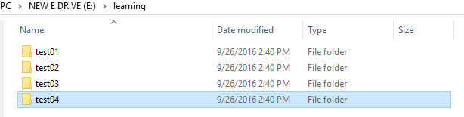

The names are arbitrary, but we do recommend that instance names have a pattern which can be scripted. A sample script to create this structure is given below (**Adapt as required**)

@echo off

mkdir e:\learning

for /l %%c in (1,1,4) do mkdir "e:\learning\test0%%c"

Now for each directory, you need to create a vagrant file inside. This creates a sample vagrant file inside each of these folders. A sample code is given below: (**Adapt as required**)

@echo off

for /l %%c in (1,1,4) do (

echo "*** init in directory e:\learning\test0%%c"

cd "e:\learning\test0%%c"

vagrant init ubuntu/trusty64

)

cd e:\

Now for each folder, you need to edit the vagrant file to reflect correct

1. IP Address
2. SSH Port
3. Hostname

A sample vagrant file is attached for your reference.



After making the changes, you can start all machines by either manually going to each folder and typing the following at command prompt:

|  |
| --- |
| Vagrant up  @rem to stop a machine: use vagrant halt  **@rem the first time vagrant up is called, it has to download the full image so it will take time.** |

A sample script to start all of these machines is given below: (**Adapt as required**)

@echo off

for /l %%c in (1,1,4) do (

echo "*** init in directory e:\learning\test0%%c"

cd "e:\learning\test0%%c"

vagrant up

)

cd e:\

A sample script to stop all of these machines is given below: (**Adapt as required**)

@echo off

for /l %%c in (1,1,4) do (

echo "*** init in directory e:\learning\test0%%c"

cd "e:\learning\test0%%c"

vagrant halt

)

cd e:\

There is still one final step. You need to be able to SSH to these machines. To do so, create a folder called

E:\learning\keys. Then from each folder, navigate to folder: **.vagrant\machines\default\virtualbox**

Eg. *E:\learning\test01\.vagrant\machines\default\virtualbox*

Copy the file private_key to e:\learning\keys giving it a unique name.

Eg. *copy e:\learning\test01\.vagrant\machines\default\virtualbox\private_key e:\learning\keys*

Once this has been done, you can use any SSH client to connect to the instance as follows:

*Ssh -i e:\learning\keys\pk_test01 -p 8222* [*vagrant@127.0.0.1*](mailto:vagrant@127.0.0.1)

A sample script to copy keys for all of these machines is given below: (**Adapt as required**)

@echo off

for /l %%c in (1,1,4) do (

echo "*** init in directory e:\learning\test0%%c"

copy e:\learning\test0%%c*\.vagrant\machines\default\virtualbox\private_key e:\learning\keys\pk_test0%%c*

)

