CURRICULUM VITAE
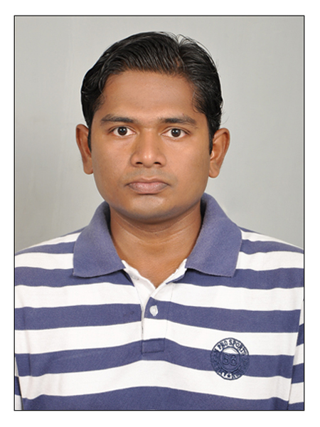

SANJEEV KUMAR
Mobile No. : 08800139219
E-mail : sanjeevsonu03@gmail.com
Present Address : Sector – 28, House No-661
Faridabad, Haryana

Career Objective:
To obtain a position in a result-oriented company that seeks an ambitious and career-conscious person, where acquired skills and education will be utilized toward continuous mutual growth and advancement.

Experience:
Designation: - Web Developer

Company: - New Foto Life Pvt. Ltd.
April, 2014 - Present

Create, update and maintain site pages for New Foto Life Pvt. Ltd., using CSS, HTML, JavaScript, Jquery, PHP, MySQL and CMS (magento).

Education Qualification:
Academic Profile:

Class/Course | School/University | University/Board | Year | %  Marks/CGPA
MCA | Patna Univ. | Patna Univ. | 2010-13 | 72.9
B.Sc.(IT) | Cybotech Campus  Patna | SMU | 2007-2010 | 69.5
Intermediate (10+2) | B.N.C College  Dhamdha | BIEC-Patna | 2003 | 70.01
High School | Dhamdha HighSchool,  Dhamdaha | BSEB-Patna | 2001 | 57

Technical Skills:
- Languages Known: - HTML, CSS, Bootstrap, JSON, Jquery, AJAX, PHP, CSS, Wordpress, Magento.
- Operating Systems :- Windows
- Database :- MySQL, Access
- Applications : Dreamweaver, Eclipse, Visual Studio

Project Details:

Title: Library Management System

Methodology:
- Analyzed the current online Library Management System
- Designed the E-R diagram and DFD for the entire system
- Implemented it using VB.Net and Microsoft Access.
- Security-enabled and password-protected administration.
- Database connectivity using Microsoft Access.
Deliverables:
- A reliable and secure system.
- Instant result display.
- Data entry by administrator also enabled.

Title: ONLINE EXAMINATION SYSTEM

Methodology:
- Analyzed the current online Examination System
- Designed the E-R diagram and DFD for the entire system
- Implemented it using HTML, JavaScript, PHP, and CSS.
- Security-enabled and password-protected administrator and user.
- Database connectivity using MySQL.

Deliverables:
- A fast and secure system.
- Instant result display.
- Data entry by administrator is enabled.

Hobbies & Interest:
  - Listening to music, cooking, watching movies, working on computers, playing cricket.

Seminar, & Training Programmes Attended
  - Participated in Two Month Android Application development training programs.
  - Participated in workshop organised by HCL.

Strengths:
Honest, punctual, self-motivated, confident, and flexible to every situation, quick-learner, hardworking as well as smart in execution of plans & strategies.

Personal details:

- Father’s name: -Shambhu Prasad
- Mother’s name: -Nilam Sinha
- Nationality: - Indian
- Date of Birth: 15/12/1986
- Language Known: - English & Hindi

- Permanent Address: - S/O – Shambhu Prasad,Koshi Colony
Nehru Chowk, Dhamdaha
Purnea, (Bihar) 854205

Declaration:

I hereby affirm that the information provided in this document is accurate and true to the best of my knowledge.

Place: -Delhi (Sanjeev Kumar)

