**Closed parking lot _ Pham Tien Anh**

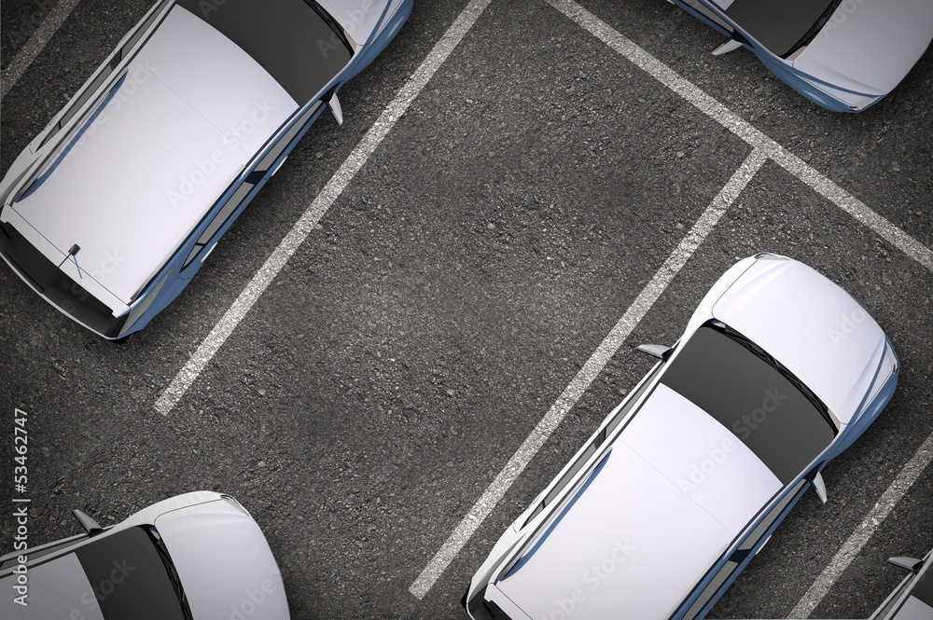

**Service list**

|  |  |  |  |  |  |  |
| --- | --- | --- | --- | --- | --- | --- |
| **ServiceId** | **Name** | **Description** | **Price** | **Type** | **Type Vehical** | **Time (Hours)** |
| {{Service.ServiceId}} | {{Service.NameService}} | {{Service.Description}} | {{Service.Price}} | {{Service.Type}} | {{Service.TypeVehical}} | {{Service.Time}} |

**Print Day : {{PrintDay}}**