**Closed parking lot _ Pham Tien Anh**

**Vehicle history {{inorexit}} on {{date}}**

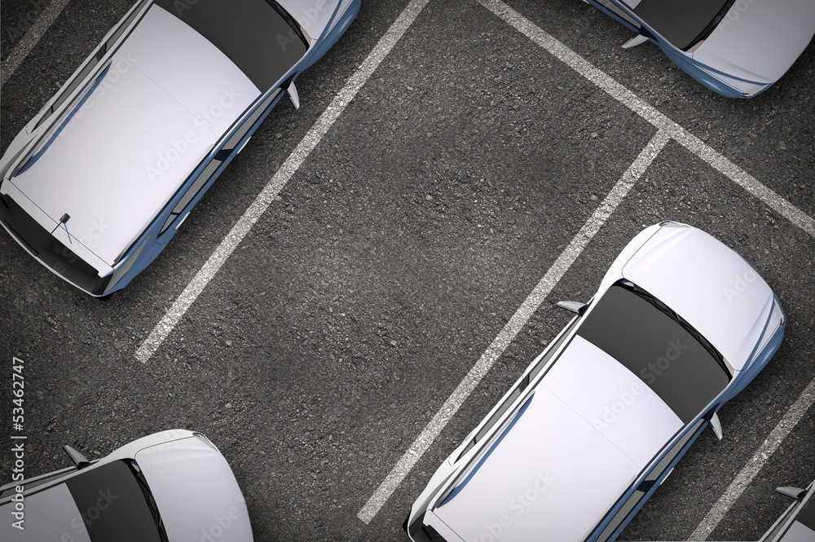**ParkArea ID : {{ParkAreaId}}**

**Address : {{ParkAreaName}}**

**Type Park Area : {{ParkAreaType}}**

|  |  |  |  |
| --- | --- | --- | --- |
| **VehicleId** | **CheckIn** | **CheckOut** | **Price** |
| **{{Parking.VehicleId}}** | **{{Parking.CheckIn}}** | **{{Parking.CheckOut}}** | **{{Parking.Price}}** |

**Total Renuve : {{{Renuve}}}**