**Closed parking lot _ Pham Tien Anh**

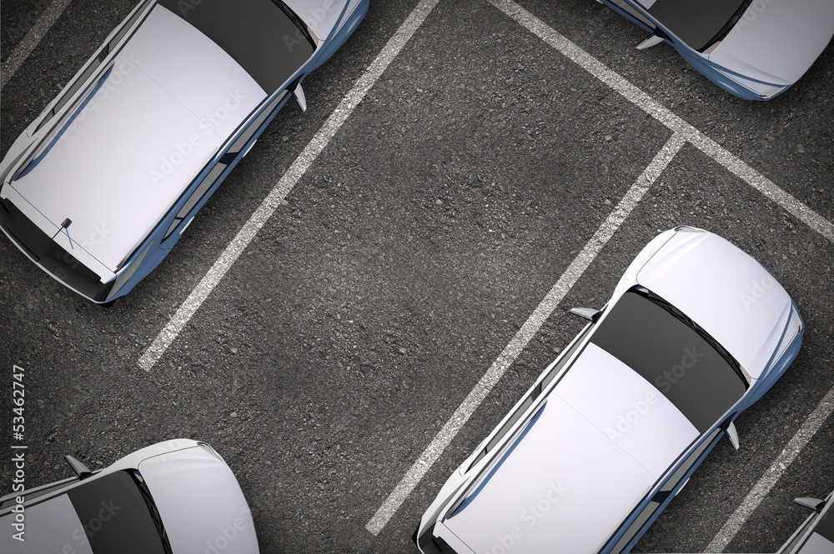

**Worker list**

|  |  |  |  |  |
| --- | --- | --- | --- | --- |
| **Worker Id** | **Full Name** | **Address** | **Type Worker** | **Work Place** |
| **{{Worker.WorkerId}}** | **{{Worker.FullName}}** | **{{Worker.Address}}** | **{{Worker.Type}}** | **{{Worker.ParkArea}}** |

**Print Day : {{PrintDay}}**