**TACS Challenge Documents**

**SOP 1 – How to build the tACS cap**

**Created by**: Umair Hassan; **Revised by**: Ines Violante, Carlo Miniusse

**Last edited:** 9 June 2025

**List of material:**

|  |  |
| --- | --- |
| **Quantity** | **Item** |
| 1 | Measuring tape |
| 1 | Scissors |
| 3 | Polystyrene head – matching desired cap head sizes (56, 58 and 60 cm) |
| 3 | Landmark cap – matching desired cap head sizes (56, 58 and 60 cm) |
| 3 | EEG cap – matching desired cap head sizes (56, 58 and 60 cm) |
| 1 | Marker pen |
| 3 | 45 mm holder – 3D print file 45mmHolder.STL |
| 3 | 25 mm holder – 3D print file 25mmHolder.STL |

**Protocol:**

1. Measure the head crown size with the measuring tape.

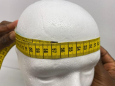

2. Get the landmark cap of that size and place it in the polystyrene head

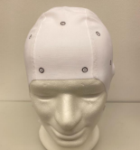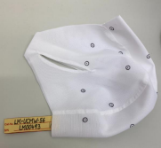

3. Place the EEG cap of the same size on top of the landmark cap in the polystyrene head.

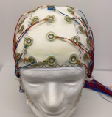

4. Identify and mark O1, O2, Oz, CP5, CP6, CPz, Cz, FPz, and POz EEG

electrode positions.

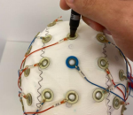

5. Remove the EEG cap. In the landmark cap, mark 1 cm x 1 cm square around O1, O2 and Oz marks.

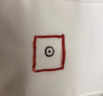

6. Mark 2 cm x 2 cm squares around CP5, CP6 and CPz

7. Mark 5 mm x 5 mm squares around Cz, AFz and POz

8. Take the cap off from the head. Cut the fabric inside the marked areas with the scissors. It is better to make incremental cuts and adjust with the electrode holders (image on the right) as needed until these fit well in the cap.

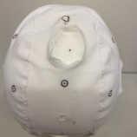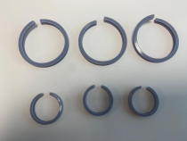

9. Place the holders and EEG electrodes inside the cut fabric areas. When applying in the participant, fill the tACS electrode areas with gel, then place the electrodes and then place the net cap over to help hold the cap and electrodes in place.

