**TACS Challenge Documents**

**SOP 2 – Setting up and using the tACS Challenge Device**

**Created by**: Edward Rhodes; **Revised by**: Ines Violante

**Last edited:** 30 March 2024

**List of material / Required hardware:**

| **Quantity** | **Item** |
| --- | --- |
| 1 | tACS Challenge Device |
| 1 | LED Array |
| 2 | USB-A to Micro-USB cables |
| 1 | 6-Pin Mini DIN cable |
| 1 | Laptop with Java Installed |
| 1 | (Optional) 5V portable battery |

**1. Hardware Description**

The device consists of two parts: the control interface which includes the response buttons, and the LED array. We have also provided a micro-USB cable to connect the interface to the control PC and a 6-pin mini-DIN cable which connects the interface to the LED array.

1.1 Control Interface

The front of the control interface has standard inputs for two EEG (touch-proof) electrodes: reference and signal. The amplifier within the device is not powerful enough to accurately record EEG signal, however, it can capture the tACS current delivered to the scalp with a sampling resolution of 1000 Hz. For the current paradigm, only a single button is required to record participants’ responses. However, two buttons are provided (left and right) to allow for more complex paradigms in future.A white and black rectangular object with a black square button

The rear of the device has a micro-USB port that must be used to connect the device to a PC with the correct drivers (Section 2) and software (Section 3). This port can be a little delicate, so we recommend you leave the cable attached once plugged in.

The LED Array is connected via a 6-pin mini-DIN cable.

There is a female BNC connector that can be used to send a short square-pulse trigger up to 5V. This trigger out can be used to trigger the tACS stimulator and begin stimulation.

Finally, there is a second micro-USB port that can be used to connect the device to an external battery for those whose ethics do not allow a powered connection from a laptop. Any 5 V battery should be suitable.

1.2 LED Array

The LED array consists of 6 LEDs, the numbering of which matches the order in which they are coded. There is a 6-pin mini-DIN connector on the back along with a clamp so the array can be attached to the top of a monitor.

**2. Driver and Java Installation**

To control and use the device a Windows PC is required with the correct drivers installed. These drivers can be found on the Arduino and Teensy websites (installation instructions below). The control software also requires Java to be installed, running at least version 8.

2.1 Arduino IDE

The simplest way to install the required Arduino drivers is to download and install the Arduino IDE (<https://www.arduino.cc/en/main/software>).

Step 1 – Download the Windows Installer

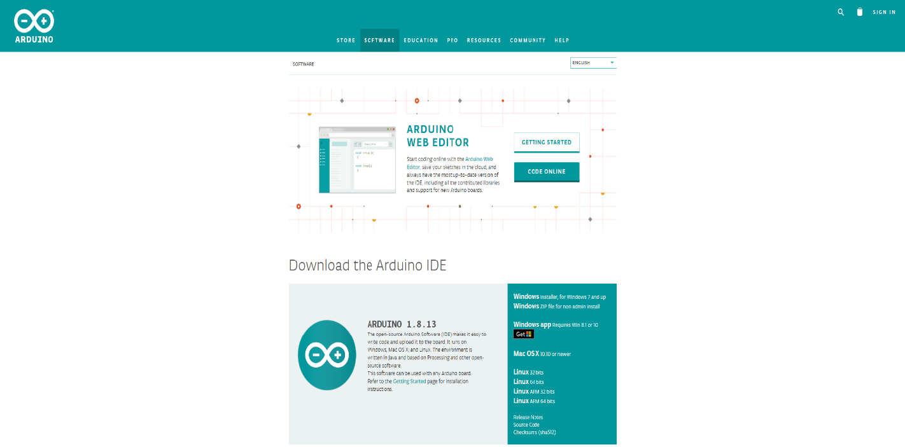

Step 2 – Run the installer and ensure the three checkboxes below are selected:

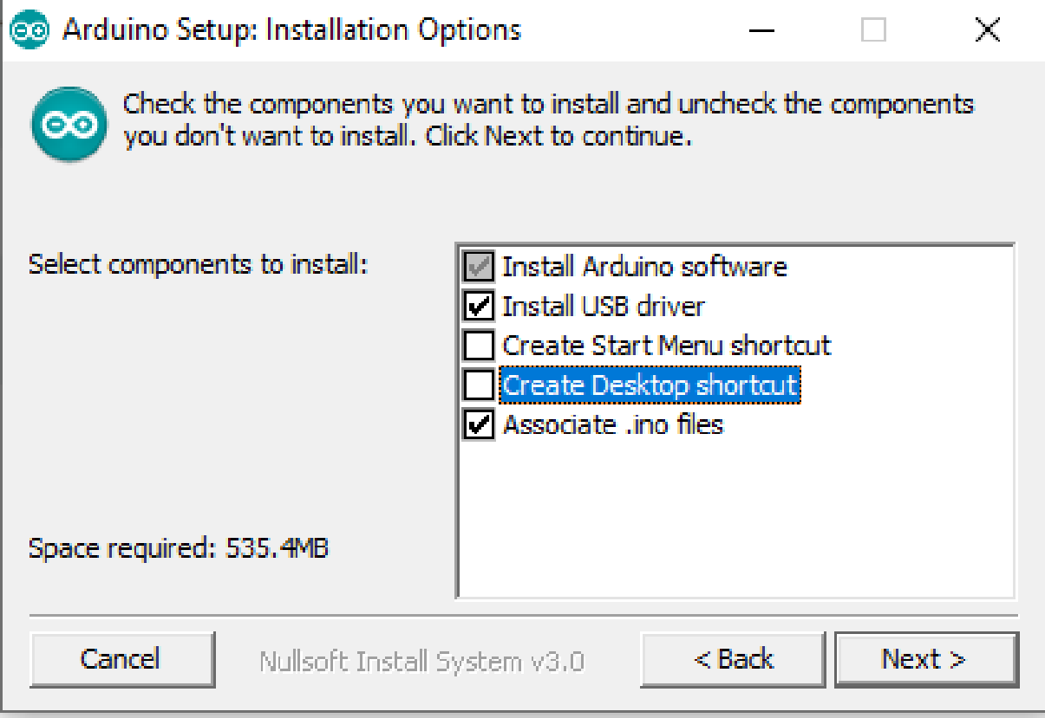

2.2 Teensyduino

The microcontroller inside the device is a custom form of Arduino board called a Teensy board. Detailed instruction on how to install Teensyduino can be found here: <https://www.pjrc.com/teensy/td_download.html>

2.3 Java

Java can be found here: https://java.com/en/download/win10.jsp. This version is sufficient to use the control software (Section 4).

**3. Software Control**

3.1 Launching Software

The device can be controlled using a custom, standalone Java application: “TACSChallenge.jar”.

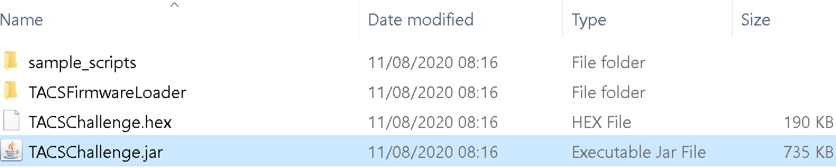

Once launched the UI should appear as in the image below (Section 3.2). If the screen you are using is a UHD or 4K display then you may encounter issues with the presentation of the application, for example, the device measurements don’t appear correctly on the left side of the app. This issue is caused by the Windows scaling conflicting with the way Java attempts to scale the app.

To correct for this, simply reduce the scaling under display settings. Windows > Settings > System > Display > Scale and Layout. Select the dropdown below the “Change size of text, apps and other items” heading and reduce your scaling. In our case, we had to reduce from 250% to 200% scaling before the app appeared correctly.

3.2 Software Layout

1. COM Port Selection - The software should automatically detect the correct COM port for your device. However, use the dropdown menu to ensure the correct port is selected.

2. Open Connection – If the correct COM port has been selected pressing the Open button will establish a connection between the device and your PC.

3. Output Folder – The folder path where the data log file will be saved. You define the filename within the control script.

4. Browse Log – Clicking this button will open a file explorer to allow you to manually select the folder in which you would like to save the output file.

5. tACS Signal Monitor – Here you can monitor the tACS signal that is recorded from the active electrode placed on the scalp.

6. LED Output Monitor – This monitor shows the square pulse output of each LED, colour-coded to the legend on the right. If you see changes in your LED array and not in the monitor there has likely been a communication failure between the device and PC.

7. Button Press – As with the LED monitor, we can see the subject’s button press response. It is a good idea to test each button before the subject arrives to ensure they are being properly monitored.

8. Trigger Out Monitor - Displays the square pulse voltage output for the BNC trigger out on the reverse of the device.

9. Control Script Editor – The commands used to control the device will be entered here. They can either be entered manually or loaded in from a text file using the buttons above. The full command reference can be found in the appendix and example scripts have been provided.

10. Command Status - Here you can monitor the commands being sent to the device. Any errors will appear here. During a manual staircase function, you can also use the command status output to monitor the luminance threshold.

11. Command Loading Controls – Here you can load in commands from a text file or save the current commands into a different text file. Once the commands are loaded, simply press “Send Cmds” to begin the experiment.

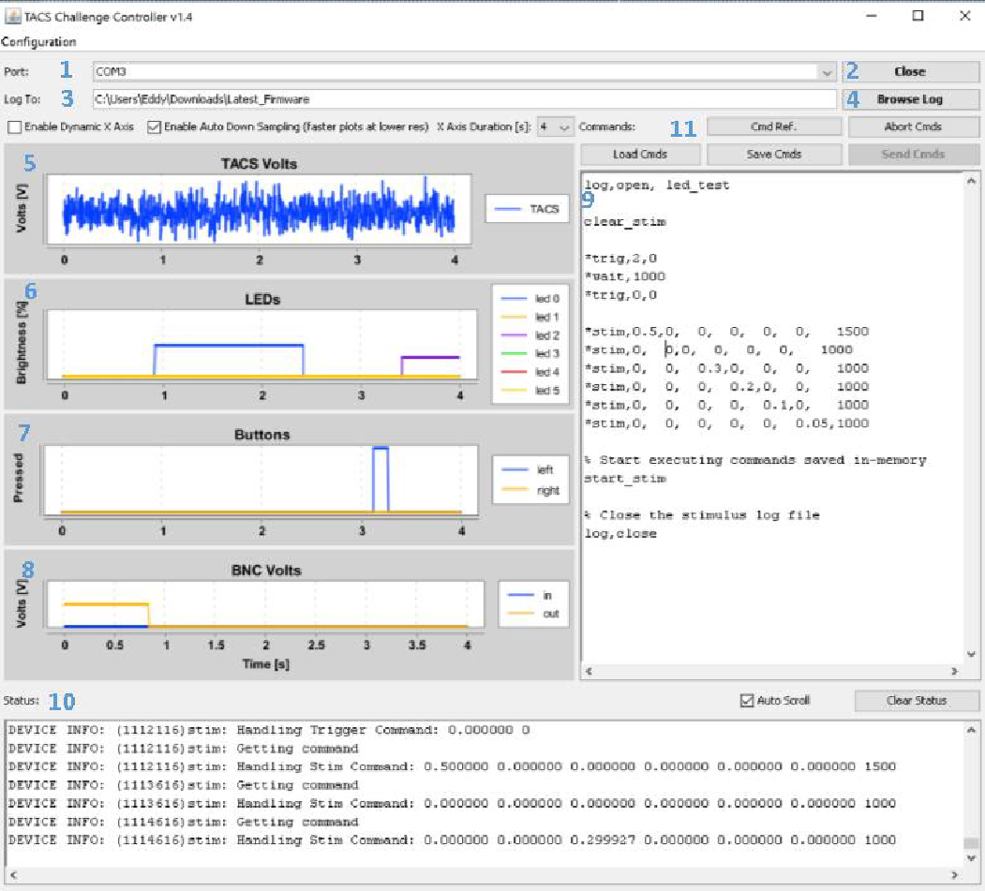

3.3 Data Output

The device saves all logged data into TSV files, under the filename specified by the command scripts. Each output file consists of 14 columns, each with fairly self-explanatory headings.

• DateTime – The full date and time each row of data was sampled.

• Time (μS) – The time represented in microseconds.

• tACS (V) – The recorded tACS signal in volts.

• BNCMode – Will be 1 if BNC triggers are active, 0 if not.

• BNCIn/ BNCOut (V) – The recorded voltage at the BNC input whether it is receiving or sending a trigger out.

• Left/Right Button - Will be a 1 if the button is pressed, 0 if not.

• LED Bright – The brightness of each LED (0 – 1).