**TACS Challenge Documents**

**SOP 3 – Experimental procedure**

**Created by**: Carlo Miniussi; **Revised by**: Simon Hanslmayr; Trento

**Last edited:** 02 July 2025

**List of material / Required hardware:**

|  |  |
| --- | --- |
| **Quantity** | **Item** |
| 1 | Exclusion Criteria Questionnaire |
| 1 | Information sheet (as approved by your local ethics committee or equivalent  board) |
| 1 | Consent form (as approved by your local ethics committee or equivalent board) |
| 1 | Demographics Questionnaire |
| 1 | Questionnaire tES sensation questionnaire |
| 1 | tACS Challenge Device |
| 1 | LED Array |
| 2 | USB-A to Micro-USB cables |
| 1 | 6-Pin Mini DIN cable |
| 1 | Laptop with Java Installed |
| 1 | (Optional) 5V portable battery |
| 1 | tACS device |
| 1 | tACS cap |
| 1 | set of all tACS electrodes and cables for 3 montages |
| 1 | set of all EEG electrodes to record tACS input signal |
| 1 | Metric tape |
|  | Alcohol wipes |
|  | Skin tape (e.g. 3M Transpore Transparent Plastic Tape) |
|  | Skin pencil / marker (blue / red / white) |
|  | Abrasive gel |
|  | Hair comb with pointy ending to help move hair out of target areas |
|  | EMLA cream + plastic foil + syringe (optional) |
|  | Ten20 conductive paste |
| 1 | Net cap |
| 1 | Hair dryer |

# Informed consent and pre-stimulation questionnaires

* 1. Recruitment: participants aged 18-39 years with normal or corrected-to-normal visual acuities and without any known risk factors for the application of tACS. The whole experimental session lasts approximately3 hours.
  2. Prior to involvement in the experiment, each participant is required to provide written informed consent, indicating their understanding of the procedures and their voluntary agreement to participate. Informed consent is based on document(s) approved from the corresponding institutional review board.
  3. Participants complete the Exclusion Criteria Questionnaire
  4. Participants complete the Demographics Questionnaire

.

# tACS setup

Electrode Locationnd Skin Preparation:

Measure participant’s head circumference by placing a tape measure around the widest part of the head. Add head circumference measurement in cm to the Demographics Questionnaire.

* 1. 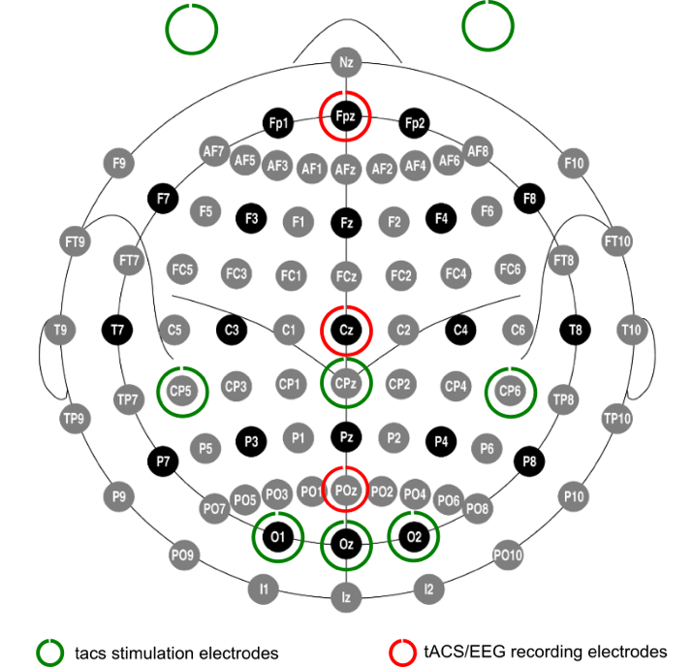Select the appropriate tACS cap (with holders and recording electrodes) based on head size and adjust it to the participant’s head. Cz should be at half distance between the participant’s nasion and inion and placed left-right symmetric by measuring the half point between the left and right preauricular points.
  2. Mark the following positions on the scalp:

**POz, Cz, FPz, O1, Oz, O2, CP5, CPz, CP6**

* 1. Comb / move participants’ hair in a concentric fashion from the centre of the electrode position outwards and clean the skin using isopropyl alcohol and/or abrasive gel (with subsequent removal of remaining gel with alcohol and hair drying). Use mild pressure and limited application times for the alcohol and abrasive gel to avoid irritation or small injuries of the skin.

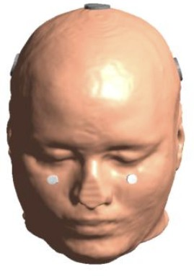

* 1. Clean the left and right cheek area below the eyes with alcohol.

Local Anaesthetic Application (optional – see also EMLA cream instructions sheet):

If EMLA cream is not being applied jump to Electrode Mounting step. To minimise skin sensation and reduce the activation of nociceptors, a local anaesthetic cream, such as EMLA, can be applied to electrode sites (except the ones close to the eyes). In total 3*3 g + 3*6 g = 24 g of EMLA cream are required per subject (i.e., almost 1x 30g tube).

* 1. Put on gloves to handle the cream.
  2. The cream is put on to the scalp in a thick layer. Ensure the cream is in good contact with the skin (and not only on top of the hair). It should cover the areas on the scalp where stimulation is applied, that is electrode locations O1, Oz, O2 and CPz, CP5, CP6. No cream should be put on the locations around the eyes!
  3. Apply 3g (10.5 cm) of EMLA cream (2.5 cm diameter electrode + 1 cm extra margin = 4.5 cm diameter = 15.9 cm² → ~3g) to each occipital electrode site (O1, Oz, O2); Cave: electrode areas may overlap for smaller heads, reduce amount of cream accordingly.Apply 6g (21 cm) of EMLA cream (4.5 cm diameter electrode + 1 cm extra margin = 6.5 cm diameter = 33.2 cm² → ~6g) to each centroparietal electrode site (CPz, CP5, CP6).
  4. Cover the area where the cream is with plastic wrap, i.e. plastic foil.
  5. Wait 60 minutes. This waiting time can also be used to perform the “Training on the behavioural task and titration of the visual stimulus” – see step 2.
  6. Wash the cream off using wipes and blow dry the hair (to avoid bridging of electrodes).

Electrode Mounting:

* 1. Fill the tACS electrode areas (O1, Oz, O2, CP5, CPz, CP6) with Ten20 conductive paste.
  2. Place the tACS electrodes applying pressure to the location.
  3. Fill the recording electrodes with Ten20 conductive paste and apply pressure.
  4. Place the net cap over to help hold the cap and electrodes in place.
  5. Apply a layer of approximately 3 mm of Ten20 conductive paste to the tACS electrodes to be placed on the cheeks and apply those to the face with some pressure to keep in place. Skin tape can be added on top of the electrodes to keep those in place.

# Impedance check

Largely different impedances should be avoided to avoid asymmetric current distributions across hemispheres. Measurement of all electrode pair-wise impedances is not feasible if conducted manually (i.e., without automated montage switching device) as it would result in a long protocol. **All labs will record as a minimum a sampling of most relevant pair-wise impedances as compromise solution**.

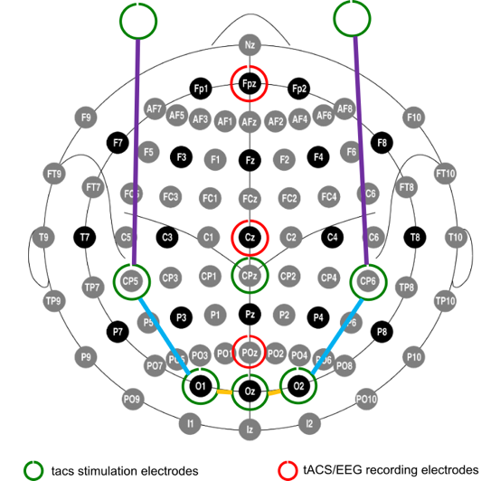Electrodes’ impedances will be measured and recorded for each montage at the beginning and end of their usage for the following electrode pairs (marked with an X in the table below):

|  |  |  |  |  |  |  |  |
| --- | --- | --- | --- | --- | --- | --- | --- |
|  | **O1** | **Oz** | **O2** | **CP5** | **CPz** | **CP6** | **Values** |
| **Oz** | **X** |  |  |  |  |  |  |
| **O2** |  | **X** |  |  |  |  |  |
| **CP5** | **X** |  |  |  |  |  |  |
| **CPz** |  |  |  |  |  |  |  |
| **CP6** |  |  | **X** |  |  |  |  |
| **Left Eye** |  |  |  | **X** |  |  |  |
| **Right Eye** |  |  |  |  |  | **X** |  |

* 1. Connect the right electrode leads to the stimulator to test each combination above.
  2. Set the tES stimulator to 500 µA absolute direct current for 10 seconds and measure impedance for each electrode pair with a X in the table above.
  3. Adjust the electrodes if any impedance >10 K Ohms or between pairs of electrodes in the same montage >3 K Ohms (matching same colours in the table and figure above).
  4. Record impedance for each electrode pair in the table above.

# Training on the behavioural task and titration of the visual stimulus

The visual stimuli are presented to participants using an Arduino-based device controlled by the experimenter through a Java program *(see SOP 2 – Setting up and using the tACS Challenge Device)*. This device consists of a small console containing six LED lights arranged in a specific configuration. [Note that part of the following description is repeated below in the “Main behavioural task” section]. This step should take approximately 10 min.

* 1. Participants are seated comfortably 1 meter from the LED array in a dimly illuminated, soundproof room.
  2. During the tasks, participants are instructed to maintain focus on a central LED light, denoted as '0', which remains constant in brightness throughout the task.
  3. Participants are asked to maintain fixation and avoid excessive blinking during the task.
  4. While all LEDs are continuously lit, any of the LEDs, but never more than one (or none at all) can change their luminance for 10 ms without any preceding temporal or spatial cue.
  5. Participants are asked to detect changes in brightness occurring in their lower left and right peri-foveal visual fields, i.e., the surrounding LED lights, numbered '1' through '5', undergo changes in brightness individually, one at a time.
  6. Participants are instructed to press a button with their dominant hand index finger upon detecting a target, i.e., change in brightness in any of the peripheral LED lights.
  7. The brightness change intensity for the first stimulation block is determined based on the participant's performance in the preceding behavioural block for titration of the visual stimulus.
  8. The staircase procedure to titrate the change intensity of the target can be executed directly from the GUI controlling the Arduino. Base brightness controls the intensity of background LEDs and should be set to 0.2. Target brightness controls the initial change intensity of the target and should be set to 0.4. The step size parameter controls the initial size of the change with every trial in the staircase and should be set to 0.19. Number of trials should be set to 40, target latency ITI min and max should match the parameters in the main experiment. Num Miss should be 1, Num Hit should be 2 to implement a 2 up 1 down staircase procedure. If participants perceive the intensity of the LEDs as too bright, the base brightness parameter can be lowered to 0.1.

# tACS stimulation intensity titration for phosphenes and cutaneous sensation

Follow up SOP 4 – tACS stimulation intensity titration for phosphenes and cutaneous sensation.

# Main behavioural task

A fixed frequency of 10 Hz will be employed across the three different montages (A = occipital TACS; B = retinal control stimulation; C = cutaneous control stimulation). TACS will be delivered in 9 blocks (7 min each), 3 per montage condition, in balanced order (with a random permutation of the Latin Square for each subject, e.g., ACB CBA BAC).

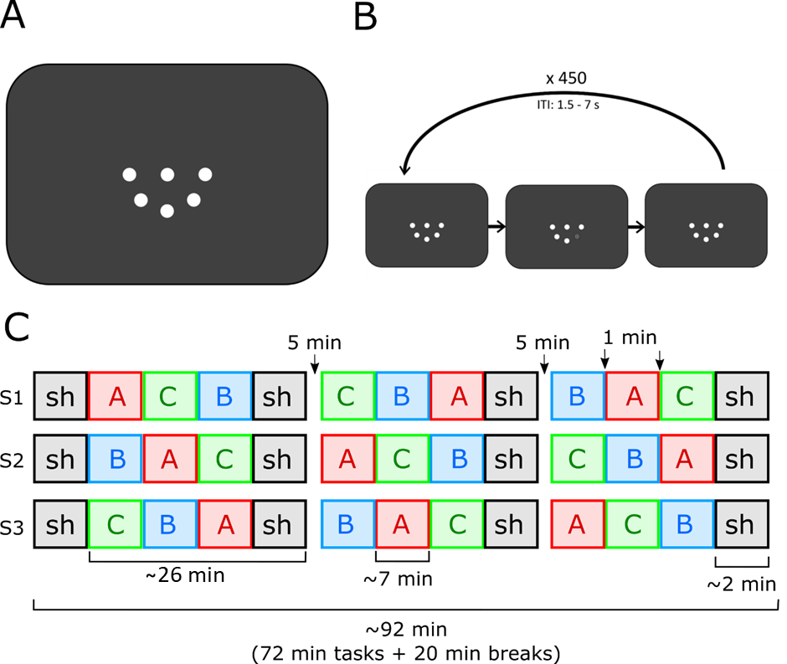

* 1. Check the Questionnaire – TES associated perceptions for the order of the blocks for the participant you are testing. Connect the matching electrode leads to the stimulator.
  2. Set the stimulator to tACS 10 Hz with the correct intensity defined in SOP 4 for the montage to be used in this block (A, B or C). Set the duration to 7 min.
  3. Ensure participant is seated comfortably 1 meter from the LED array in a dimly illuminated, soundproof room.
  4. Remind participant to maintain fixation and avoid excessive blinking during the task and remind them of the instructions:

“Press a button with your dominant hand index finger upon detecting a target, i.e., change in brightness in any of the peripheral LED lights. Be as quickly and as accurate as you can.”

The brightness change intensity for the first stimulation block is determined based on the participant's performance in the preceding behavioural block for **titration of the visual stimulus**.

* 1. At the end of the block ask participant about their tES associated perceptions following the Questionnaire – TES associated perceptions.
  2. Repeat steps 6.1 to 6.5 until three blocks are completed. Tell participant that they will now have a break (self-paced, but minimum 5 minutes).
  3. Repeat steps 6.1 to 6.6.