**TACS Challenge Documents**

**SOP 6 – Double Blinding and Assignment of Condition Sequences**

**Created by**: Yifan Shen, Chaofan Kong; **Revised by**: Simon Hanslmayr

**Last edited:** 3 July 2025

**List of material / Required hardware:**

|  |  |
| --- | --- |
| **Quantity** | **Item** |
| 1 | Opaque Cover |

**1. Role Description**

Two experimenters are involved in the tACS challenge experiment:

* Experimenter 1 (blinded): Unaware of the condition sequences for each participant; responsible for interacting with the participant throughout the experiment.
* Experimenter 2 (non-blinded): Responsible for assigning balanced condition sequences to participants prior to the experiment and for switching stimulation conditions between blocks during the experiment. Does not interact with the participant during the experiment.

The following sections describe the procedure for assigning conditionsequences to participants (by experimenter 2) and implementing the double-blind setup during the experiment.

**2. Assigning Condition Sequences to Participants (by Experimenter 2)**

图片包含 图形用户界面

AI 生成的内容可能不正确。Experimenter 2 is responsible for randomly assigning balanced Latin Square sequences (S1, S2, and S3; see figure below, where A = Occipital, B = Retinal Control, C = Cutaneous Control) to participants, while keeping these assignments hidden from Experimenter 1.

The detailed procedure is as follows:

* 1. Generate a random array of integers from 1 to 21



* 1. Split this array equally into three sub-sequences: S1, S2, and S3.



* 1. Rearrange the array from smallest to largest.



* 1. Combine the sequences represented by S1, S2, and S3 with the array and add required column names.

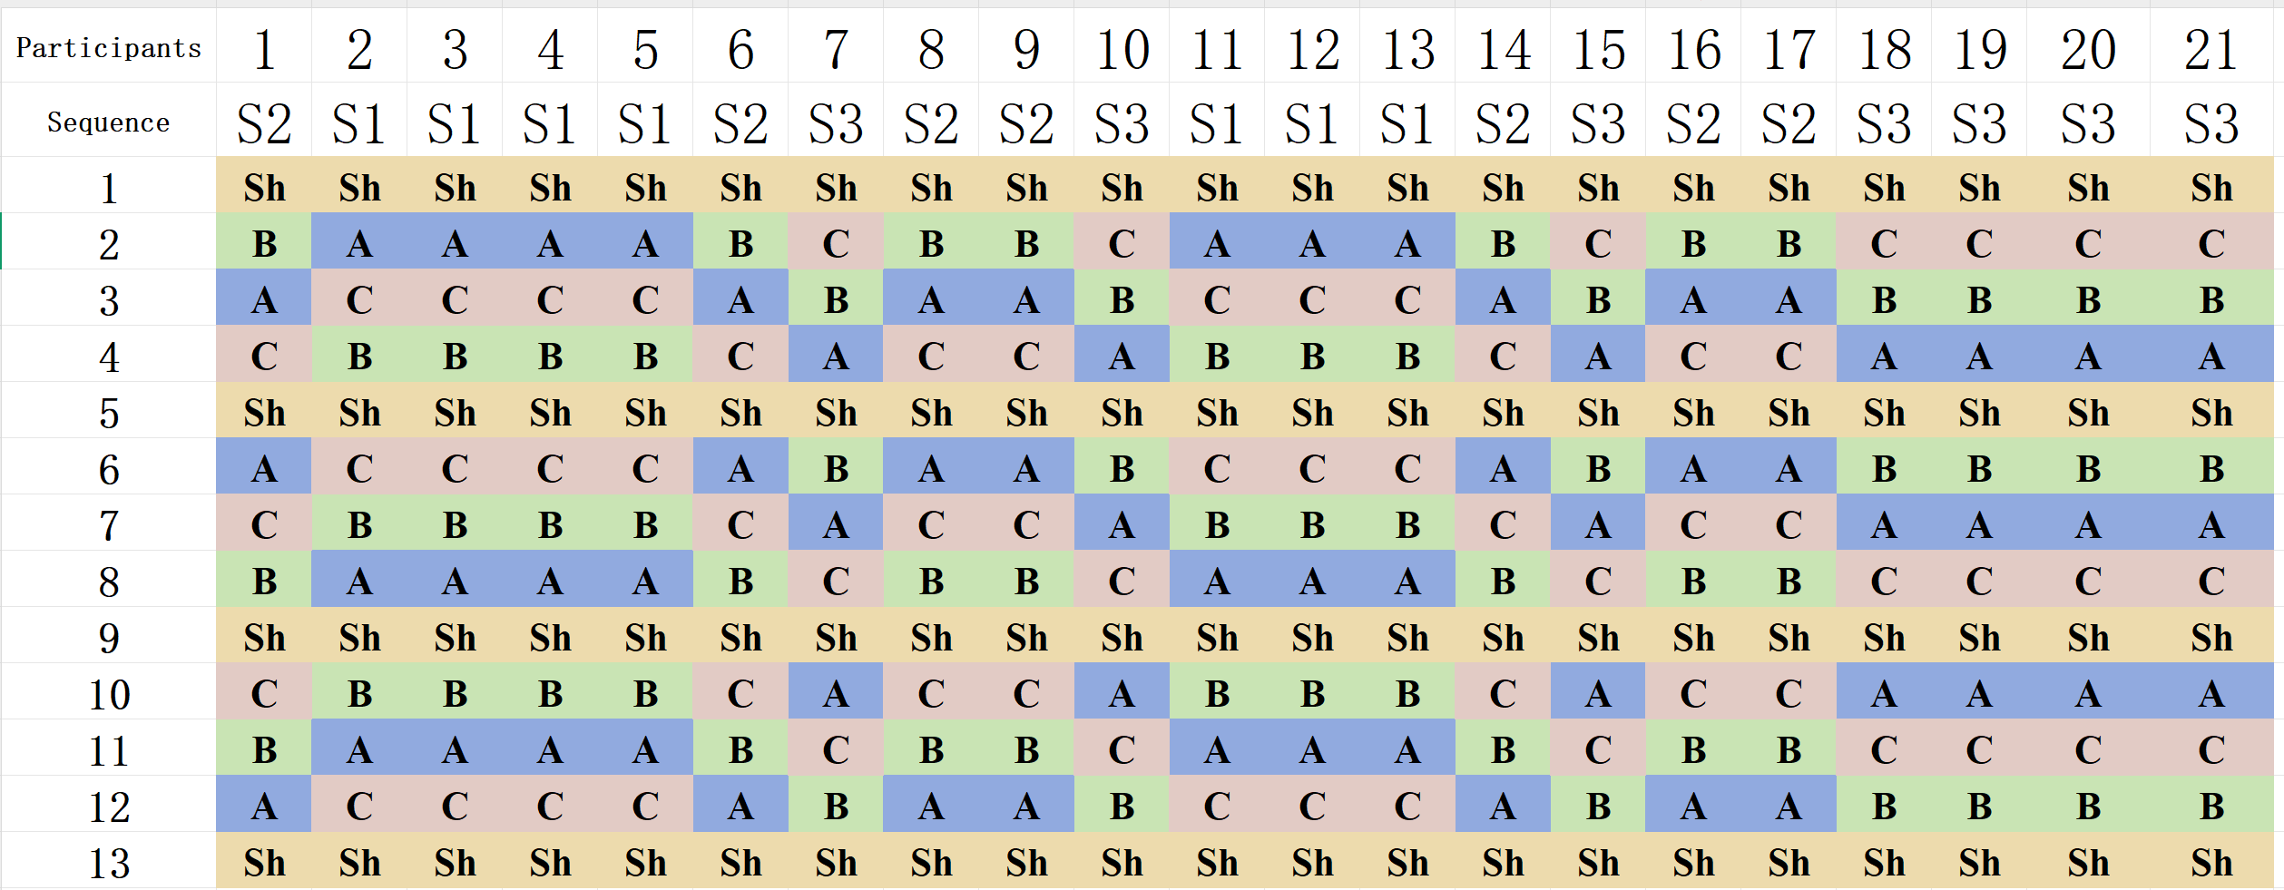

* 1. Remove the last participant to obtain the final sequences for 20 participants.
  2. Apply the assigned condition sequence to the corresponding participant during the experiment.

**3. Double-Blind Procedure During the Experimental Process**

1. After each block, Experimenter 1 (blinded) enters the participant’s room to administer the tES-sensation questionnaire and to carry out all necessary interactions with the participant, such as confirming rest times and informing them about the start of the next block.
2. Meanwhile, Experimenter 2 (non-blinded) enters briefly to adjust the stimulation montage and parameters to switch to the next condition, without interacting with the participant.
3. After making the adjustments, Experimenter 2 covers the montage switching device or the cable-to-stimulator interface with an opaque cover (e.g., a towel) to prevent Experimenter 1 from seeing any condition-related information. Any identifying details displayed on the stimulator screen (e.g., current intensity) must also be concealed.
4. During the experiment, Experimenter 2 needs to ensure that condition-related information is not disclosed through any other means. For example, when saving files according to the naming conventions outlined in SOP 5 during the experiments, the file names must not be visible to the experimenter 1.