TACS Challenge Documents

SOP 5 – Data Sharing

Created by: Benedikt Zoefel; Revised by: Simon Hanslmayr, Ines Violante
Last edited: 10 September 2025

List of material / Required hardware:

Quantity | Item
1 | OSF account
For each subject | tsv output for each experimental block
For each subject | tsv output for staircase
For each subject | tACS Challenge Data table (tsv)
For each subject | EEG data in BIDS format
1 | Notes.txt – optional, containing relevant information (e.g., additional participants because of technical issues)
Required structure and files for data sharing
- Create a data folder for your lab on OSF: https://osf.io/gz84a/files/osfstorage
and label it with a code (L+ number of your lab as assigned on https://tacschallenge.github.io/labs/). For example: ‘L06’ if you are in the Bergmann lab, or ‘L40’ if you are in the Tarantino lab.

- Create a folder for each subject that you can then store in your lab folder on OSF. Label each participant’s folder with your lab code and an individual participant code. Example: ‘sub-L01_S01’ for the first participant in the Aglioti lab.

- Create three subfolders inside each subject folder names: beh, eeg, metadata

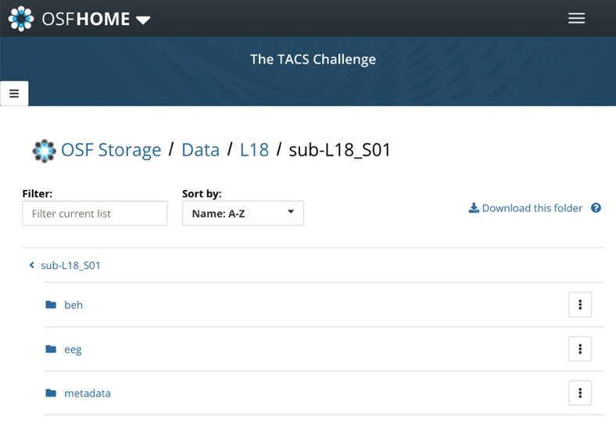

- beh folder
The following files are required in each subject’s beh folder:
- .tsv output file from each experimental block, labelled according to lab code, participant code, block number (between 1 and 13), and montage. For example:
‘sub-L04_S03_B4_A.tsv’ for the Battaglini Lab, participant nr 3, Block 4, Montage A. Note that the order of montages varies from participant to participant according to a latin square permutation (see here). Montage labels correspond to those on the tACS Challenge Sensation Questionnaire and the registered report (Sh = sham, A=occipital, B=phosphene, C=cutaneous).

- .tsv output file from the staircase procedure, labelled as described above, e.g.
sub-L01_S01_Staircase.tsv

- .tsv file from TES associated sensations questionnaire with rows coding the questions (i.e. Q1: Do you see flashes/flickering of light?, etc.) and columns coding the responses in numeric values (insert 0 when no sensations are reported). The resulting file is labelled as described above, e.g. sub-L18_S02_TES_questionaire.tsv

- eeg folder

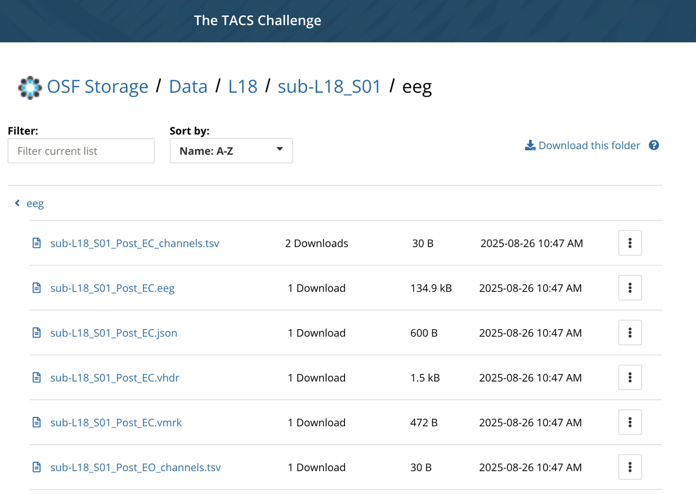

The following files are required in each subject’s eeg folder:

- .edf or .vhdr, .vmrk, .eeg files from Pre and Post, EO and EC EEG recordings, labelled according to lab code, participant code, Pre/Post, EO/EC

More information about eeg data formats here - https://bids-specification.readthedocs.io/en/stable/modality-specific-files/electroencephalography.html

Although other formats are available, we will follow EEG BIDS recommendation to use the European data format, or the BrainVision data format.

- .json files – one per EEG recording with information on EEG condition, EEG hardware, EEG electrodes, lab, etc. Follow the structure available for sub-L18_S01_Pre_EO.json
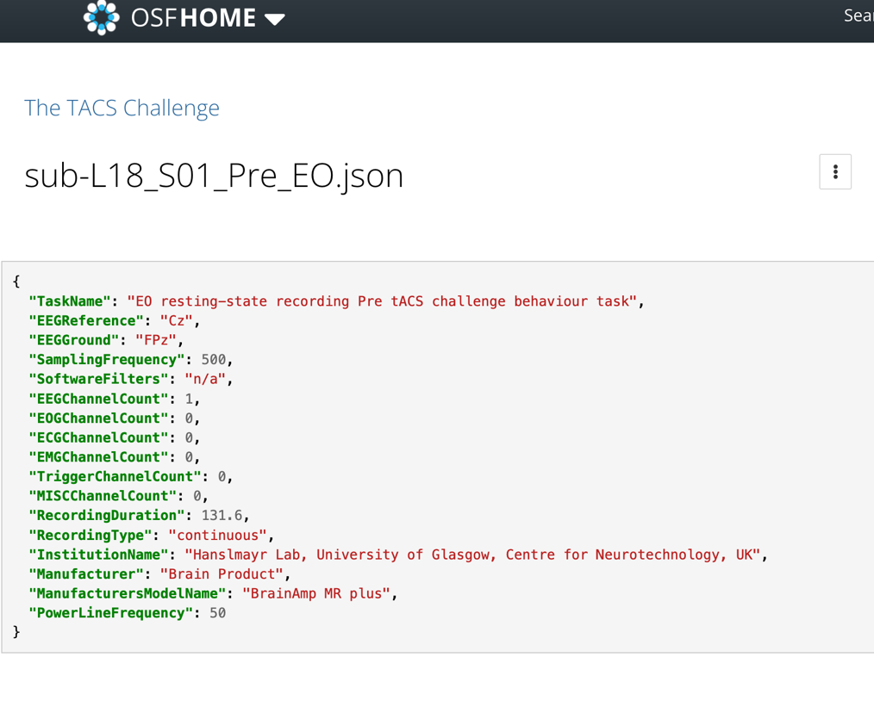

- *_channels.tsv – 2 files in total, one for Pre and one for Post, labelled according to labelled according to lab code, participant code, Pre/Post. For example:
‘sub-L04_S03_ Pre_EC_channels.tsv’
This file contains information on the EEG channels used as per below

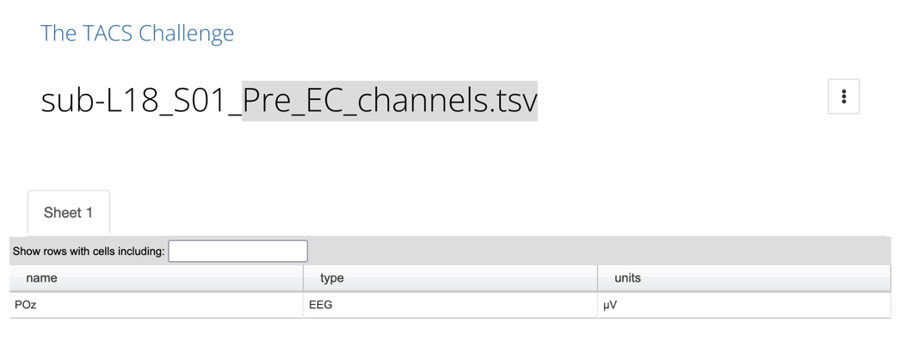
And following the EEG BIDS format

- metadata folder
Add the table tACSChallenge_Data, labelled as described above, e.g.
sub-L01_S01_Meta_Data.tsv
Please fill in the required information:
  - Lab Code (same as above)
  - Subject Code (same as above. Ideally the same as in the Demographic Information Form)
  - Gender (from the Demographic Information Form)
  - Age (5-year bracket; from the Demographic Information Form)
  - Stimulation intensity (separately for each montage)
  - Impedance difference between hemispheres (separately for each montage)
  - Use of EMLA cream (y/n)
  - Individual Alpha frequency (IAF) (if applicable)

