**Lab # 4**

**Thomas Boccinfuso**

**PART A**

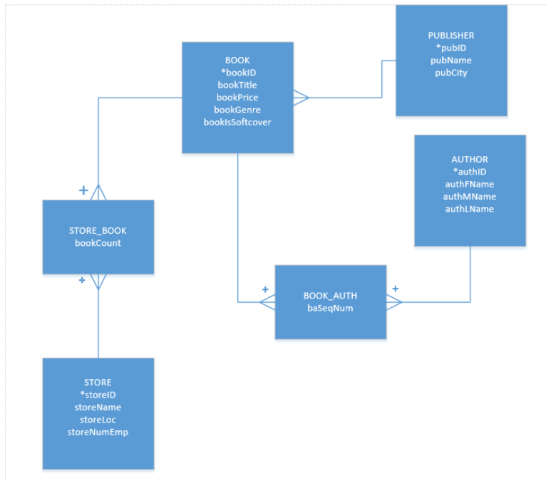

**PART B**

|  |  |  |  |  |
| --- | --- | --- | --- | --- |
| PUBLISHER | | |  |  |
| pubID | pubName | pubCity |  |  |
| 1 | Bantam books | New York |  |  |
| 2 | Pocket books | New York |  |  |
|  |  |  |  |  |
|  |  |  |  |  |
| STORE | | | |  |
| storeID | StoreName | storeLoc | storeNumEmp |  |
| 1 | Henry's Brentwood | Brentwood Mall | 15 |  |
| 2 | Henry's Downtown | 16 Riverview | 10 |  |
| 3 | Henry's Eastshore | Eastshore Mall | 9 |  |
| 4 | Henry's On the Hill | 1289 Bedford | 4 |  |
|  |  |  |  |  |
| BOOK | | | | |
| bookID | bookTitle | bookPrice | bookGenre | bookSoftCover |
| 1 | Ghost from Grand Bank | 19.95 | SFI | 0 |
| 2 | Higher Creativity | 9.75 | SFI | 1 |
| 3 | Hyms of the Night | 6.75 | POE | 1 |
|  |  |  |  |  |
| AUTHOR | | | |  |
| authID | authFName | authMName | authLName |  |
| 1 | Arthur | C | Clarke |  |
| 2 | Novalis |  |  |  |
| 3 | Willis |  | Harmon |  |
| 4 | Hoawrd |  | Rheingold |  |
|  |  |  |  |  |
| STORE_BOOK | | |  |  |
| bookID | storeID | bookCount |  |  |
| 1 | 1 | 2 |  |  |
| 2 | 2 | 2 |  |  |
| 3 | 2 | 3 |  |  |
|  |  |  |  |  |
| BOOK_AUTH | | |  |  |
| authID | bookId | baSeqNum |  |  |
| 1 | 1 | 1 |  |  |
| 2 | 2 | 1 |  |  |
| 3 | 3 | 1 |  |  |
| 4 | 3 | 1 |  |  |
|  |  |  |  |  |
|  |  |  |  |  |