

University of Ljubljana  
 Faculty of Computer and Information Science

**SEMINAR 1**

**Synthesis of clarinet**

**Subject:** Digital signal processing Ljubljana, december 2020

**Author:** Timotej Tim Rus, 63180256

Table of Contents

1. Introduction 3

2. Method 4

3. Result 5

4. Discussion 6

# Introduction

**How does clarinet work?**

The clarinet is a single reed instrument. Made from wood, the clarinet produces a fluid sound when air is blown between a single reed and the mouthpiece. By pressing metal keys with the fingers of both hands, the player has the ability to play many different notes very quickly. The clarinet can play in the low register, where the notes are rich and full. It can play in the middle register. It can also play in the high register.

Sound on a woodwind instrument comes from a vibrating column of air inside the instrument. The player makes this column of air vibrate in one of three ways: as air is blown across the top of an instrument (like the flute), across a single reed (like the clarinet), or across two reeds (like the oboe).

# Method

Task1:

For first task I wrote a function that loops through list and checks if the length of note is equals to 0.25 or 0.5. This is how I determined the length on note for example: if the len in list is 0.25, I used the formula from the instructions (w = 2 * pi + F0/Fs) and set n = 0:1999 (which is ¼ of Fs), after that I added result of function note(w, n) to my list toPlay.

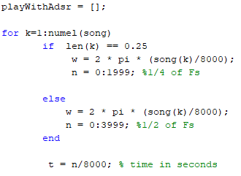

After that I set values for Attack, Decay, Sustain and Release with linspace (generates linearly spaced vector) and save them to values list.

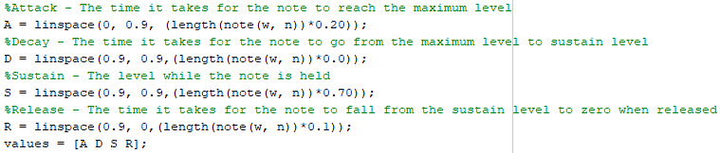

Below that, I multiplied signal with envelope, so the sound will be more like clarinet-like.



Task2:

First I made notes variables and add frequencies for each note, then add them to more tables named line1, line2, etc.. (in the order of my song - Ringaraja). Then added those lines of song to the list through which I am looping in task 1, and set lenght of each notein list on lens.

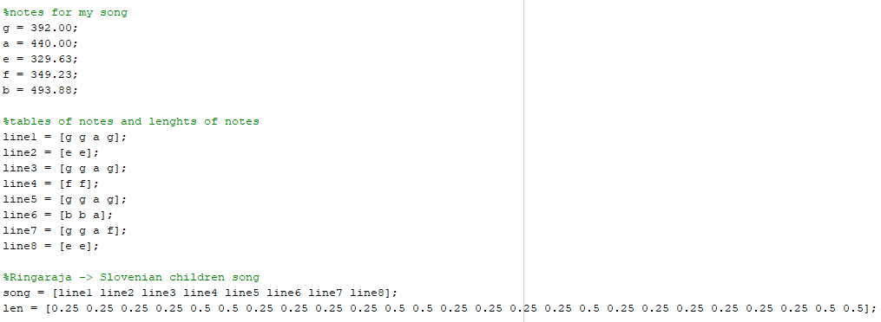

The song was played on the end of the file with function soundsc(playWithAdsr, Fs) from Matlab.

# Result

Sound from my ADSR function is cleaner than sound which was just played with my notes in matlab. The plot of Ringaraja song with clarinet is similar to one on our online classroom.

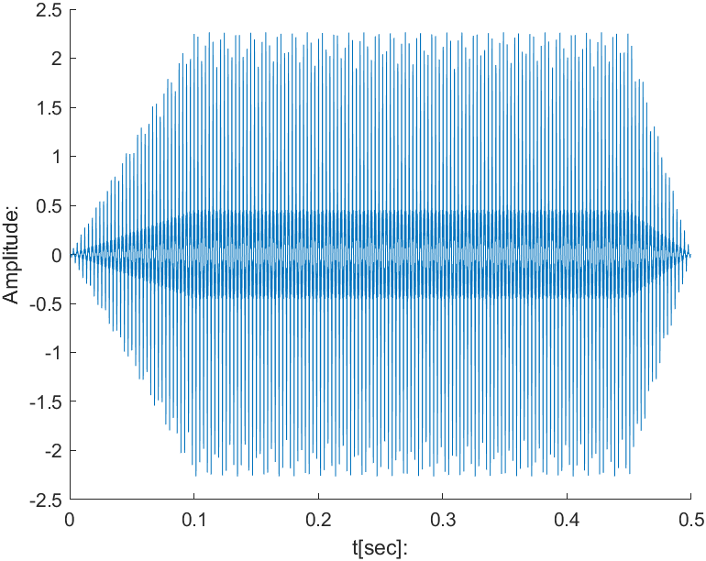

Plot from my function (clarinet playing Ringaraja song).

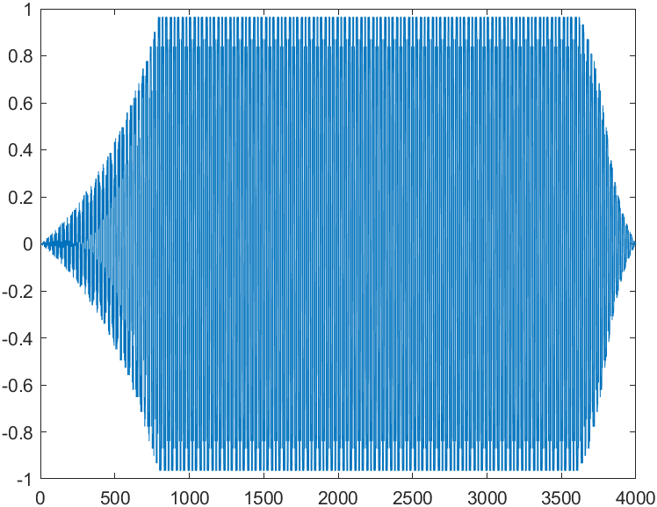

Plot from clarinet sound from our online classroom.

The most important components for ADSR envelope to generate more clarinete-like sound are A – Attack (The time it takes for the note to reach the maximum level) and R – Release (The time it takes for the note to fall from the sustain level to zero (silence) when released).

# Discussion

I tried to get plot signal more like one from our classroom, with logspace function, but it was not as good as linspace (in sound and in signals). Picture below:

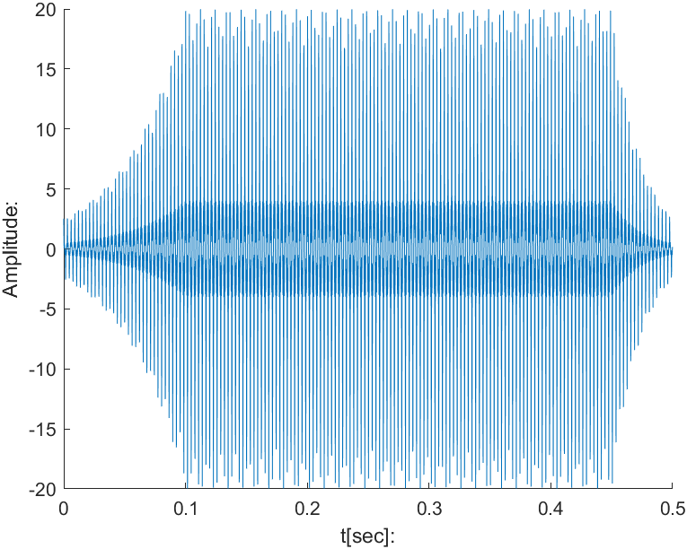

ADSR using logspace