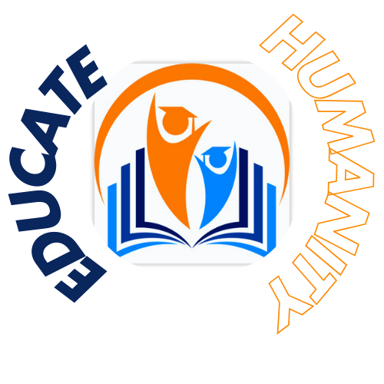

**Educating Humanity, Transforming lives**

**Our Mission:**

We believe that education should be easily accessible to everyone. In a country like Pakistan, where 28.3 million are out of school, we are keen on providing orphans and underprivileged children with a better education until primary school and mitigating child labor all over Pakistan.

**Documents Required for Orphan Students Verification:**

Death Certificate of Father

School fee proof

Proof of Cost of Uniform and other expenses regarding study

Mark sheet of the previous exam

Electricity Bill

Guardian’s CNIC

Proof of Rental Agreement (In case of rental house)

**Documents Required for Needy Students Verification:**

Father's Salary should be less than 45000

Father's Cnic

Father’s Salary slip

Electricity Bill

Agreement of rent (if living in a rental house)

School fees proof

Proof of Cost of Uniform and other expenses regarding study

Mark sheet of the previous exam

**Be a part of our cause:**

If you are passionate and eager to bring a change in Pakistan, we need you at Educate Humanity

Fill up the Volunteer Form Below

<https://forms.gle/P1MkHpYLKEhZRpVy9>

**For Donations:**

Support a child’s education for as low as **Rs.5000 per month (includes fee, uniform, books and other study related expenses)** or You can contribute for as low as **Rs.3000 per month (includes fee and uniform)**

**Easypaisa:**

03108323340

Taha Yaseen

**Allied Bank Ltd.**

06420010094463410013

Taha Yasin