COVID CASE STUDY

Mark Druss

21 June 2021

# EXECUTIVE SUMMARY

The COVID outbreak continues although symptomatic cases are decreasing across all cities as we enter summer in Fulton County.

As of 21 June, 2021 there have been 89880 confirmed cases reported and 1869 (2.1%) deaths.

# Person

*Age Pyramid*  
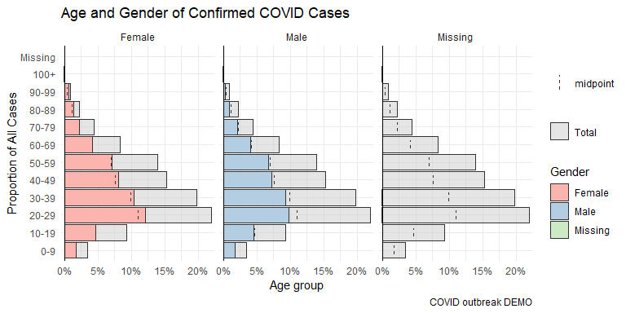

* As of June 21 2021, Fulton County has recorded 89880 confirmed cases of COVID-19. Of these 42040 are Male and 47399 are Female. The average age is 39.6716798 with a range of 0 to 106.

*Hospitalizations by Race*

| **Characteristic** | **No**, N = 48,6051 | **Yes**, N = 5,8721 | **p-value**2 |
| --- | --- | --- | --- |
| Race |  |  | <0.001 |
| AI/AN | 48 (96%) | 2 (4.0%) |  |
| ASIAN | 2,052 (95%) | 110 (5.1%) |  |
| BLACK | 21,268 (85%) | 3,866 (15%) |  |
| OTHER | 3,276 (91%) | 318 (8.8%) |  |
| WHITE | 20,198 (93%) | 1,489 (6.9%) |  |
| Unknown | 1,763 | 87 |  |
| 1n (%) | | | |
| 2Pearson's Chi-squared test | | | |

* Among all confirmed cases of COVID-19 in Fulton County, 5872 (6.5%) required hospitalization.

*Deaths by Race*

| **Characteristic** | **No**, N = 47,6551 | **Unknown**, N = 1661 | **Yes**, N = 1,8691 |
| --- | --- | --- | --- |
| Race |  |  |  |
| AI/AN | 46 (100%) | 0 (0%) | 0 (0%) |
| ASIAN | 1,996 (98%) | 4 (0.2%) | 35 (1.7%) |
| BLACK | 21,735 (95%) | 59 (0.3%) | 1,170 (5.1%) |
| OTHER | 3,190 (99%) | 12 (0.4%) | 33 (1.0%) |
| WHITE | 19,277 (96%) | 73 (0.4%) | 631 (3.2%) |
| Unknown | 1,411 | 18 | 0 |
| 1n (%) | | | |

* As of June 21 2021, Fulton County has recorded 1869 (2.1%) overall deaths.

# Time

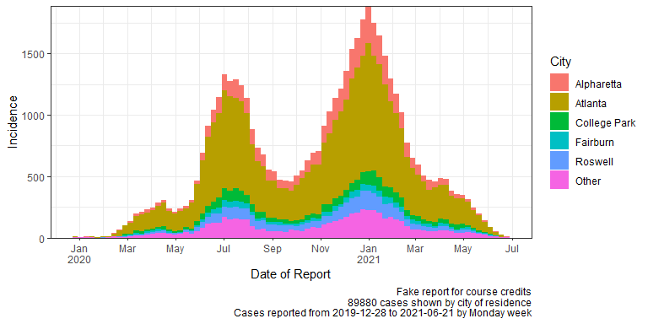

* A rapid decline of symtomatic cases is being reports as of June 21 2021 for all cities in the county.

# Place

*Top 5 Cities reporting confirmed cases from 2019-12-28 to 2021-06-21*

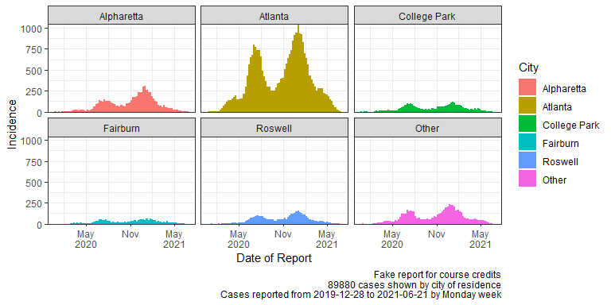

- Atlanta is reporting the largest incidence rate decline in 2021 compared to the other Fulton County cities.

*Cumulative Case Incidence Table by City*

| City | Cases | COVID Cases in last 14 days | Confirmed | Deaths | Cumulative incidence per 10,000 |
| --- | --- | --- | --- | --- | --- |
| College Park | 5,680 | 5,642 | 5,680 | 102 | 4,077.5 |
| Fairburn | 3,291 | 3,273 | 3,291 | 54 | 1,996.6 |
| Hapeville | 1,185 | 1,180 | 1,185 | 27 | 1,808.3 |
| Alpharetta | 11,719 | 11,681 | 11,719 | 181 | 1,780.5 |
| Palmetto | 628 | 626 | 628 | 10 | 1,238.4 |
| Atlanta | 51,615 | 51,397 | 51,615 | 1,186 | 1,035.0 |
| Union City | 2,186 | 2,173 | 2,186 | 59 | 814.8 |
| Roswell | 6,741 | 6,721 | 6,741 | 125 | 726.1 |
| East Point | 2,559 | 2,545 | 2,559 | 59 | 667.1 |
| Duluth | 1,365 | 1,363 | 1,365 | 19 | 428.3 |
| Sandy Springs | 2,911 | 2,905 | 2,911 | 47 | 269.3 |

# City Summary

* As of June 21 2021, College Park has recorded the highest incidence of confirmed COVID-19.

# EXTRA

