DEMO Situation Report

Ebola Outbreak in Sierra Leone

Mark Druss

2023-05-08

## Purpose

I’m learning R because I seek:

* Analytical *flexibility* and *ownership*.
* Advanced *graphics* and automated *reporting capability*.
* To **support the movement towards free, open-source software**

Today’s date is 2023-05-08 and I am finishing the Intro to R Field Epidemiology class via AppliedEPI!

# 1. Load Packages

* Using pacman() several packages were loaded for the analysis (e.g., lubridate, epikit, tidyverse)

## package 'raster' successfully unpacked and MD5 sums checked  
##   
## The downloaded binary packages are in  
## C:\Users\druss\AppData\Local\Temp\RtmpEJEyJH\downloaded_packages

# 2. Import Data

* Surveillance Linelist
* Hospital Linelists
* Lab Dataset
* Case Investigation Dataset

# 3. Clean the Surveillance Linelist

* Cleaned the dataset using, clean_names(), rename(), select(), distinct(), mutate(), recode(), ifelse(), case_when(), filter().

# 4. Joins

* Combine a series of hospital datasets and join them to a surveillance linelist
* Join a *lab* dataset
* Join a *investigation* dataset

Then tidy up the new combined dataset and create *EPIWEEKS*

# 5. Export the cleaned *combined* dataset

* Can export the dataset individually or part of a project.

# 6. Practical Report Example

# Executive summary

The Ebola outbreak continues, although reported cases are decreasing in all districts following the surge of contract-tracing support provided by international partners.

As of there have been 539 confirmed cases reported.

Table of partners involved in the response

| Partner | Arrived | Activities |
| --- | --- | --- |
| Doctors without Borders (MSF) - Belgium | 20 July | Treatment centers |
| World Health Organization (WHO) | 22 July | Surveillance and analytics |
| Red Cross (ICRC) | 1 August | Community-based surveillance |

[Area intended to summarize trends and response activities]

## Person

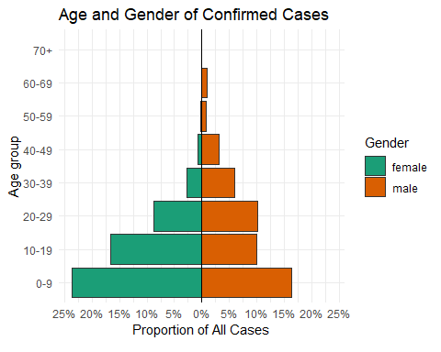

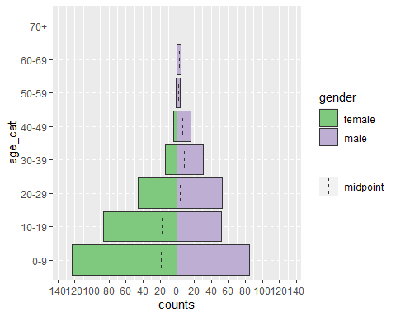

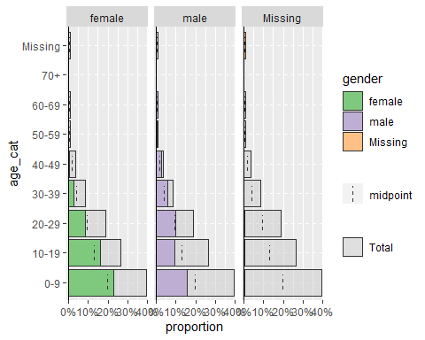

## Time

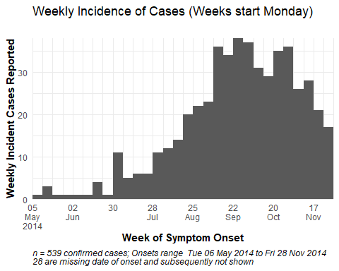

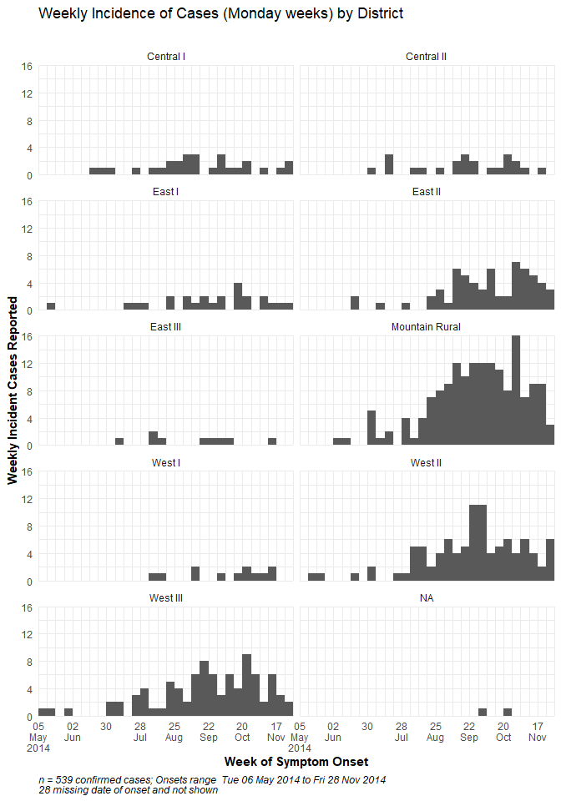

## Place

### Summary by District

| district | n | percent |
| --- | --- | --- |
| Mountain Rural | 176 | 33% |
| West II | 102 | 19% |
| West III | 93 | 17% |
| East II | 65 | 12% |
| Central I | 30 | 6% |
| East I | 25 | 5% |
| Central II | 23 | 4% |
| West I | 13 | 2% |
| East III | 10 | 2% |
| Missing | 2 | 0% |

### Summary by Hospital

| Hospital | Total cases | Latest onset | Under 5 years | Vomit (n) | Vomit (%) | Max weight (males) |
| --- | --- | --- | --- | --- | --- | --- |
| Central Hospital | 40 | 2014-11-24 | 10 | 22 | 55% | 97 |
| Military Hospital | 78 | 2014-11-25 | 19 | 33 | 42% | 80 |
| Other | 85 | 2014-11-26 | 16 | 43 | 51% | 97 |
| Port Hospital | 174 | 2014-11-28 | 47 | 86 | 49% | 96 |
| SMMH | 29 | 2014-11-28 | 6 | 15 | 52% | 73 |
| Missing | 133 | 2014-11-27 | 30 | 71 | 53% | 98 |

## District Spotlight

Below is a spotlight on hospital admissions and outcomes for patients reported in West II

| Outcomes in West II District, by Hospital | | | |
| --- | --- | --- | --- |
| hospital | Death | Recover | Total |
| Central Hospital | 4 | 4 | 8 |
| Military Hospital | 6 | 6 | 12 |
| Other | 3 | 6 | 9 |
| Port Hospital | 22 | 11 | 33 |
| SMMH | 4 | 1 | 5 |
| Missing | 9 | 8 | 17 |
| Total | 48 | 36 | 84 |

# 7. Supplemental Example Plots

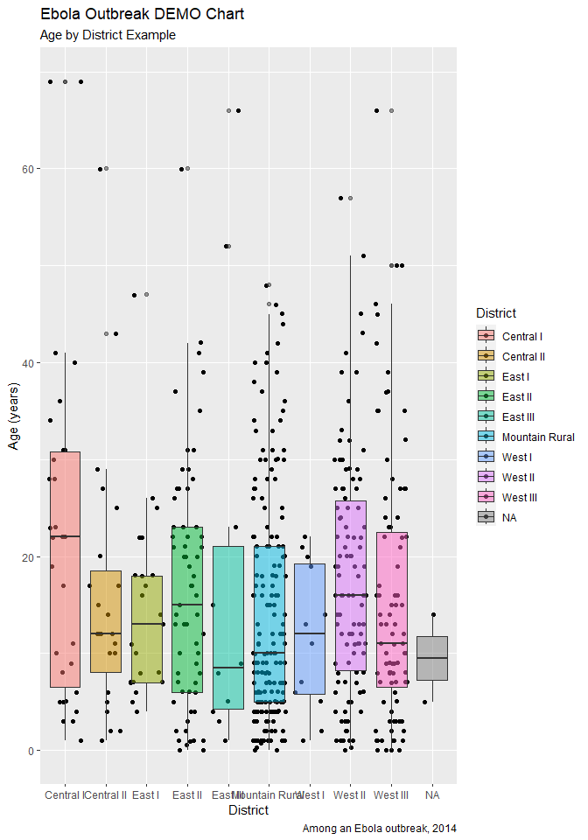

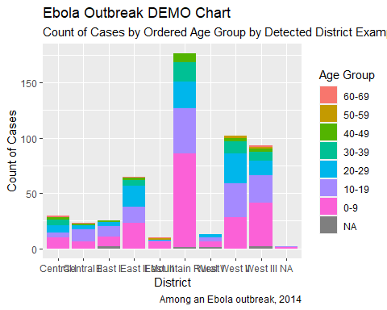

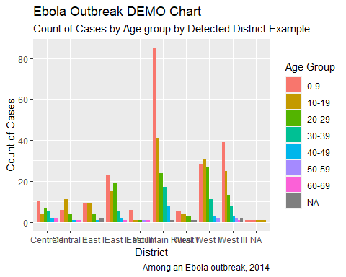

#Summarized data

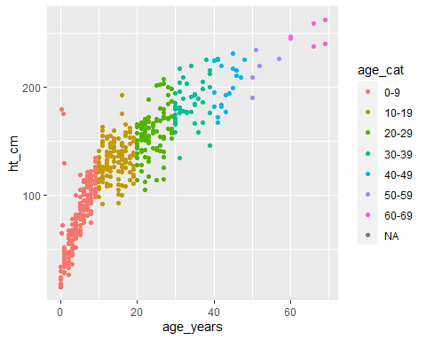

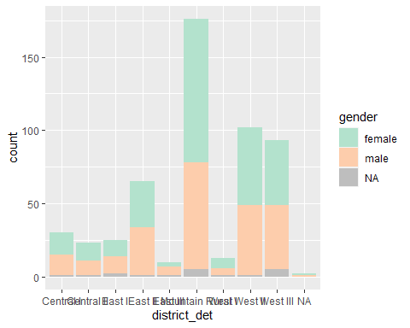

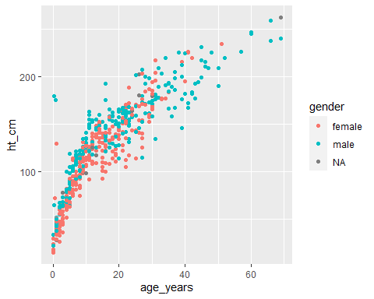

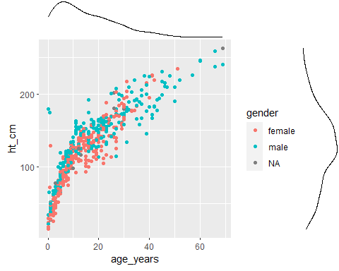

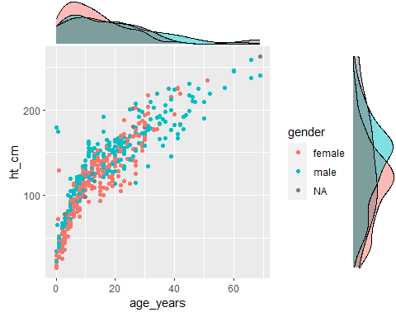

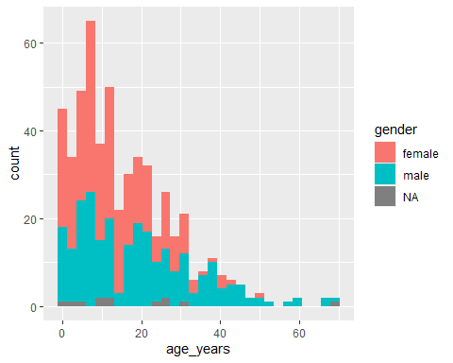

#FACETS

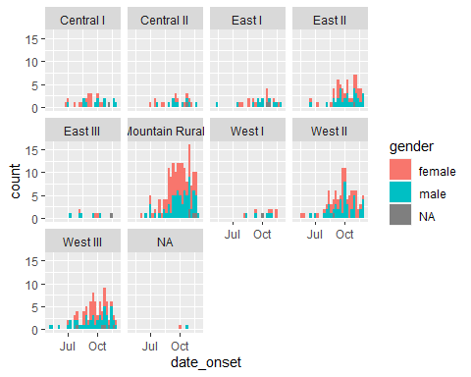

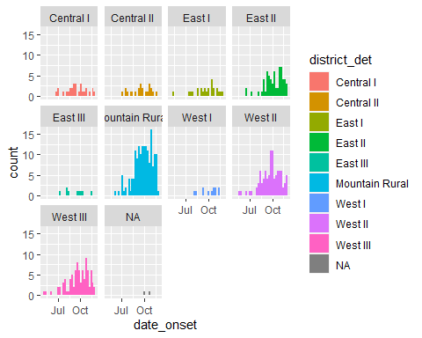

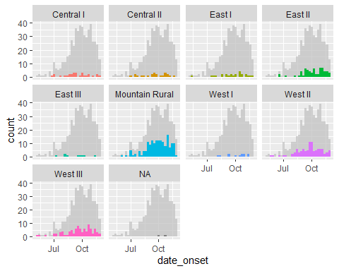

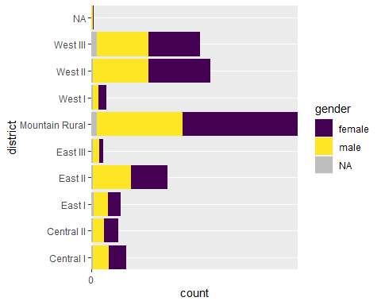

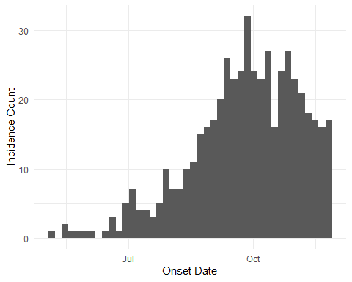

## [1] "2014-05-06" "2014-05-13" "2014-05-20" "2014-05-27" "2014-06-03"  
## [6] "2014-06-10" "2014-06-17" "2014-06-24" "2014-07-01" "2014-07-08"  
## [11] "2014-07-15" "2014-07-22" "2014-07-29" "2014-08-05" "2014-08-12"  
## [16] "2014-08-19" "2014-08-26" "2014-09-02" "2014-09-09" "2014-09-16"  
## [21] "2014-09-23" "2014-09-30" "2014-10-07" "2014-10-14" "2014-10-21"  
## [26] "2014-10-28" "2014-11-04" "2014-11-11" "2014-11-18" "2014-11-25"

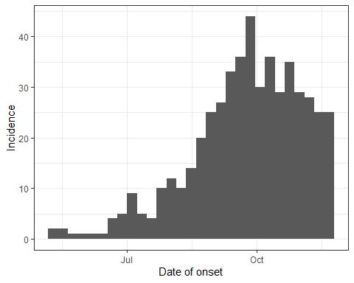

## [1] "2014-05-05"

## [1] "2014-12-01"

## [1] "2014-05-05" "2014-05-12" "2014-05-19" "2014-05-26" "2014-06-02"  
## [6] "2014-06-09" "2014-06-16" "2014-06-23" "2014-06-30" "2014-07-07"  
## [11] "2014-07-14" "2014-07-21" "2014-07-28" "2014-08-04" "2014-08-11"  
## [16] "2014-08-18" "2014-08-25" "2014-09-01" "2014-09-08" "2014-09-15"  
## [21] "2014-09-22" "2014-09-29" "2014-10-06" "2014-10-13" "2014-10-20"  
## [26] "2014-10-27" "2014-11-03" "2014-11-10" "2014-11-17" "2014-11-24"  
## [31] "2014-12-01"

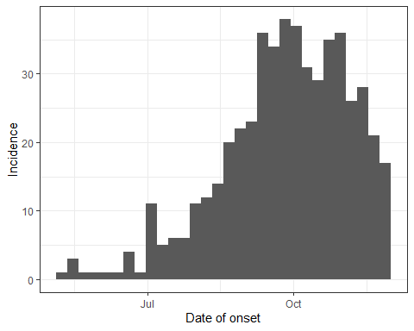

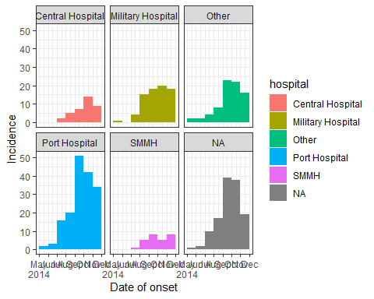

#Creating Proportions

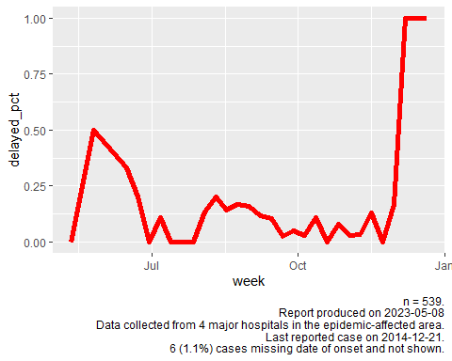

Percents

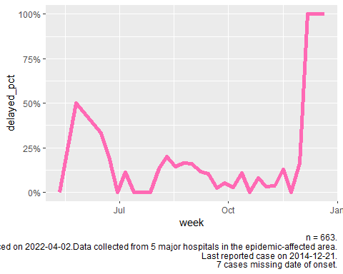

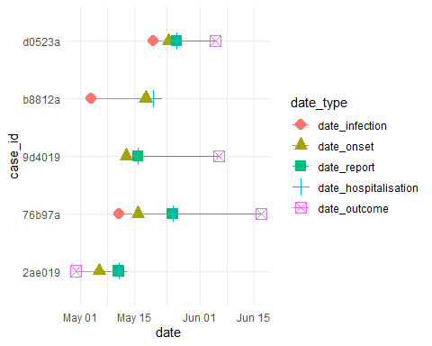

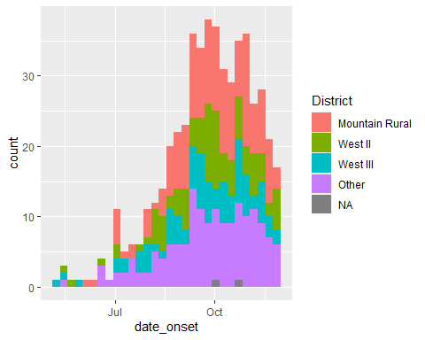

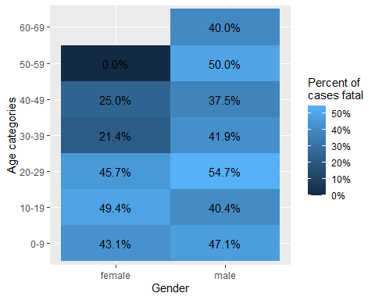

#Continuous Data

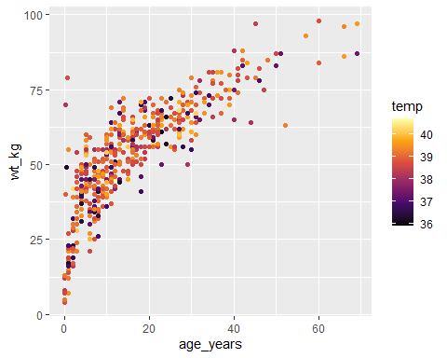

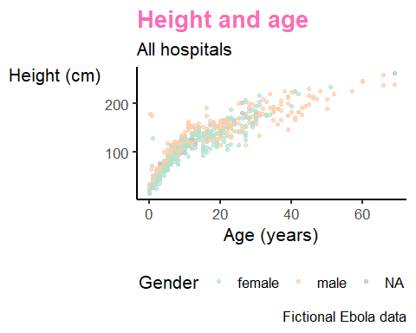

#GIS Example

## Geometry set for 531 features   
## Geometry type: POINT  
## Dimension: XY  
## Bounding box: xmin: -13.27101 ymin: 8.447887 xmax: -13.20613 ymax: 8.489986  
## Geodetic CRS: WGS 84  
## First 5 geometries:

